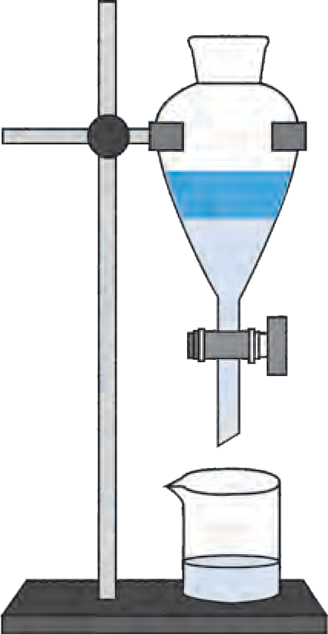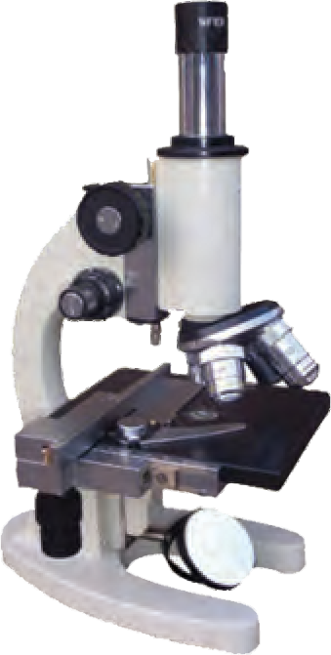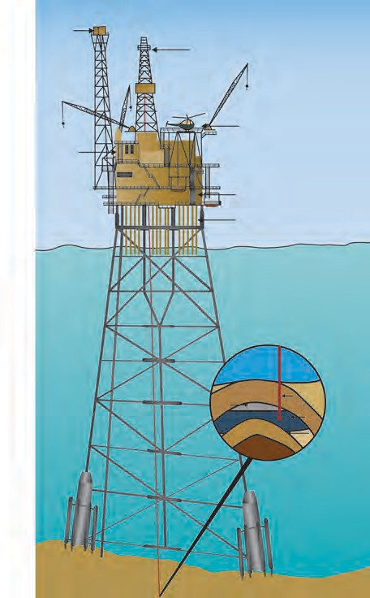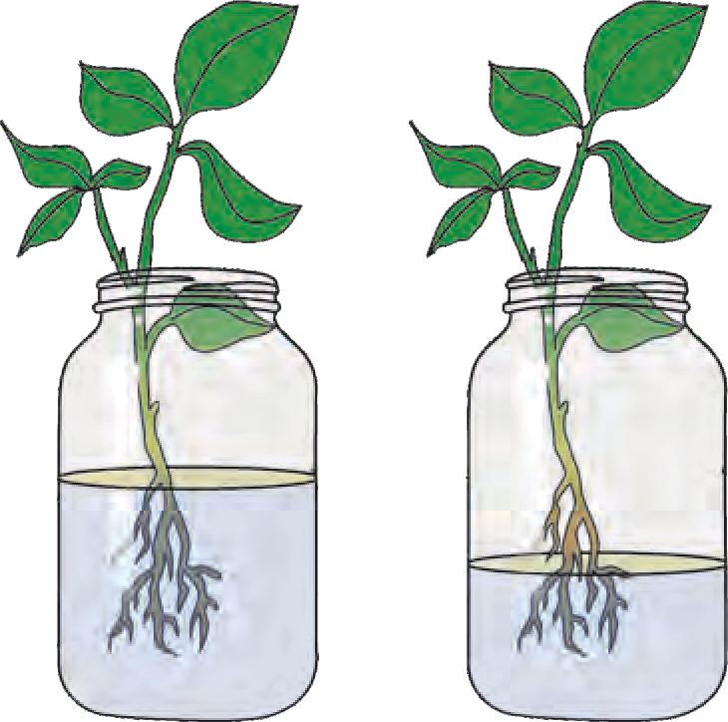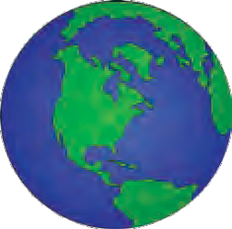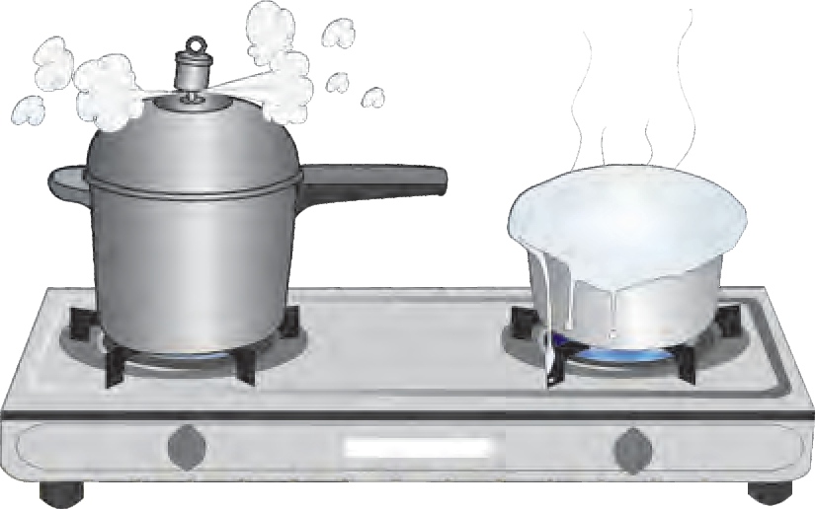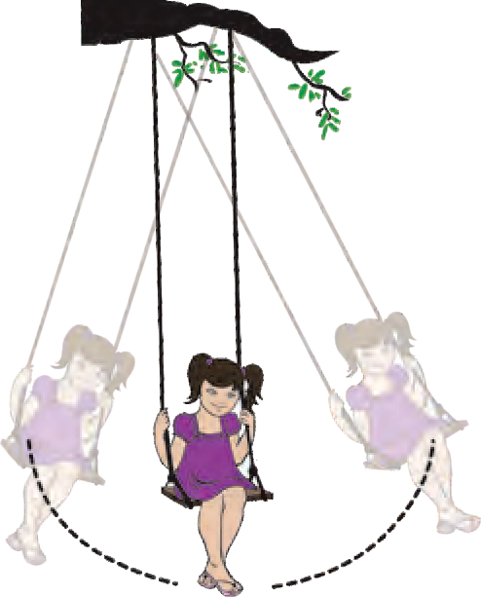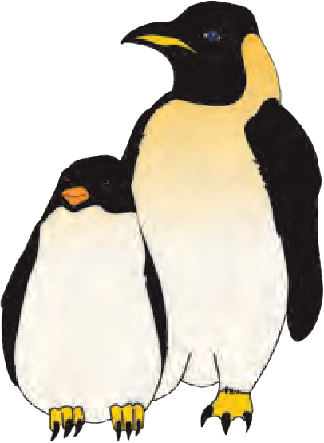





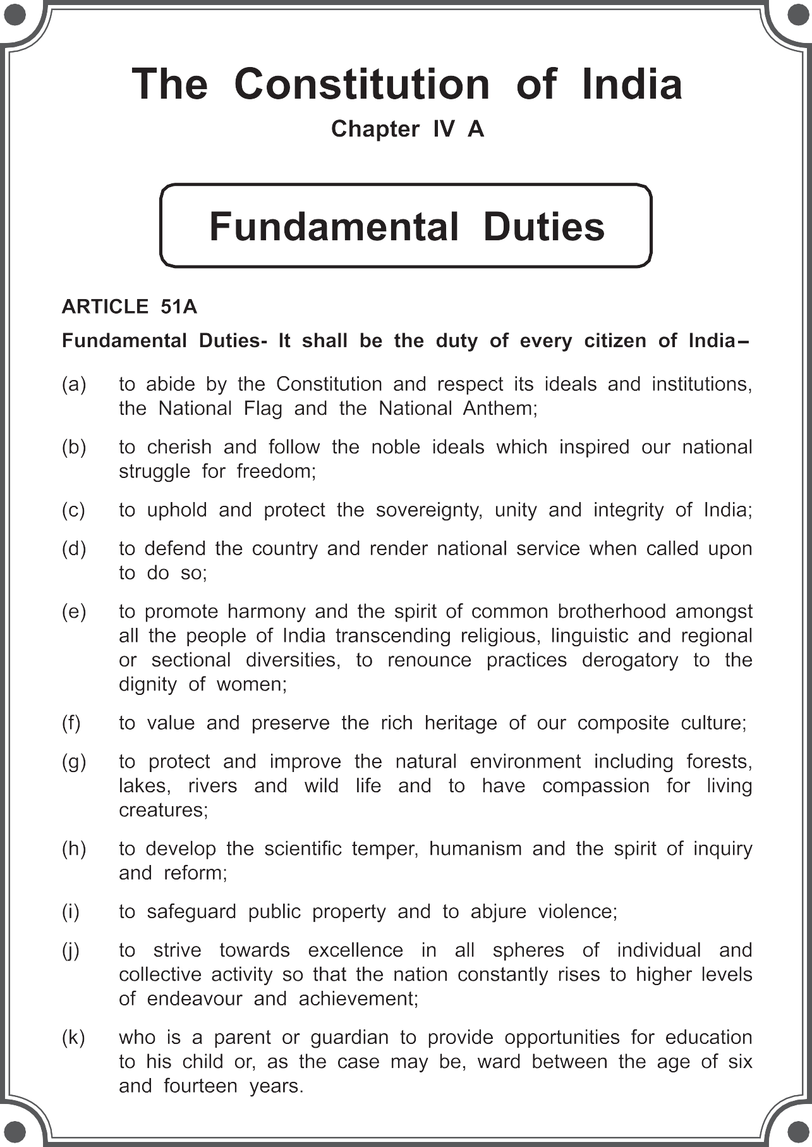

**The Coordination Committee formed by GR No. Abhyas - 2116/(Pra.Kra.43/16) SD - 4 Dated 25.4.2016 has given approval to prescribe this textbook in its meeting held on 3.3.2017**

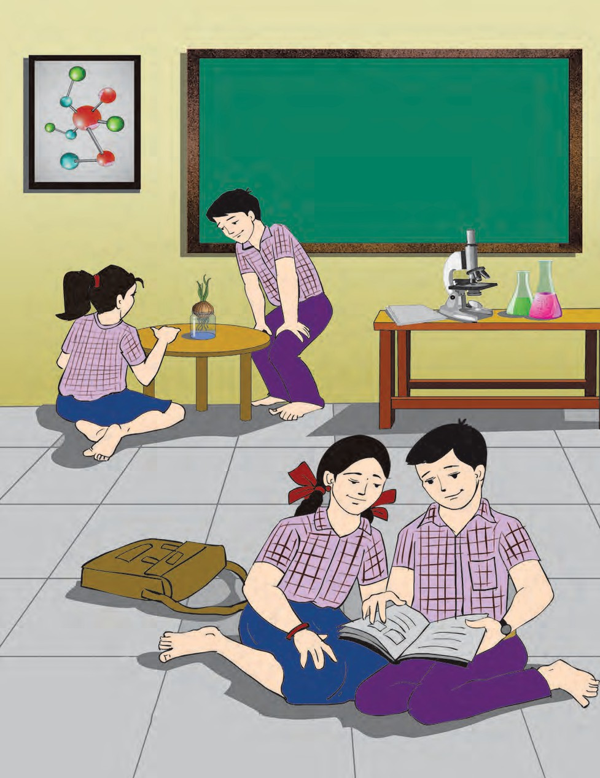

GENERAL SCIENCE

**STANDARD SEVEN**

**Maharashtra State Bureau of Textbook Production and Curriculum Research, Pune - 411 004.**

The digital textbook can be obtained through DIKSHA APP on a smartphone by using the Q. R. Code given on title page of the textbook and useful audio-visual teaching-learning material of the relevant lesson will be available through the

Q. R. Code given in each lesson of this textbook.

**First Edition : 2017 © Maharashtra State Bureau of Textbook Production and**

**Fifth Reprint : 2022**

**Curriculum Research, Pune - 411 004.**

The Maharashtra State Bureau of Textbook Production and Curriculum Research reserves all rights relating to the book. No part of this book should be reproduced without the written permission of the Director, Maharashtra State Bureau of Textbook Production and Curriculum Research, ‘Balbharati’, Senapati Bapat Marg, Pune 411004.

**Science Subject Committee :**

**Dr Chandrashekhar Murumkar, Chairman**

Dr Dilip Sadashiv Jog, Member Dr Abhay Jere, Member

Dr Sulabha Nitin Vidhate, Member Smt. Mrinalini Desai, Member

Shri. Gajanan Suryawanshi, Member Shri. Sudhir Yadavrao Kamble, Member Smt. Dipali Dhananjay Bhale, Member

Shri. Rajiv Arun Patole, Member-Secretary

**Science Study Group :**

Dr Prabhakar Nagnath Kshirsagar

Dr Shaikh Mohammed Waquioddin H. Dr Vishnu Vaze

Dr Ajay Digambar Mahajan

Dr Gayatri Gorakhnath Choukade Shri. Sukumar Shrenik Navale Shri. Prashant Panditrao Kolse Shri. Dayashankar Vishnu Vaidya Smt. Kanchan Rajendra Sorate Smt. Anjali Khadke

Smt. Shweta Thakur Smt. Jyoti Medpilwar

Smt. Pushpalata Gawande Shri. Rajesh Vamanrao Roman Shri. Shankar Bhikan Rajput

Smt. Manisha Rajendra Dahivelkar Shri. Hemant Achyut Lagvankar Shri. Nagesh Bhimsevak Telgote Shri. Manoj Rahangdale

Shri. Mohammed Atique Abdul Shaikh Smt. Dipti Chandansingh Bisht

Shri. Vishwas Bhave

Smt. Jyoti Damodar Karane

**Cover and illustrations :**

Shri. Vivekanand Shivshankar Patil Ashana Advani

Shri. Suresh Gopichand Isave

**Typesetting :**

DTP Section, Textbook Bureau, Pune

**Coordination : Rajiv Arun Patole**

Special Officer for Science

**Translation :**

Smt. Mrinalini Desai Dr Sushma Jog

**Scrutiny :**

Dr Dilip Jog Smt. Pushpa Khare

**Coordination : Dhanavanti Hardikar**

Academic Secretary for Languages

**Santosh Pawar**

Assistant Special Officer, English

**Paper :**

70 GSM Creamwove

**Print Order : Printer :**

**Production : Sachchitanand Aphale** Chief Production Officer

**Rajendra Vispute**

Production Officer

**Publisher : Vivek Uttam Gosavi**

Controller Maharashtra State Textbook Bureau,

Prabhadevi, Mumbai - 400 025.

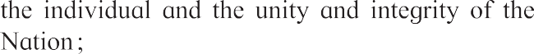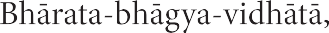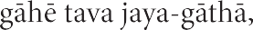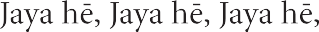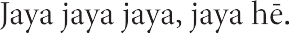

**Preface**

Dear students, Welcome to Std VII.

We have great pleasure in offering to you this General Science textbook, based on the new syllabus. In Stds III to V you have acquired some knowledge of Science from your Environment Science textbooks. Last year, however, you began to study Science from a separate General Science textbook.

The basic purpose of this textbook can be said to be ‘Understand and explain to others’. You will learn Science through many activities such as Observe and Discuss, Use your brain power ! Find Out, Think about it, etc. Do take part in all these activities. Use the activities Can you recall? and Can you tell? to revise the science you have already learnt.

The textbook also includes many activities and experiments under the titles Try this and Let's try this. You must yourself carefully carry out these activities, experiments and observations. Wherever necessary you may, of course, take the help of your teachers, parents or classmates. On some occasions you may have to look for some information. You must use the library or technology like the Internet for that purpose. A number of activities that explain the science behind everyday events, have been given. You too must make your own efforts to use science in everyday life. What you learn from the lessons in this textbook will not only help you with the studies of higher classes, but will also enable you to do many new things and equip you with many new skills.

Take all precautions while doing the activities and experiments given in the textbook and encourage others to take the same precautions. Understand Science and learn to use it. Lastly, a gentle reminder to you that, while carrying out activities related to plants and animals, all care must be taken to avoid doing them any harm or causing them injury.

Do tell us about the parts that you like as well as about the difficulties you face as you read and understand and study this textbook. We are especially eager to know about the questions that come to your mind as you study science. Do write to us about them.

Our best wishes for your academic progress.

**Pune**



**Date :** 28 March 2017

Gudi Padwa Indian Solar Year : Chaitra 7, 1939

**(Dr Sunil Magar) Director**

Maharashtra State Bureau of Textbook Production and Curriculum Research, Pune.

**For Teachers**

* We learn many new facts while studying science. So, young children with a lot of curiosity find the subject enjoyable. However, the real objective of learning science

is to learn to think about the world and all the events that take place in it, in an objective and rational manner so as to lead a happy confident life. Through the study of science we also expect children to develop social consciousness, awareness about conservation of the environment and adeptness in handling technology.

* We need to have adequate factual information and understanding about our world. However, in a rapidly changing world, the knowledge gained today may not suffice

tomorrow. Hence, the skills required for obtaining knowledge must be learnt. These are the very skills that are learnt in the process of studying science.

* Many topics in science are more easily learnt by direct observation than by reading about them. Some abstract phenomena become visible through the effects they have.

Hence, we do experiments related to them. They help to learn the skills of inference and verification. While learning science, these skills are learnt and internalized. This is an important objective of learning science.

* That we should be able to articulate what we have learnt, explain it to others, use it for further studies and finally bring about the proper changes in our behaviour is also

an expectation from the learning of science. That is why, it is important to ensure that along with the content of the subject, these skills are also developed.

* **Can you recall?** is a section for reviewing the related topics already learnt, while

the purpose of **Can you tell?** is to introduce a topic by bringing together what the children might already know about a topic through their own reading or experience. **Try this** is meant to give some specific experience while **Let’s try this** are the parts that teachers must demonstrate to the class. **Use your brain power!** makes children apply the knowledge gained. **Always remember-** gives some important instructions or values. The sections **Find out**, **Do you know?** and **Science watch** are to create an awareness of the vast information that cannot be included in the textbook and to inculcate the habit of doing reference work independently.

* Teachers can see for themselves that this textbook is not meant for reading and explaining but for guiding students to gain knowledge by carrying out the given

activities. Reading the textbook **after** the children have carried out the activities and discussed them in the class will make it easy and will also help to bring together and reinforce what they have already learnt. The attractive pictures will support their efforts to learn.

* Teachers should prepare well for discussions under **Can you tell?**, **Use your brain**

**power!** etc. and for the various activities and experiments. They should maintain an informal atmosphere during such discussions and activities, encourage everyone to participate and make efforts to organize Science Days, presentations in the class, etc.

* + **Front Cover :** Experiments and activities included in the textbook.
  + **Back Cover :** Flamingos and other birds visiting Bhigwan in Pune District.

## English General Science - Standard VII - Learning Outcomes

|  |  |
| --- | --- |
| **Suggested Pedagogical Processes** | **Learning Outcomes** |
| **The learner is to be provided with opportunities in pairs/groups/ individually in an inclusive setup and encouraged to -**   * Explore surroundings, natural processes, phenomena using senses viz. watching, touching, tasting, smelling, hearing. * Pose questions and find answers through reflection, discussion, designing and performing appropriate activities, role plays, debates, use of ICT etc. * Record the observations during the activity, experiments, surveys, field trips/field visits, etc. * Analyse recorded data, interpret results and draw inference/make generalisations and share findings with peers and adults. * Exhibit creativity presenting novel ideas, new designs/patterns, improvisation etc. * Internalise, acquire and appreciate, values such as cooperation, collaboration, honest reporting, judicious use of resources, etc. * Plan for sky watching/observation and record the observation of different constallations and nakshatras. * Be aware of and act on the various crises and disasters happening in the surroundings. | **The learner —**   * + 1. Identifies materials and organisms, (such as animal fibres; types of teeth; mirrors and lenses) on the basis of observable features, for example, appearance, texture, functions, etc.     2. Differentiates materials and organisms such as digestion in different organisms; unisexual and bisexual flowers; conductors and insulators of heat; acidic, basic and neutral substances, images formed by mirrors and lenses, etc. on the basis of their properties, structure and function.     3. Classifies materials and organisms based on properties/characteristics, for example, plant and animal fibres, physical and chemical changes.     4. Conduct simple investigations to seek answers to queries, for example, extract of coloured flowers and their uses. Do leaves other than green also carry out photosynthesis? Is white light composed of many colours?     5. Relates processes and phenomenon with causes, for example, wind speed with air pressure, crops grown with types of soil, depletion of water table with human activities etc.     6. Explains processes and phenomenon, for example, processing of animal fibres, modes of transfer of heat; organs and systems in human and plants, heating and magnetic effects of electric current, etc.     7. Write word equation for chemical reactions, for example, acid-base reaction, corrosion, photosynthesis, respiration, etc.     8. Measures of calculates, for example, temperature, pulse rate, speed of moving objects, time period of a simple pendulum, etc.     9. To understand scientific concepts by using the instruments like microscope, thermosflask, centrifuge.     10. Awaken (dietary) about the diet and identify food adulteration.     11. To explain the correlation between the measures of various physical quantities.     12. Draws labelled diagrams/flow charts, for example, organ systems in human and plants; electric circuits; experimental set ups; life cycle of silk moth, etc.     13. Plots and interprets graphs, for example, distance time graph, sound frequency-high and low pitch of sound.     14. Constructs models using materials from surroundings and explains their working, for example, stethoscope, anemometer, electromagnets, Newton’s colour disc, bakery food, magnetic needle, etc..     15. Discusses and understands the importance of stories of scientific discoveries.     16. Applies learning of scientific concepts in day-to- day life, for example, dealing with acidity; testing and treating soil; taking measures to prevent corrosion; cultivation by vegetative propagation; connecting two or more electric cells in proper order in devices; taking measures during and after disasters; suggesting methods for treatment of polluted water for reuse; uses of magnet, preparation of soap and their uses; separating components from mixture, etc. |

|  |  |
| --- | --- |
|  | * + 1. Explains the uses of natural resources by classifying them.     2. Makes efforts to protect environment, for example, following good practices for sanitation at public places; minimising generation of pollutants; planting trees; sensitising others with the consequences of excessive consumption of natural resources, etc.     3. Exhibits creativity in designing, planning, making use of available resources, etc.     4. Exhibits values of honesty, objectivity, cooperation, freedom from fear and prejudices.     5. Remains awaken about famine, flood, cloudburst, lightning strikes, storms, etc. in the circumjacent to prevent them, uses the circumventions in day-to-day life.     6. Understands the different scientific concepts, process by using different ICT equipments and techniques.     7. Makes efforts to remove misconceptions related to zodiac signs and Nakshatra by observing the sky. |

**CONTENTS**

**Page No.**

**Chapters**

**No.**

1. The Living World : Adaptations and Classification 1
2. Plants : Structure and Function 10
3. Properties of Natural Resources 16
4. Nutrition in Living Organisms 26
5. Food Safety 34
6. Measurement of Physical Quantities 41
7. Motion, Force and Work 46
8. Static Electricity 51
9. Heat 58
10. Disaster Management 64
11. Cell Structure and Micro-organisms 71
12. The Muscular System and Digestive System in Human Beings 81
13. Changes – Physical and Chemical 88
14. Elements, Compounds and Mixtures 92
15. Materials we Use 100
16. Natural Resources 104
17. Effects of Light 113
18. Sound : Production of Sound 118
19. Properties of a Magnetic Field 126
20. In the World of Stars 131
21. **The Living World : Adaptations and Classification**

In what different ways is the diversity in living things seen ?

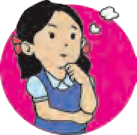

**Let’s recall.**

A great variety of plants is found on the earth. Some plants have colourful flowers. Some plants grow in water whereas some are to be found in deserts which have a scarcity of water. Some plants are found only in snowy regions. Some plants cannot be seen without a microscope whereas some are huge in size. Like plants, animals too show diversity. Some are unicellular, others, multicellular. Some are vertebrates whereas others are invertebrates. This world is full of a variety of animals - aquatic, terrestrial, amphibian, reptilian, aerial, etc. These observations give rise to the question - How did this great diversity come into being ?

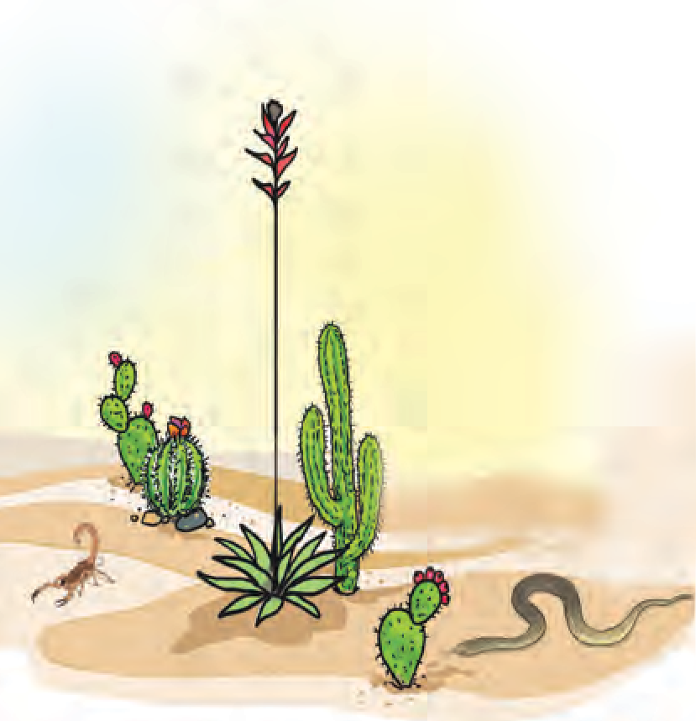Are the plants and animals from Kashmir and Rajasthan of the same type ? Can you elaborate on any differences between the two ?



**Can you tell ?**

Coniferous trees like pine and deodar flourish in snowy regions like Kashmir. However, in the deserts of Rajasthan, plants like cactus and acacia (*babhul*) are to be found. The camel, a desert animal, is not found in Kashmir. What is the reason for these differences ?

#### Adaptation

Gradual changes occur in the body parts and also in the behaviour of organisms which help them to adjust to their surroundings. Such changes are called **adaptations**. They take place over a long period of time.

* 1. **Desert**

**Adaptation in plants**

**Observe and complete the chart. (Include other plants from your own region too.)**

|  |  |  |  |  |
| --- | --- | --- | --- | --- |
| **Plant** | **Habitat** | **Type of**  **root** | **Characteristics of leaves** | **Characteristics of**  **stem** |
| Lotus | Aquatic | Fibrous | Large and round with waxy layer | Hollow and flexible |
| Cactus |  |  |  |  |
| Banyan |  |  |  |  |

**Adaptation in aquatic plants**

Visit various water bodies such as a river, brook, pond, lake, in your surroundings. What differences do you observe between terrestrial and aquatic plants ?

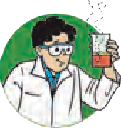

**Try this.**

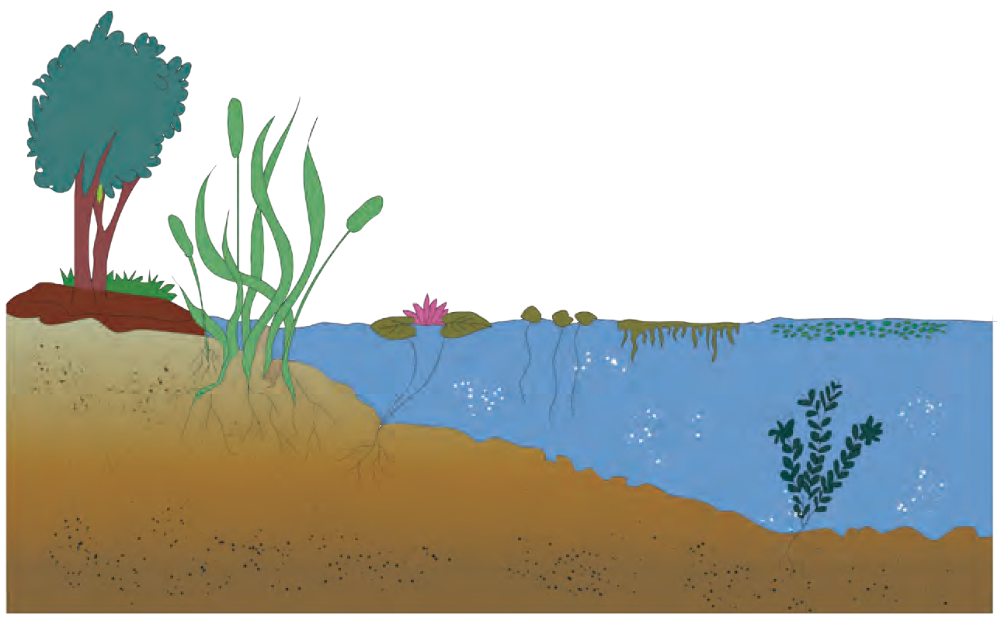Some of the aquatic plants are firmly rooted in the soil at the bottom of the water bodies. Their stems are submerged, while leaves and flowers float on the surface. However, some plants are entirely afloat. Their roots are not anchored in the soil.

The surfaces of leaves and stems of many aquatic plants are covered with a waxy layer. Leaves of some aquatic plants

are thin and slender like a ribbon. This shape helps them to withstand fast currents of water. Air spaces in stems and petioles of aquatic plants are useful for

* 1. **Aquatic plants**

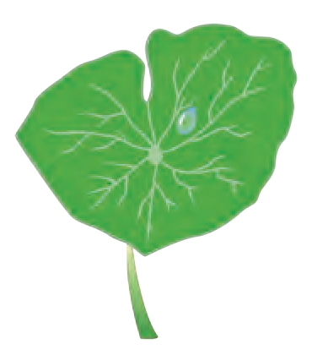

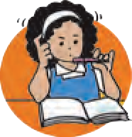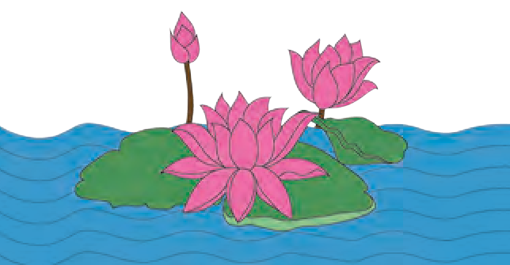

**Use your brain power !**

1. Why does water trickle off lotus leaves ?
2. Why don’t the leaves of these plants rot in water ?
3. Why are their roots short and fibrous ?

#### Adaptation in desert plants

floating in water.

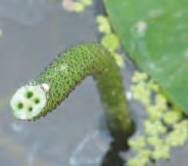

* 1. **Lotus stalk**

Take two potted plants - one, a cactus and the other, a leafy plant. Tie plastic bags loosely around the leaves of these plants and keep them in sunlight from early in the morning. In the afternoon, bring those pots into the classroom and observe them.



**Try this.**

Has the same quantity of water collected in both bags ?

Desert plants are either leafless or their leaves are like small needles or have been modified into thorns. As a result, they lose very little water by evaporation. The stem stores water and food and is therefore fleshy. The stems are green as they perform photosynthesis in the absence of leaves. Their roots penetrate deep into the soil and some roots spread away into the soil in search of water. There is a thick layer of a waxy

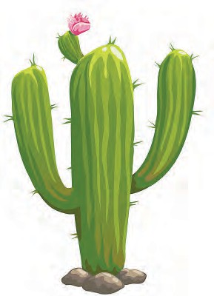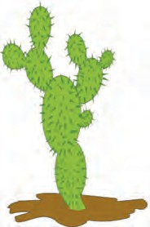

* 1. **Cactus**

substance on the stems of these plants, too.

#### Adaptation in plants of snowy regions

**Can you tell ?**

In what way are sloping branches useful to plants in a snowy region ?

Plants of snowy regions mainly include conifers like deodar and pine. These trees are conical in shape due to their sloping branches. In the heavy snowfall and extreme cold in these regions, their conical shape prevents the snow from accumulating on the tree and the thick bark helps the tree to withstand the cold.

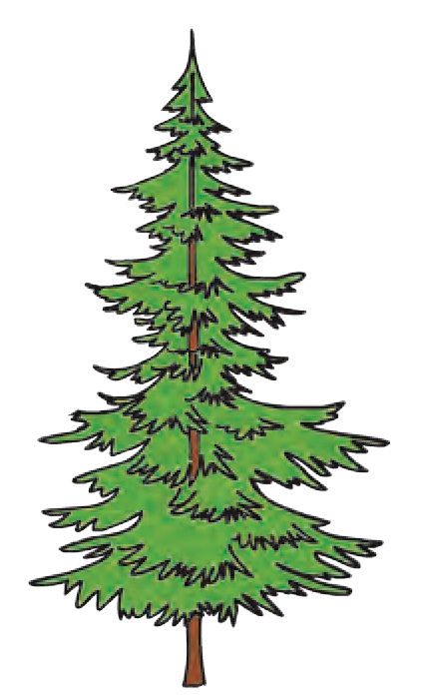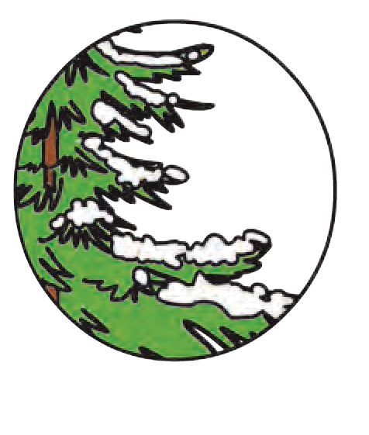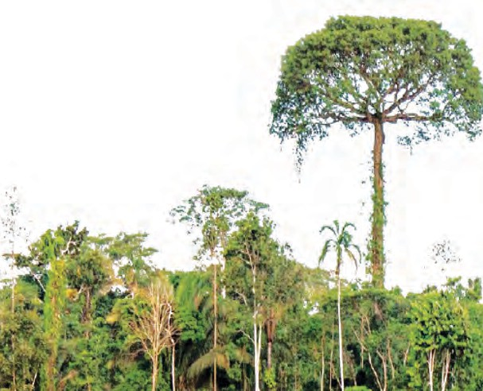

* 1. **Deodar tree**

#### Adaptation in plants of forest regions

A variety of plants - trees, shrubs and herbs - are found in forests. These plants compete amongst themselves for sunlight. Hence, trees grow tall to get sunlight and climbers and vines grow to a great height with the support of trees. Spring-like tendrils on the stems of some climbers is an example of adaptation.

#### Adaptation in grassland plants

* 1. **Forest**

Diverse types of bushes and grasses are found in the grasslands. Fibrous roots of grasses prevent soil erosion. Forests in the equatorial region are dense. Animals like tiger, elephants and deer can remain hidden in these grasses. However, grasses in cold regions are very short. Animals like the rabbit are found in such grasses. Vast meadows are found in hilly areas as well as plains.

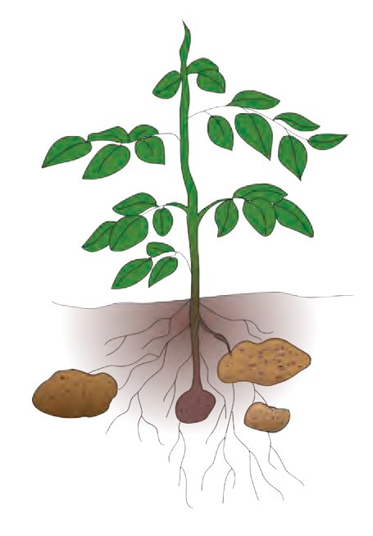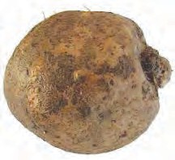

**1.7 Yam and potato**



**Observe and discuss.**

Observe and note down the adaptations in the parts of plants like potato, groundnut, yam, water hyacinth, aloe, acacia, carrot, onion, beet, bitter-gourd, grape vine, etc. and other plants in your surroundings.

#### Adaptation for ingestion of food in plants

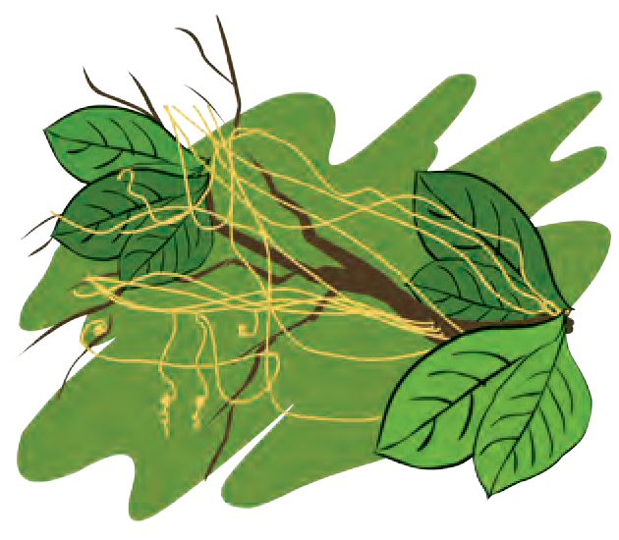Most of the plants are anchored in the ground and are autotrophic. However, plants like dodder (cuscuta) are parasitic. The plant body of dodder consists of yellow wire-like stems. It is leafless and cannot perform photosynthesis. However, it has haustorial (sucking) roots for absorbing nutrients from the host plant. These roots penetrate upto the conducting vessels of the host plant to absorb water and food.

* 1. **Cuscuta**

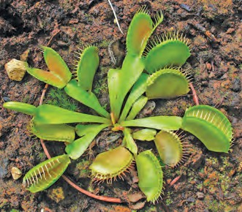

* 1. **Venus flytrap**

#### Adaptation in animals

Fungi do not have chlorophyll and cannot perform photosynthesis. They obtain food from starchy foodstuffs like *bhakri* and bread. They have root-like fibers for absorption of food.

Plants need nitrogen, phosphorus and potassium for growth. Plants that grow in soil which is deficient in nitrogen, like drosera (sundew), Venus flytrap, pitcher plant, etc. fulfill their need for nitrogen by consuming insects. Adaptations are seen in these plants which serve to attract insects and hold them captive.



**My friend, the internet !**

Collect information about plant adaptations from websites like – [www.mbgnet.net](http://www.mbgnet.net/)

Make a list of animals in your surroundings. Compare the diversity of animals listed by your friends, with your list. Discuss the habitats, food-habits, charactersistics of body structures like vertebral column, wings, gills, tails, etc. and prepare a chart.

What differences do you see between terrestrial and aquatic animals ?

As compared to terrestrial animals, the skin and body shape of aquatic animals appear to have undergone changes. Fishes have scales on the skin and fins on the body. Their body tapers towards both its ends, like a spindle. Fish breathe with gills instead of a nose. Their eyes have transparent eyelids. They have air bladders within the body to help them to float.

Observe the bodies of the frog, duck and tortoise.

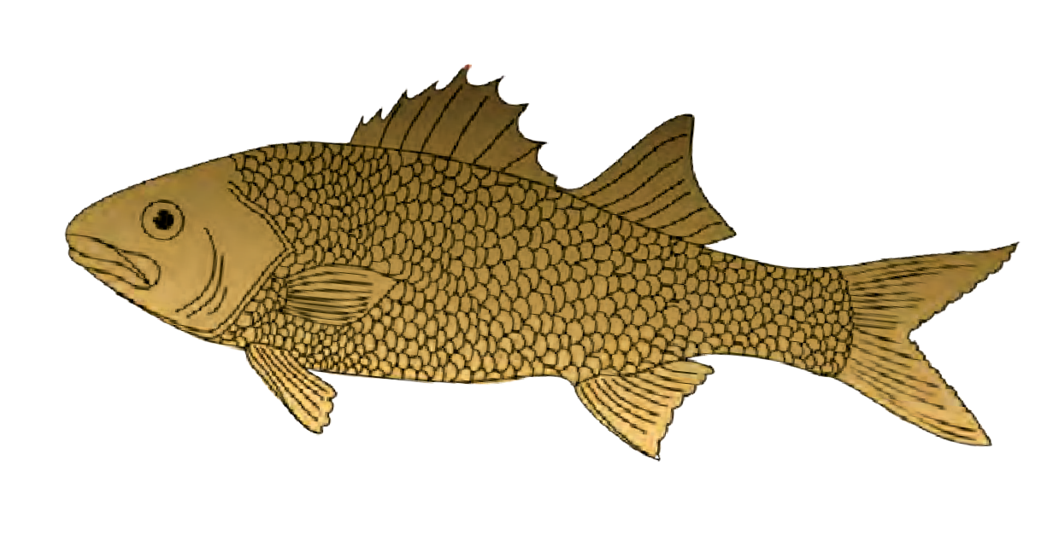

1. Of what use are their legs to these animals ?
2. What helps frogs to breathe underwater ?
3. Of what use are the long hind legs of a frog ?
4. Why doesn’t a duck get wet in

**Gills**

**Scales**

**Fins**

water ?

* 1. **Fish**

As the frog and duck have webbed toes, they can use their legs like oars. Water flows off the waxy feathers of birds like duck and waterhen. Webbed toes, slippery, smooth skin and a triangular head help frogs to swim easily through water. They can live on land as well as in water due to their ability to breathe through the skin in water and using the nose and lungs on land. The typical colours of a frog’s back help it to hide among grasses.

Make a list of the names of some other amphibians you know and study their adaptations.

#### Adaptation in forest and grassland animals

* 1. **Duck**

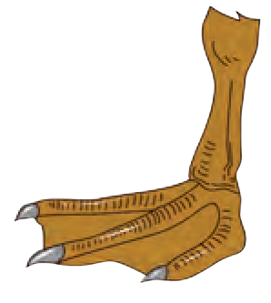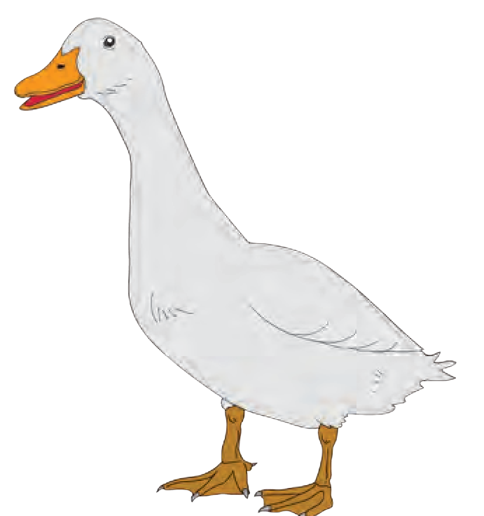

**Webbed toes**

* 1. **Lion**

Carnivorous animals like the wild dog, fox, tiger and lion have strong legs to run fast and capture their prey. They have claws and their canine teeth are sharp and pointed. What is the function of such teeth ?

Tigers have padded paws. This enables them to silently stalk their prey and capture it easily. The eyes of predatory carnivores are located in the front of their head. It helps them to spot their prey from a long distance.

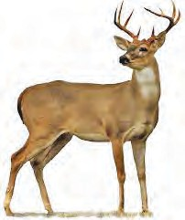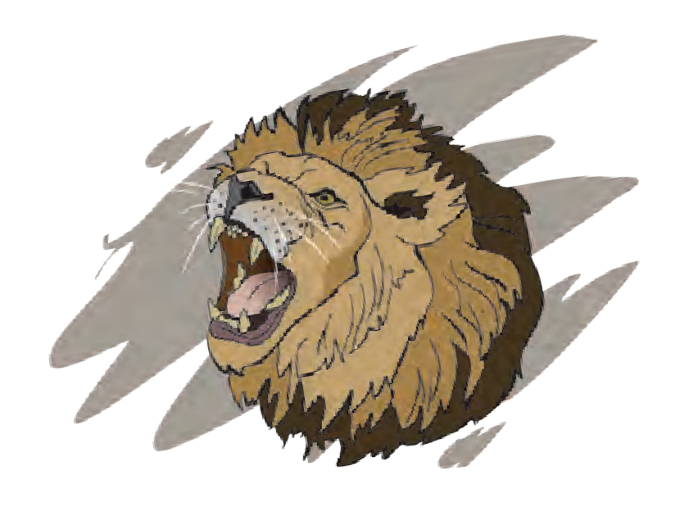

The eyes of herbivores are below the forehead, on either side of the head. This gives them wide-angle vision which helps to protect them from predators. Their legs are long and tapering with strong hooves, which enables them to run fast taking long leaps. Their long and freely moving ears can receive sounds from long distances and different directions. Deer and blackbucks have colours that merge with their surroundings. Their teeth are strong for chewing tough plant material.

* 1. **Blackbuck**

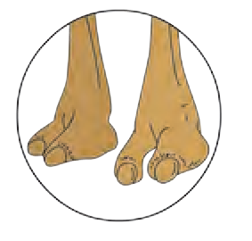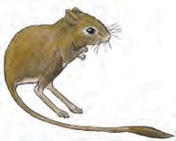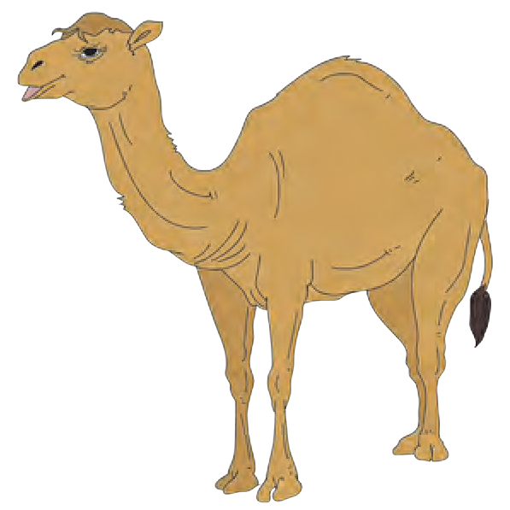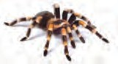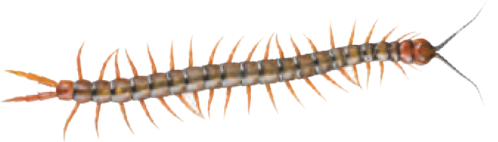

#### Adaptation in desert animals

Deserts are characterized by severe scarcity of water. Hence, desert animals have a thick skin to prevent loss of water from the body. Their legs are long with flat and cushioned soles. The nostrils are protected by folds of skin. The eyelashes are long and thick. Rats, snakes, spiders, lizards in deserts live in deep burrows during daytime and are active at night.

* 1. **Desert animals**

5

#### Adaptation in animals of snowy regions

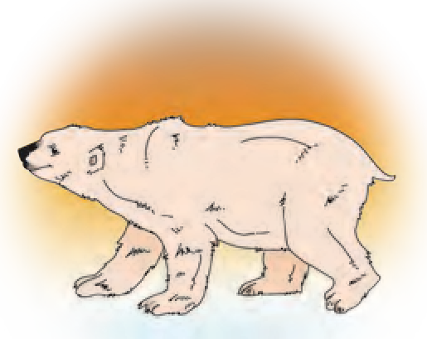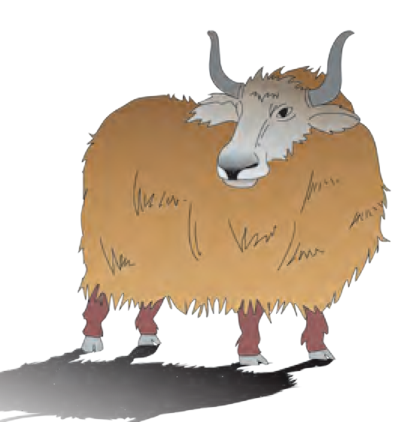

From the internet, download images of animals like yak, polar bear, white fox, silver fox, mountain goat, Siberian husky dog and snow leopard. Compare these images with those of similar animals from tropical forests.

A white or silver body colour, long, thick hair on the skin are typical characteristics of animals of snowy region. How are these useful to them ?

#### Adaptation in aerial animals

* 1. **Animals of snowy regions**



**Can you tell ?**

What is the main difference between vehicles on the road and aeroplanes ?

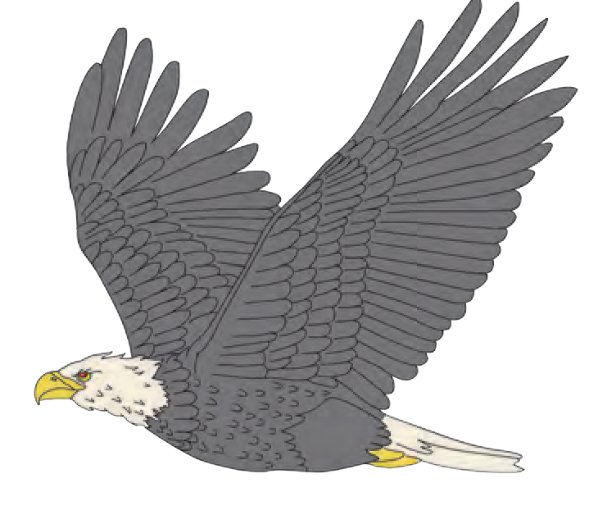

**Wings**

**Tapering slender body**

The spindle-shaped body of birds also minimises the resistance of air while flying. With hollow bones, a body covering of feathers and modification of forelegs into wings, their body is light in weight and adapted for flying.

The body of insects also is light in weight and tapers at both ends. They can fly with two pairs of wings and also walk with six stick-like legs. Bats can fly with the help of the patagium, a thin fold of skin between their forelegs and hind legs.

Observe the various birds and insects in your area.

#### Adaptation in reptiles

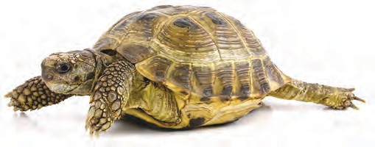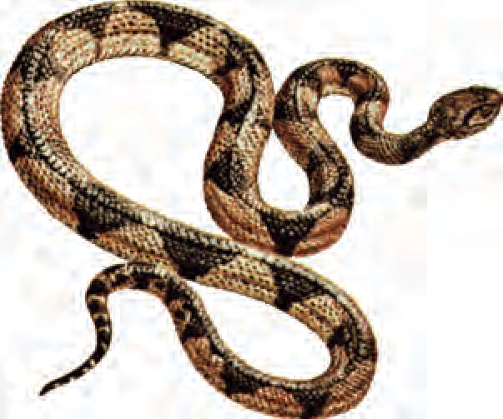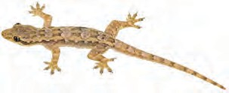Observe, from a distance, how snakes and earthworms creep. Which organs do they use for creeping ? Are there any special changes for that purpose ? Note any such changes. Animals like house lizard, garden lizard, crocodile use their muscles for creeping. Similarly, they show adaptations in skin, soles of feet, body colour, etc. For example, the house lizard and monitor lizards have clawed toes and thin soles, whereas snakes have a scaly skin.

**1.17 Reptiles**

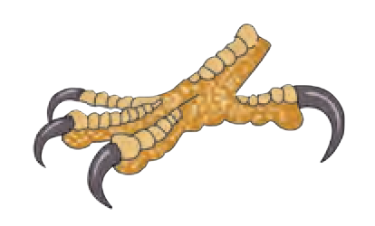

**Claws**

* 1. **Adaptations in birds**

#### Adaptation for food in animals

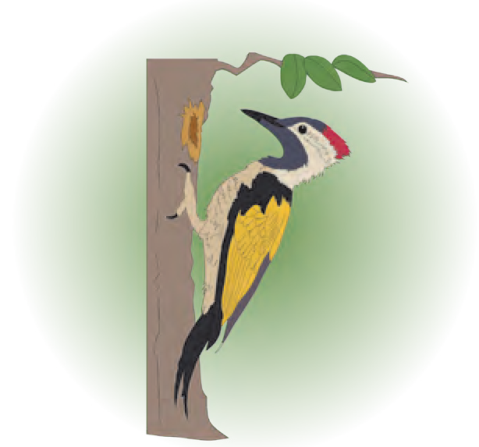We can categorize animals as herbivores and carnivores. Special adaptations are seen in each category to make the process of feeding easy. We will discuss this in greater detail in the chapter on Nutrition.

Watch the programmes on channels like National Geographic Wild, Discovery, etc. to learn about the feeding habits of animals like frogs, snakes, birds, mosquitoes, butterflies, etc.

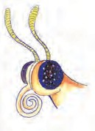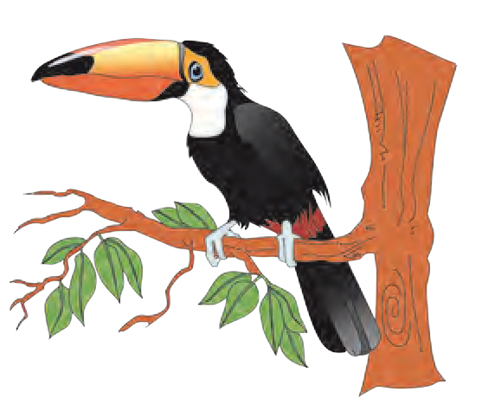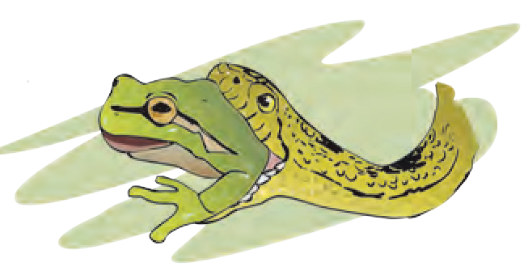

**1.18 Adaptation for food in animals**

**Complete the following chart from your own observations.**

|  |  |  |
| --- | --- | --- |
| **Adaptation** | **Animal** | **Use of adaptation** |
| Sharp teeth | Lion, tiger | To tear the flesh |
| Long and pointed beak |  |  |
| Short beak |  |  |
| Long and sticky tongue |  |  |
| Long neck |  |  |

#### Adaptation for blending with the surroundings

We cannot easily spot colourful butterflies, lizards and grasshoppers. They get camouflaged amidst grasses, parts of plants like stem, leaves, flowers, etc. That is because their colours blend with those of their surroundings.

Changes that take place in the various organs and life-processes of organisms, that enable them to live, feed, reproduce to perpetuate themselves and protect themselves from their enemies in specific surroundings, depending upon the habitat and its geographical conditions, are called adaptations.



**Always remember -**

Adaptation is not a sudden process. It is gradual and continuous. Differences in the structure and appearance of present-day animals and animals of thousands of years ago are the adaptations that occured according to prevailing conditions. It is our duty to conserve this diversity.

## Great Scientists

#### Darwin’s theory of evolution

Charles Darwin, a biologist, studied numerous types of plants and animals and suggested that only those organisms are likely to survive which can best adapt themselves to a changing environment. This is called the theory of **survival of the fittest**. This is Darwin’s first principle.

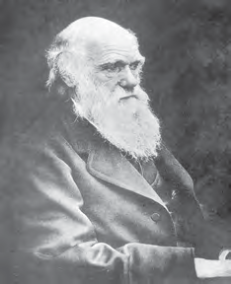

If an organism is born with a new beneficial characteristic and is able to survive, this change is preserved in the next generation. This is Darwin’s second principle and is called the theory of ‘**natural selection**’.

## Classification of living organisms

Why are living things classified ?



**Let’s recall.**

Which are the criteria used for classification of plants and animals ?

|  |  |  |
| --- | --- | --- |
| Hierarchy | Mango | Human |
| Kingdom | Plantae | Animalia |
| Phylum | Anthophyla | Chordata |
| Class | Dicotyledonae | Mammalia |
| Order | Sapindales | Primates |
| Family | Anacardiaceae | Hominidae |
| Genus | *Mangifera* | *Homo* |
| Species | *indica* | *sapiens* |

It is difficult to study and remember all the organisms in this diverse living world at the same time. Classification helps in this respect.

Different scientists have used different criteria and independently classified plants and animals. A hierarchy is

formed in the classification that starts with Kingdom Animalia or Kingdom Plantae; further groups and sub-groups are formed depending upon basic similarities and differences. This is called the ‘**hierarchy of classification**’.

#### Binomial nomenclature by Carl Linnaeus

Imagine that there are four students with a name ‘Kabir’ or ‘Kiran’ in a classroom. If you are talking about any one of them, how would you ensure that others know which one of them you are talking about, without any confusion? We would tell the full name i.e., the first name and the last name. This is similar to binomial nomenclature.

Binomial nomenclature is used to identify each organism. Accordingly, a scientific name has been assigned to each organism. It consists of two parts – the first part is ‘genus’ and second, ‘species’. All identified organisms have been assigned a binomial name as per the guidelines of the International Code of Nomenclature.

All the organisms of a species are so similar that irrespective of differences in colour, height, habitats and habits, they can reproduce among themselves and form new individuals like themselves. For example, all domestic cats in the world belong to the same species. The same is true in the case of animals like hen, cow, dog, etc. and plants like mango, wheat, maize, etc.

#### Following are some examples of organisms from Kingdom Plantae and Animalia classified by the binomial method of nomenclature :

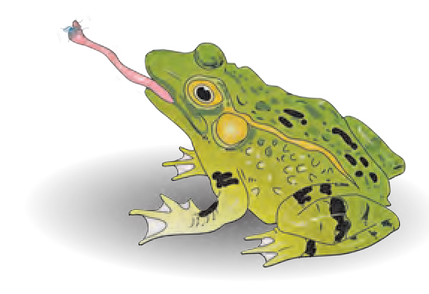

29th April is observed as ‘World Frog Protection Day’.

Killing or harming frogs is prohibited by the Wild Life Protection Act.

|  |  |
| --- | --- |
| **Living Things** | **Scientific Name** |
| Dog | *Canis lupus familiaris* |
| Cow | *Bos taurus* |
| Hibiscus | *Hibiscus rosa-sinensis* |
| Jowar | *Sorghum bicolor* |

Find out the scientific names of other animals and plants in your surroundings and discuss in class.



**Exercise**

* + 1. **Find my match !**

**‘A’ Group ‘B’ Group**

* + - 1. Lotus (a) flower and leaves attract insects
      2. Aloe (b) Haustorial roots for absorption of food
      3. Cuscuta (c) Adapted to live in

deserts

* + - 1. Venus flytrap (d) Adapted to live in

water.

* + 1. **Read the paragraph and answer the following questions.**

I am a penguin. I live in polar region covered by snow. My abdomen is white. My skin is thick with a layer of fat underneath. My body is spindle- shaped. My wings are small. My toes are webbed. We live in flocks.

1. Why is my skin white and thick and why is there a thick layer of fat underneath ?
2. Why do we live in flocks sticking close to each other ?
3. Which geographical region do I inhabit? Why?
4. Which adaptations should you have to enable you to live permanently in the polar region ? Why ?
   * 1. **Who is lying ?**
5. Cockroach – I have five legs.
6. Hen – My toes are webbed.
7. Cactus – My fleshy, green part is a leaf.
   * 1. **Read each of the following statements. Write a paragraph about adaptation with reference to each statement.**
8. There is extreme heat in deserts.
9. Grasslands are lush green.
10. Insects are found in large numbers.
11. We hide.
12. We have long ears.
    * 1. **Answer the following.**
13. Why is the camel called the ‘Ship of the desert’ ?
14. How can the plants like cactus and acacia live in deserts with scarce water ?
15. What is the inter-relationship between adaptations of organisms and their surroundings ?
16. How are organisms classified ?

**Activity :** Find out how the gradual adaptation from primitive man to modern man must have taken place.

⧫  

1. **Plants : Structure and Function**
   1. What helps us to easily identify the plants around us?



**Let’s recall.**

* 1. Which are the various parts of plants?

The root, stem, leaves, flowers, fruits, etc. of different plants are different. We can identify plants with the help of these different charactersistics. Let us now acquaint ourselves with these plant organs in greater detail.

**Root**



**Try this.**

**Plumule**

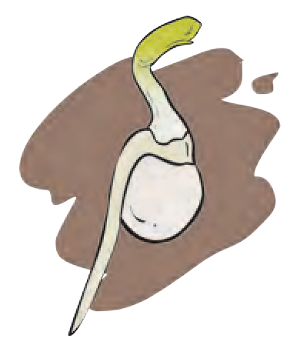

**Radicle**

1. Keep a moistened ball of crumpled paper in a conical flask. Place some soaked *moth* beans/gram seeds in the flask between the paper and the glass wall. Observe and note the changes in the seeds in two or three days.

The part that grows from inside the seed towards the soil is called the **radicle** and the part that grows above the soil is called the **plumule**.

The root that forms from the radicle, grows into the ground. The root is thick near the ground and gradually tapers to a pointed end. This part of the plant growing below the soil for support is called

* + 1. 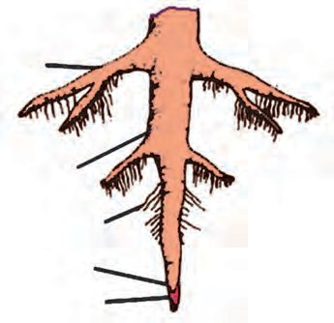**Formation of root**

**Secondary root**

**Primary root**

**Root hair**

**Root tip Root cap**

* + 1. 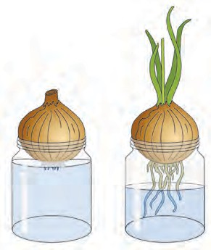**Tap root**
    2. **Fibrous roots**

‘**root**’.

Roots of some plants produce secondary roots; that grow obliquely and spread far and wide in the soil. Roots support the plant. This type of root is called a **tap root**.

Roots bear hair-like processes near the root tips. These are **root hairs**. The root tip is delicate. This is the region of the growth of the root. The tip is covered by cap-like structure called the **root cap**. The root-cap protects the root-tip from injuries.

1. Take a glass jar and fill three-quarters of it with water. Place an onion on the mouth of the jar in such a way that its roots are towards the water. Observe the growth of the roots for eight days.

Thread-like or fibre-like roots arising from the stem are called **fibrous roots**.

Thus, there are two main types of roots : tap roots and fibrous roots. Dicotyledonous plants have tap roots while monocotyledonous plants have fibrous roots.

1. Sow the seeds of plants like mustard, sorghum (jowar), maize (corn), pea, coriander, etc. in an earthern pot. Cultivate the plant for eight days. Once the plants grow 15 to 20 cm high, uproot them

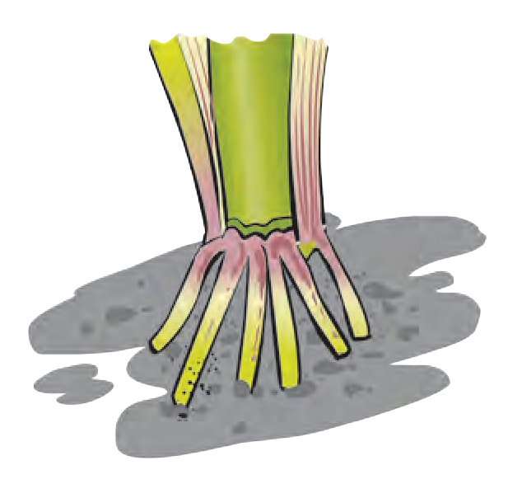carefully while the soil is moist and put them gently in a large conical flask containing water. The soil will get washed off without any harm to the roots. Observe the roots carefully to see which plants have tap roots and which ones have fibrous roots.

Plants like maize, sugarcane, sorghum have two types of roots. Some roots are underground whereas some grow from the stem just above the soil. The latter are called **adventitious roots**. Besides the normal functions like absorption of water and minerals, anchoring and supporting the plant, roots perform some other functions too. Roots show some modifications to perform these additional functions. Some examples of such **modified roots** are aerial roots, stilt- roots, runners, breathing roots (pneumatophores), etc.

1. Take some water in a small glass jar. Put a plantlet in it in such a way that its roots are dipped in the water. Mark the water-level on the jar and add 5ml of oil to the water. Record the water-level on the next day.

Discuss your observations in the class.



**Use your brain power !**

* + 1. **Maize stalk**

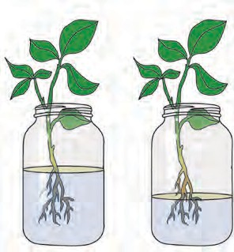

* + 1. **Water level**

1. What would have happened if plants like tamarind, banyan and mango had fibrous roots ?
2. What will happen if the root-tip is injured ?
3. Which types of roots do the fenugreek, spinach and onion plants have ?

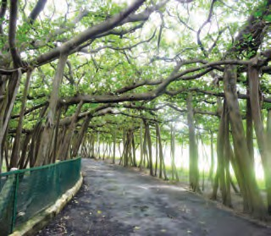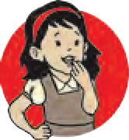

**Do you know ?**

Roots emerging from the trunk and branches of a banyan tree grow towards the soil. These roots are called prop roots. What could be the use of these prop roots ? In the beginning, the banyan tree has very few prop roots. But later on, their number increases so much that it appears like a small forest.

In Kolkata, a 250 years old banyan tree in the Indian Botanical Garden covers a very large area. It

is supported by thousands of prop-roots. Is there any such tree in your neighbourhood ?

Why are the underground parts of plants like radish, carrot, beet and sweet potato thick, fleshy and swollen ? Which part of the plant are they ?

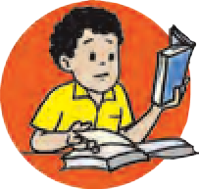

**Find out.**

Collect images of different types of roots and send them

to your friends via e-mail.



**Techno-support**

## Stem

The stem grows above the soil from the plumule of the sprouting seed. As the sprout grows the length of stem gradually increases, too. There are nodes on the stem. Leaves come out at the nodes. The part of the stem between two nodes is called an internode. The tip or the apical end of the stem is called a bud. Observe a branch of any plant and identify its different parts as per the diagram.

**Bud**

**Nodes**

**Internode**

**Growing end**

**Bud**

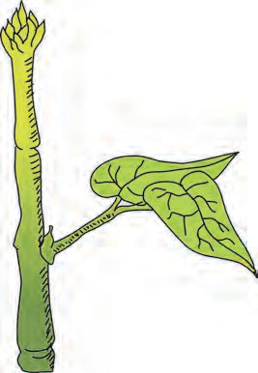

**Leaf**

* + 1. **Parts of a stem**

**Complete the chart. (Collect information about other local plants, too.)**

|  |  |  |
| --- | --- | --- |
| **Name of Plant** | **Thickness (circumference) of node (mm)** | **Length of internode (mm)** |
| 1. Sugarcane |  |  |
| 2.Fenugreek |  |  |
| 3. ......... |  |  |

## Leaf

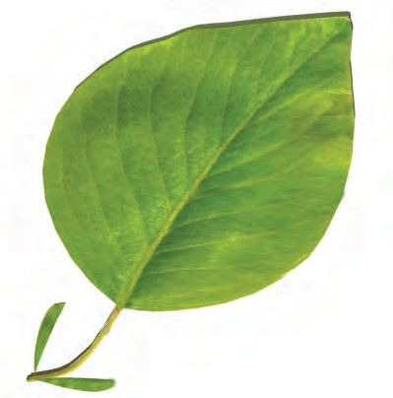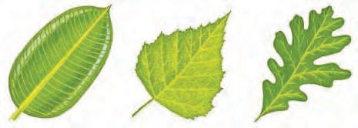

Leaves grow from the nodes on a stem. Leaves are generally thin, flat and green in colour. The broad, spread-out part of the leaf is called the **leaf-blade** or **lamina** and its edge is called the **leaf- margin**. Leaf margins may be entire, dentate or lobed.

**Leaf apex**

**Leaf margin Vein**

**Mid vein Leaf blade**

**Petiole**

**Entire**

**Dentate Lobed**

* + 1. **Parts of a leaf**

**Stipule Leaf base**

The tip of the leaf is called the **leaf apex**. It may be tapering, pointed or rounded. Leaves of some plants have a stalk called a **petiole**. Leaves of some plants do not have a petiole. The portion of the leaf attached to the stem is called the **leaf-base**. Small leaf-like structures may be present near the leaf-base. These are called **stipules**. Do you see stipules in all plants ?

Leaves of some plants have a single undivided leaf blade and a single mid-rib. Such leaves are called **simple leaves**. However, the leaf-blade of leaves in some plants is divided into many small parts called leaflets. Such leaves are called **compound leaves**. Simple leaf and compound leaf are the two main types of leaves.

Observe a branch of plants like rose, neem, coriander, hibiscus, etc.



**Observe and discuss.**

In different plants the arrangement of leaves on the stem is different. It may be alternate, opposite, whorled, spiral, etc. According to shape, leaves are rounded (obovate), palmate, lanceolate, linear, etc.

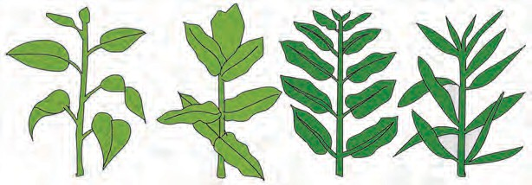**Alternate Decussate Opposite Whorled**

* + 1. **Different types of leaves**

Take a peepal leaf and a maize leaf and observe them carefully.



**Try this.**

The peepal leaf is divided into two equal parts by a single mid-vein which lies along the mid-line of the leaf blade. Secondary veins arise from the mid-vein. They are branched and form a network or reticulum. On the other hand, in leaves of maize, all the veins are parallel, running from the leaf-base to the leaf apex. Thus, the peepal leaf-blade has **reticulate venation** and the maize leaf-blade has **parallel venation**.

Observe the leaves of some other plants in your surroundings and identify the type of venation.

**In the box, draw a special leaf you may have found.**

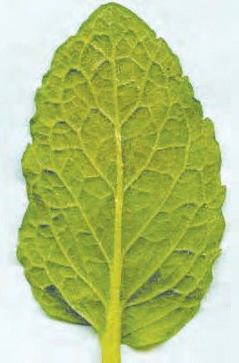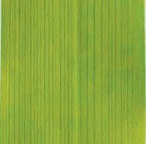

* + 1. **Leaves**

**A little fun !**

Take a fallen peepal leaf and soak it in water for 15-20 days. Dry it and make a greeting card of the lace-like leaf you get.

**Complete the following chart by observing the plants around you.**

|  |  |  |  |  |  |  |  |  |  |
| --- | --- | --- | --- | --- | --- | --- | --- | --- | --- |
| S.  No. | Name of plant | Type of leaf | Shape of leaf- blade | Venation | Shape of leaf margin | Shape of leaf apex | Petiole Yes/no | Stipule Yes/no | Arrange- ment on stem |
| 1. | Maize |  |  |  |  |  |  |  |  |
| 2. | Canna |  |  |  |  |  |  |  |  |
| 3. | Peepal |  |  |  |  |  |  |  |  |
| 4. |  |  |  |  |  |  |  |  |  |

13

## Flower



**Try this.**

1. Carefully observe a fully opened hibiscus flower.

Flowers may have a long or a short stalk called pedicel. One end of the pedicel is attached to the stem. The other end of the pedicel is expanded and swollen. It is called the receptacle. Petals and other parts of the flower are supported on the receptacle. Calyx, corolla, androecium, gynoecium are different parts of a flower.



**Stigma**

**Anther**

**Petal**

**Pedicel**

**Calyx :** In the bud condition the petals are covered by leaf-like parts called sepals which are green in colour. They form the calyx.

**Corolla :** This is made up of colourful parts called petals. Observe the shape, colour and smell of the corolla of various flowers like the rose, chrysanthemum, hibiscus, *mogara*, *kanher*, *tagar*, etc.

**Androecium :** This is the male reproductive part of the flower. It consists of stamens. Each stamen is made up of anther and filament.

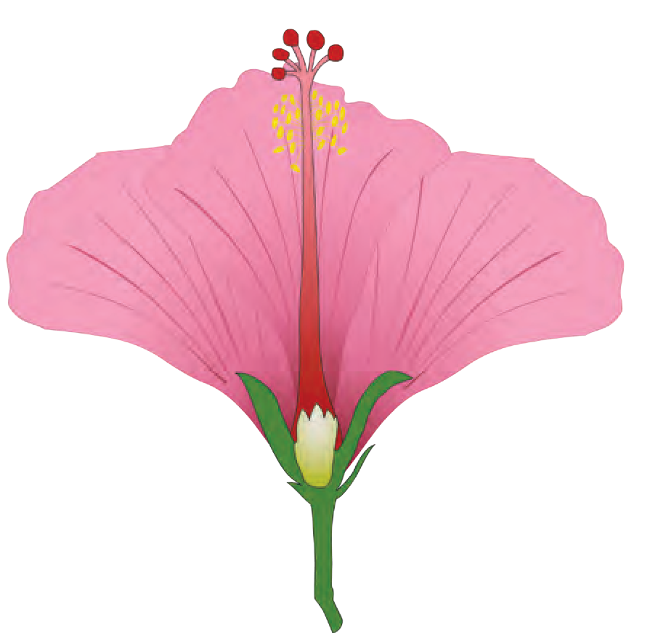

**Stigma**

**Corolla**

**Style**

**Anther**

**Filament**

**Calyx**

**Ovary**

**Pedicel**

**Gynoecium :** This is the female reproductive part of the flower. This is made up of carpels. A carpel consists of stigma, style and ovary.

1. Take a vertical section of a hibiscus flower with the help of a sharp blade, by cutting the flower vertically from stigma to pedicel. Both sections of the flower will be seen to have the same structure.

After maturity, anthers burst and the pollen grains which are released fall on the stigma. This process is called pollination. Due to pollination, ovules (egg cells) in the ovary

* + 1. **Vertical section of a hibiscus flower**

get fertilized. Fertilized ovules form the seeds and the ovary develops into a fruit.

Of what use to a plant are the insects flitting about around its flowers ?



**Use your brain power !**

#### Observe the various flowers and complete following chart.

|  |  |  |  |  |  |
| --- | --- | --- | --- | --- | --- |
| **Name of flower** | **Number of Sepals** | **Sepals – free/united** | **Number of petals** | **Petals free/united** | **Form of androecium and gynaecium** |
|  |  |  |  |  |  |

**Fruit**

We eat many different types of fruits. Each type of fruit has its own characteristics. There are variations in their shape, colour, taste, etc. Mango contains only one seed where as jackfruit consists of many small fruitlets, each with its own seed.

Observe the fruits of *ber* (ziziphus), mango, chikoo, apple, etc. What do you observe ? Each fruit has a different skin or shell, fleshy part and seed. In case of fruits like cashew, its seed is outside the fruit.

Soak the seeds of, pea, wheat, rice, jowar, groundnut in water for 3-4 hrs. Press the seeds with your fingers and observe them. Which seeds get divided into two equal parts? Seeds which get divided into two equal parts are called dicotyledonous seeds. Seeds which do not divide into two equal parts are called monocotyledonous seeds.

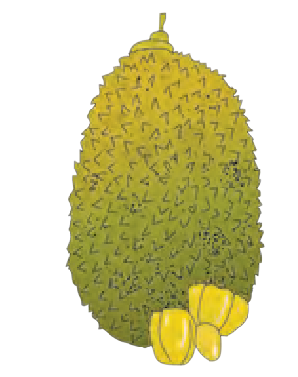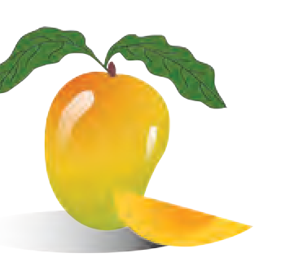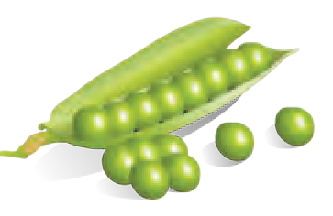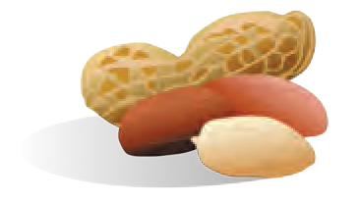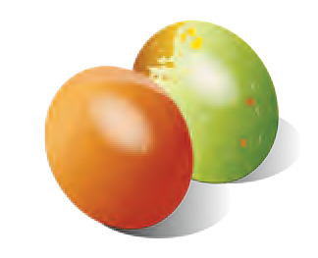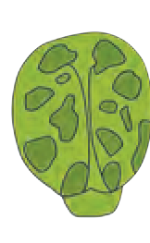

* + 1. **Various fruits and seeds**



**Exercise**

1. **Give examples of 3 plants that have :**
   1. spiny fruits
   2. spiny stem
   3. red flowers
   4. yellow flowers
   5. leaves which close at night
   6. single-seeded fruits
   7. many-seeded fruits
2. **Observe any one flower and its various parts and describe it in your own words.**
3. **What are the similarities and differences between ?**
   1. jowar and moong
   2. onion and coriander
   3. leaves of banana and mango
   4. coconut tree and jowar stalk plant
4. **Explain the following images in your own words.**
5. **Describe the functions of various parts of a plant.**
6. **Certain properties are mentioned be- low. Find a leaf corresponding to each property and describe those plants.** leaves with smooth surface, leaves with rough surface, fleshy leaf, spines on leaf.
7. **Find the plant parts.**

|  |  |  |  |  |  |  |  |
| --- | --- | --- | --- | --- | --- | --- | --- |
| r | b | u | d | x | s | r | f |
| o | w | p | y | e | t | a | l |
| o | l | l | d | n | e | d | o |
| t | a | o | i | l | m | i | w |
| c | n | e | t | a | l | c | e |
| a | v | o | v | u | m | l | r |
| p | e | t | a | l | s | e | o |
| r | o | o | t | h | a | i | r |

**Activity :** Sketch various types of leaves in Paintbrush on the computer and save the sketches in a folder of your own name.

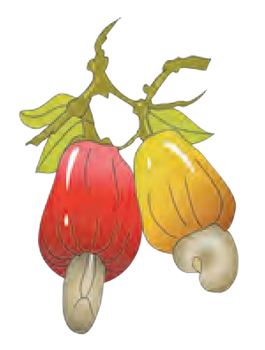  

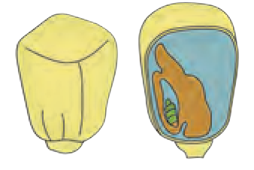

A.

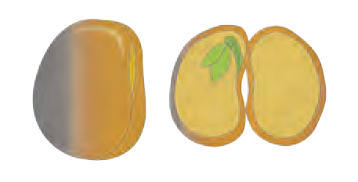

B.

1. **Properties of Natural Resources**

#### Properties of air

1. Which are the gases present in air ? Why is air called a homogeneous mixture ?
2. What are the uses of the various gases in air ?



**Let’s recall.**

Air is all around us. We cannot see it, yet we feel the presence of air. When we inhale, air is taken in through the nose. If we blow on our hand through our lips, we can feel the air.



**Try this.**

**Hole**

* 1. **Air pressure**
     1. Take a stick from a broom or a paper or plastic straw. Tie a thread at its centre and hang it so that it remains horizontal.

Tie two rubber balloons of the same size at the two ends of the stick. See to it that the stick remains horizontal. Now remove one balloon, inflate it and tie it again at its original position. Does the stick remain horizontal ? The stick goes down on the side of the inflated balloon. This means that air has weight. Air is a mixture of gases. Therefore, like all other matter, it has **mass** and **weight**.

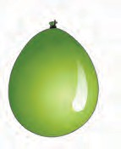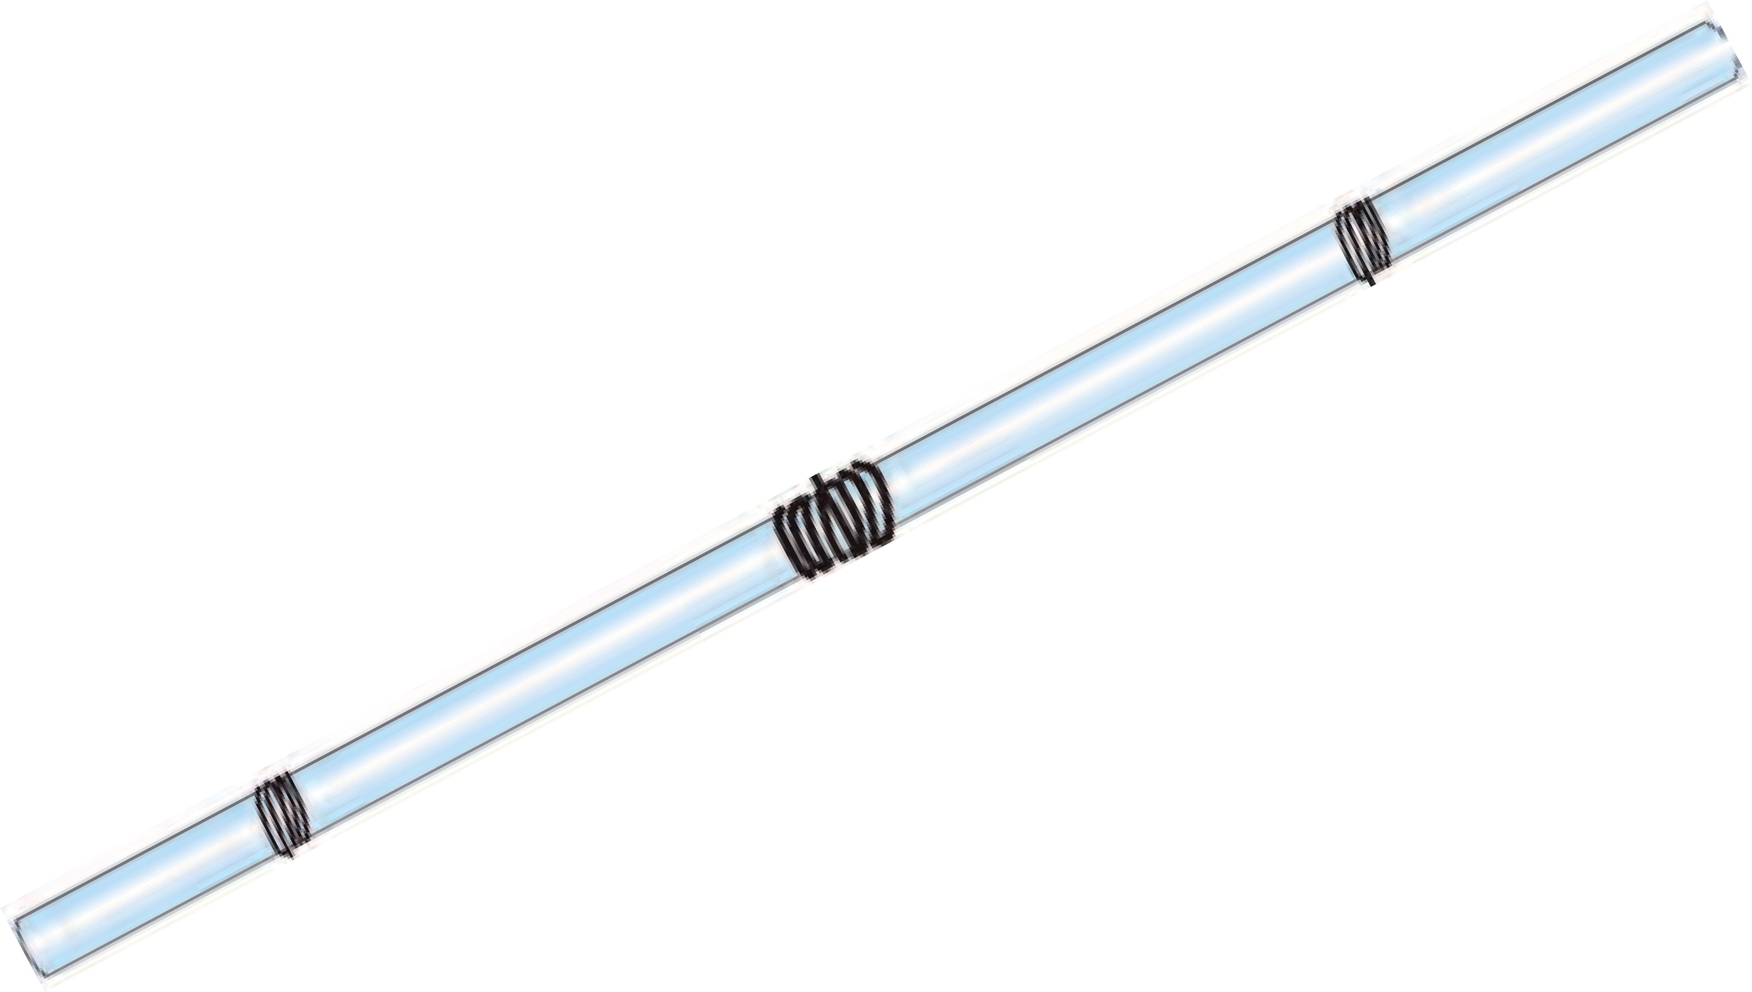

**3.1 Balloons**

* + 1. Take an injection syringe without the needle. Pull its piston and observe it as you do so.

The piston can be pulled out easily. The piston then remains in that position even if you let it go. Now, close the inlet hole of the syringe tightly with your thumb, pull the piston and let it go. Is the force required to pull out the piston more or less than before ? Does the piston remain as it is after you let it go.

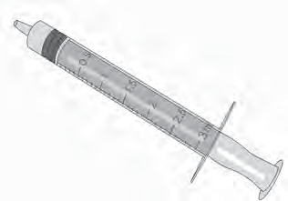

**Piston**

The molecules of the gases in the air are in constant motion. When these molecules strike a body, they create pressure on that body. This is the pressure of air that we call ‘**atmospheric pressure**’.

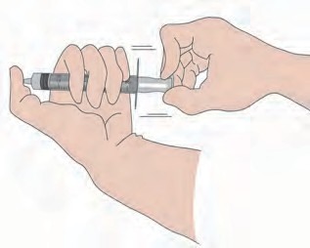On pulling the piston with the inlet hole of the syringe closed, more space becomes available to the air in the syringe, and it becomes rarified. As a result, the pressure of the air in the syringe is lowered. Comparatively the pressure of the outside air is very high. That is why, when the pulled out piston is released, it is immediately pushed in. If this experiment is repeated, holding the syringe in different positions like vertical, horizontal or inclined, the piston is found to go in to the same extent in all the cases. From this, we can infer that **atmospheric pressure is the same in all the directions**.

Is there any atmospheric pressure on the moon?



**Find out.**



**Do you know ?**

Under

ordinary

conditions,

atmospheric pressure at sea level is about 1,01,400 Newtons per square metre. It can be measured with the help of a barometer. As we go higher above sea level atmospheric pressure decreases.

**A Little Fun !**

Place a piece of cardboard on the mouth of a glass filled completely with water. Holding the cardboard firmly in place with one hand, invert the glass quickly. Take your hand away from the card board. What do you see ?

**Great Scientists**

In 1726, the Swedish scientist Daniel Bernoulli put forth the important principle that the pressure of air decreases when its velocity increases while the pressure of air increases when its velocity decreases. If a body is moving through air, the air pressure decreases perpendicular to the direction of the motion and then the air in its surroundings flows rapidly from higher pressure to the lower pressure.

**Download a photograph of Daniel Bernoulli from the internet, print and paste it here. What commands did you give the computer to do this ?**



**Observe and discuss.**

Take some water in a plastic cup and hold a straw upright in it. Hold a small piece of another straw near the upper end of the first straw and perpendicular to that straw. Blow hard through the small piece of straw. You will see a fountain of water. Why did this happen ?

On blowing through the straw, the air at its open end is pushed away and hence the pressure of the air at the opening goes down. As the pressure of the air near the upper end of the erect straw becomes less than atmospheric pressure, the water in the cup is pushed from where the pressure is higher to where it is lower, that is, in the upward direction, and the water comes out in the form of a fountain. The more forcefully you blow the higher will be the fountain. This straw fountain works on Bernoulli’s principle.

**Fountain of water**

**Straw**

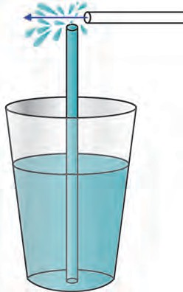

**Water**

* 1. **Effect of air pressure**

What is the effect of increased temperature on the pressure of air ?



**Use your brain power !**

When there exists a difference in the air pressure at two different places, the air starts flowing from the place of higher pressure to the place of lower pressure. At such times, we feel a breeze or a wind blowing. Thus, winds are an effect of the difference in air pressure. You will learn more about this in the lesson called ‘Winds’, in Geography.



**Try this.**

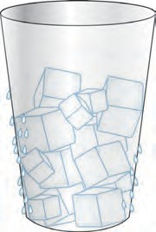

* 1. **Water droplets collected outside the glass**

Take ice-cubes in a glass upto three-fourths of its height. Now observe what happens. How did the water droplets appear on the outside of the glass ?

Due to the ice cubes in the glass, the air surrounding the glass cools down. As the water vapour in this air cools down, it condenses and gets transformed into water. It is this water that collects on the outer surface of the glass.

The level of humidity is different in different places. Similarly, the humidity levels also change from time to time during the period of a single day.

The level of humidity of the air is determined by its capacity to hold water vapour. During the night or at dawn, when the temperature of air is low, its capacity to hold the vapour is less. At such times, the excess vapour is transformed

into water droplets. This is what we call dew.

In the afternoon, when the temperature of the air is high, the capacity of the air to hold the moisture also increases. Then, compared to its full capacity to hold water, the proportion of moisture in the air is less and we feel that the air is dry.

The proportion of water vapour in the air is high during the monsoons and in coastal areas. As a result, we feel the dampness or humidity.

In summer, wet clothes dry quickly, but in the rains, they do not. Why is this so ?



**Use your brain power !**

* + 1. Dip an uncorked inverted empty bottle in a slanting position into the water in a wide container. What do you observe ?



**Try this.**

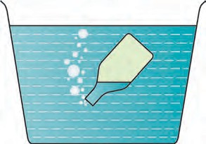

* 1. **Properties of air**

2. What change takes place in a balloon on filling air in it ?

We come to know from the activities above, that air has properties like occupying space, having a certain volume, having mass and weight.

Air is a mixture of very fine particles of some gases, dust, smoke and moisture. When rays of light fall on these minute particles, the particles spread the light in all the directions. This natural phenomenon is called **scattering of light**.

#### Temperature regulation



**Use your brain power !**

1. What would happen if all the air surrounding us is removed ?
2. Will sound be heard in space ?

The earth receives energy from the sun. This energy is reflected by the earth in the form of heat. The constituents of air surrounding the earth, such as water vapour, carbon dioxide, absorb a part of this heat and give it to the other constituents of air. As a result, the earth’s surface

remains warm and thereby becomes suitable for the living world on the earth. If there were no air on the earth, the average temperature of the earth’s surface would have been very low.

#### Transmission of sound

All the sounds that we hear reach us through the surrounding air. The density of air also changes due to change in its temperature. In winter, the density of the air increases. We can hear the whistle of a distant train clearly early in the morning in winter. Air is useful as a medium for the transmission of sound.

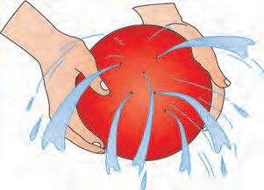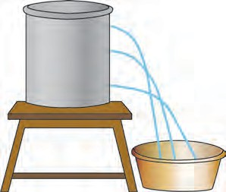

#### Properties of water

1. What are the states in which water is found ?



**Let’s recall.**

What inference will you draw from the pictures alongside ?

Water occurs in liquid state under ordinary conditions. Water is a fluid substance. Water does not have its own shape, but has a volume. It can pass through small holes or seep through very small gaps or cracks.

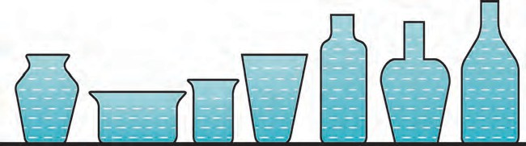On pouring water in an oil-cladded dish, water does not spread but forms small round drops. Why does this happen ?

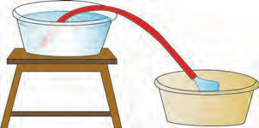

* 1. **Properties of water**



**Try this.**

1. Take a plastic bottle, more than half full of water. Mark the water level on the bottle. Keep this bottle upright in the freezer for

making ice. Open the freezer after a couple of hours and observe. You will see that the water has changed into ice. Note the level of the ice. You will find that the ice-level is higher than the water-level before freezing. What can you infer from this ?

As water freezes to form ice, it expands and its volume increases. On freezing, how much was the increase in the volume of the water ? In what proportion did it increase ?

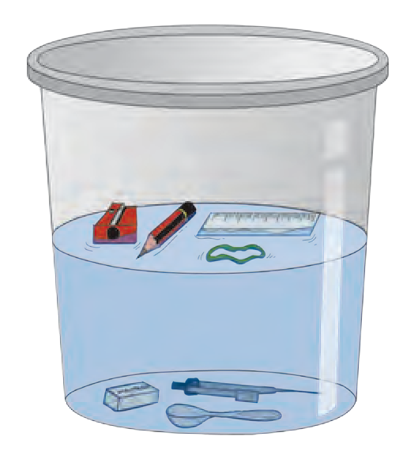

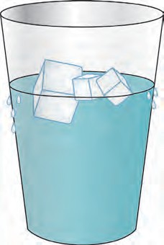

* 1. **Density of water**

1. Take a bucket of water. Drop many different kinds of articles in it. Make separate lists of the articles which sink in the water and those that float on it.
2. Take some water in a pot and add a few pieces of ice to it. Observe what happens.

Why do we see the ice float on water ?

Ice is lighter than water. When water freezes to form ice, it becomes lighter than the original liquid. When water freezes, that is, when it transforms into the solid state, its volume increases. Therefore, the density of ice is less than that of water. That is why the ice floats on water.

**Density of water**

The inter-relation between the volume and mass of a substance : the space occupied by a substance is its volume. The store of matter in a substance is its mass.

Density =

mass

volume

Mass is measured in grams

centimetres. Hence, density =

and volume in cubic gm

cc

Hence, g/cc is the unit of density. If the mass of 1 litre of water is 1 kilogram, then what is the density of water ?

**Think :** Will the mass of water change when its state changes during the transformation of liquid water into ice?

#### Anomalous behaviour of water

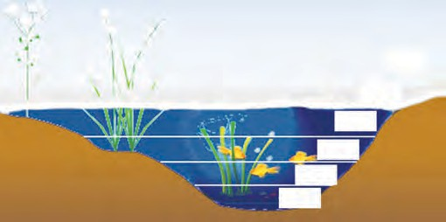

**Ice**

00 C

10 C

-10 C

20 C

30 C

40 C

Usually, when the temperature of a substance is lowered, its density increases as the volume decreases; but water is an exception to this rule.

1. Keep a glass full of water in the freezer for five to ten minutes. Then take it out and observe it carefully.

From which part in the glass does the water first start freezing ?

* 1. **Anomalous behaviour**

The density of water is peculiar. When water at normal temperature starts cooling, its density increases like that of most liquids. However, if its temperature falls below 40 C its density starts decreasing. This means that the density of water is maximum at 40 C. If the temperature of water is lowered below 40 C, its density decreases and volume increases. It means that water expands when the temperature falls below 40 C. This is called the **anomalous behaviour** of water.



**Try this.**

**A**

**B**

* 1. **Effect of density**

In cold countries, how do aquatic animals remain alive even after the rivers or lakes freeze in winter ?

Take two big glasses of water. Add 4-5 spoonfuls of salt to the water in one glass and dissolve it completely. Now place a potato in the water in the second glass. The potato will sink.

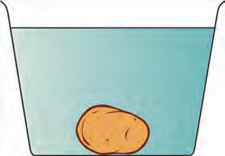

**Water**



**Use your brain power !**

Take out the potato from that glass and put it in the salt water and observe. The density of water in that glass is greater due to the dissolved salt. The potato floats in that water because of the increased density.

Why is it easier to swim in the sea than in a well or a lake ?

In the above activity the salt dissolves in the water in the glass, that is, it disappears. What happens when it disappears like this ?

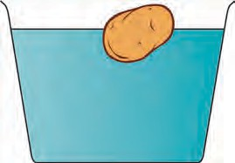

**Salt solution**

When the salt dissolves in water, its particles spread in water. Slowly they become smaller and smaller. Ultimately they become so small that they cannot be seen, that is, they mix completely with water. This is what is called dissolving.

**Solute :** the substance that dissolves - **Salt**

**Solvent :** the substance in which the solute dissolves - **Water Solution :** what we get when the solute dissolves in the solvent.

**Uses of water according to its properties**

1. Water is useful for water transport due to its fluidity. Water falling down from a height is used to generate electricity with the help of a generator.
2. Water is a good coolant and is used in motor vehicles to control the temperature of the engine.
3. Many substances are soluble in water. Water is a universal solvent. Water is used as a solvent in factories, laboratories, foodstuffs and in various types of biological processes occurring in the body such as digestion, excretion, etc.
4. Water is useful for cleaning purposes such as for bathing, washing clothes.

#### Soil

* + 1. What is meant by soil ? How is soil formed ?



**Let’s recall.**

* + 1. What are the ingredients of soil ?

#### Properties of soil

Colour is an important property of soil. The soil gets its colour as a result of several processes. The colour of soil near land surface is darker than the colour of the lower layers. Soil may be of different colours, such as black, red, copper, yellow, gray.

The colours of soil are useful for its classification. Besides, they are indirectly useful in indicating several properties of the land. In this way, the properties of the soil such as its fertility, drainage of water, capacity to hold water become clear from its colour. The colour of the soil depends upon its texture and its organic ingredients as well as on chemical ingredients like iron, lime.

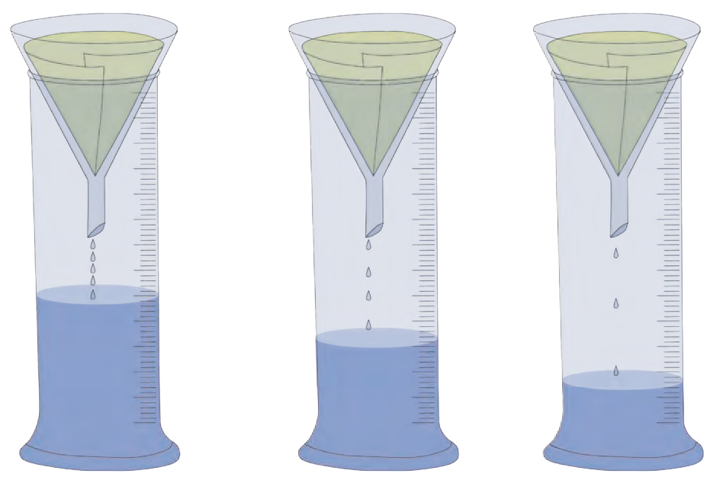

**Try this.**

**Apparatus :** Three measuring cylinders, three glass funnels, filter paper, water, fine sand, coarse sand, soil from an earthen pot used for growing plants, etc.

**Procedure :** Fit cones of the filter paper in the three glass funnels. Fill the cones with equal quantities of (a) sand (b), sandy soil and (c) clay respectively. Place the funnels on the measuring cylinders. Pour one test tube of water into each of the funnels and observe how much water is collected in each measuring cylinder.

**a b c**

* 1. **Collected water**

#### Soil texture

What inference will you draw from this ?

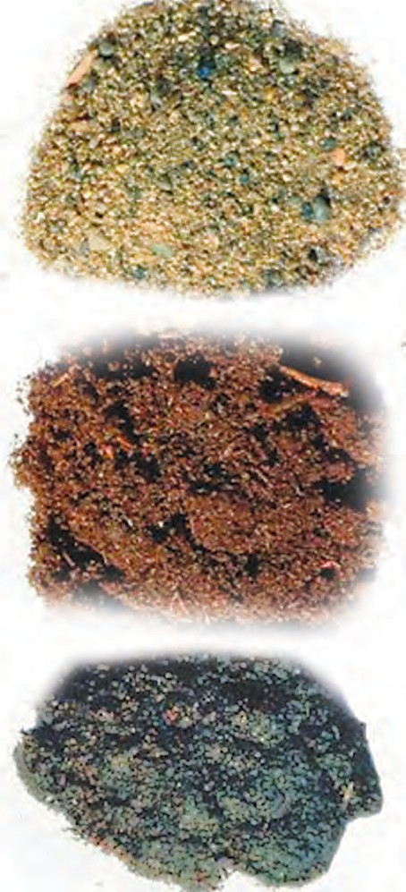Soil contains particles of different sizes. The texture of the soil is determined by the proportion of particles of the various sizes in it. Following are the types of soil on the basis of its texture.

**Sandy soil :** The proportion of sand, i.e., large particles

is high in sandy soil. Water drains rapidly through sandy soil. **It is easy to plough this soil**. But it is less fertile. This is because the particles of sandy soil are made of the mineral called silicon dioxide (quartz). These particles do not dissolve in water and, therefore, the soil has very little capacity to supply nutrients.

**Silt soil :** The particles of silt soil are of medium size. Silt soil is not as ploughable as sandy soil. However, it is much more ploughable than clay soil. This soil contains a large proportion of organic materials. Its capacity to supply nutrients is much greater. Silt soil is also called sedimentary soil.

**Clay soil :** In this soil, the proportion of small particles is maximum. The particles of clay soil feel smooth to touch. Clay soil has a high water holding capacity.

**Sandy soil**

**Silt soil**

**Clay soil**

* 1. **Types of soil**
     1. Why is it difficult to plough clay soil ?



**Use your brain power !**

* + 1. Why is it easy to plough sandy soil ?
    2. What is the water holding capacity of silt soil ?

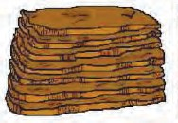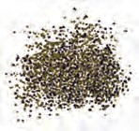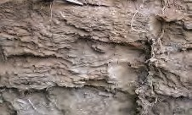

* + 1. Which soil is suitable for cultivation ? Why ?

#### Soil structure

The structure of soil depends upon the different shapes of the particles in it. Soil occurs in the form of columnar, laminar, granular as well as block-shaped structures.

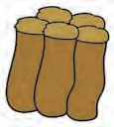 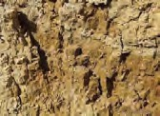

**Importance of soil structure**

The fertility of soil depends upon soil structure. The advantages of good soil structure are as follows :

1. Roots get a sufficient supply of oxygen.
2. Water drainage is good. Therefore, the roots of plants grow well.

#### Uses of soil

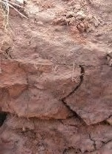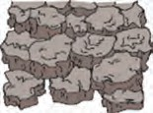

1. **Plant conservation :** To help plants grow.
2. **Water conservation :** Soil holds water. As a result, by means of bunds and lakes, we can get water for use throughout the year.
3. **Plasticity :** Soil can be given any required shape. This property of soil is called plasticity. Because of its plasticity, we can use it to make articles of a variety of shapes. These articles can be baked to make them hard. Water storage earthen pots, earthen lamps, idols, bricks, etc. are articles made from soil.

#### Some useful types of soil

1. **China clay : (Kaolin)** It is white in colour. It is used to make crockery, bathroom tiles, tanks, laboratory apparatus, masks, jars, etc.
2. ***Shadu* soil :** It is whitish in colour. It is used for making statues and idols.
3. **Terracotta soil :** This soil is red in colour. Decorative articles and pots used for growing plants are made from this soil.
4. **Multani soil :** This soil is used in cosmetics.
   1. **Soil structure**

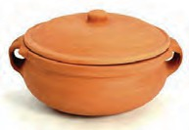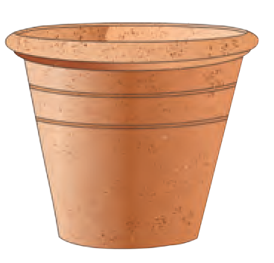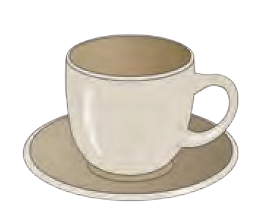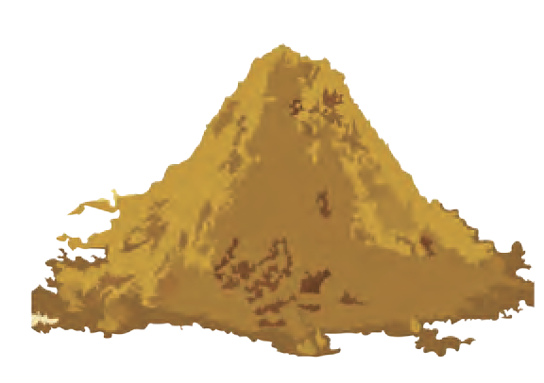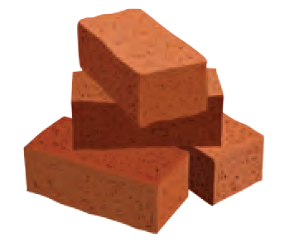

* 1. **Uses of soil**



**Do you know ?**

China clay is an industrial mineral of the type ‘Kaolinite’. It is found in China and hence called China clay. Upon heating, this soil acquires a glaze and hardness and, therefore, is used for making crockery.

#### Soil testing

**Great Scientists**

The Danish Scientist Sorensen put forth the concept of pH, based on the concentration of hydrogen ions. To determine the pH of soil, a mixture of water and soil in the proportion 1:2 is taken and tested using several indicators. Accordingly, soil may be found to be one of the following three types.

1. Acidic soil - pH less than 6.5
2. Neutral soil - pH 6.5-7.5
3. Alkaline soil - pH higher

than 7.5

The proportions of the various ingredients of soil can be determined by ‘soil testing’. During soil testing, the soil is examined for colour, texture and the proportion of organic matter in it. Soil is tested to find out if there is a deficiency of any ingredients and to decide what measures should be taken to remove the deficiency.

The soil sample collected for testing is dried in an open space in the shade for eight to ten days. It is then sifted through a sieve.

Two tests, namely, the pH and the electrical conductivity tests, are particularly useful in finding out the characteristics of soil. You can determine the fertility of the soil in your fields with the help of different tests.



**Always remember -**

Soil texture is disturbed if chemical fertilizers are used excessively and that land becomes unsuitable for sowing. Crops should be rotated in order to maintain the fertility of the land.

For example, the fertility of land decreases after a harvesting of wheat. Hence, leguminous crops like peanut, *moong*, *moth bean*, *pea*, lentil, Bengal gram, soyabean should be cultivated to restore the fertility of the soil.

#### Causes of diminished soil fertility :

1. Soil pH less than 6 or higher than 8.
2. Low proportion of organic matter.
3. No proper drainage of water.
4. Repeated cultivation of the same crop.
5. Continuous use of saline water.
6. Excessive use of chemical fertilizers and pesticides.

**World Soil Day : 5th December To make efforts for conservation of soil**



**Exercise**

* 1. **Fill in the blanks with the appropriate term.**

(Temperature, volume, mass, density, humidity, acidic, weight, neutral, shape.)

* + 1. The capacity of air to hold moisture depends upon the ......... of the air.
    2. Water does not have a .............

but has definite .......... and .......... .

* + 1. While freezing, the of

water is lowered.

* + 1. ................. soil has pH 7.
  1. **Why is it said that -**
     1. Air is a homogeneous mixture of various gases.
     2. Water is a universal solvent.
     3. There is no alternative to water for cleaning purposes.
  2. **What will happen if.....**
     1. The amount of water vapour in the air increases.
     2. Only one crop is grown repeatedly in the soil.
  3. **With whom should I pair up ? Group ‘A’ Group ‘B’**

1. Air (a) Excretion
2. Water (b) Scattering of light.
3. Soil (c) Plasticity
   1. **State whether the following statements are true or false.**
      1. Sandy soil has low capacity for holding water.
      2. The substance in which a solute dissolves is called a solvent.
      3. The pressure exerted by air is called atmospheric pressure.
   2. **Explain the picture in your own words.**

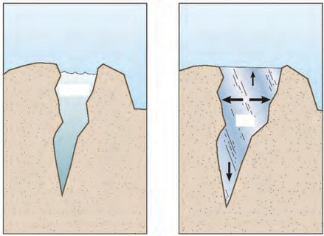

Water

Ice

**a b**

* 1. **Write answers to the following questions in your own words.**
     1. How is light scatterred by the air ?
     2. Explain the various properties of water.
     3. Why is the density of seawater more than that of rain water ?
     4. What is the importance of good soil structure ?
     5. What are the various uses of soil ?
     6. What is the need and importance of soil testing from the point of view of farmers ?
     7. What is the importance of air in transmission of sound ?
     8. Why should a glass bottle completely filled with water never be kept in a freezer ?

**Project :**

Visit a soil testing laboratory. Learn the process of soil testing and share it with others.

⧫  

1. **Nutrition in Living Organisms**

#### Nutrition



**Let’s recall.**

1. What is malnutrition ?
2. Which are the ways to prevent malnutrition ?

Some life-processes go on continuously in living organisms. Substances which are **digested** and **assimilated** for obtaining energy and for the growth and health of our body are called foodstuffs.

The process of taking in and using food, which takes place in living organisms is called **nutrition**.

**Need for nutrition**

1. To supply the energy required for doing work.
2. Growth and development of the body.
3. To replace the damaged cells and repair tissues.
4. To fight diseases.

**Autotrophic nutrition**

Some organisms can produce their own food and thus nourish themselves. This is called **autotrophic nutrition**.

**Heterotrophic nutrition**

Some organisms depend on other organisms, plants or animals, for their food. This is called **heterotrophic nutrition**.

We get several types of nutrients from foodstuffs. Nutrients can be classified into two types, namely, **macro-nutrients** and **micro- nutrients**.

Nutrients like carbohydrates, proteins and fats are required in large quantity. These are macro-nutrients. Minerals and vitamins are required in very small quantity. They are called micro-nutrients.

#### Autotrophic plants

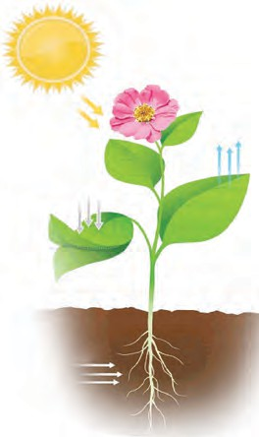

**Can you tell ?**

How do plants produce food ?

Plants also need food growth. They can produce

their

own

**Oxygen**

**Sunlight**

for their

their own and

**Carbon dioxide**

food. With the help of sunlight

**chlorophyll**, plants make their food in their leaves, using water and nutrients from the soil and carbon dioxide from

**Chlorophyll in the leaves**

the air. This process is called as

**photosynthesis**.

**Water, minerals, salts**

**4.1 Photosynthesis**

2

6 12 6

2

2

O + 6O

C H

food (glucose) + oxygen

Sunlight

Chlorophyll

Carbon dioxide + water

6 CO + 6H O

Plants convert light energy into chemical energy and store it in the form of food.

Water, minerals and salts are absorbed by roots from the soil. The stem transports them up to the leaves. The leaves have microscopic openings called stomata through which they take in the CO2 from the air. The chloroplasts present in the leaves contain chlorophyll, which absorbs sunlight, helping to convert carbon dioxide and water into food. Oxygen is given out in this process.

Besides leaves, photosynthesis takes place in some other parts like green stems, too, as they contain chlorophyll.

← ← ←

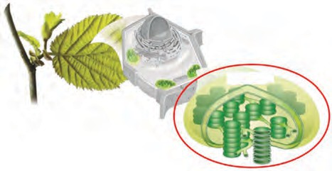

**Chloroplast**

* 1. **Chloroplasts in a leaf**



**Find out.**

How does photosynthesis occur in dark red or purple coloured leaves ?

#### Transport system in plants

Take a pumpkin stem having 2-3 leaves. Cut it under water with a sharp blade. Take some water in a conical flask and add 7-8 drops of ink to it. Put the pumpkin stem vertically in that flask. Observe the changes that take place in it and discuss them in the classroom.

←

The transport system of plants consists of the **xylem** and the **phloem**. The xylem transports minerals and water from the root to all aerial parts of the plant. The phloem transports the food (glucose, etc.) from the leaves to other parts of the plant where it is either consumed or stored. Though the plants have a transport system, they do not have a separate digestive or excretory system.

←←

**Phloem**

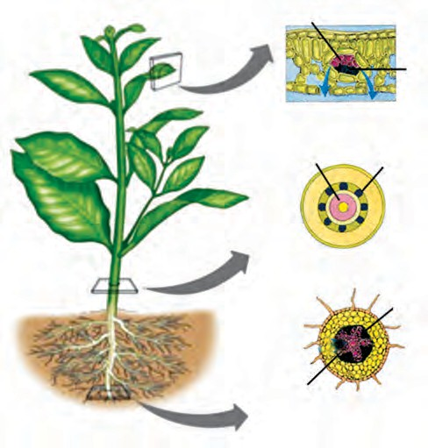

**Section of a leaf**

**Section of a stem**

**Section of a root**

**Xylem**

* 1. **Transport system in plants**

What is chemosynthesis ? Which plants produce their food by chemosynthesis ?



**Find out.**

Which are the different substances excreted by plants? Why?



**Let’s recall.**

Plants produce carbohydrates by the process of photosynthesis. Carbohydrates are made from carbon, hydrogen and oxygen. Proteins are made from carbon, hydrogen, oxygen and nitrogen. How do plants obtain the nitrogen necessary for the synthesis of proteins ?

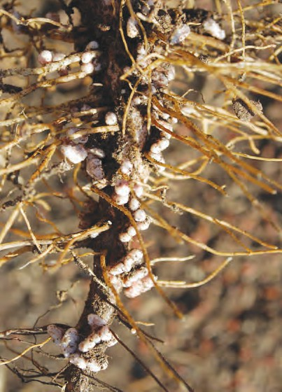

* 1. **Roots of a leguminous plant**

Air contains gaseous nitrogen. However, plants cannot utilize gaseous nitrogen. It needs to be fixed

i.e. converted into compounds. Fixation of nitrogen occurs by biological and atmospheric methods. **Biological fixation of nitrogen**

Two different types of micro-organisms can bring about biological nitrogen fixation. Root-nodules of leguminous plants contain the rhizobium micro- organisms. These micro-organisms absorb atmospheric nitrogen and convert it into its nitrate, a compound.

Micro-organisms like azotobacter are present in soil. They also convert atomspheric nitrogen into nitrates.



**Do you know ?**

**Atmospheric fixation of nitrogen :** Lightning (thunderbolts) occur in the rainy season. This causes atmospheric nitrogen and oxygen to react with each other to form nitric oxide (NO) which is again oxidized to form nitrogen dioxide (NO2).

The nitrogen dioxide dissolves in rainwater and is converted into nitric acid (HNO3) which gets added to the soil along with the rain-water. This acid reacts with different minerals in the soil and convert into salts. Plants use this nitrogen salts for their growth.

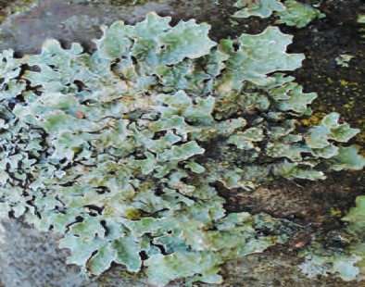

* 1. **Lichen**

#### Symbiotic nutrition

In some cases, two or more than two different types of plants live together to fulfill their needs of nutrition, protection, support, etc. with each others’ help. This type of nutrition is called **symbiotic nutrition**.

Some fungi grow around the roots of some other plants. These plants supply nutrients to the fungi and in turn, fungi supply minerals and water to the plants. Some fungi and algae live together. The fungi provides water, minerals as well as shelter to algae. In return, the algae provide food to the fungi. **Lichen** is an example of a symbiosis between algae and fungi.

#### Heterotrophic plants

Heterotrophic plants do not contain chlorophyll. How do the heterotrophic plants live ? From where do they get food ?

Have you seen a yellow, wire-like, leafless climber plant growing on a big tree ? What is its name ?

The plants that grow on the body of other plants to obtain food are called as parasitic plants, for example, loranthus, cuscuta, etc.

Due to the absence of chlorophyll, the *cuscuta* is completely dependent on the host plant. Hence, it is said to be a completely parasitic plant.

You must have also noticed loranthus that grows on trees.

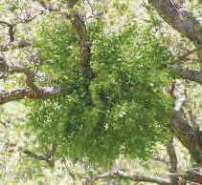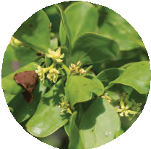

* 1. **Loranthus**
     1. Which part of the loranthus plant carries out photosynthesis ?



**Use your brain power !**

* + 1. From where do they obtain minerals and water ?
    2. 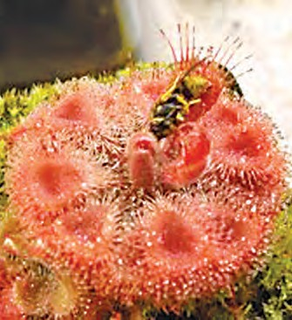Why is loranthus known as a partially parasitic plant ?

#### Insectivorous plants

We have seen how some plants feed upon insects to obtain nutrients. These insectivorous plants generally grow in soil or water deficient in nitrogen compounds. The plant body of the Drosera burmanii has a flower- like appearance. It grows close to the ground. Its leaves are attractively pink or red in colour with hairs at the margin. Droplets of a sticky subtance found at the tips of the hairs attract insects. The scientist Johannes Burman identified this plant in Sri Lanka in 1737.

Hence, the plant is named after him.

* 1. **Drosera burmanii**

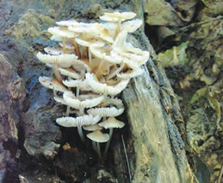Why does the pitcher plant feed on insects even though it produces food by photosynthesis ?



**Use your brain power !**

#### Saprophytic plants

Plants which obtain the food from dead and decaying bodies of other organisms are called saprophytic plants.

Various types of fungi like mushrooms and yeast are saprophytes. Fungi secrete digestive enzymes on the dead remains to digest or breakdown the carbon compounds they contain. The resulting solution is absorbed to obtain nutrients.

* 1. **A saprophytic plant**



**Always remember -**

Food gets spoiled due to some fungi. Some fungi cause diseases or illness while some fungi have medicinal properties.

Yeast and some mushrooms are useful. Yeast is used in fermentation processes and for making bread. Mushrooms are a rich source of iron and vitamins.

#### Role of nutrients and effects of their deficiency on plants :

|  |  |  |
| --- | --- | --- |
| **Nutrient** | **Function** | **Effects of deficiency** |
| Nitrogen | Important component of protiens, chlorophyll and cytoplasm. | Retarded/stunted growth, yellowing of leaves. |
| Phosphorus | Conversion of light energy into chemical energy. | Early leaf-fall, late flowering, slow growth of roots. |
| Potassium | Necessary for metabolic activities. | Weak stem, wilting of leaves, failure to produce carbohydrates. |
| Magnesium | Production of chlorophyll | Slow/retarded growth, yellowing of leaves. |
| Iron | Production of chlorophyll | Yellowing of leaves |
| Manganese | Production of main plant hormones | Retarded growth, spotted leaves |
| Zinc | Production of hormones and their intermediates | Retarded growth, yellowing of leaves |

* **Observe the plants around you and diagnose the nutrient deficiency, if any. Nutrition in animals**

This concept refers to the body’s need for nutrients, mode of ingesting food and

its use in the body.

Which are the various nutrients in food ? For what purpose Nutrients necessary for various activities of the body are obtained from food. They



**Let’s recall.**

are the nutrients used ?

are supplied to the various parts of body through blood. The food that we consume does not mix with blood as it is. It needs to convert into soluble forms that can easily mix in blood. Nutrition in animals involves various steps from ingestion to egestion.

**Steps in nutrition**

1. Ingestion - Food is taken into the body.
2. Digestion - Conversion of food into simple soluble forms.
3. Absorption - Transfer of soluble food to the blood.
4. Assimilation - Utilization of absorbed food by cells and tissues for energy production, growth and repair.
5. Egestion - Removal of waste products and undigested food from body.

#### Observe the animals around you and complete the following table.

|  |  |  |  |
| --- | --- | --- | --- |
| **No.** | **Name of animal** | **Type/Name of food** | **Method of ingestion** |
| 1. | Cow |  |  |
| 2. | Frog |  |  |

You must have observed that there are different methods of ingestion of food in different animals, like swallowing, chewing, sucking, scraping, gnawing, etc.

#### Types of nutrition in animals

1. **Holozoic nutrition**

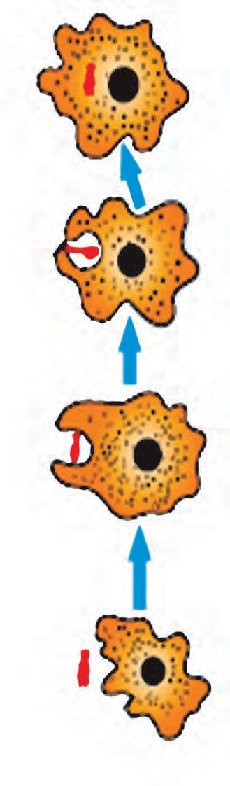

How does ingestion occur in unicellular animals like *Amoeba* ?



**Can you tell ?**

Amoeba does not have organs like hands and mouth. It is a unicellular animal. It can take in food through any part of the surface of its unicellular body. It surrounds the food particle from all sides to take it into the cell. After that, it digests the food with the help of different enzymes. Undigested food is left behind as the amoeba moves further with the help of pseudopodia. In unicellular animals like amoeba, euglena, paramoecium, etc. all the steps of nutrition occur within their unicellular body.

Insects have mouth-parts for ingestion of food. For example, insects like the cockroach and grasshopper which nibble have jaw-like mouth-parts. Butterflies suck food with a a tube-like proboscis. Mosquitoes and bedbugs use a

**Food particle**

**Nucleus**

**Food particle**

**Nucleus**

needle-like mouth part to pierce and a tube-like mouth part to suck blood or other fluids.



**Observe and discuss.**

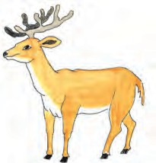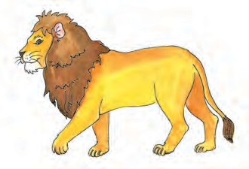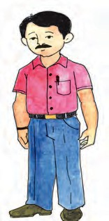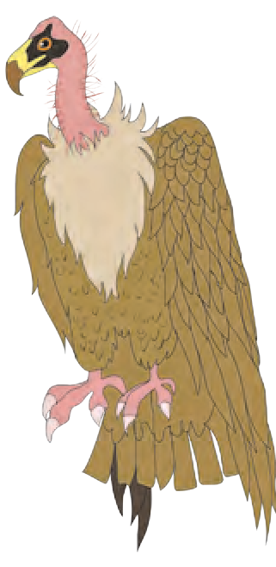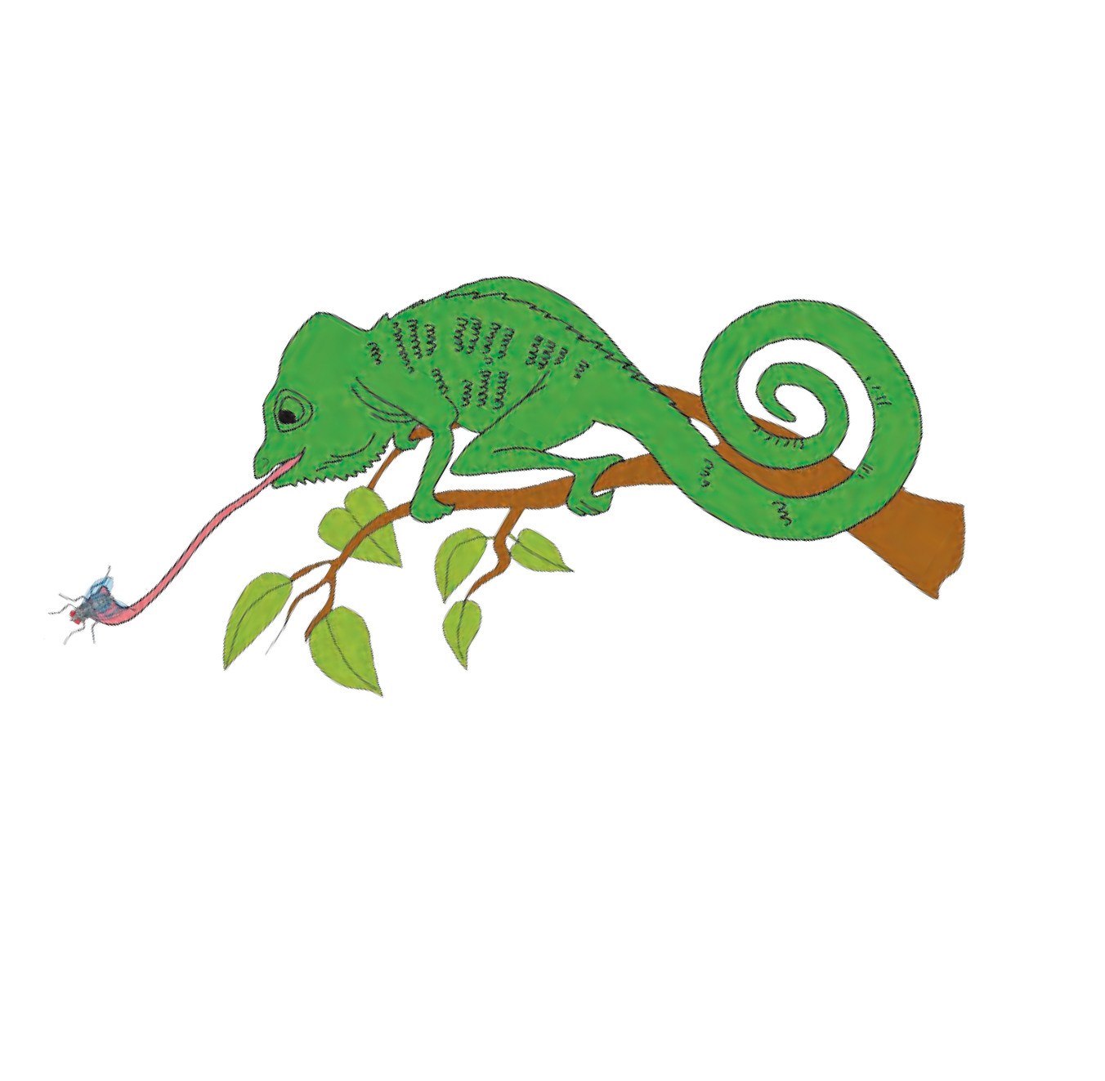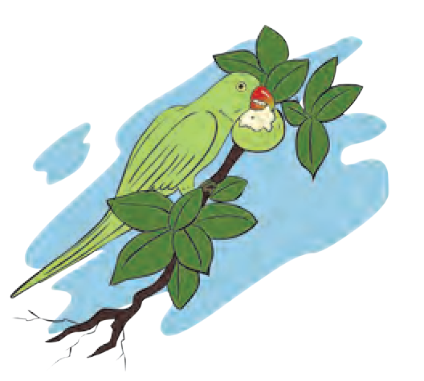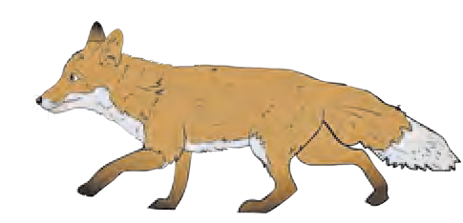

**4.9. Amoeba**

How will you classify the following animals according to their food-type ?

**4.10 Animals with different food habits**

31

#### According to the type of food, animals can be classified as -

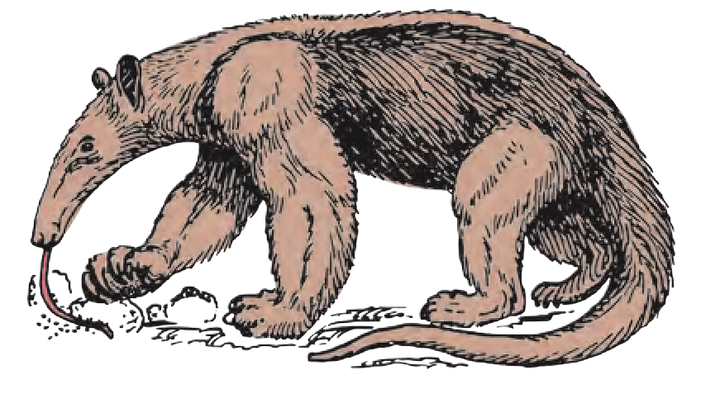

The anteater is found in Central and South America.

The bobcat or *udmanjar* is found in India. Obtain its pictures from the internet.

1. **Herbivores :** Herbivores use plants directly as their food. Example are grazing animals, granivores (seed-eaters), frugivores (fruit-eaters), etc.
2. **Carnivores :** Animals that depend on other animals for their food are carnivores. Carnivores are indirectly dependent on plants for food. Examples are animals that feed on herbivores (predators), animals that feed on insects (insectivores).
3. **Omnivores :** Animals that obtain their food from both plants and animals are called omnivores. Examples are monkey, chimpanzee, human, etc.

Some of the organisms around us perform the function of cleaning and conserving the environment by the very act of feeding themselves. They are called **scavengers** and **decomposers**.

1. **Scavengers** obtain their food from dead bodies of animals, for example, vulture, crow, hyena, etc.
2. **Decomposers** are some microbes which obtain their food by decomposing the dead bodies of organisms or other materials.

#### Saprozoic nutrition

Some insects, unicellular animals, etc. obtain the nutrients by absorbing the liquid organic material from the dead bodies of other animals or from the environment. This is saprozoic nutrition. Example, houseflies, ants, spiders, etc.

#### Parasitic nutrition

* 1. Have you seen small animals on the bodies of animals like dogs and buffalloes ? Which are those small animals ?
  2. From where do these little animals obtain **4.11 Parasites**

their food ?

* 1. From where do the worms in the intestine obtain their food ?

Some animals depend upon other animals for food. They can obtain the food only from animals on whom they are dependent. This is called as **parasitic nutrition**.

Some animals live on the body surface of other animals and obtain their food by sucking their blood. This is called **ectoparasitic nutrition** and such animals are called ectoparasites, for example, louse, bed-bug, tick, etc. Animals like tapeworm and roundworms live inside the body of other animals and obtain their food. This is **endoparasitic nutrition** and these animals are known as endoparasites.



**Exercise**

1. **Classify according to food-type.**

tiger, cow, vulture, bacteria, deer, goat, human, fungus, lion, sparrow, buffalo, frog, cockroach, tick.

1. **Match the pairs.**

**Group ‘A’ Group ‘B’**

* 1. Parasitic plant (a) Mushroom
  2. Insectivorous plant (b) Lichen
  3. Saprophytic plant (c) Drosera
  4. Symbiotic plant (d) Cuscuta

1. **Answer the following questions in your own words.**
2. Why do living organisms need nutrition ?
3. Explain the process of production of food in plants.
4. What is meant by parasitic plants ? Name their different types with examples of each.
5. Explain the various steps of nutrition in animals.
6. Name some unicellular organisms in which all life-processes take place within their unicellular body.
7. **Give reasons.**
8. Insectivorous plants are attractively coloured.
9. Butterflies have a long tube-like proboscis.
10. **Prepare and complete the flowchart according to type of nutrition.**

Nutrition

1. **Think and answer.**
2. We prepare a variety of foodstuffs and dishes at home. Are we then autotrophic organisms ?
3. Which organisms are greater in number - autotrophs or heterotrophs ? Why ?
4. The number of heterotrophs found in desert regions is smaller. However, they are found in greater numbers in the sea. Why is this so ?
5. What damage or harm do ectoparasitic and endoparasitic animals cause ?
6. Why is plant food not produced in any other parts of the plant except the green ones ?

**Project :**

1. Many heterotrophic organisms live on one and the same plant. Observe one such plant in your neighbourhood and find out about the heterotrophs that depend upon it for their food. Observe and make notes about other organisms that use these heterotrophs as their food.
2. Prepare a power point presentation on the topic ‘Nutrition in Living Organisms’.

⧫  

Plants Animals

Autotrophic

Insectivorous

  Parasitic

Ectoparasitic 



**5. Food Safety**

**Let’s recall.** Complete the following chart with the correct information.

|  |  |  |  |
| --- | --- | --- | --- |
| **Sr.**  **No.** | **Food / Source** | **Nutrients obtained** | **Function in body** |
| 1. | Jowar, wheat, millet (bajra), rice |  |  |
| 2. | Beans and pulses |  |  |
| 3. | Oil, ghee, etc. |  |  |
| 4. | Fruits and vegetables |  |  |

All constituents of food-carbohydrates, fats, proteins, vitamins, minerals, fibre and water are necessary for the proper growth of the body. We get these nutrients from food materials like wheat, jowar, pulses, rice, vegetables, fruits, etc. However, what will happen if these food materials are infested by insects or spoiled in any way ?

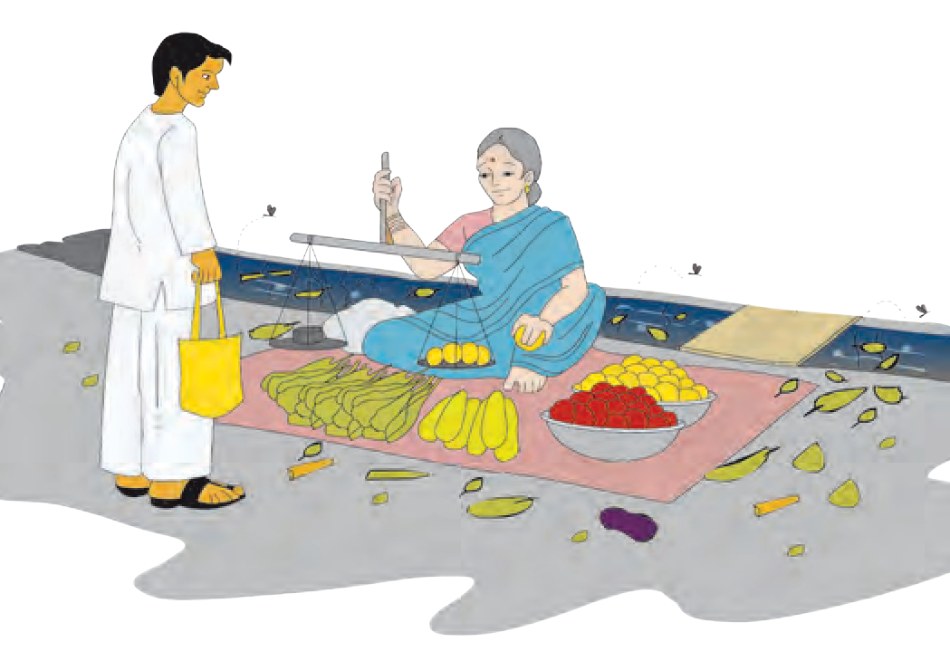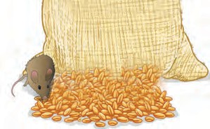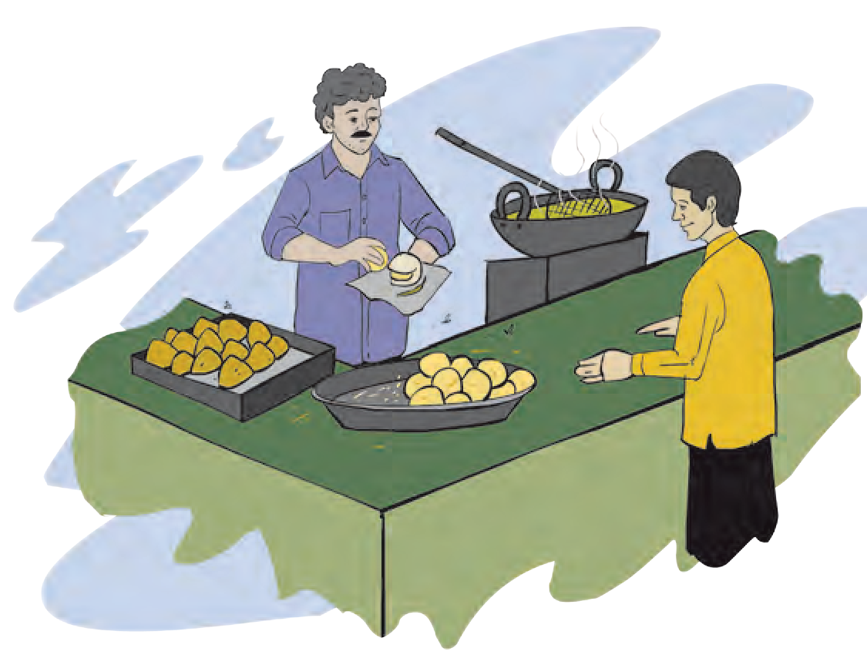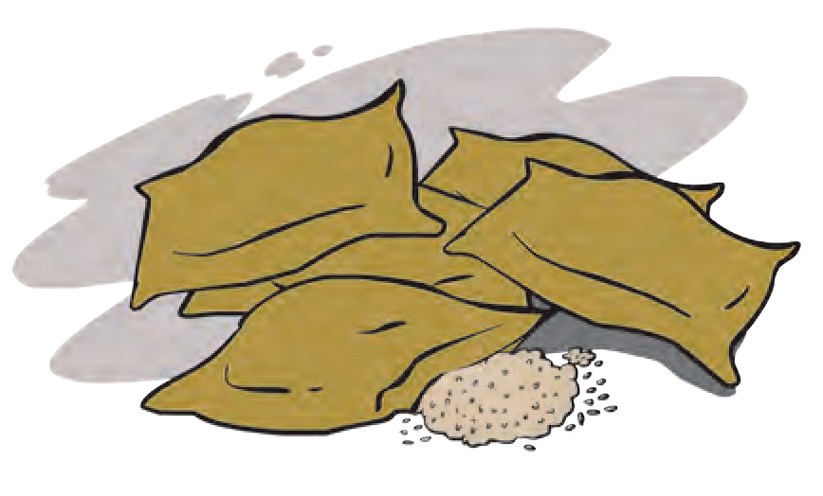

**Food spoilage**

**Observe and discuss.**

**A**

**B**

**C**

**D**

**5.1 Events in our surroundings**

#### Factors responsible for food spoilage

Sometimes, fruits or their skins turn black. Some foodstuffs give out a foul or bad odour. Such foodstuffs are not suitable for us to eat. Sometimes, naturally available food materials are spoiled by wrong handling as when they are over- cooked, or improperly stored, say in a damp place. In such cases, the quality of the food materials deteriorates. They may also be spoiled during transportation. Can you give more such examples of food spoilage ?

The foodstuffs we consume, whether of animal or plant source, must be of the best quality. Otherwise, we may fall prey to disease or illness. Food is said to be spoiled if there is a change in its colour, odour, texture, quality, taste and there is a loss of its nutrient content.

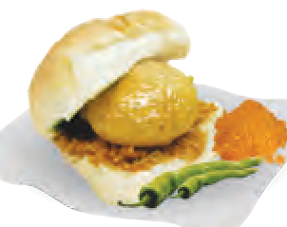

**5.3 Our favourites**



**Observe.**

**5.3 Fruits**

On a day out with our friends or family we enjoy mouth-watering dishes like *pani-puri*, *shev- puri*, *pav-bhaji*, *vada-pav*, pizzas, burgers. But, have you ever given a thought to how or where they were made ? Were they displayed and served hygienically ? What was the source of the water used for preparing them ? Discuss all these matters with your science teacher.

Which fruits in the picture appear to be good to eat ? Why ? Various kinds of changes occur in food materials.

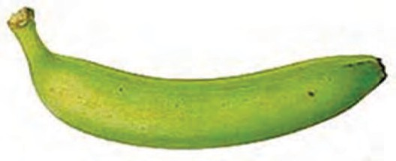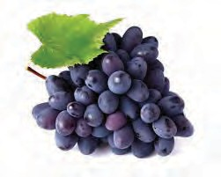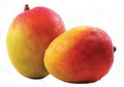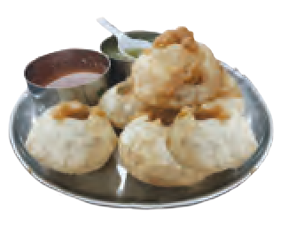

**Observe and discuss.**

For example, fruits turn black or change taste, meat

becomes sour or peanuts become rancid. All these changes occur due to factors within the food materials. Often, food grains, etc. produced in farms are

damaged due to various reasons like improper handling,

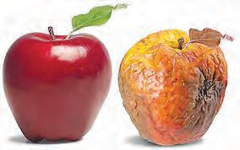improper storage, improper transportation, etc. Some foodstuffs like meat and milk are either acidic or alkaline. They may get spoiled due to chemical reactions on contact with metals. Sometimes, foodstuffs may be spoiled due to contamination by micro-organisms or insects from the surrounding air, water or soil.

Can you give some other examples of factors that cause spoilage of food ?

#### Food wastage



**Can you tell ?**

How and where is food wasted ?

With the help of science and technology, India has shown great progress in the production of various foodstuffs like cereals, fruits, vegetables, fish as well as milk and milk-products. Even so, many people in our country and all over the world face the problem of hunger. Many do not get even one meal a day. Hence, it is our duty to prevent wastage of food wherever it takes place.

**Quantitative wastage of food :** Wrong methods of farming like hand sowing of seeds, inadequate threshing, improper storage and wrong methods of distribution are some reasons for quantitative wastage of food. Besides, much food is wasted as a result of the custom of offering and serving too much food to guests at traditional feasts or banquets. Had it not been wasted, all this food could have met the need of many others.

**Qualitative wastage of food :** Using wrong methods of protecting food, excessive use of food preservatives, over-cooking, washing the vegetables after cutting them, mis-handling of fruits like grapes and mangoes, mis-calculation of the time required to transport food from producers to consumers, are some of the causes of qualitative wastage of food.

**What can you do to prevent food wastage and spoilage ?**

1. Serve yourself only as much as you can eat.
2. Avoid over-cooking food.
3. Avoid throwing away left-over food. Re-use it in a proper way.
4. Buy only as much grain, vegetables, fruits, milk, etc. as you need. Avoid the temptation to make excessive purchases.
5. Store grains and other perishable foodstuffs like vegetables, fruits, milk, etc. using proper methods.
6. Check the expiry date of bottled, canned, packed food and use within that time.
7. Eat all the food that you have served yourself.



**Observe and discuss.**

What can we do to avoid use of rice grains as ‘*akshata*’ and to prevent wastage of food during wedding feasts ?

**16th OCTOBER WORLD FOOD DAY**

**To work towards food security and avoid food wastage.**

#### Food storage and preservation

**National Institutions**

**Food and Drug Administration**

This is a government organization that controls production and distribution of food and drugs by their standardization. Food Safety and Standardization Authority of India (FSSAI) has been established as per the Food Safety and Standardization Act-2006.

Web addresses : [www.fssai.gov.in](http://www.fssai.gov.in/) [www.fda.maharashtra.gov.in](http://www.fda.maharashtra.gov.in/)

We have learnt about various methods of safe storage of food like freezing, drying, boiling, air-tight packing, etc. These different methods prevent the growth of micro-organisms in food and thereby save the food from spoiling.

**Food protection and food preservation Food protection :** Prevention of food spoilage by microbial growth and

infestation by pests is called food

protection.

**Food preservation :** Use of various preservatives to prevent, for a long period of time, food spoilage due to internal factors is called food preservation.

#### Freezing

Biological and chemical reactions in food materials are slowed down at low temperature. As a result, food remains in good condition for a longer duration. That is why, refrigerators are used in the kitchen.

#### Smoking

Food is preserved with

#### Use of insert gas

Nitrogen gas is filled in air-tight packets of potato wafers and other food products thus preventing the growth of fungus and insects in them.

#### Use of preservatives Natural preservatives

Some naturally available materials like salt, sugar, oil

the help of smoke. Aluminium phosphide is used in this method.

**Use of insecticides**

Melathion is sprayed on the gunny bags containing foodgrains.

#### Methods of Food Protection

are used as preservatives in pickles, jams, *murabba*, *petha*, etc.

#### Chemical preservatives

Acetic acid (vinegar), citric acid, sodium benzoate and some nitrate and nitrite salts are some examples of chemical preservatives. They are used in sauces, jellies, jams, and in packaged ready- to-cook vegetables and ready- to-eat foods, etc. These preservatives keep the food safe for a very long duration.



#### Do you know ?

In Maharashtra, irradiation plants have been installed at Lasalgaon for onions and potatoes and at Navi Mumbai for spices and condiments.

#### Pasteurisation

This method involves heating the milk or other similar foodstuffs up to a certain temperature, e.g., milk at 80o C for 15 minutes and cooling it quickly. This destroys the microbes present in the milk and it keeps for a longer duration.

**Irradiation**

In this method, food is exposed to ionizing radiations such as high energy electrons emitted by accelerators, X-rays, gamma-rays emitted by radioactive isotopes, etc. This process destroys the microbes, insects, etc. Shelf-life of fruits increases due to increase in ripening period. The shelf- life of potatoes and onions increases due to slowed-down sprouting.

#### Great Scientists

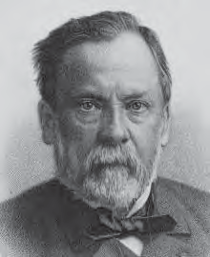

The microbiologist, Louis Pasteur developed the technique of preserving the quality of food by raising its temperature to prevent microbial growth in the food.

What is meant by adulteration of food ?

**Food is adulterated in this way too !**

1. Removal of some important components of food; e.g., removal of fat content of milk, essence of cloves, cardamoms, etc.
2. Mixing of a low quality inedible or cheaper material or a harmful colour with food.
3. Mixing of some harmful materials like small stones, fine sand, iron filings, urea, dung of horse, sawdust, etc.



**Let’s recall.**

#### Complete the following table.

|  |  |  |
| --- | --- | --- |
| **Sr. No.** | **Foodstuff** | **Adulterant** |
| 1. | Milk | ---------------- |
| 2. | Red chilly powder | ---------------- |
| 3. | ----------------- | Seeds of papaya |
| 4. | Ice cream |  |

The health of all people, young and old, poor or rich, is endangered by food adulteration. Different types of adulterants affect our health in different ways. Some adulterants cause abdominal discomfort or poisoning, while some may affect the functioning of some organs if consumed over a long period of time, or even cause cancer.

**Think a little !**

Each one of us should think about what we eat every day and about the nutritive value and quality of the food we eat.

#### How will you find out if food has been adulterated?

|  |  |  |  |
| --- | --- | --- | --- |
| **Food material** | **Adulterant** | **Test** | **Conclusion** |
| Milk | Water | Put a drop of milk on a glass slide and slightly incline it to spread the drop. | If the spread-mark of milk does not appear milky white, water must have been added to it. |
| Red chilly powder | Brick dust | Take a spoonful of chilly powder in a beaker, add water up to half of the beaker, stir it and leave it undisturbed for a few minutes. | If a red layer is seen settled at the bottom of the beaker, it must have been adulterated with brick dust. |
| Turmeric powder | Metanyl yellow | Take a pinch of turmeric powder in a test tube, add a small quantity of water to it, shake the mixture and add a few drops of conc. HCl. | The mixture becomes red on addition of conc. HCl and the red colour does not disappear if metanyl yellow is present. |
| *Rava* | Fine iron filings | Pass a magnet through the *rava*. | Iron filings adhere to the magnet. |

Watch the video-clips about food adulteration on [www.youtube.com](http://www.youtube.com/) and make an identification kit for detecting food adulteration.



**My friend, the internet !**

Collect books which give more information about food adulteration. Read and try to identify food adulteration.



**Books, my friends !**



**Do you know ?**

In 1954, Parliament passed the Prevention of Food Adulteration Act. It has been amended from time to time and the amendment of 1976, provides for ‘life imprisonment’ for the person involved in adulterating food with a harmful substance. There are clear directions that food should be properly stored, packing material should not endanger the food or medicines and there should clear and legible information on it about the manufacturing date, expiry date, and instructions for storage.



**Always remember -**

1. Some chemicals are injected into fruits to make them more attractive and tasty.
2. Milk vendors add urea to the milk so that it appears to have higher fat content.
3. Shopkeepers change the ‘Expiry date’ of the food packets and air tight containers to avoid a financial loss.
4. Calcium carbide and some other chemicals are used to make fruits look more attractive, e.g., bright yellow bananas.
5. Frequently, harmful chemicals like carbonated soda, phosphoric acid, etc. are mixed with cold drinks.



**Exercise**

1. **Complete the following statements by using the correct option from those given below.**

(Irradiation, dehydration, pasteurization, natural, chemical)

* 1. Drying the food grains from farms under the hot sun is called .......... .
  2. Materials like milk are instantly cooled after heating up to a certain high temperature. This method of food preservation is called ............ .
  3. Salt is a .................. type of food preservative.
  4. Vinegar is a .................. type of food preservative.

1. **Answer the following questions in your own words.**
   1. How is milk pasteurized ?
   2. Why should we not consume adulterated food materials ?
   3. What precautions do your parents take to keep foodstuffs safe ?
   4. How does food spoilage occur ? Which are the various factors spoiling the food ?
   5. Which methods of food preservation would you use ?
2. **What shall we do?**
3. There are vendors selling uncovered sweetmeats in open places in the market.
4. A ‘*pani-puriwalla*’ is serving the

*pani puri* with dirty hands.

1. We have purchased a large quantity of fruits and vegetables.
2. We need to protect foodstuffs from pests like rats, cockroaches, wall-

-lizards, etc.

1. **Find the odd-man-out.**
2. salt, vinegar, citric acid, sodium benzoate
3. *lakhi* dal, brick dust, metanyl yellow, turmeric powder
4. banana, apple, guava, almond
5. storing, freezing, settling, drying
6. **Complete the chart below.**
7. **Explain why this happens and suggest possible remedies.**
8. Qualitative wastage of food.
9. The cooked rice is underdone.
10. The wheat that was bought is a bit moist.
11. The taste of yoghurt is too sour/slightly bitter.
12. Cut fruits have turned black.
13. **Give reasons.**
14. Food remains safe at 5o Celsius.
15. Nowadays, food is served buffet style during large gatherings.

**Project :**

1. Go to your kitchen and take notes about the food safety measures and the food wastage you see there.
2. In a science exhibition demonstrate the various methods of detecting food adulteration.

⧫  

|  |  |  |
| --- | --- | --- |
| **S.No.** | **Foodstuff** | **Adulterant** |
| 1. | ----- | Metanyl yellow |
| 2. | Black pepper | ----- |
| 3. | ----- | Iron filings |
| 4. | Honey | ----- |



**6. Measurement of Physical Quantities**

articles and materials, shown

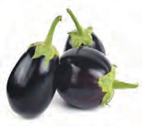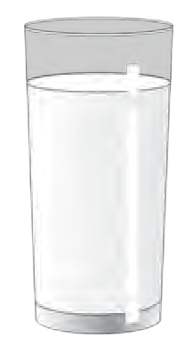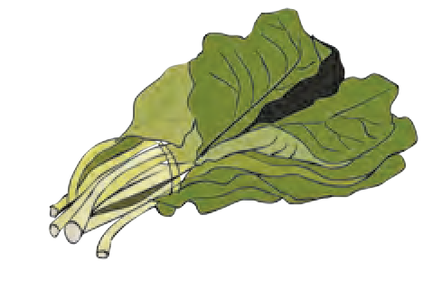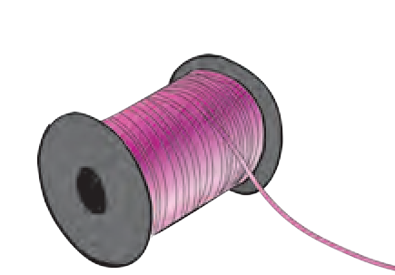

**Observe and discuss.**

How are the various in the picture measured ?

**6.1 Various articles and materials**

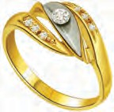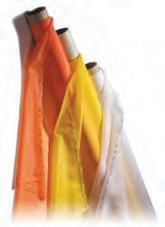

#### Physical quantity

In day-to-day life, we measure many things such as the weight of fruits, vegetables, food grains, temperature of the body or some liquids, volume of liquids, density of various substances, the speed of vehicles, etc. Quantities such as mass, weight, distance, speed, temperature, volume are called **physical quantities.**

A value and a unit are used to express the magnitude of a physical quantity. For example, Swarali walks two kilometres everyday. In this example, ‘two’ is the value and ‘kilometre’ is the unit used to express the magnitude of the distance which is a physical quantity.

#### Mass

**Scalar quantity**

A quantity that can be completely expressed by its magnitude alone is called a scalar quantity. For example, only magnitude, i.e. a value with a unit, is used to express quantities such as length, breadth, area, mass, temperature, density, time, work, etc. Thus, we say that the length of a tunnel is two kilometres, the fever (temperature) is 101o Farenheit, etc.

**Vector quantity**

The quantity that is expressed completely only when magnitude and direction are both given is called a vector quantity.

Displacement, vector quantities. displacement of

velocity

are

For example, a

20 kilometres

towards the north, the aeroplane flying at a velocity of 500 km/hr towards Mumbai.

The amount of matter present in a substance is called mass. Matter has a natural tendency to resist a change in its state, which is called inertia. **Mass** is the qualitative measure of the inertia of an object. The larger the mass, the greater is the inertia. **Mass is a scalar quantity**. It does not change from place to place anywhere in the world. The quantities mass and weight are, however, different. Gram and kilogram are the units of mass.

When we use the two-pan common balance in a shop, we compare two masses.

#### Weight

What we measure in grams, kilograms is mass, and not weight. The gravitational force that acts on this mass is called its **weight**. The gravitational force by which the earth attracts an object towards its centre is called the weight of the object. Therefore, **weight is a vector quantity**. It is different at different places on the earth.

* 1. Why would the weight of an object be maximum at the poles and minimum at the equator ?



**Use your brain power !**

* 1. Why is the weight of an object at a high altitude less than its weight at the sea-level ?

Will it be possible to use one and the same unit to measure physical quantities such as mass, weight, distance, velocity, temperature ?



**Do you know ?**

Our body has weight because of the gravitational force of the earth. The gravitational force of the moon being less, our weight will turn out to be less there. Our mass, however, is the same at both the places.

In everyday affairs, we measure many different physical quantities. As these physical quantities are different from each other a specific unit is used to measure each quantity. Therefore, different units are used while measuring different quantities.



**Try this.**

#### Standardized measurement

1. Take a ball of string. Let one student from the class measure four hand-spans of the string and cut it there. Let each of the other students in the class cut four hand-spans of the string, too. Now hold all the pieces together by one end. Are they all of the same length ?



**Always remember -**

**Prevailing systems of measurement**

1. MKS System : In this system distance is measured in metres, mass in kilograms and time in seconds.
2. CGS System : In this system distance is measured in centimetres, mass in grams and time in seconds.

In the MKS system of measurement, distance, mass, and time are accepted as the fundamental quantities. These three quantities are used to measure all other quantities.

Complete the following table.

1. Now, measure the length of a bench by means of the span of your hand. Ask your friends to do the same. Did each of you obtain the same measure for that bench ? What could be the reason ?

Standardized measures are required for measuring things. Such measures are called standard units.

We have to measure many physical quantities accurately. To measure any quantity, we use the unit specified for it.

For example, the metre (m) is the specified unit for measuring length. A certain distance has been accepted as the standard for 1.0 metre. Why is there a need for such a standard unit ? Suppose, the span of a hand is accepted as the unit for measuring length. With this unit, we can measure lengths of cloth as two hand-spans, three hand- spans, and so on. However, the lengths of the cloth measured by each one of us will come out to be different. That is why a ‘hand-span’ cannot be a standard unit for measuring length.

|  |  |  |
| --- | --- | --- |
| **Physical Quantity** | **M.K.S.** | **C.G.S.** |
| Mass | Kilogram | Gram |
| Distance |  |  |
| Time |  |  |
| Speed |  |  |

There are many physical quantities but a majority of them are related to each other. For example, you have learnt that the quantity ‘speed’ is the ratio of the quantities ‘distance’ and ‘time’.



**Try this.**

Work out the area of your classroom. Which quantities are taken into account to calculate the area ?

**Fundamental quantities :** It is enough to select a few out of the many quantities and standardize their units. You can see from the above examples, that units of the quantities length and time need to be standardized. Such quantities are called fundamental quantities and their units are called standard units. Of course, a standard fundamental unit must be available to all, and it must not be variable.

**Standards of quantities**

**the**

**fundamental**

As the standard of mass a solid cylinder made of a platinum- iridium alloy is kept in the International Bureau of Weights and Measures at Paris. As per the international agreement, this mass is called one kilogram. Official accurate copies of this prototype are kept in the

laboratories/institutes world.

Two fine lines

standardizing all over the

are engraved

on a platinum-iridium bar kept in the International Bureau of Weights and Measures at Paris. The distance between these two lines is accepted as the standard metre. Accurate copies of this prototype are made and distributed to standardizing laboratories/institutes all over the world.

The time required for one revolution of the earth is measured by means of an accurate device. This time is taken as 24 hours. To standardize one second, one hour is considered to have 60 minutes and one minute, 60 seconds.

**International system of units :** An international system of units based on seven fundamental units, called the System International (SI), is currently used all over the world. It is also called the **metric system**.

The names and symbols of the units of the fundamental quantities, length, time and mass, in this system, are given in the following table :

|  |  |  |
| --- | --- | --- |
| **Quantity** | **Name of the unit** | **Symbol of the unit** |
| Length | metre | m |
| Mass | kilogram | kg |
| Time | second | s |

1. What is an atomic clock ? Where is it kept ?



**Find out.**

1. How is the velocity of light used for determining the standard metre ?

**Great Scientists**

When man felt the need to measure things, he started by using the parts of his own body for the purpose. In Egypt in ancient times, the distance from a man’s elbow to the tip of his middle finger was called a ‘cubit’. This measure would differ from person to person. Therefore, the cubit of the King was considered as the standard. In olden times, we weighed gold in a unit called *gunj*. An ‘hour glass’ was used for measuring time. Have you seen one ?

#### Observe and discuss.

Identify the wrong methods of measurement shown in the picture and explain why they are wrong.

#### Importance of accurate measurement

**6.2 Various methods of measurement**

How accurate a measurement must be depends upon its purpose. Accordingly, an appropriate device has to be used for the measurement. Measurement of substances that are precious, of great importance and used in very small quantities, is done meticulously and accurately. Due to advancements in technology, devices that measure very small magnitudes of quantities like distance, mass, time and temperature, are available now, for example, distance and time in connection with very important sports competitions, mass of gold, body temperature, etc.

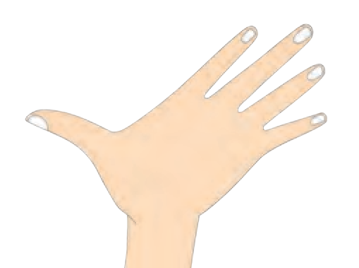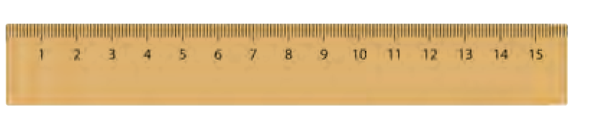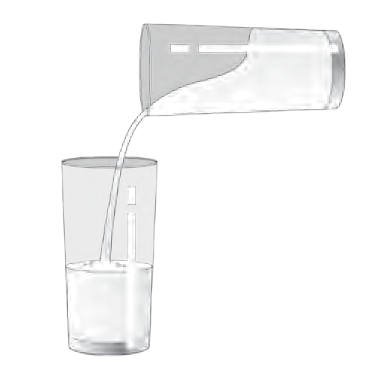

#### Major causes of errors in measurement

1. Not using the appropriate device.
2. Not using the device properly.

Make a list of possible errors other than these.

Do you really get as many litres of petrol as the petrol pump indicates ? To ensure this, it is necessary to check it against a standard measure from time to time. This is called standardization. Similarly, it is necessary to standardize the weights and measures used in the market.

While buying things at grocery shops, the vegetable market, remember to look out for the following and tell your guardians to do so, too.

1. Does the balance carry the stamp of standardisation by the department of weights and measures ?
2. Is the balance stable ? Is the pointer of the balance upright ?

To prevent consumers from being cheated, a Weights and Measures sub-division functions as part of the Food, Urban Supply and Consumer Protection Division of the Government. Officers of this sub-division visit different places from time to time, and ascertain whether the weights and balances being used are proper or not. It is binding by law to use standard weights and measures. It is also a function of the Weights and Measure sub-division to grant licences for the production, sales and repairs of weights and measures.

**My friend, the internet !**

1. www.legalmetrology. maharashtra.gov.in
2. **The standards of the six fundamental units, namely, metre, kilogram, second, Kelvin, Ampere and Candela are kept in the National Physical Laboratory at New Delhi.** [www.nplindia.org/npl-charter](http://www.nplindia.org/npl-charter)
3. Is the weight made of metal ? How is the balance held ?

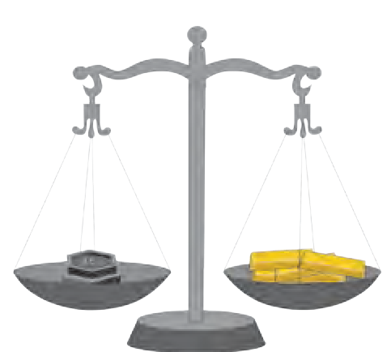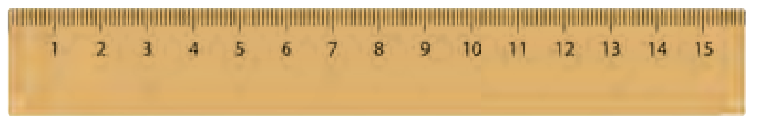

1. Has the underside of the pan of the balance been tampered with ?



**Do you know ?**

During the rainy season, you might have heard, seen and read, news regarding how much water is collecting in the dam, how much water is being released and about the present stock of water in the dam. Do you know the following terms in this connection ?

1 TMC means one thousand million cubic feet. 1 cubic foot means 28.317 litres.

1 TMC = 28316846592 litres, that is about 28.317 thousand million litres.



**My friends, newspapers**

What is the capacity of the various dams in Maharashtra ? Collect information about the discharge of water from various dams during the month of August, September and October and of the consequences of the discharge.



**Exercise**

1. **Write answers to the following questions in your own words.**
   1. Why is the weight of the same object different on different planets ?
   2. What precautions will you take to make accurate measurements in day-to-day affairs ?
   3. What is the difference between mass and weight ?
2. **Who is my companion ? Group ‘A’ Group ‘B’**
3. Velocity (a) litre
4. Area (b) kilogram
5. Volume (c) metre/second
6. Mass (d) kilogram/cubic metre
7. Density (e) square metre
8. **Explain giving examples.**
   1. Scalar quantity
   2. Vector quantity
9. **Explain, giving examples, the errors that occur while making measurements.**
10. **Give reasons.**
    1. It is not proper to measure quantities by using body parts as units.
    2. It is necessary to get the weights and measures standardized at regular intervals.
11. **Explain the need for accurate measurement and the devices to be used for that.**

**Project :**

Collect information about various physical quantities used in day-to-

-day life and the devices used for their measurement.

⧫   

**7. Motion, Force and Work**

#### Observe and discuss.

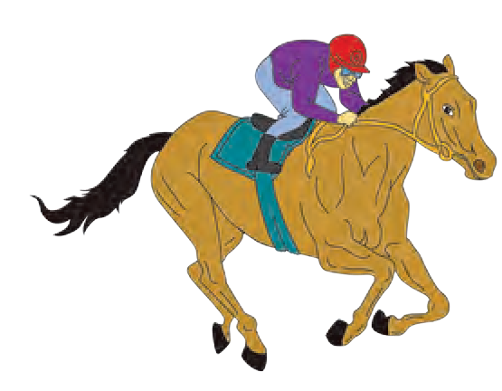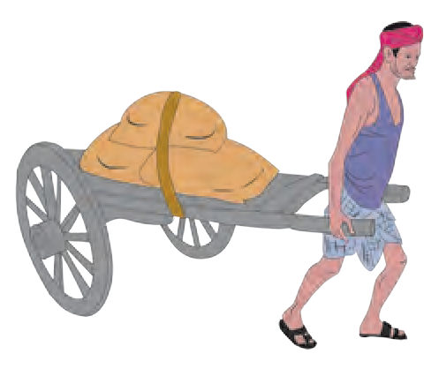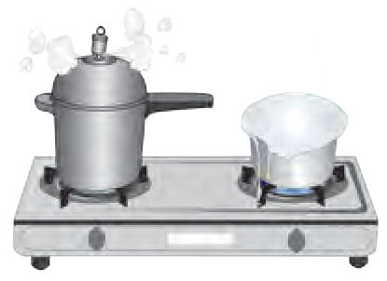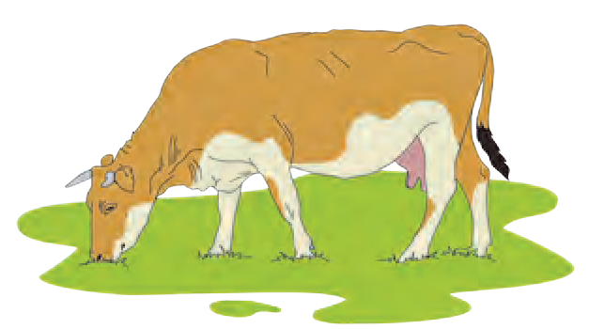

**Let’s recall.**

* 1. **Work**

What is meant by motion ?

What causes a change in motion ?

D

B

C

A

We have seen that a change occurs in the motion or the shape of a body when a force acts on it. Now let us see how work is done when a force acts.

#### Distance and displacement

Ranjit’s house is at place A. The figure alongside shows the distance traversed by Ranjit to reach his school at

D. If we do not take direction into account, we find that Ranjit traversed a distance equal to AB+BC+CD. However, on doing this, his displacement was equal to AD. Ranjit’s displacement from his house to the school is shown in the picture with the broken line AD. AD is the minimum distance along a straight line from Ranjit’s house to the school.

The minimum distance traversed in a particular direction along a straight line is called displacement.

#### Speed and velocity

1. What is meant by speed ?
2. What is the formula for calculating speed ?

When we say that the speed of a car is 40 km per hour, there is no need to specify the direction, but, to predict whether a storm will reach a particular place or not, a mention of its direction is essential.

* 1. **Distance and displacement**

**Distance :** The length of the route actually traversed by a moving body, irrespective of the direction, is called distance. Distance is a scalar quantity.

**Displacement :** The minimum distance traversed by a moving body in one direction from the original point to reach the final point, is called displacement.

In displacement, both distance and direction are taken into account. Therefore, displacement is a vector quantity.

The unit of measurement of distance and displacement is the metre, in the SI as well as in the MKS system of measurement.

**Velocity :** Velocity is the distance traversed by a body in a specific direction in unit time. The velocity of a body can

be calculated by the following formula: Velocity = Displacement

Period of time required for

the displacement

#### Let’s find the unit.

|  |  |  |
| --- | --- | --- |
| **Task** | **Speed** | **Velocity** |
| Write the formula | Speed = | Velocity = |
| Write the units of the quantities | Distance : Time period : | Displacement : Time period: |
| Insert the units instead of quantities in the formulae. You will get the unit of speed and velocity. | | |

The unit of speed or velocity is written as metres/second (m/s)

Let us now use the above formulae to find out Ranjit’s velocity and speed when he goes to school as shown in the figure 7.2.

The actual distance traversed by Ranjit from home to school

= AB + BC + CD

= 500 m + 700 m + 300 m = 1500 m.

Total time from home to school = 8 minutes + 11 minutes + 6 minutes = 25 minutes Ranjit’s displacement from home to school, AD = 1000 metres

Thus, Ranjit’s velocity when going from home to school

Velocity =

Displacement Total time

1000 metres

= =

25 minutes

40 metres = 0.66 metres/second

60 seconds

Ranjit’s speed while going to school

### Distance traversed 1500 metres 60 metres

Speed = = = = 1 metre/second

Total time

25 minute

60 seconds

Ranjit did not take the straight route of minimum distance while going to the school. Therefore, the magnitudes of his velocity and speed came out to be different. Had Ranjit actually gone by the straight route AD, then the magnitude of his velocity and speed would have been the same.

**Average velocity and instantaneous velocity :** The velocity of an object can change even while it is moving along a



straight line. Suppose that a truck is covering a distance of 40 km from A to D in a straight line. That is, its displacement will be 40 km.

A B C D

10 km 10 km 20 km

* 1. **Displacement**

If it requires altogether 1 hour for this, its average velocity is 40 km/hour. However, if the truck traverses the 10 km distance AB in 10 minutes, BC in 20 minutes and CD in 30 minutes, then

10 km

Velocity for the distance AB in km/hr =

= 60 km

= 60 km /hr

10 minutes 60 minutes

Now deduce the velocities for the distances BC and CD. We see that the velocity of the truck is different in the different segments of the road AB, BC and CD. However, the average velocity for the entire route AD is 40 km/hour. The velocity at a particular moment of time is called instantaneous velocity. The instantaneous velocity can be different at different times.

#### Acceleration

In the previous example, the truck covered the distance AB at the velocity of 60 km/hour, BC at 30 km/hour and CD at 40 km/hour. It means that the velocity for the distance CD is greater than the velocity for the distance BC.

Change in velocity

Acceleration =

Time taken for change

From the number of seconds required for this change in velocity to take place, the change in velocity per second can be deduced. This is called acceleration. What is the cause of acceleration?

You know that the truck driver increases or decreases the velocity of the truck by means of the accelerator. You might have seen a toy car that runs on a clockwork spring. When it is released on a flat floor, after winding up the spring, it goes in a straight line. However, when it is hit on one side, it changes direction and keeps going. If it collides into a wall, it stops. It means that its velocity changes. How did this change take place? It happens because the car comes into contact with something external to it. On a football ground, how does the direction of the ball moving in a straight line, change ? We see some player changing its direction by kicking it. When its direction changes, the velocity of the ball changes, that is to say, an acceleration takes place. The interaction that brings about the acceleration is called force. Force acts on a body.

#### Force and accleration

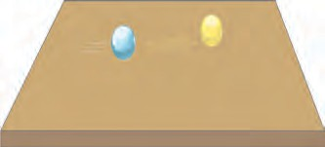



**Try this.**

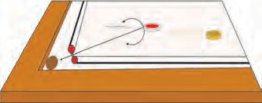

* 1. **Force and acceleration**

The unit of acceleration is m/s2. Verify this.

Take a glass marble and let it roll on a big smooth tabletop. After some time its velocity will decrease and it will stop. On a carrom board, too, the carrom coin, pushed by a striker will move forward some distance, and then come to a stop. If the coin is pushed after applying talcum powder to the carrom board, it will keep moving for a longer time and then come to a stop.



**Use your brain power !**

What can we infer from this ?

The velocity of the coin decreases due to the force of friction, and the coin stops. If the friction between the carrom board and the coin is reduced, the coin keeps moving for a longer time. It would mean that, if no force of friction is acting on a moving body, it will keep on moving with a constant velocity.

The scientist Sir Isaac Newton was the first to study force and the resulting acceleration.

**Newton’s First Law of Motion :** If no force is

acting on a body, its velocity does not change, i.e. the body does not accelerate. In other words, if a body is stationary, it will remain stationary. If it is in motion, it

will continue moving with the same velocity and in the same direction.



**Use your brain power !**

Acceleration is a vector quantity. Is force a vector quantity, too ?

You have learnt what is meant by force. You have seen that a body is accelerated due to force. Suppose, you place the 1 kilogram standard weight (See the chapter on ‘Measurement’.) on a surface with no friction and pull it with an acceleration of 1m/s2, the force applied is called 1N (1 Newton).



**Try this.**

Place a weight of 1 kilogram on a smooth wooden table. Spread some talcum powder evenly on the table. Now pull the

1 kg weight with an acceleration of 1 m/s2. Again pull it with an acceleration of 2m/s2. It means that, now, you have applied a force of 2N. You will have to take many trials for this experiment.

Force is measured by the acceleration that it produces.

We have learnt about the relationship between the displacement of a body resulting from the force applied to it and the work done. We have also learnt about the work-energy relationship and that the ability to do work is called energy.

#### Force, displacement and work

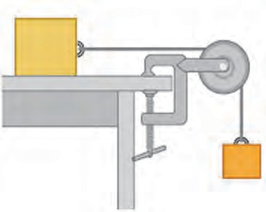

**Wooden block**

**Pulley**

**Weight**

In the figure alongside, a string, attached to a wooden block on a table, is passed over a pulley and tied to a weight. On applying a sufficient weight, the block will be seen to move.

Which force is being applied here ? How can this force be increased ? What will happen on applying more force ? When can we say that work

is done by the applied force ?

* 1. **Work**

If the block moves forward, we can say that it has been displaced. Due to the displacement, we say that the force has done some work. Can we measure this work ? We know that work done depends on the force and the displacement.

The following formula expresses this relationship : Work (W) done by the force = force (F)

If a force of 1N parallel to the surface of the table is applied to a wooden block on the table, and the block is displaced by 1 metre, then it can be said that the force has done 1 Joule of work. In this example,

displacement is in

the the

direction of the force.

applied to the body 🞨 displacement (s) of the

body that takes place in the direction of the force, W = F 🞨 s

In the SI system, the unit of work is Joule (J), while the unit of force is Newton (N) and the unit of displacement is metre (m). In the CGS system the unit of work is erg.



**Exercise**

1. **Fill in the blanks with the proper words from the brackets.**

(stationary, zero, changing, constant, displacement, velocity, speed, acceleration, stationary but not zero, increases)

* 1. If a body traverses a distance in direct proportion to the time, the speed of the body is ............... .
  2. If a body is moving with a constant velocity its acceleration is .......... .
  3. .............. is a scalar quantity.
  4. ............. is the distance traversed by a body in a particular direction in unit time.

1. **Observe the figure and answer the questions.** C
2. **A bird sitting on a wire, flies, circles around and comes back to its perch. Explain the total distance it traversed during its flight and its eventual displacement.**
3. **Explain the following concepts in your own words with everyday examples : force, work, displacement, velocity, acceleration, distance.**
4. **A ball is rolling from A to D on a flat and smooth surface. Its speed is 2 cm/s. On reaching B, it was pushed continuously up to C. On reaching D from C, its speed had become 4cm/s. It took 2 seconds for it to go from B to C. What is the acceleration of the ball as it goes from B to C ?**
   1. 3 km
   2. 3 km

A D

D 3 km E B C

4 km

5 km



Sachin and Sameer started on a motorbike from place A, took the turn at B, did a task at C, travelled by the route CD to D and then went on to E. Altogether, they took one hour for this journey. Find out the actual distance traversed by them and the displacement from A to E. From this, deduce their speed. What was their velocity from A to E in the direction AE ? Can this velocity be called average velocity ?

1. **From the groups B and C, choose the proper words, for each of the words in group A.**

|  |  |  |
| --- | --- | --- |
| A | B | C |
| Work | Newton | erg |
| Force | Metre | cm |
| Displacement | Joule | dyne |

1. **Solve the following problems.**
2. A force of 1000N was applied to stop a car that was moving with a constant velocity. The car stopped after moving through 10m. How much is the work done ?
3. A cart with mass 20 kg went 50m in a straight line on a plain and smooth road when a force of 2N was applied to it. How much work was done by the force ?

**Project :**

Collect information about the study made by Sir Isaac Newton regarding force and acceleration and discuss it with your teacher.

⧫  

**8. Static Electricity**

Do you have experience of the instances given below ? What is the cause of these effects ?



**Let’s recall.**

* 1. A plastic comb or ruler rubbed on dry hair attracts pieces of paper.
  2. If we pass near a polyester curtain again and again, it gets attracted towards us.
  3. If we rub a blanket with our hands and take it near a metal object, a spark is seen in the dark.

Do you know of other such instances ?

#### Electric charge

What do the above observations tell us ? These examples are just a glimpse of the ‘electric charge’ that all objects in our surroundings hold in abundance. Electric charge is stored even in our own bodies. All substances are made of very tiny particles. Electric charge is an intrinsic property of these particles. Though, in this way, electric charge is abundantly present, it is always in a hidden state. This is because two opposite types of charges are present in equal numbers in all these substances. When the positive charge (+) and negative charge (-) on an object are balanced, the object is neutral, i.e. there is no net charge on the object. If these charges are not balanced, the object is said to be ‘charged’.

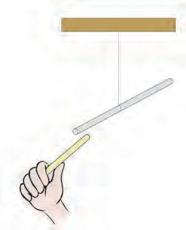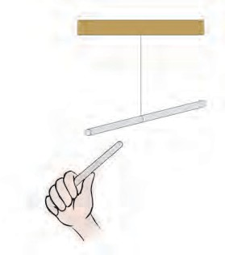

How would two charged objects interact with each other ?



**Try this.**

Rub one end of a glass rod against a silk cloth. Due to the rubbing a small charge will get transferred from one object to the other. As a result both the objects will become somewhat charged. Suspend this rod freely in air with the help of a thread. Now charge another glass rod in the same manner and bring it near the suspended rod. What do you see ? The two rods push each other away. Now take a plastic rod. Rub one of its ends against a woollen cloth. Bring that end near the suspended glass rod. Now what do you see ? The two rods are pulled towards each other.

What did you find in the first experiment ? Two rods carrying similar charges push each other away. This is called **repulsion**. We learn from the second experiment that rods carrying opposite types of charges get pulled towards each other. This is called **attraction**.

**Glass rod**

A

**Glass rod Plastic rod**

B

* 1. **Repulsion and attraction**

The scientist Benjamin Franklin named the electric charges positive charge (+) and negative charge (-).

#### What is the origin of an electric charge ?

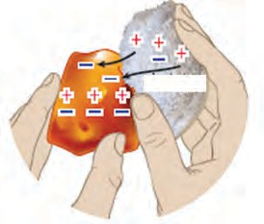

**Friction**

All substances are made up of particles, and these particles are ultimately made up of very tiny atoms. We shall be looking at the details of atomic structure later. At this stage, it is sufficient to know that each atom contains a stationary positive charge and moving negative charges. These two charges being perfectly balanced, an atom is electrically neutral.

All objects are made up of atoms, which means that they are electrically neutral. Then, how do objects become electrically charged ?

For some reason, the balance of electrically neutral atoms gets disturbed. For example, when certain objects are rubbed against each other, the negatively charged particles on one object go to the other object. The object to which they go, becomes negatively charged due to an excess of negatively charged particles. Similarly, the object from which the negatively charged particles go away becomes positively charged due to a deficiency of negatively charged particles. It means that, of the two objects

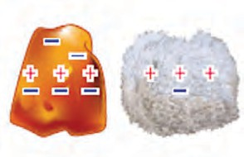**Negative charge**

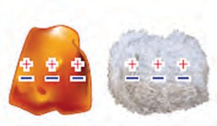

**Neutral**

**Positive charge**

being rubbed, one becomes positively charged and the other, negatively charged.



* 1. **Electric charge**

#### Try this.

**Materials :** Paper, polythene, nylon cloth, cotton cloth, silk cloth, etc.

**Procedure :** First take the objects mentioned in the chart near some small pieces of paper and observe what happens. Then rub each of these objects in turn against one of the given materials and take it near the pieces of paper. Record your observations in the chart.



**Always remember -**

Each atom is electrically neutral. It has equal amounts of positive and negative charge. If for some reason, the negative charge decreases, the atom becomes positively charged.

|  |  |  |
| --- | --- | --- |
| **Material used for rubbing: ....................** | | |
| Object | Whether paper pieces get attracted ?  Yes / No | Does the object get charged ? Yes / No |
| 1. Balloon |  |  |
| 2. Ball pen refill |  |  |
| 3. Eraser |  |  |
| 4. Wooden ruler |  |  |
| 5. Steel spoon |  |  |
| 6. Copper strip |  |  |



**Use your brain power !**

Repeat this procedure with each of the given

materials.

Do all objects get charged by rubbing ?

#### Do you know ?

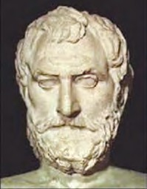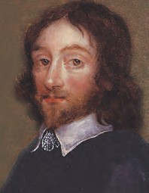

About 2500 years ago a Greek scientist named Thales found that feathers are attracted towards a rod of yellow coloured amber which had been rubbed against a woollen cloth. Amber is called ‘elektron’ in the Greek language. Therefore, this property of amber to attract things was named ‘electricity’ by Thomas Browne in 1646 A.D.

#### Frictional electricity

**Thales Thomas Browne**

The electric charge generated by friction is called frictional electricity. This charge is produced only at the place of friction. Hence, it is called static electricity. It remains on the object for a short duration. The charges of static electricity are absorbed in moist air. That is why these experiments should be performed in dry weather, particularly in winter.



**Try this.**

**Apparatus :** A few straws, woollen cloth (socks or gloves), glass bottle.

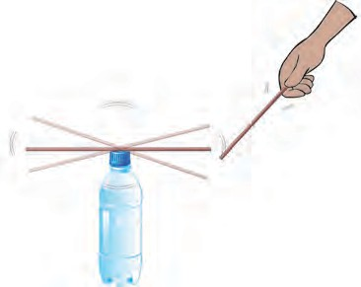

**Procedure :** Place a straw on a bottle. Take another straw near it. Observe what happens. Leave the straw on the bottle as it is. Rub the other straw against a woollen cloth and take it near the straw on the bottle. Observe what happens. Now take two straws and rub them against woollen cloth at the same time. Keep one of the straws on the bottle and take the other near it. See what happens. Keep the rubbed straw on the bottle as it is. Take the woollen cloth on

which it was rubbed, close to it.

* 1. **Changes in the straw**

#### Record your observations in each of the above procedures in the chart.

|  |  |  |
| --- | --- | --- |
| **Procedure** | **Repulsion / Attraction** | **Inference** |
| A charged straw is taken near the uncharged straw. |  |  |
| Two straws carrying similar charges are brought near each other. |  |  |
| A charged straw and the oppositely charged cloth which was used for rubbing are brought near each other. |  |  |

**Electrically charged objects attract uncharged objects. There is repulsion between like electric charges. There is attraction between unlike electric charges. Hence, repulsion is used as a test for identifying an electrically charged object.**

Take thermocol balls or mustard seeds in a bottle and shake the bottle vigorously. The seeds try to move away from each other, but stick to the bottle. Why does this happen ?



**Observe and discuss.**



**Try this.**

* + 1. To charge an object by contact.

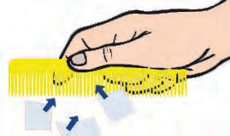

Rub a plastic comb against paper. Touch this comb with another uncharged comb. Take the other comb near some pieces of paper. What happens?

* + 1. To charge an object by induction.

Rub a comb or a balloon on your hair. As shown in the picture, take the comb near a thin trickle of water from a tap. See what happens. Now draw the comb away from the trickle and observe what happens.

#### Mark your observation with a tick (✓) :

* + - 1. When the charged comb is brought close to the flowing water, water gets attracted/repelled/ remains as it was.
      2. When the charged comb is taken away from the flowing water, it gets attracted/repelled/remains

**Comb**

**Pieces of paper**

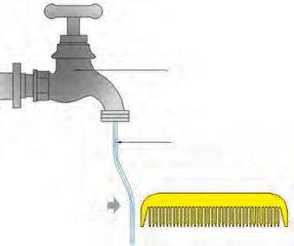

**Tap**

**Flowing water**

**Comb**

as it was, initially.

* 1. **Generation of electric charge**

At first, the flow of water is not charged. When a negatively charged comb comes near the flowing water, the negative particles in it nearest the comb are pushed away. That part becomes positively charged due to a deficiency of negative charge. The comb has negative, and the water has positive charge. Due to the attraction between these opposite charges, the flowing water is attracted towards the

comb. When the comb is taken away, the negative particles in the flowing water come back to their original position and positive and negative charges become equal in number. As



**Use your brain power !**

a result, the water becomes uncharged again, and stops getting attracted to the comb, as it is away from it.

Why does a charged

balloon stick to a wall ?



**Always remember -**

1. The number of positive and negative charges are equal on an uncharged or neutral object.
2. The electric charge generated by induction stays only as long as the charged object is near to it.

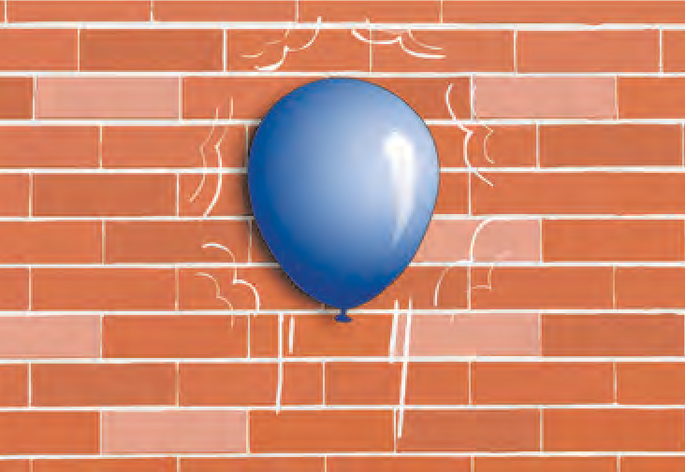

* 1. **A balloon sticking to a wall**
     1. Keep a spent tubelight in a dark place. Rub it vigorously with a thin polythene bag. What happened ? Why ?



**Try this.**

* + 1. When an uncharged aluminium ball is brought near a negatively charged balloon, the following things happen.

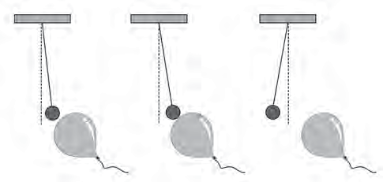

e

**Balloon**

**Aluminium ball**

* As shown in figure A, an opposite charg is generated in the other object by induction and both the objects get attracted to each other.
* As shown in figure B, on touching, both the objects become similarly charged.
* As seen in figure C, the like charges repel each other.

**a b c**

* 1. **Effects of electric charge**

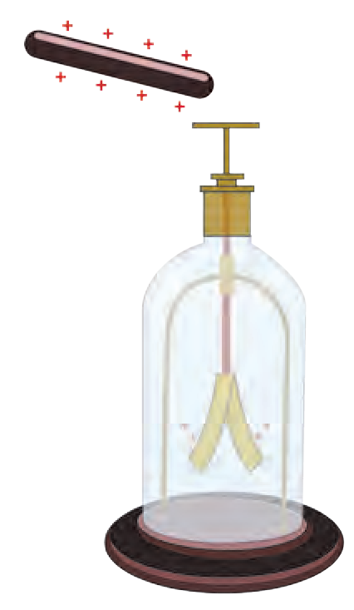

**Gold leaf electroscope**

This is a simple device to detect the electric charge on an object. It consists of a copper rod which has a metal disc at the upper end and two thin gold leaves at the other end. The rod is placed in a bottle so that the disc is above the bottle. When an uncharged object is taken near the disc, the leaves remain closed. When a charged object is taken near the disc, both the leaves are charged by the same electric charge, and repel each other, i.e. move away from each other, or open up. When we touch the disc with our hand, the leaves collapse, because the charge in the leaves goes into the earth through our body, and the leaves get discharged.

#### Great Scientists

Can we use leaves of some other metal instead of gold, in the electroscope ? Which properties must that metal have ?

In the year 1752, Benjamin Franklin conducted an experiment of flying a kite with his son William. The kite was made using silk cloth, deodar wood and a metal wire. The metal wire was joined in such a way that its one end was at the top of the kite and the other end was joined to the string of the kite. There was lightning in the sky on the day they flew the kite. When the metal wire touched the clouds, the electric charge got transferred from the clouds to the kite. Then the loose string of the kite became taut and the electric charge

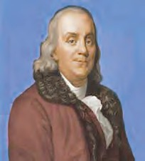

**Use your brain power !**

reached the earth through the string. A spark was seen where the string touched the earth. Thus, he showed that lightning is a form of electric charge.

#### Atmospheric electric charge

We have experienced clouds, thunder and lightning. Sometimes we hear or read that lightning struck a tree or a building and some people or animals were killed. How does this happen ? How can we prevent such injury or death ?

What is it that actually happens when there is lightning in the sky and when lightning strikes the earth ?

#### Lightning

Where air and clouds rub against each other in the sky, the upper part of some clouds on the upper side becomes positively charged and the lower sides become negatively charged.

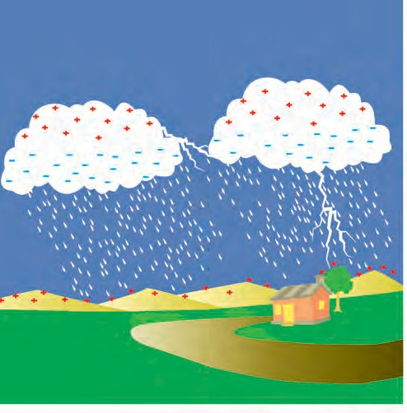

* 1. **Lightning**

The science behind lightning and a lightning strike is complicated. Let us, therefore, consider a cloud in the sky with a negatively charged base above a plain ground. When this negative charge on the bottom of the cloud becomes much larger than the charge on the ground, it starts flowing towards the ground in stages. This happens very fast, in much less than a second, and heat, light and sound energy are produced along with the electric current.

#### A lightning strike

You probably know that, when there are electrically charged clouds in the sky electricity is attracted towards a tall building or tree. When lightning strikes, an opposite electric charge is generated on the roof of a building or on the top of a tree by induction. Due to the attraction between the opposite charges on the cloud and the building, the charge on the cloud flows towards the

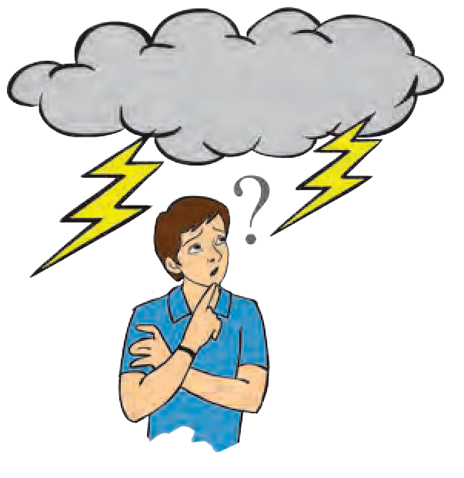

building. This is called a lightning strike.



**Use your brain power !**

1. What kind of damage is caused by a lightning strike ?
2. What measures will you take to prevent the damage caused by lightning ?

#### Do you know ?

* 1. Due to the tremendous heat and light generated by lightning, a chemical reaction occurs between nitrogen and oxygen in the air and nitrogen oxide gas is formed. It mixes with the rain water, comes down to the earth, and supplies nitrogen to the soil thus improving its fertility.
  2. Due to the energy of the lightning, the oxygen in the air is converted into ozone. This ozone gas protects us from the harmful ultra violet rays coming from the sun.

#### Lightning conductor

The lightning conductor is a device used for protection from a lightning strike.

It consists of a long copper strip with one end forked. This end is at the highest part of the building. The other end of the strip is connected to a plate of cast iron. A pit is dug in the ground, coal and salt are filled into the pit and the iron plate is placed upright in the pit. There is also a provision for pouring water into it. This helps to spread the electric charge quickly into the ground and prevent damage.

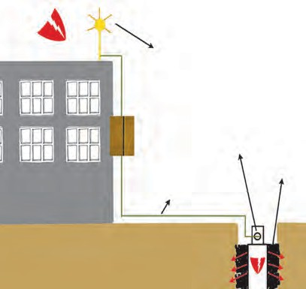

**Tip/End**

**Cast iron Coal plate**

**Copper strip**

**and salt**

* 1. **Lightning conductor**

Whenever an electrically charged cloud passes over the building, the electric charges flowing towards the building are conducted into the ground through the copper strip, and damage to the building is prevented. When such a lightning conductor earthing is fixed on a tall building, the surrounding area is also protected from lightning. You will get more information about how to get protection from lightning in the lesson on disaster management.

* + 1. Why is the upper end of the lightning conductor pointed ?



**Use your brain power !**

* + 1. Why are coal and salt added to the pit in the ground ?



**Exercise**

1. **Choose the correct option and fill in the**

**blanks.**

**(always repulsion, always attraction, displacement of negative charge, displacement of positive charge, atom, molecule, steel, copper, plastic, inflated balloon, charged object, gold)**

* 1. There is ……… between like charges.
  2. is responsible for generation

of electric charge in an object.

* 1. A lightning conductor is made of a

… strip.

* 1. does not get electrically charged

easily by rubbing.

* 1. There is …………… when opposite electric charges come near each other.
  2. A ............... can be detected with an electroscope.

1. **Explain why it is not safe to go out with an umbrella when there is heavy rain,**

**lightning or thunder.**

1. **Answer in your own words.**
   1. How will you protect yourself from lightning ?
   2. How are charges generated ?
   3. In the lightning conductor, what provision is made for spreading the electricity into the ground ?
   4. Why do farmers stick an iron staff into the ground while working in the field in rainy conditions ?
   5. Why is lightning not seen everyday during the rainy season ?
2. **What are the characteristics of a static electric charge?**
3. **What is the damage caused by lightning? How will you create awareness to prevent it ?**

**Project :** Make an electroscope yourself by using a thin aluminium foil and check which substances become

electrically charged.

57

⧫  

#### Observe and discuss.

# Heat

What are the causes of what you see happening in the pictures below ? Write in the boxes.

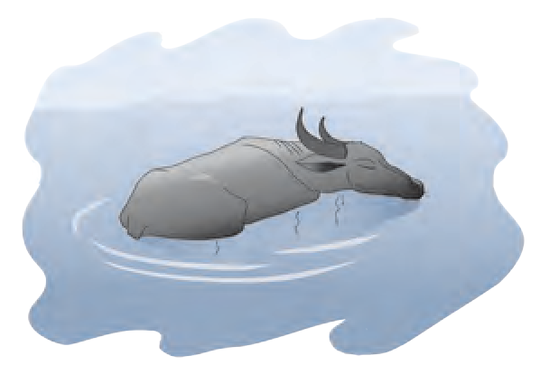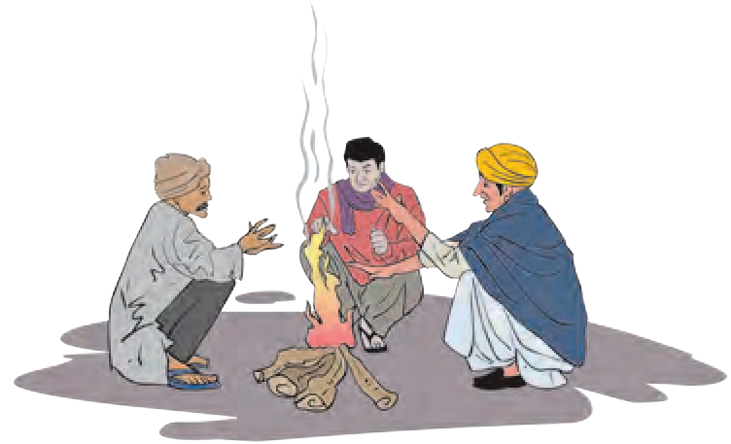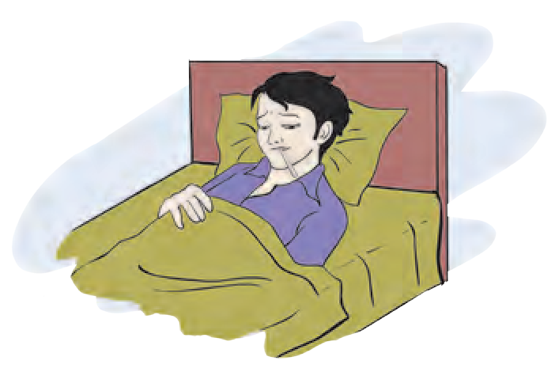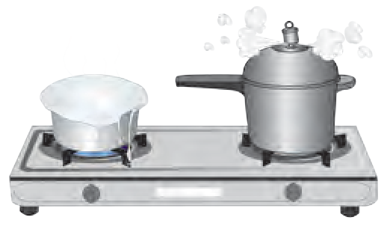

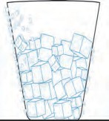

#### Try this.

* 1. **Various events**

Rub your palms against each other and put them on your cheeks. What do you feel ?



We come to know some properties of heat energy from the examples in the pictures and the above activity. The sun’s heat has many effects and uses. How does the solar heat reach the earth ? Why does the heat in the water heated to boiling slowly decrease once it is taken off the flame ? Where does this heat go ? The moisture in the air cools down due to the ice cubes in the glass and collects on the outside of the glass. A thermometer is used to measure the temperature of a substance. We have already studied the changes in the state of matter, caused by heat.

#### Transfer of heat

* + 1. Why does the *halwai* wrap up cloth around the end of his slotted spoon while stirring the boiling milk in his large *kadhai* ?



**Can you tell ?**

* + 1. Why do we hold a steel glass in a handkerchief while drinking hot milk from it ? What are other examples of this kind ? Make a note of them.

When we take a hot object in the vicinity of a cold one, the cold object becomes warm and the hot one becomes cooler. From this, we can infer that heat is transferred from a hot body to a cold body.

Transfer of heat means the flow of heat from one place to another.



**Use your brain power !**

Why do we wear woollen clothes in winter ?

#### Modes of heat transfer : Conduction, convection and radiation

**Apparatus :** Bars of stainless steel, aluminium and copper, a candle, a burner, pins, etc.



**Try this.**

**Procedure :** Take stainless steel (or iron), copper

**spots of wax**

**Burner**

**Pins**

**Metal strips**

**Tripod**

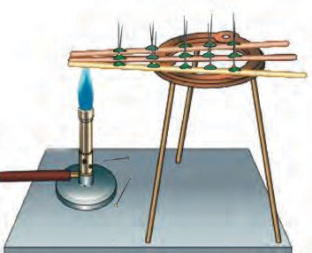

and aluminium bars, each about 30 cm long and having the same shape. Apply wax spots with the help of candle at a distances of 2 cm from each other on all the three bars. Stick a pin in each of these spots so that it is upright. Now insert the ends of all three bars into a flame at the same time. Observe for a while.

What do you see ? From which bar do the pins start falling first ? Why ?

Pins fall starting from the end near the burner. It means that transfer of heat takes place from the hot

* 1. **Conduction of heat**

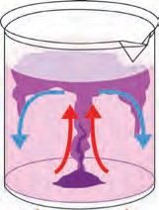

end of the bar to the cold end. This transfer of heat from the hot part of an object to the cold part, is called **conduction** of heat.

The pins on the copper bar start falling first. The pins on the steel bar fall comparatively late. Heat is conducted quickly through copper. Conduction of heat through a substance depends on the property of that substance. That conduction of heat takes place through a solid substance, shows that a medium is required for the conduction of heat.

#### How does the transfer of heat take place through

**Beaker**

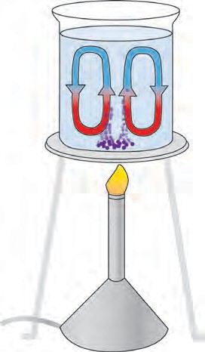

**Stream**

#### a liquid ?

**Apparatus :** a beaker, potassium

**Crystals of**

**potassium permanganate**

**Burner**

* 1. **Convection of heat**

**Convection can occur in liquid and gaseous substances. Convection needs a medium.**

permanganate crystals, a burner, water, etc.

**Procedure :** Take some water in a beaker. Heat the beaker slowly on a gas burner. Drop a few crystals of potassium permanganate into the water. Now watch the water in the beaker carefully. What do you see?

You will see streams of water going upwards and coming back to the bottom. Due to the potassium permanganate, these magenta coloured streams can be identified easily. When heating begins, the water near the bottom becomes warm and its density decreases. As a result, it moves upwards and is replaced by cold water coming from above. In this manner, heat is transferred by means of currents, called convection currents.This process is called **convection of heat**.

**Apparatus :** a test tube, a piece of ice, wire gauze, a burner, a candle, etc.

**Procedure :** Take some water in a test tube. Wrap a piece of ice in a wire gauze and drop it in the test tube. It will sink to the bottom. Now, using a test tube holder, hold the test tube at a slant, as shown in the figure. Heat the upper part of test tube. Stop heating when the water starts boiling. Observe the piece of ice at the bottom. The heat does not reach the bottom even though the upper part is heated. How does this happen ? The density of water decreases due to heating. Therefore, it cannot sink and the

**Boiling water Ice**

**wrapped in wire gauze**

**Test tube holder**

**Burner**

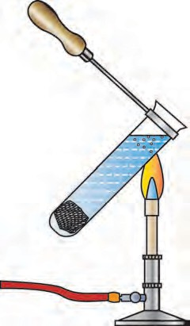

process of convection does not occur.

**Procedure :** Light a candle and stand it upright. Hold your hands on its two sides at some distance from the candle. Bring them closer. What do you feel ? Have you warmed yourself near a bonfire or in the morning sun in winter ? The sun is millions of kilometres away from us. There is no air between the sun and the earth and the earth’s atmosphere is only a thin layer of air close to the earth. Then, how does the heat of the sun reach us ? This heat is transferred in the absence of any medium. The

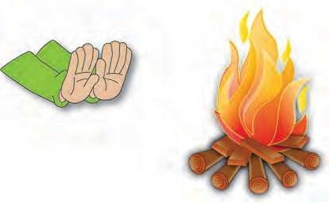

* 1. **The relation between density and convection**
  2. **Radiation**

transfer of heat that takes place in this way, without a medium, is called radiation. In the two examples above, heat reaches us mainly by **radiation**.

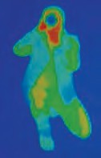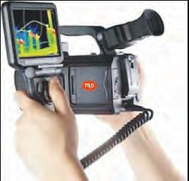

**A wonder of science :** Radiation of heat takes place from many objects in nature such as trees, mountains, stones and roads. A camera has been developed which uses these radiations to make our surroundings visible at night. It is called an infrared camera. Using this camera, it is possible to keep a watch on the movements of the enemy during the night.

When heat rays fall on an object, a part of the heat is absorbed by the object and a part of it is reflected. The ability of a substance to absorb heat radiation depends on its colour and also its intrinsic properties.

**Apparatus :** Two aluminium tins of the same size, two small glasses, water, thermometers, black paint, etc.



**Let’s try this.**

**Procedure :** Paint the outer surface of one tin with black paint, and let it dry. Then in both tins, place one glass, each filled with water at the same temperature. Cover the tins with lids. Keep them in the sun for two hours. Now measure the temperature of the water in the glasses in the two tins. What is the reason for the difference in the temperature ?

#### Good and bad conductors of heat

Place a steel spoon, a copper strip or rod, a divider from your compass box, a pencil and a plastic ruler in a glass beaker. Pour hot water (heated upto 600-700C) into the beaker. Wait for a while. Then touch the outer end of each of the objects. Record your observations in the table below.

|  |  |
| --- | --- |
| **Object** | **How hot is the outer end ?**  **(very hot, hot, warm, as cool as the atmosphere)** |
|  |  |

#### What inference will you draw from this ?

Some substances are good conductors of heat while some are bad conductors of heat. Heat is easily conducted through a copper strip or pot, but not through plastic or wood.

We can hold a glass tumbler or china cup full of hot tea easily in our hand, but not so a steel or copper cup if the same tea is poured into them.

Why do we use white clothes in summer and dark or black clothes in winter ?



**Use your brain power !**

#### Expansion and contraction of a solid substance due to heat



**Let’s try this.**

**Apparatus :** a metal ring, a metal ball, a burner, etc.

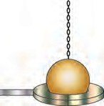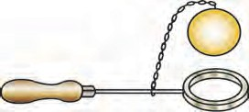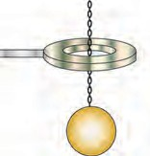**Activity :** Take a metal ring and metal ball of such size that the ball just passes through the ring. Heat the ball and check whether it passes through the ring. Now let the ball cool down, and check whether it passes through the ring.

The above experiment tells us that metals expand on heating and contract on cooling. Solids expand due to heat and come back to

the original state if heat is removed. However,

**Before heating**

**After heating**

the extent to which different solids expand is different.

* 1. **Expansion and contraction of a solid substance**

Why is there a gap at the joints of rails and of cement concrete bridges?



**Use your brain power !**

#### Expansion and contraction of liquids due to heat

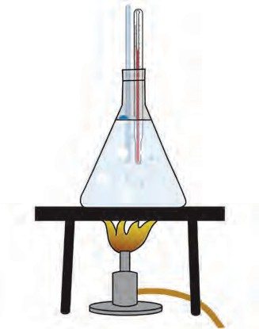

**Hollow glass tube**

**Thermometer**

**Conical flask**

**Water**

**Stand**

**Apparatus :** 500 ml conical flask, two-holed rubber stopper, glass tube, measuring ruler, thermometer, stand, wire gauze, burner, graph paper, etc.

**Procedure :** Fill the conical flask completely with water. Insert the glass tube and the thermometer in the two holes of the stopper and fit it to the conical flask. Heat the water and with the help of the ruler, record the water level in the glass tube after every 2C rise in

temperature. Take about 10 readings. Observe what happens when heating is stopped. Draw a graph to show the change in water level as the temperature rises.



**Use your brain power !**

Why is mercury or alcohol used in a thermometer ?

When a liquid is heated the distances between its particles increase and its volume too increases. This is called the expansion of liquids. When its temperature falls, the liquid contracts.

**Expansion and contraction of gases due to heat Apparatus :** Glass bottle, balloon, hot water, etc.

**Procedure :** Fix a balloon on the mouth of a glass bottle. Hold this bottle in hot water. What happens ?

The volume of a gas increases on heating. This is called expansion of the gas. On the other hand on removing heat, the volume of the gas decreases. This is called contraction of the gas.

#### Thermos flask (Dewar Flask)

You might have seen a thermos flask used for keeping tea, coffee, milk, etc. hot or a sherbet cold for a long time. What is its structure and how does it function ?

This is a double-walled flask. Its consists of two glass tubes, one inside the other with the gap between them sealed. The surfaces of both the tubes are made shiny by a silver coating. The air between the two tubes

* 1. **Expansion and contraction of a liquid**

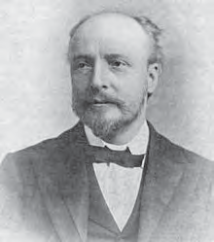

**Great Scientists**

Sir James Dewar was a Scottish scientist. He made the first thermos flask in 1892. That is why it is called Dewar flask. Even today, a Dewar flask is used for keeping a substance cold or hot.

is removed to create a vacuum. There is a protective jar of metal or plastic outside the tubes. For the protection of the flask, pieces of sponge or rubber are fixed between the outer jar and the flask.

**Function of the thermos flask :** When a hot substance is placed in a thermos flask, the heat going out gets reflected due to the shining surface of the inner tube. Hence, heat is not radiated. Neither conduction nor convection of the heat occurs because of the vacuum. As a result, heat is not transferred to the outer cooler region and is retained inside for a long time. Still, a little heat is lost from around the lid and by a small amount of conduction through the glass. Therefore, the hot substance does not remain as hot after two or three hours.

**Hot or cold liquid**

**Sponge**

**Silvered surface of the glass**

**Spring**

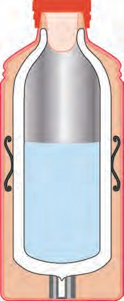

**Metal/ plastic jar**

**Vacuum Rubber support**

What is meant by thermoware ?



**Find out.**

* 1. **Thermos flask**



**Exercise**

1. **Fill in the blanks with the proper word from the brackets.**

(radiation, white, conduction, blue, convection, bad conductor, good conductor, black, reflection)

* 1. Maximum heat is absorbed by a

….…. coloured object.

* 1. ………… of heat does not require a medium.
  2. Conduction of heat takes place through a substance.
  3. The shining surface in a thermos flask decreases the outgoing heat by

....... .

* 1. Cooking utensils are made from metals due to their property of …….
  2. The earth receives heat from the sun by ................. .

1. **What will absorb heat?**

Steel spoon, wooden board, glass vessel, iron griddle (*tava*), glass, wooden spoon, plastic plate, soil, water, wax

1. **Write answers to the following questions.**
   1. How does a fever get lowered by putting a cold compress on the forehead of a patient ?
   2. Why are the houses in Rajasthan painted white ?
   3. What are the modes of heat transfer ?
   4. Explain which mode of heat transfer causes sea breezes and land breezes.
   5. Why is the outer coat of the penguins of Antarctica black ?
   6. Why are heaters fitted near the floor and air conditioners, near the ceiling of a room ?
2. **Give scientific reasons.**
   1. An ordinary glass bottle cracks when boiling water is poured into it, but a borosil glass bottle does not.
   2. The telephone wires which sag in summer become straight in winter.
   3. Dew drops form on the grass, in winter.
   4. In winter, why does an iron pillar feel colder than a wooden pole ?

**Project :**

Make a note of the various examples of heat transfer seen in day-to-day life.

⧫  

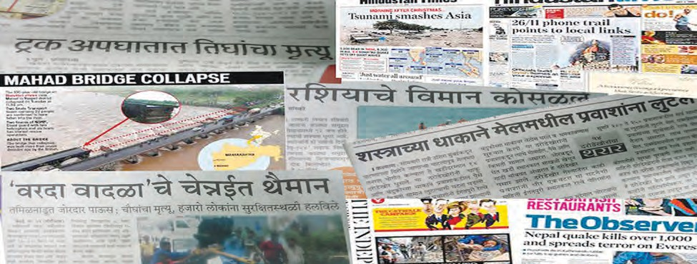

**10. Disaster Management**

**Observe and discuss.**

* 1. **Various news items about disasters**



**Can you tell ?**

* + 1. Is it possible to prevent the loss of life caused by lightning ?
    2. What should be done to prevent the bunds on a farm from getting washed away in the rainy season ?

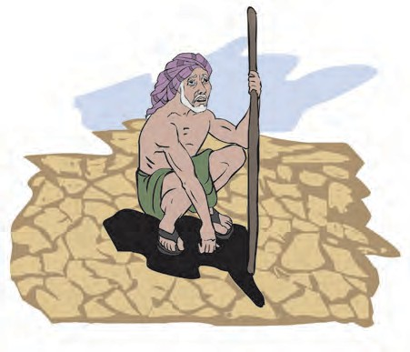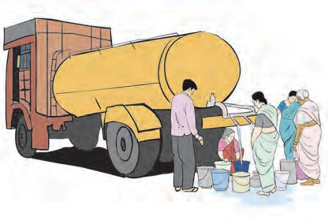

* + 1. Why do we experience water-scarcity ? We have studied two types of disasters,

namely, manmade and natural disasters. Into

which categories do the disasters shown in the news items above, fall ?

We can prevent certain disasters, while it is necessary to take precautions in the case of some other disasters. Natural and manmade disasters are related to each other.

Natural disasters such as famine, lightning strikes, cloudbursts, storms, etc. occur due to changes in the weather. There is the possibility of damage to property in such natural calamities. Who is to be held responsible for that ? What can we do to deal with these losses ?

#### Famine

The condition that arises due to long term

* 1. **Famine, water scarcity**

and severe scarcity of foodgrains and water is

called famine. Famines can be very severe. Although the main cause of famine is natural phenomena, yet a famine condition is created by some human activities besides some natural events.

#### Think.

What would happen if no food were grown during one whole year ?

**Causes of famine**

Drought, heavy rains and flood, crops getting washed away or damaged in the flood, environmental changes such as temperature change, storms, cold waves or fog, damage of crops by animals like mice and rats, attack of pests, locusts or diseases of crops, a natural calamity like earthquake, etc. are some of the causes of famine. Of these, drought is the main cause. Man-made causes of famine include

war, internal

unrest, routes,

absence of

transport

uncontrolled

population growth, etc.

There are records of loss of life caused by severe famines in various parts of the world. Asia has turned out to be the most famine affected continent of the world. A majority of the famines occurred in drought prone and flood affected regions. Among the most dreadful famines that have occurred in the world, are the famines that affected

India and China.

**What can we do to ease the severity of a famine ?**

1. Planned usage of water and reuse of water.
2. Proper planning of water conservation and harvesting at the local level.
3. Large scale plantation of trees and prevention of deforestation.
4. Making appropriate changes in plans, taking into account the weather forecasts.

overcome the famines of their time. Their water supply and water storage schemes are ideal even in today’s circumstances. You too can make schemes like these to face future crises and disasters, which will be of use not only in your own life in the future, but also for society at large.

Malik Ambar implemented a canal scheme for drinking water in Aurangabad. It exists even today. Collect more information about it.

to

schemes

Maharaj

Shahu many

Shivaji Maharaj and

Chhatrapati Chhtrapati implemented

drinking water, food, and fodder for animals date back to historic times.

of

problems

not a new

are The

**In the Past...**

Famines phenomenon.

#### Are we responsible for famine?

* + 1. Water shortage is increasing as the balance between rainfall and population is disturbed.
    2. 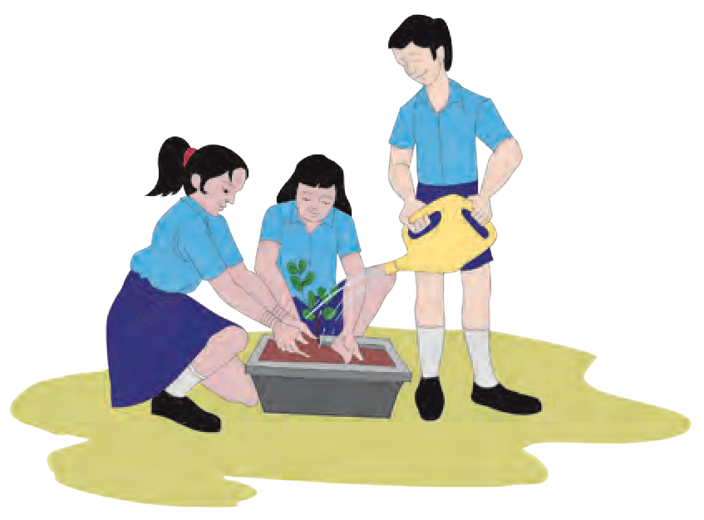Though there has been a very high rise in the production of foodgrains as a result of the green revolution, the balance of the environment has been lost due to use of chemical fertilizers, pesticides and weedicides.
    3. Unlimited lifting of water.

**Large scale tree plantation - No famine, no land erosion !** Compose a variety of such slogans and use them during Environment Awareness Rallies.

* + 1. Erosion of land.
    2. Misuse of water.

#### Cloudburst

What causes rain ?



**Can you tell ?**

#### Do you know ?

Sometimes the water coming down from rain clouds does not reach the land in the form of rain. Instead, due to very high temperature near the land, it vapourizes and goes back into the same clouds. As a result the amount of vapour in those clouds becomes very high. Due to rapid condensation, it rains suddenly over a specific and small region at a rate of 100 mm per hour or more. This is known as a cloudburst.

A cloudburst occurred at Leh (Ladakh) on 6th August 2010. The cloudburst that occurred in Mumbai on 26th August 2005 was extraordinary and unforgettable. On that day it rained about 950 mm, that is, 37 inches, in 8 to 10 hours, and the entire city of Mumbai was waterlogged and flooded.

## Flood

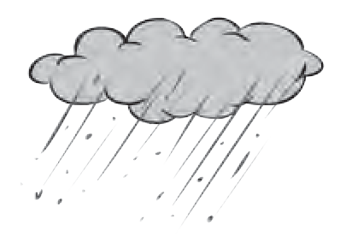

**Use your brain power !**

Why shouldn’t we wait at the foothill while it is raining heavily ?

What is meant by flood ? What are the effects of flood ?



**Let’s recall.**

We have already learnt about floods and the effects of floods. Collect information about the floods that have occurred at various places in Maharashtra in the last

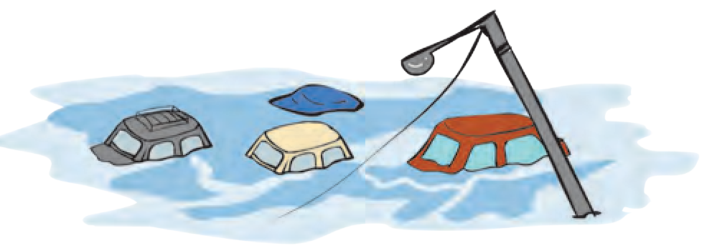

few years.

#### Protective measures in view of floods

Government

established the Commission in Commission has

of India National Flood 1976. The

made special

efforts towards the control of floods. A plan regarding flood control is kept ready from national level to village level. Large scale damage of property and loss of life can be avoided because of this plan.

1. Construction of small dams in mountainous regions
2. Construction of percolation tanks
3. Making river beds flat
4. Cultivation of new forests
5. Connecting rivers

#### Lightning

* 1. Have you seen a flash of lightning in the sky ? When ?



**Can you tell ?**

* 1. What causes lightning ?

You have learnt about generation of electric charge and lightning strikes in the lesson on static electricity. In this lesson we shall learn something more about lightning and the measures for protection from it.

**Wonderful things to know ! Lightning temperature more intense than the sun**

Not all lightning strikes the ground. In fact, about 95% of the lightning flashes are limited to the sky. Only 5% of lightning reaches the ground. Lightning can be generated within one cloud, between two clouds or between a cloud and the ground. About forty lightning flashes occur per second in the atmosphere. The temperature generated by lightning is higher than that of the sun. Due to this high temperature, the air under high pressure expands suddenly and a loud crashing sound is heard.



**Do you know ?**

**Lightning strikes open ground maximum times**

The world’s mortality rate due to lightning is low. However, survivors of lightning strikes suffer long term effects. Immediate treatment of lightning affected persons can save their life. A study of places struck with lightning show that it happens more on open ground than under a tree or near water. Mishaps have occured most often when a person is at a high place or near a tall object.

#### What precautions will you take during thunder storms ?

1. Do not stand on open ground or below a tree. Do not go to a high location or climb a tree.
2. Do not stand near an electric pole, a telephone pole, a tower, etc.
3. Do not lean on wired fences around a farm, a compound, a garden or a house.
4. If you are on a two-wheeler, a bicycle, a tractor or a boat, get off immediately and go to a safe place.
5. Do not gather all together in one place.
6. Take care to keep a distance of 15 feet between any two persons.
7. Do not use plugged in electrical appliances. Do not use a mobile or telephone.
8. Stand on dry wood, a plastic sheet, sack or jute cloth or dry leaves.
9. Keeping your feet together support yourself on the soles of your feet placing your hands on your knees and crouch low.
10. Swimmers or fishermen should immediately come out of the water.
11. A pucca house is the safest place. Find out if there is a lightning conductor on any tall building near your house. If necessary get a lighting conductor fitted on your house.

Visit the website [www.ndma.gov.in](http://www.ndma.gov.in/) and compile information about disasters and disaster management.



**My friend, the internet !**

#### Volcano

A volcano is a natural event or phenomenon. The interior of the earth is very hot. Movement of hot substances continuously occur from the interior towards the surface of the earth. As a result, sometimes the solid, liquid and gaseous substances below the earth’s crust are pushed towards the crust. When these substances come out of the earth’s crust in an eruption and start flowing, it is called a volcano.

* 1. **Volcano**

#### What are the effects of a volcano?

1. 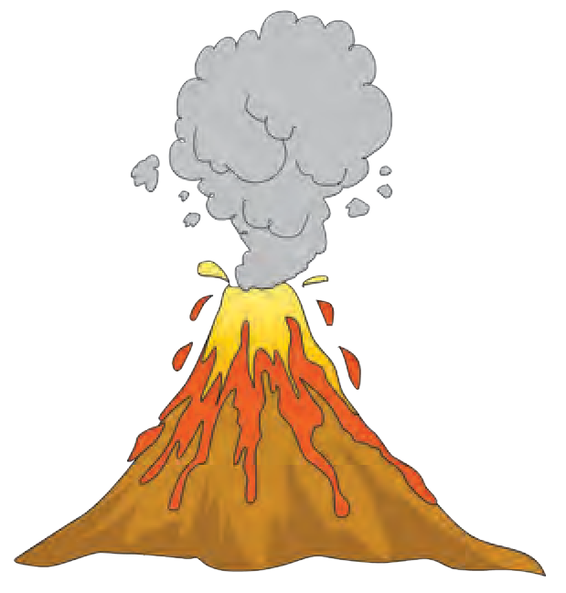The chemical substances such as lava, vapour, hot mud, sulphur, etc. get collected on the surface of the earth and thereby mountains and hills are created.
2. The atmosphere gets polluted due to the ash and gases ejected by the volcano.
3. Often, it rains as a result of a volcanic eruption.
4. Temperature rises due to hot gases.
5. Forests and settlements get buried under the hot mud.

Volcanoes erupt in the sea as they do on land. The same substances that come out during the eruption of a volcano on the land are ejected during the eruption of a volcano in the sea. Some islands are created due to the eruption of volcanoes in the sea.

It is not possible to prevent the eruption of a volcano, to stop it after it erupts or to control it. However, by means of science and technology, it is possible to predict an eruption and to take immediate steps for disaster management.

#### Tsunami

* 1. What is an earthquake ?



**Let’s recall.**

* 1. What will happen if an earthquake and volcanic eruption occur at the bottom of the sea ?

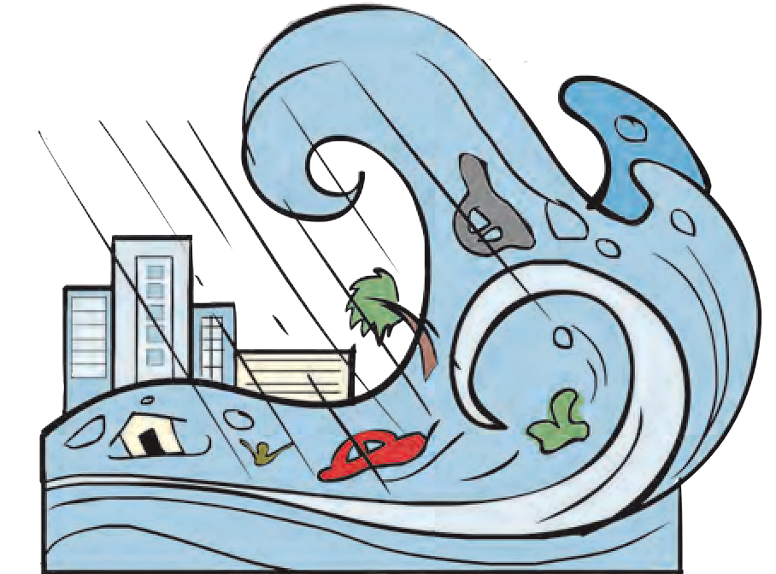As on land, earthquakes and volcanic eruptions occur at the bottom of the sea, too. If an earthquake occurs at the bottom of ocean, the energy released pushes the water upwards. As a result of this, a peculiar type of waves are formed. These waves are not very high near the source, but they start spreading very fast to long distances. The velocity of these waves is 800 to 900 kilometre per hour. When they reach a coastal area, their velocity is reduced, but their height is found

to have increased tremendously, even to about 30 metres.

* 1. **Tsunami**

Such a wave, generated by an earthquake or volcano occurring on the ocean floor, is called a ‘tsunami’. ‘Tsunami’ is a Japanese word which means ‘harbour wave’.

#### Destructive effects of tsunami

* + 1. Buildings and other constructions are destroyed.
    2. There is large scale loss of life and financial loss.
    3. Boats and ships near the coast get damaged.
    4. Trees get uprooted. Landslides take place on a large scale.
    5. Changes take place in the original land near the coast giving rise to swamps.
    6. Traffic obstructions arise.
    7. The business/industry related to the sea are adversely affected and normal day-to-day life is disrupted.
    8. Large scale damage is caused to harbours.

#### Storms

**Precautionary measures**

When a tsunami wave is formed due to an earthquake on the sea floor, it is necessary that an immediate estimate is made of its progress and a warning of the danger is issued to the people in the coastal area. For this purpose, an artificial geostationary satellite is of great use.

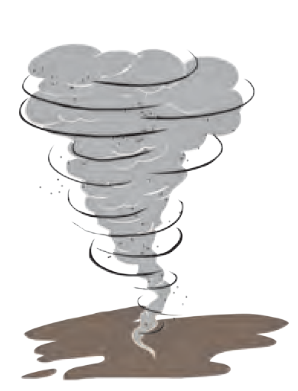

What gives rise to a storm ? What are their effects ?



**Let’s recall.**

We have already learnt about the formation of storms and their effects. Suppose, you are caught in a storm. What will you do to keep yourself safe ?



**Always remember -**

1. Regularly cut down trees or branches that are likely to fall and cause damage.
2. If you are outside, take shelter in a safer place.
3. If you are away from home, inform your close relatives and friends about your exact location.
4. At home, shut the valves of gas regulators and turn off the electric supply.
5. Make telephone calls to warn your relatives and friends about the probable danger. Tell them to go to a safer place.
6. Give temporary shelter to people who are far away from their homes.

**National Institutions**

United Nations established a standing international organisation (UNDP) in 1965. About 177

nations from all over the world are members of the the UNDP. One of the main functions of this organization is to send equipment, financial aid and also volunteers to the place of the distater. In addition, international medical teams and groups of other experts are also sent.

**Note: Refer to the lesson on ‘Winds’ in the Std VII in the Geography textbook and read the part about storms.**

**13th October International Day for Disaster Reduction**

With the help of your teacher prepare a power point presentation on ‘Effects of Natural Calamities and Measures for their Management’ and present it in the class.



**Techno-support**



**Exercise**

1. **Find the odd man out.**
   1. Famine, earthquake, cloudburst, railway accident.
   2. Drought, heavy rains, storm, tsunami.
   3. Lava, hot mud, ash, locusts.
   4. Washing away of crops, attack of pests on crops, volcano, singeing of crops
2. **What are the remedial measures for the following calamities ?**
   1. Famine
   2. Lightning strike
   3. Storm
   4. Cloudburst
3. **True or false ? Give reasons for your answer.**
   1. Information about a forthcoming storm is to be kept secret.
   2. You should not swim when there is lightning in the sky.
   3. It is possible to prevent the eruption of a volcano.
   4. Heavy rains result in famine.
4. **Write answers to the following questions in your own words.**
   1. What is a tsunami ? What gives rise to a tsunami ?
   2. What is a cloudburst ?
   3. Explain the effects of a volcano.
   4. What are the measures to prevent loss of life due to lightning ?
5. **What measures have been taken to deal with calamities such as floods and landslides under the disaster management programme in Maharashtra ?**
6. **With reference to disaster management what are the things in your house that you will check?**

**Project :**

1. With the help of the internet, collect information about the places where a calamity has occurred.
2. Collect information from the internet about how cyclonic storms are named.

⧫  



**11. Cell Structure and Micro-organisms**

#### Cell

What is the name of the minute components of which the body of a living organism is made ? Is the number of these smallest units the same in the bodies of all living organisms ?

We have learnt that cellular organization is the primary characteristic of all



**Let’s recall.**

living organisms and that the cell is the fundamental structural and functional unit of living organisms.

#### Complete the flow chart:

Words

Sentences

Chapters

Book

We see the structural organization of a book in the above flow chart. Similarly, there are organizational levels in living organisms, too. These are : cells, tissues, organs, organ systems, organism. Cells form the basis of the structure

and function of all living organisms. It is only with the help of cells that living organisms carry out all their different life processes.

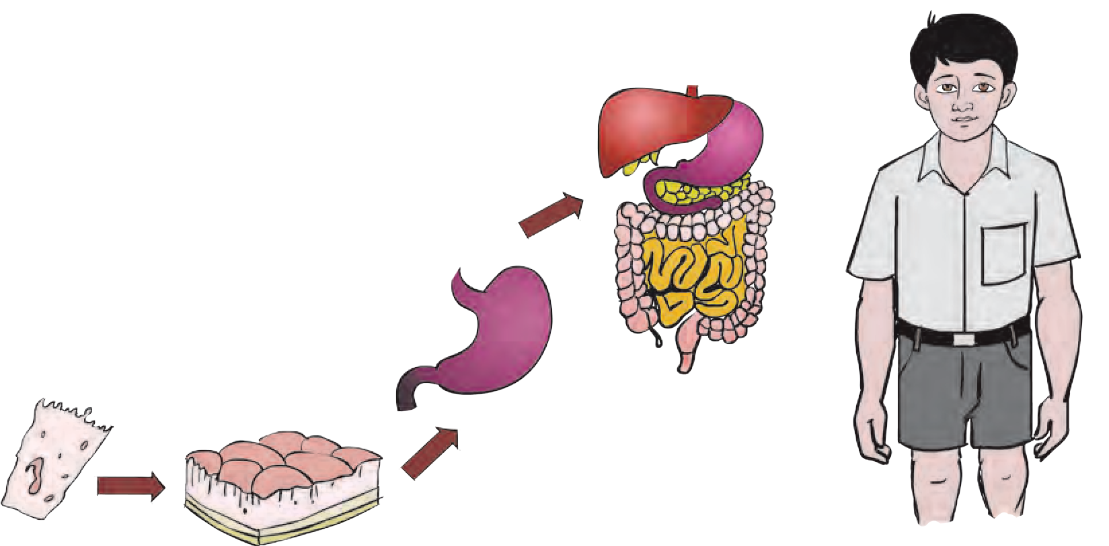

**Body**

#### Use your brain power !

Where do the life processes of unicellular organisms take place ?

**Tissue Organ Organ System**

**Cell**

#### Great Scientists

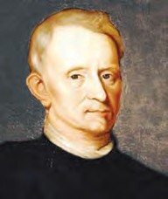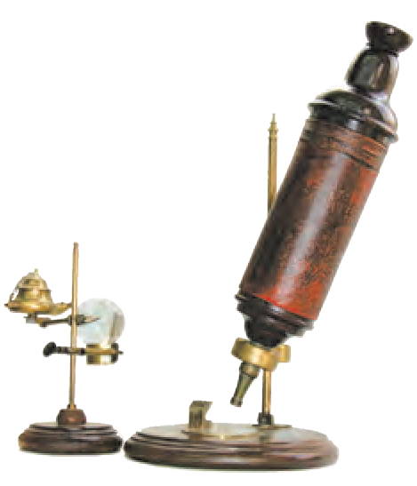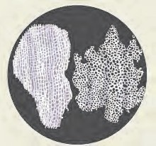

* 1. **Organization in living organisms**

In 1665, a scientist, Robert Hooke observed a thin section of cork under a microscope. In this section, he saw hexagonal compartments like those of a bee-hive. He named those compartments ‘cells’. This term is derived from the Latin word ‘*cella*’ which means ‘small room’.

In 1838, the two scientists M. J. Schleiden and Theodore Schwann formulated a theory about cellular structure which stated, ‘All the living organisms are made up of cells and the cell is the fundamental component of living organisms’. In 1885, Rudolph Virchow stated that all cells are formed from pre-existing cells.

**Measurement and observation of cells** In 1673, Anton van Leeuwenhoek assembled various lenses to construct a

microscope. He was the first to observe

live bacterial and protozoan cells under the microscope.

Cells are extremely minute in size.

**Eyepiece/Ocular**

**Tube Coarse**

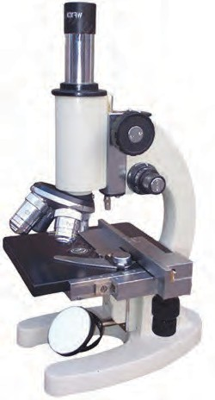

**focus knob**

**Fine focus**

We cannot see cells with the naked eye. Micrometre and nanometre are the units used for measuring their sizes. The compound microscope is used for observing cells. An object on a glass slide magnified many times by the lenses of this microscope.

**Objective lenses**

**Stage**

**Illuminator**

**knob**

**Base**

* 1. **Compound microscope**

1 centimetre = ....... millimetres, 1 millimetre = 1000 micrometres, 1 micrometre (or micron) = 1000 nanometres

Take a piece/segment of onion and carefully separate the thin skin from its concave surface with the help of forceps. Place the membrane on a glass slide and put a drop of water on it. (Take care that the membrane does not get folded while placing on the slide). Put a drop of a dilute solution of iodine or eosin over it and observe under the 10X objective of the compound microscope. Don’t forget to



**Let’s try this.**

**Segment**

**B**

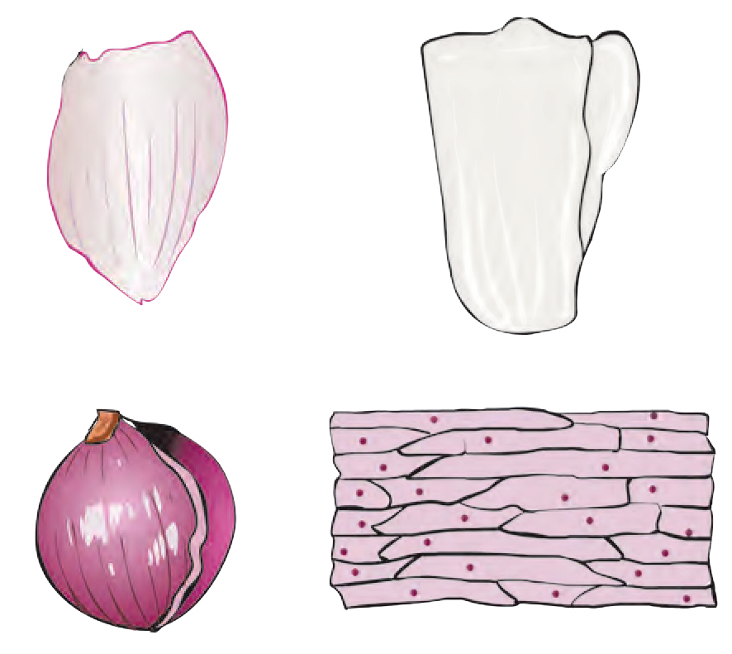

**A**

**Membrane**

**C**

**D**

**Cells**

put a cover-slip over the onion skin on the slide before placing it under the microscope.

* 1. **Onion cells seen under a compound microscope**

In the same way, observe the cells from various parts of plants like leaves, bark, root tips, etc. Do you remember that last year you had observed the amoeba and paramoecium that are found in water ?



**Can you tell ?**



**Books, my friends !**

Are the cells that you observed, all alike ? What is their structure ? What are their shapes ?

Collect interesting information about cells, from the reference books in the school library. For example, the largest cell, smallest cell, etc.

#### Cell size

There is great variation in the shapes of cells. Their shapes are mainly related to their function. Observe the cells of different shapes shown below.

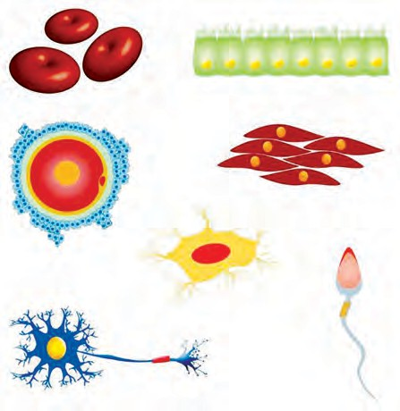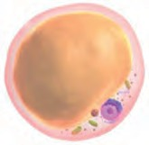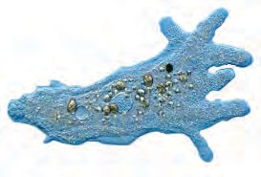

**Amoeba**

**Red blood cells**

**Surface cells**

**Muscle cells**

**A fat cell**

**An egg cell**

**A bone cell**

**Spirogyra A sperm**

**A nerve cell (Neuron)**

* 1. **Various cells**

Cells are of many different shapes e.g. circular, rod-shaped, columnar, spiral, oval, rectangular, etc.

Each cell contains various components for carrying out the life-processes of the living organism. These components are called organelles. These organelles are studied in detail with the help of the electron microscope which can magnify images up to (2 x 109) two billion times their actual size.

There are two main types of cells - animal cells and plant cells. These cells consist of various types of membrane-bound cell organelles. Plant cells have a definite shape due to the presence of the cell wall around them. Besides, unlike animal cells, plant cells contain single large vacuole. All these cells are known as eukaryotic cells.



**Observe.**

**Cell wall**

हरितलवक

**Chloroplast**

**Cytoplasm**

**Free ribosomes**

**Lysosome Cell membrane**

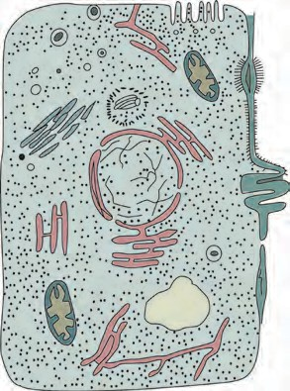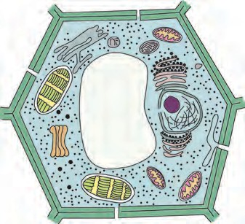

**Golgi body**

**Nucleus Endoplasmic**

**reticulum**

**Vacuoles**

**Mitochondrion**

**Plant cell Animal cell**

* 1. **Cells as seen under the electron microscope**

The cell has four main parts - the cell wall, cell membrane, cytoplasm and cell organelles.

1. **Cell wall :** The cell wall is the outermost covering of a cell. It is present only in plant cells.
2. **Plasma membrane :** The plasma membrane, also called the cell membrane, is a kind of thin covering. It is extremely delicate and flexible. It is the outermost covering of animal cells.
3. **Cytoplasm :** The liquid part in the cell, present around the nucleus is called cytoplasm. It occupies the space between the plasma membrane and nucleus. Cell organelles are scattered in the cytoplasm.
4. **Cell organelles :** These mainly include the nucleus, endoplasmic reticulum, Golgi bodies, lysosomes, mitochondria, vacuoles, plastids, etc. Plant cells contain chloroplasts.

Which are the common components of plant and animal cells ? Which are the different ones ?

The nucleus is the most important organelle of the cell. There is a porous double membrane around it. The nucleus controls all functions of the cell. The endoplasmic reticulum is a sprawling net-like organelle. Its function is to make necessary changes in the proteins produced by ribosomes and send them to the Golgi bodies. Golgi bodies are made up of several flat sacs. Their function is the proper distribution of proteins. Mitochondria and plastids are organelles with double outer coverings. As mitochondria produce energy, they are called the powerhouses of the cell. The chloroplasts in plant cells carry out the function of photosysthesis. Vacuoles help to throw out waste products of the cell. Vacuoles in animal cells are small whereas there is only one large vacuole in a plant cell.

#### Micro-organisms



**Let’s recall.**

1. How do the cells acquire definite shapes ?
2. How are cells protected ?



**Use your brain power !**

1. What are the needs of cells ?
2. What is meant by micro-organisms ?
3. Categorise the following organisms into two groups, according to size - amoeba, paramoecium, euglena, snail, elephant, pigeon, worms.

We have learnt that there are countless living organisms on the earth. Of these, the organisms which cannot be seen with our eyes but can only be observed under a microscope are called **micro-organisms**.

#### Occurence of micro-organisms

Micro-organisms are present all around us in the air, water, soil, food, sewage, garbage as well as in the bodies of plants and animals, including humans. Some micro-organisms are solitary, that is, they live singly, e.g. amoeba, paramoecium, whereas some live in colonies. Some micro-organisms live on the remains of dead plants and animals.

#### Observation and measurement of micro-organisms



**Try this.**

1. Keep a moistened piece of bread or bhakari in a closed box. Observe it after 3-4 days using a magnifying lens.
2. Observe a drop of muddy water or water from a stagnant puddle, under the compound microscope.



**Do you know ?**

We cannot see objects smaller than 100 micrometres in size, with our eyes. So, we make glass slides of the micro-organisms and observe them under a compound microscope. However, if a magnification of 1000 x proves to be insufficient, then, we need to use an electron microscope to observe those micro- organisms.

**Sizes of some microbes :**

* Paramoecium : about 100 micrometres
* Bacteria of typhoid: 1to 3 micrometres
* Polio virus: 28 nanometres

Microbes micrometres.

measure

less than 100

Even in these minute organisms, their organelles carry out all life-process within the single cell.

1. Take a drop of yoghurt or buttermilk on a glass slide and observe it under a compound microscope.

In your notebook, draw sketches of the microbes you observe.



**Use your brain power !**

Can the point of a needle accommodate micro-organisms?

#### Nature of micro-organisms

Among the sketches you have drawn , do you find any of the micro-organisms you see below ? What inferences can you draw about their sizes ?

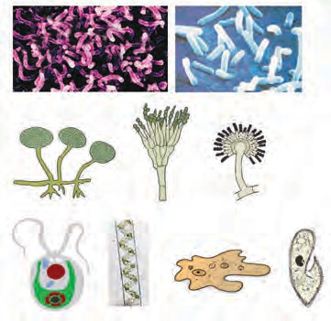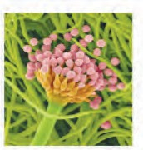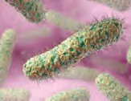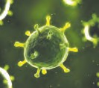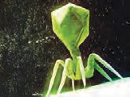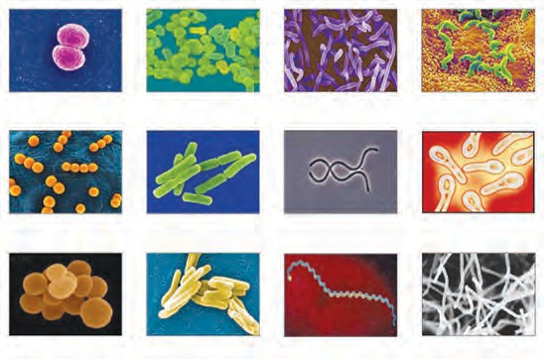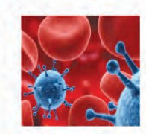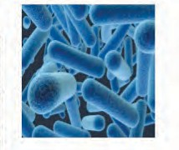

**11.7 A variety of microbes**

Some micro-organisms like the fungus that grows on bread or strands of algae in ponds are multi-cellular. However, most micro-organisms such as bacteria and viruses are unicellular. They have a somewhat different cellular structure. They do not have the membrane-bound organelles found in eukaryotic cells. The plasma membrane, cytoplasm and nucleoid are their only components. Such cells are called prokaryotic cells.

**National Institutions**

**National Center for Cell Science (NCCS), Pune, is an institute involved in research in the field of cell science (cytology), biotechnology, etc.**

**Web address:** [**www.nccs.res.in**](http://www.nccs.res.in/)

**Cell wall Plasma membrane**

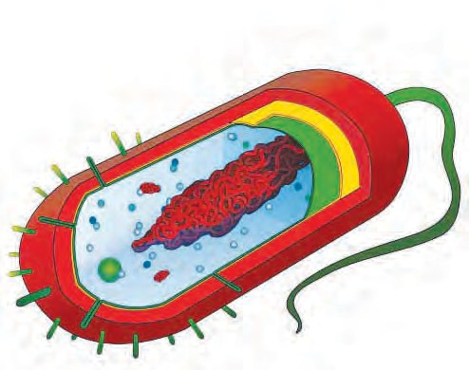

**Nucleoid**

**Capsule**

**Cytoplasm**

**Flagellum**

**Ribosomes**

**Plasmid**

* 1. **Prokaryotic cell**

#### Growth of micro-organisms

**Where do the micro-organisms grow? Medium :** Soil, water, decaying matter, etc.

**Temperature :** 25० - 37०. **Nutrition :** specific nutrients, e.g. algae-chlorophyll, oxygen.

**Atmosphere :** Moist, humid, warm

Each micro-organism needs a specific environment for growth and reproduction. Many microbes need oxygen for their growth whereas some microbes can grow without oxygen. Some micro-organisms survive even in extreme and adverse conditions like the ocean floor, ice in polar regions, hot water springs, etc. During adverse conditions, micro- organisms form a thick covering around themselves and stop their life-processes. On return of favourable conditions, they come out of the protective covering and continue their life processes.

According to shape, and life- processes, micro-organisms are classified as algae, fungi, protozoa, bacteria and viruses.

#### Useful micro-organisms

Take two earthen pots half filled with soil and mark them ‘A’ and ‘B’. Mix some waste material like garden waste, dung, fruit peel, vegetable stalks, paper scrap, etc. with the soil in pot ‘A’.



**Try this.**

Mix things like pieces of glass, scrap metal, plastic bags, etc. with the soil in pot ‘B’. Keep both pots at the same spot in the garden and observe them after 3 to 4 weeks.

Did the garbage in pot ‘B’ remain unchanged ? Where did the garbage in pot ‘A’ disappear ? Why ?



**Can you tell ?**

Microbes present in soil, dung, etc. decompose the garbage to obtain food material. As a result, garbage is soon converted into manure of the best quality and our surroundings are kept clean. As in the case of garbage, for proper sewage disposal, too, microbes are released into the sewage so as to help in the quick decomposition of the organic compounds in it.



**Use your brain power !**

Why should dry and wet waste be collected separately ?

Observe the roots of the pea, bean and fenugreek plants. What could be the functions of the nodules on their roots ?



**Can you tell ?**

We have seen that some micro-organisms present in the soil and those in the root nodules of leguminous plants convert atmospheric nitrogen into its compounds. These nitrogenous compounds help to increase soil fertility and thereby the protein content of the pulses grown in that soil.

**Project :** Visit the garbage depot near your village/city. Find out the reason for burying the garbage in the large pits there ?



**Let’s recall.**

What does your mother do to make yoghurt from milk ?

If a few drops of yoghurt or buttermilk are mixed with lukewarm milk and it is kept at that temperature for 8-10 hours, microbes present in the drops of yoghurt quickly multiply and the milk gets converted into yoghurt. Microbes are thus useful for producing milk products like butter, buttermilk, cheese, etc.



**Use your brain power !**

Who discovered the process of fermentation ?



**Books, my friends !**

1. Why is yoghurt mixed in the batter or dough for making *rava*-*idli*, *bhature*, *naan* ?
2. How do preparations like yoghurt, idli, dosa become easy to digest?

**Fermentation**

The chemical process of conversion of one type of carbon compound into another type of carbon compound by the action of micro-organisms is called fermentation. Heat is generated in this process and carbon dioxide and some other gases are released. These gases cause an increase in volume, e.g. bread dough and idli batter are seen to ‘rise’. The process of fermentation is used for making yoghurt from milk, producing alcohol from grains and fruits, bread from flour as well as in the production of acetic acid, citric acid, lactic acid, vitamins, antibiotics, etc.

If microbes are allowed to grow in batter, dough, fruit juices, etc., they break down these substances producing new compounds as they grow and multiply in them. This microbial process is used in the production of various common foodstuffs.

Sometimes, when you are ill, the doctor prescribes capsules or injections of medicines like penicillin. These types of medicines destroy the pathogens and retard their growth. They are called antibiotics. Antibiotics are produced with the help of specific microbes.

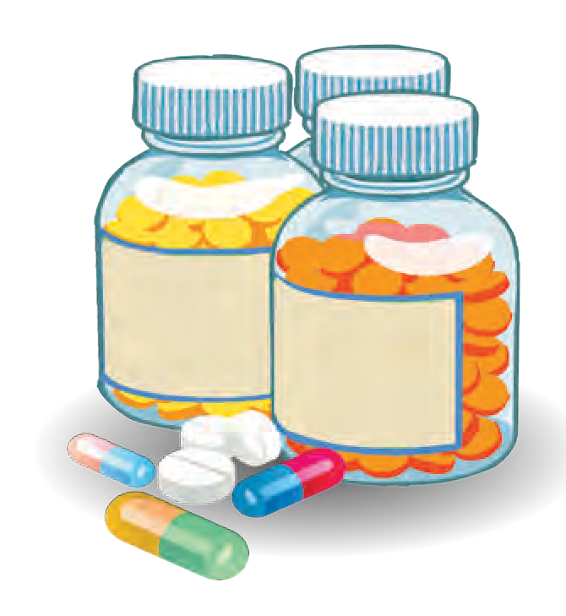

Diseases like tuberculosis, typhoid, cholera, etc. which were previously considered incurable, have now come under control because of antibiotics.

Domestic animals too can be protected from various diseases by mixing antibiotics with their food. Plant diseases can also be controlled with the help of antibiotics.

#### Always remember -

Though antibiotics are useful for curing certain diseases, they can be harmful if used without consulting a physician. Hence, a course of antibiotics should be completed strictly following the doctor’s prescription. In fact, we should not take any medicines on our own to treat ailments like body-aches, headaches, common colds, etc.



**Find out.**

Why are infants vaccinated according to a fixed time schedule ?

What is a vaccine ?

A vaccine is produced in a laboratory with the help of microbes, that gives immunity against a particular disease. If we have been vaccinated against any disease, our immunity i.e. resistance to that disease, increases, so that the possibility of contracting that disease is greatly reduced.

Microbes are also used in processes like tanning of skin, production of ropes and strings from agave. Some microbes use oil for their growth. Such microbes are used to clear a layer of oil floating on the surface of an ocean or lake formed due to a leak or a spill i.e. to clear an oil slick.

Farm waste, human urine and faeces, wet garbage, etc. is collected and used in a biogas plant to produce biogas and fertilizer.

#### Harmful micro-organisms

What happens to the sweetmeat or bread forgotten in a lunch-box for three or four days ?



**Let’s recall.**

If jars of pickles, jams (*murabba*), etc. are opened after a long time, a round layer of white scum or black particles may appear to have formed on the surface. In summer, milk and meat get spoilt quickly. Fungus grows quickly on moist and stale food. What do we do with such spoilt food ? Why ?

**Food poisoning**

As they use foodstuffs for their own nutrition, some microbes release toxic materials (enterotoxins), into the food. Such toxins spoil the food. Eating such spoiled food can cause loose motions and vomiting.



**Use your brain power !**

1. How will you know that a foodstuff is spoilt ?



**Always remember -**

1. Eat fresh and properly covered food.
2. Drink boiled water.
3. Hold a handkerchief over your mouth and nose when you cough or sneeze.
4. Don’t allow garbage and water to accumulate around your house.
5. What precautions will you take while purchasing food ? Why ?
6. Why do food poisoning incidents occur during marriage or other community feasts ?

#### Pathogens : Disease-producing micro-organisms

Pathogens may be present in water bodies contaminated with sewage and dirt from the surroundings, in food left uncovered in unhygienic conditions with houseflies sitting on it, etc. If such contaminated food or water is consumed, we may fall ill with diseases of the alimentary canal, like amoebiasis, typhoid, cholera, hepatitis, gastro, etc. Pathogens are released in the air when a person having an infection of the respiratory tract sneezes or coughs. A healthy person may get infected with such pathogens on breathing in the same air and contract diseases like common cold, cough, diphtheria, pneumonia, tuberculosis, etc.

Mosquitoes reproduce in places like heaps of garbage, drains, stagnant water, etc. Microbes that cause diseases like malaria, dengue, elephantiasis, yellow fever, chikungunya, Zika fever, etc. gain entry into the human body through the bite of a female mosquito.



**Swachha Bharat Abhiyan**

Almost 80% of all diseases occur due to uncleanliness. Keeping our surroundings clean, avoiding litter and disposing garbage properly, avoiding defecation in the open are some easy ways to stop the spread of diseases.

The Swachha Bharat Abhiyan is a national movement started several years ago to increase awareness about public hygiene along with habits of personal hygiene. Let us participate in this movement by starting a cleanliness drive in our school and neighbourhood.



**Find out.**

Which diseases do micro- organisms cause in plants and animals ?

#### Do you know ?

**Make sure to check -**

1. Is the water tank and the water in it, clean ?
2. Are the water tanks and toilets in the school, clean ?
3. Is the water that accumulates in pots, tyres, cans, etc. around the house drained promptly ?
4. Are the water storage containers cleaned regularly ?

What exactly happens when we have fever ?

The body temperature of a healthy human being is about 370 C. If micro-organisms enter our body, our immune system starts acting and body temperature rises. This destroys the micro-organisms. The site of an injury also feels warm for the same reason.

What is the corelation between the normal body temperature of humans which is 370 C and the optimum temperature for the growth of micro- organisms, 150C to 350C ?



**Use your brain power !**



**Can you tell ?**

1. What happens if clothes remain damp in the rainy season ?
2. What are the black or white spots sometimes seen on gunny bags ?
3. Why are leather articles like purses, wallets, belts, footwear always polished before storing away ?
4. What is the powdery material found on old currency notes or old rubber or paper ?

All the materials mentioned above i.e. gunny bags, cotton clothes, paper, rubber, etc. are plant products and leather is an animal product. In a humid atmosphere, fungi and some other micro-organisms grow on these articles and spoil or damage them.



**Exercise**

1. **Answer the following questions.**
   1. What is a ‘cell’ ?
   2. Name the different organelles in a cell ?
   3. What are micro-organisms ?
   4. Which are the different types of micro-organisms ?
2. **Fill in the blanks with the proper word.**
   1. The organelle called the is

present in plant cells only.

* 1. Garbage is converted into ............. by micro-organisms.
  2. In the cell, photosynthesis is carried out with the help of ............... .
  3. An electron microscope is necessary for the study of ............... .

1. **What is difference between us?**
   1. Plant cell and animal cell.
   2. Prokaryotic cell and eukaryotic cell.
2. **Sketch and describe in your own words, the plant cell and animal cell.**
3. **Explain the uses and the harmful effects of micro-organisms.**
4. **Give reasons.**
   1. Diseases spread on a large scale during periods of heavy rainfall and floods.
   2. There is a possibility of food poisoning if we eat stale food.
   3. Soil is turned over during tilling.
   4. Fungus grows quickly in moist or humid conditions.
   5. A refrigerator is used in almost every home.
   6. Bread ‘rises’ during baking.
   7. Fodder is soaked in water before offering to cattle.
5. **When will you use a simple microscope and when, a compound microscope? Explain in detail how you will use them.**

**Project :** Visit a bakery in your area, collect information about the process of manufacture of their products and make one of them at home.

⧫  

**12. The Muscular System and Digestive System in Human Beings**

1. What is meant by ‘organ system’ ?



**Let’s recall.**

1. How are the bones in our body joined to each other ?

#### Muscular system



**Try this.**

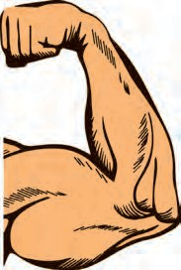

Close your fist tightly and bend your arm at the elbow. Now feel the upper part of this arm with the fingers of your other hand. What did you experience ?

Did you feel the hardness in the upper arm ? This fleshy part consists of muscle. Muscles contract and relax as different parts of our body move. Muscles give our body a specific shape and posture.

**Muscles** are bundles of fibres that can contract and relax as required.

What is the mutual relationship between muscles and bones ?



**Can you tell ?**

Muscles are firmly attached to bones by means of tendons. When muscles contract, there is movement at the joint and the bones move either nearer to or away from each other.

The action of muscles is necessary for all kinds of movements - from the small movements of eyelids to those that demand great strength as when chopping wood with an

**Relaxation of muscles**

**No movement**

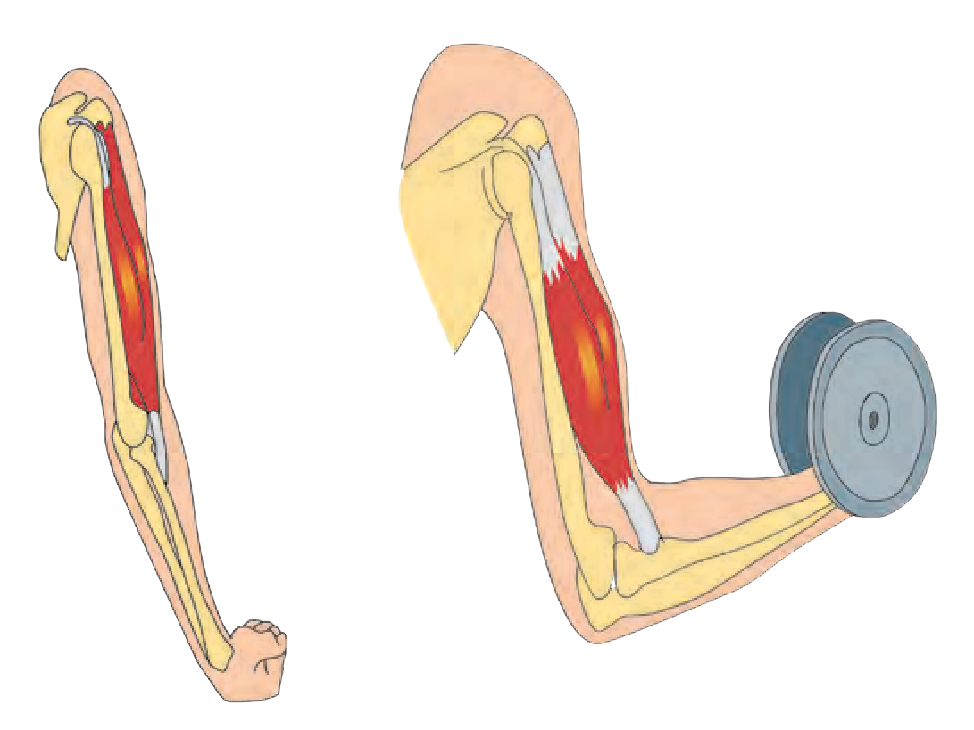

**Contraction of muscles**

**movement**

axe. We use muscles for various movements like talking, laughing, walking, jumping, throwing, etc.

* 1. **Contraction of muscles**

Which parts of our body are made up only of

muscles ?



**Use your brain power !**



**Do you know ?**

There are more than 600 muscles in the human body. Muscles contribute almost 40% of the weight of a healthy adult human body. There are about

30 muscles in the human face. Our eyes, mouth and nose are encircled by small muscles. Expressions like happiness, sadness, fear are expressed by the movements of these muscles of the face.

Are the muscles of the different organs in our body identical ?



**Can you tell ?**

1. **Voluntary muscles :** Working with our hands, walking, eating, etc. are functions that depend upon our will. Muscles used in these actions are called **voluntary muscles**. For example, muscles in our arms and legs are voluntary muscles.
2. **Involuntary muscles :** Various processes like breathing, blood circulation, digestion are vital functions, i.e., they are essential for life. They do not depend upon our will. The muscles of organs which carry out these involuntary functions are called **involuntary muscles**. Functions of organs like the stomach, intestine, heart are carried out in their own fixed manner by involuntary muscles.

#### Which organs in our body have voluntary muscles and which ones have involuntary muscles ? Find out and make a list of each type.

**Types of muscles**

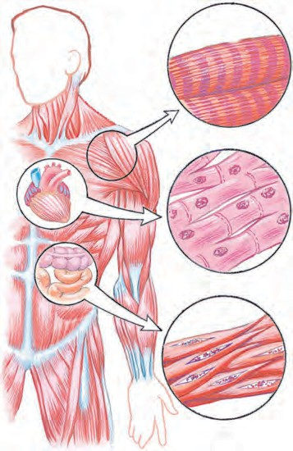

* 1. **Muscles in the human body**

1. **Skeletal muscles :** The two ends of each of these muscles are attached to two different bones. Examples of such muscles are muscles of the arms and legs. Their movements are voluntary. They are also responsible for holding the bones of the skeleton together and giving shape to our body.
2. **Heart or cardiac muscles :** These muscles bring about the contraction and relaxation (beating) of the heart. Their movement is involuntary. Cardiac muscles cause our heart to relax and contract continuously at a rate of about 70 times per minute.
3. **Smooth muscles :** These muscles are present in the internal organs other than the heart. For example, muscles of the stomach, intestine, blood vessels, uterus, etc. Their movements are involuntary and slow. Various vital functions of our body, of which we remain quite unaware, are carried out by these special muscles.

How do muscles perform their functions ?



**Can you tell ?**

* 1. Hold your arm straight at the elbow (i.e.180°) without closing your fist.



**Try this.**

* 1. Bend the arm at the elbow through 90°.
  2. Touch the shoulder with your fingers on same side.

Muscles of which part of your arm contracted and relaxed during the above three actions ?

Muscles in our body always work in groups. When some muscles contract, other muscles of the same group, relax. This is how muscles help in the proper performance of the various functions of our body.

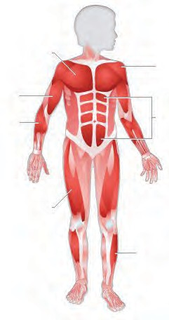The muscle on the front of the bone in our upper arm is called the biceps. The muscle at the back is called the **triceps**.



**Use your brain power !**

#### What would happen if :

1. The cardiac muscles do not move.
2. Food enters the stomach and the stomach muscles do not move.

**Chest muscles**

**Biceps Flexors**

**Deltoid**

**Abdominal muscles**

**Quadriceps**



**Always remember -**

Muscles of our body must be strong and efficient. Our diet must include proteins and carbohydrates in sufficient quantity for the proper growth and repair of muscles. We must get regular exercise. It makes the muscles strong. We must sit with a straight back, and not with the back hunched or bent. Otherwise, gradually, changes occur in the structure of the vertebrae. Muscles in the shoulder and back begin to hurt. Disorders of the vertebral column may also arise.

During exercise, movements of the heart muscles become more rapid. Breathing, too, becomes faster, ensuring a sufficient supply of oxygen and nutrients to various parts of the body.

**Flexors**

* 1. **Muscles in different parts of**



**the body**

**Do you know ?**

The study of muscles is called myology. Contraction is the basic property of muscles. The largest muscle of our body is in the thigh. The smallest muscle is attached to a bone in the ear, called the stapes.

#### Digestive system

1. What happens to the food we eat, inside our body ?



**Let’s recall.**

1. 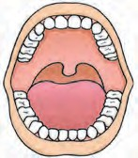Does this food mix as it is with the blood ?

Conversion of food into a soluble form and its absorption into the blood is called digestion.

The digestive system consists of the alimentary canal and digestive glands. The total length of alimentary canal is about 9 metres. Its main parts are the mouth, pharynx, oesophagus, stomach, small intestine, large intestine, rectum and anus. The salivary glands, liver and pancreas are the digestive glands connected to the alimentary canal.

Different organs of the digestive system systematically perform the function of digestion. There are different stages in the process of digestion of food and at each stage there is a different organ of the digestive system which performs its specific role. Let us study the structure and function of each organ of the digestive system.

#### Teeth

The process of digestion begins with the function of the teeth in the mouth. There are four types of teeth, namely, incisors, canines, pre-molars and molars. Each type of tooth has a specific function. Each tooth is covered by a hard substance called enamel. Enamel is made of a calcium salt.

Saliva contains an enzyme called ptyalin or salivary amylase. Ptyalin converts starch into a sugar called maltose.

**Jaw**

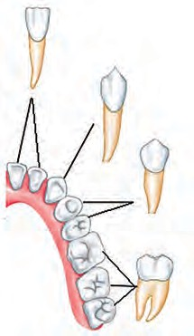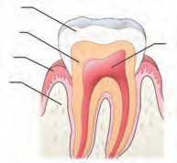

**Enamel Dentine**

**Gum**

**Bone**

**Root**

**Incisor**

**Canine**

**Premolar**

**Molar**

* 1. **Teeth**



**Use your brain power !**

During digestion, does all the food that we have eaten get converted into useful, nutritive substances ?

**Learn a new word Enzymes** are substances

secreted in the body of an organism, which bring about specific chemical reactions.

They act

as enzymes

catalysts.

Digestive

of

the

digestive system bring about changes in the food materials. Metabolic processes are impossible without enzymes. Enzymes are a specific type of proteins. They are most active at normal body temperature.



**My friend, the internet !**

Collect information about the various organ- systems from the websites [www.livescience.com](http://www.livescience.com/) and [www.innerbody.com](http://www.innerbody.com/)

**Mouth :** Digestion of food begins in the mouth. Food is chewed with the help of teeth into very small pieces.

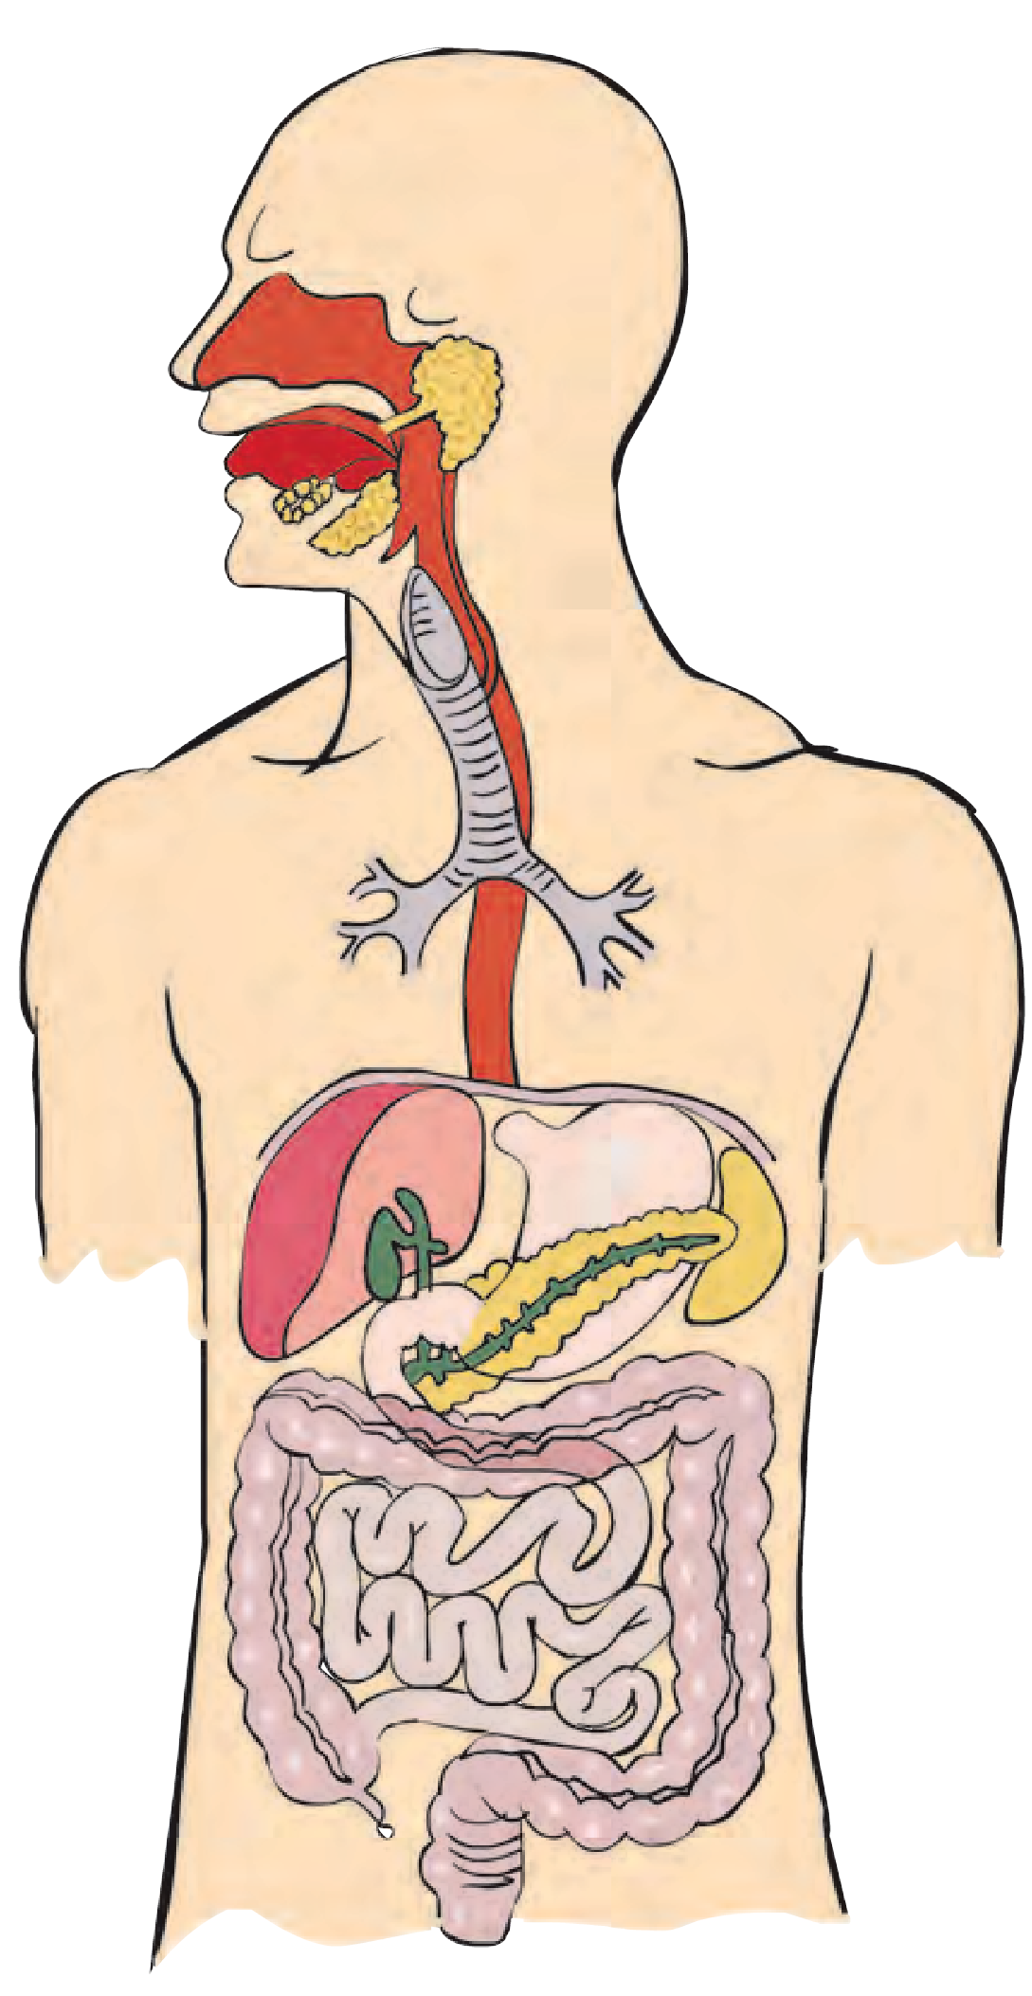

**Pharynx/Throat :** The oesophagus and trachaea open into the pharynx.

**Liver :** The liver is the largest gland in the body. It has a rich supply of blood. Its main function is storage of glucose. The gall bladder is situated below the liver. It stores the bile, the digestive juice secreted by the liver. When bile is carried into the small intestine, it mixes with the food there and helps in the digestion of fats. Bile contains bile salts.

**Small intestine :** The small intestine is about 6m long. Most of the digestion and absorption of food takes place here. Three different digestive juices are mixed with the food in the small intestine. Absorption into the blood, of nutrients obtained by the digestion of food, also occurs in the small intestine.

* 1. **Digestive system**

**Salivary glands :** Saliva is produced in the salivary glands in the mouth cavity, located in front of the ears, near the pharynx and below the tongue. It is carried to the mouth via ducts. It is mixed with food during the process of chewing.

**Oesophagus :** It is a tube leading from the pharynx to the stomach. It pushes the food towards the stomach.

**Pancreas :** The pancreas secretes the pancreatic juice that contains various enzymes.

**Stomach :** The large sac-like part of the alimentary canal is called the stomach. The gastric glands of stomach secrete gastric juice. Food that has entered stomach is churned. Three components of gastric juice, namely, hydrochloric acid, pepsin and mucus are mixed with food here and it becomes acidic. Mainly proteins are digested in the stomach. Due to the churning and the action of gastric juice, food becomes a semi-solid slurry which is slowly pushed into the small intestine.

**Large intestine :** The large intestine is about 1.5m long. Only water is absorbed in the large intestine. A small part called the ‘appendix’ is attached to the first part of large intestine. Undigested remains of the food digested in the small intestine enter the large intestine. Undigested material is thrown out of the body through the anus.

#### Important Glands of the Digestive System, their Secretions and Functions

|  |  |  |  |
| --- | --- | --- | --- |
| **Organ** | **Gland** | **Secretion** | **Functions** |
| Mouth | Salivary gland | **Saliva :** Ptyalin | Conversion of starch into maltose. |
| Stomach | Gastric wall | **Gastric juice** Hydrochloric Acid Pepsin  Mucous | To make the food acidic. Breakdown of proteins.  To protect the inner lining of the stomach  from hydrochloric acid. |
|  | Liver | **Bile** | To make food alkaline.  To convert large fat particles into small ones (emulsification of fats). |
| Pancreas | **Pancreatic juice**  Trypsin Lipase  Amylase | To convert proteins into amino acids. To convert fats into fatty acids and glycerol.  To convert complex carbohydrates into  simple sugars. |
| Small intestine |  | **Intestinal juice** | To convert proteins into amino acids. To convert complex carbohydrates into glucose.  To convert fats into fatty acids and  glycerol. |

**Are we putting our health at risk?**

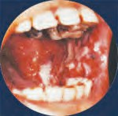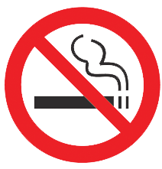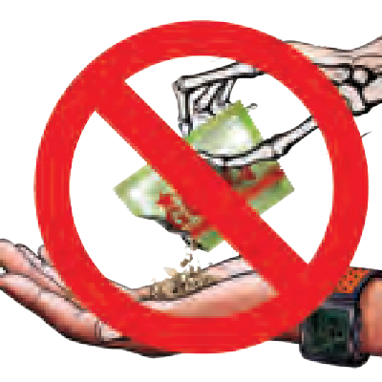

Physical health is extremely important in personality development. When all our organ systems function properly, we say that we are in good health. However, harmful habits like smoking, chewing of tobacco, drinking alcohol affect our health adversely.

#### Effects of tobacco, alcohol, smoking, on the digestive system

If we consume any tobacco products, the mouth, pharynx, alimentary canal and other organs of the digestive system cannot function properly. It causes problems like vomiting, nausea, and headache. Besides, tobacco particles stick to teeth, gums and skin of the mouth cavity and slowly cause injury to those parts resulting in their dysfunction. This causes swelling of the gums and pain when moving the jaws. The pharynx and intestine become inflamed and the condition further progresses into cancer leading to death.

#### My Role

* Making pictures and slogans against tobacco consumption, smoking, drinking alcohol, etc. and displaying them in the classroom and the neighbourhood. Keeping a watch on whether one’s surroundings are tobacco-free.
* Composing an oath against addiction and taking the oath in the class and also during assembly.
* Making parents and teachers aware of such instances in the neighbourhood.

**31st May is World No Tobacco Day and 7th April is World Health Day.**



**Exercise**

1. **Fill in the blanks with the right word from the brackets.**
   1. The process of digestion starts from the (stomach / mouth)
   2. Eyelids have muscles

(voluntary / involuntary) .

* 1. ................ is not a function of the muscular system. (Production of blood cells / Performing movements)
  2. Muscles of the heart are ................ (ordinary muscles / cardiac muscles)
  3. Pushing forward the food that has been chewed is the function of the ............ . (stomach / oesophagus).

1. **Find a match for me.**

**Group ‘A’ Group ‘B’**

1. Cardiac (a) always function muscles in pairs.
2. Are brought (b) we never feel about by muscles tired.
3. Pepsin (c) uncontrolled and painful contraction

of muscles.

1. Cramps (d) chewing movements of jaws.
2. Skeletal (e) enzyme of the

muscles gastric juice.

1. **Who is telling a lie ?**

**Organ Statement**

1. Tongue My taste-buds can tell

only a sweet taste.

1. Liver I am the largest gland in the body.
2. Large intestine I am 7.5 meter long.
3. Appendix Digestion is impossible

without me.

1. Lung I play an important role in excretion.
2. **Give reasons.**
3. Food becomes acidic in the stomach.
4. Cardiac muscles are said to be involuntary muscles.
5. Intoxicating substances should not be consumed.
6. Your muscles should be strong and efficient.
7. **Answer the following.**
8. How many types of muscles are there ? Which are those types ?
9. What causes the problem of acidity ? What is its effect on the body ?
10. Name the different types of teeth. What is the function of each type ?
11. **Sketch and label a diagram of the digestive system and describe it in your own words.**

**Project :**

* 1. Make charts about maintaining good health.
  2. Design a powerpoint presentation about the digestive system and present it in the class.

⧫  

**13. Changes – Physical and Chemical**

* + 1. What are the causes of the changes occurring in our surroundings ?



**Let’s recall.**

* + 1. What is meant by man-made changes ? Which are these changes ?

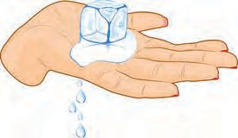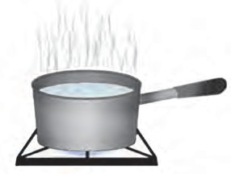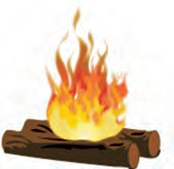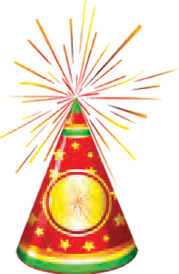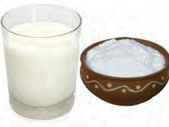

#### Observe and discuss.

What changes have taken place in the materials seen in the following pictures ? What kind of changes are they ?

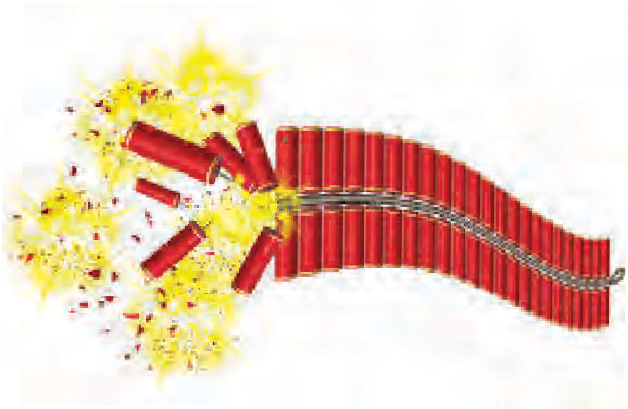

* 1. **Various changes**

Which points will you consider while classifying the following changes into two groups - a fruit falling from a tree, rusting of iron, raining, lighting an electric bulb, cutting vegetables ?



**Can you tell ?**

Which of the above changes have occurred of their own accord or naturally ?

We have previously studied some examples of changes. Changes like the ripening of a fruit, spoiling of milk occur naturally. These are called **natural changes**. Can you think of other examples of such natural changes ?

What changes have you seen taking place in the materials in your surrounding ? Let us learn about changes in greater detail in this lesson.



**Can you tell ?**

We see many man-made materials in our day-to-day life. For what purposes are they produced ?



**Use your brain power !**

1. What kind of change is the falling of a tree in a storm ?
2. What kind of change is the conversion of milk into yoghurt ?

Many changes such as sharpening a pencil, baking bread, cooking food are useful to us and these are, therefore, called **useful changes**. The changes that are not useful or changes that do us harm are called **harmful changes**.

#### Think about it.

Can you now classify the natural and man-made changes you have listed as useful and harmful changes ? So far, we have studied certain types of changes. What can you tell about two of these, namely, bursting of a balloon and ripening of a fruit, from the point of view of their duration i.e. the time they take to happen ?

The duration of the bursting of a balloon is far shorter than that of the ripening of a fruit. Changes that take place in a short period of time are called **fast/quick changes**. While changes that take place over a long period of time are called **slow changes**.



**Use your brain power !**

Give some examples of fast and slow changes that occur in your surroundings.

**Have some fun !**

**Apparatus :** Pieces of glass bangles, a candle, a matchbox, etc.

**Procedure :** Hold a piece of glass bangle in the candle flame supporting it with your fingers. Take care to heat the piece in the middle keeping its two ends outside the flame. Observe it as the middle gets heated and becomes soft. It bends due to the finger- pressure on its ends. In this way, bring the two ends together and let the piece cool.

A *toran* can be made by linking such pieces with each other. Make such *torans* of different patterns and colours and decorate your class and home.

* + - 1. You made a link from the glass piece. How will you change the shape of the link to give it its original shape ?
      2. How will you restore the original candle after melting one ?



**Can you tell ?**

Melting some wax and obtaining the original solid wax again is something that we can do repeatedly. The changes that can occur in a forward and reverse direction again and again are called **reversible changes**. A ripe mango, however, cannot be transformed back into a raw mango.



**Use your brain power !**

What is meant by irreversible change ? Give some examples.

Wood cannot be obtained from the ash formed on burning the wood.



**Can you tell ?**

1. What comes after daytime ?
2. What is the next stage after sunrise ?
3. What comes after a high tide in the sea ?
4. A bird sitting on a tree flies away.
5. Flooding
6. A meteor streaking across the sky.

On considering the above examples, we find that some changes occur again and again after a definite interval of time. Such changes are called **periodic changes**. On the other hand, it cannot be said for sure when certain changes will recur after one occurrence. Even if they recur, the time interval is not fixed. Such changes are called **non-periodic changes**.

* 1. Which type of change is the change of seasons from summer to rains to winter ?



**Use your brain power !**

* 1. Which hands of a clock show periodic changes from 6.00 am to 6.00 pm ? How many times ?



**Observe.**

1. Which of the changes shown in the picture alongside are temporary ?
2. 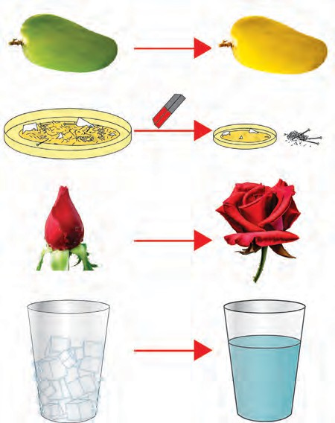Which of the changes are permanent ?
3. In which of the changes did the original matter undergo a change ?
4. In which, did the original matter remain unchanged ?
5. In which of the changes was a new substance with a new property formed ?

In some of the above examples of changes, the properties of the original substances remain the same, that is, their composition remains unchanged. No new substance is formed. Such a change is called a **physical change**.

The change due to which one substance is transformed into another substance having new and different properties is called a **chemical change**.

* 1. **Various chemical and physical changes**
     1. What processes occur during the change of state of matter ?



**Let’s recall.**

* + 1. What happens when water is taken in a bowl and heated ?

The process of formation of vapour from a liquid is called evaporation. Drying of clothes, formation of salt from seawater are possible due to evaporation. We have studied some processes that are a part of the water-cycle. Which are these processes ? Do the original properties of water change during those processes ? Previously, we have learnt about the processes of dissolving, boiling, melting. They are all examples of physical change.



#### Use your brain power !

Which of the following are physical changes and which are chemical - making a table from wood, burning wood, breaking of a glass object, ripening of a tomato, rusting of iron ?

**Try this. Apparatus :** Evaporating dish, sugar, burner, tripod, etc.

**Procedure :** Take some sugar in an evaporating dish. Place the dish on a tripod and heat it. Observe the changes taking place in the sugar. Stop heating when a blackish substance is seen at the bottom of the evaporating dish. What kind of change does the above process bring about ?

#### Corrosion



**Do you know ?**

Iron articles are given a thin coat of zinc to prevent corrosion. This is called galvanization. Copper and brass articles are coated with tin. This is called tinning.

In this age of technology, a

new coating Coats

process called

powder

has

been

developed.

of

various

colours

are

applied on metals like iron and aluminium. They prevent corrosion of the metal.

When an iron article rusts, a reddish brown layer forms on it. A greenish layer is seen to form on a copper article. This process is called corrosion of metals. Things become weak due to corrosion. Corrosion is caused by oxygen, moisture, vapours of chemicals in the air.



**Always remember -**

While classifying changes we take into account only one criterion at a time. However, a number of different criteria can be applied to the same change.



**Exercise**

1. **Distinguish between the following.**
   1. Physical change and chemical change
   2. Periodic change and non-periodic change
   3. Natural change and man-made change
2. **Under which different types can the following changes be classified ?**
   1. Conversion of milk into yoghurt.
   2. Bursting of a cracker.
   3. Occurence of an earthquake.
   4. Revolution of the earth around the sun.
   5. Stretching of a spring.
3. **Give reasons.**
   1. While purchasing canned food, its expiry date should be checked.
   2. An iron article should be given a coat of paint.
   3. A wooden article should be polished.
   4. Copper and brass utensils should be tinned.
   5. A dry handkerchief gets wet at once on dipping in water, but it takes long for a wet handkerchief to dry.
4. **What will you take into account while identifying the following ?**
   1. A physical change in a substance.
   2. A chemical change in a substance.
5. **Read the paragraph and note down the various types of changes it mentions.**

It was nearing six o’clock in the evening. The sun was setting. A breeze was blowing. Leaves on the tree were shaking. Sahil was sitting in the courtyard, rolling balls of wet soil and shaping them into various toys.Then he felt hungry and went into the house. Mother made a dough from wheat flour and fried purees. While eating hot purees, his attention was drawn outside the window. It had started raining. There was lightning, too. Sahil was enjoying his dinner in the dim light.

**Project :**

Visit a place where work like powder coating, spray painting is

done. Make a note of the information you obtain.

⧫  

**14. Elements, Compounds and Mixtures**



**Let’s recall.**

1. How many different states of matter are there ? Name them.
2. What brings about a change of state of matter ?
3. What are the properties of matter ?
4. Do all substances have the same properties ?

#### Classify the following substances according to their properties.

Water, thermocol, soil, iron, coal, paper, rubber, copper, coir, plastic.



**Can you tell ?**

* 1. What are objects made of ?
  2. What are these articles of everyday use made of - electric wire, kitchen utensils, nails, tables and chairs, window panes, soil, salt, sugar ? **Matter**

We say that an object is made of a certain substance. The term matter is also used as a synonym of substance. In scientific language, however, a single term is used for a single concept, and that which an object is made of is called **matter.**

#### The particulate nature of matter and properties of matter

1. Take a piece of chalk and keep on dividing it into smaller pieces. What will happen ?



**Try this.**

1. Wipe a drop of ink with a handkerchief. What effect does it have on the cloth of the handkerchief ?
2. What happens when the lid of a bottle of perfume is opened ?

It is the matter present in various things in solid, liquid or gaseous states that is responsible for their properties. Even though they are divided into small particles their properties due to the matter present in them, remain the same. The properties such as the white colour of a chalk, the blue colour of ink, the fragrance of a perfume are the properties of the matter of which each of them is made.



**Use your brain power !**

* 1. In day-to-day life, we come across many things in our surroundings. We touch them, we study

their properties. Are all these things made from only one kind of matter or from more than one kind of matter ?

* 1. Classify the following according to the nature of matter in them - whether it is made from one kind of matter or from more than one kind of matter; and whether it is in solid, liquid or gaseous state : an engraved idol, gold, milk, water, a plank, concrete, salt, soil, coal, smoke, sherbet, cooked *khichadi*, steam.
     1. Fill a glass of water upto the brim. Drop a small stone in it. What happens ?



**Try this.**

* + 1. Take a balance. Place a small stone in one pan and a big stone in the other. Which pan goes down ? Why ?

Which properties of matter can you tell from the above activities ?

Objects have mass and mass can be measured with the help of devices like the common balance. Also, they occupy space. They acquire both these properties from the matter that they are made of. In other words, mass and volume are two important properties of matter.

Many kinds of matter found in nature are in pure form, that is, they contain only one constituent. In scientific language, matter made of only one constituent is called ‘**substance**’, for example, gold, diamond, water, chalk. Other kinds of matter are made of two or more substances. They are called ‘**mixtures**’.

#### Elements

Which of the following are mixtures -water, sherbet, iron, steel, coal, air, salt, copper, brass, soil.

1. Take water in a teapot and cover it. Heat the water to a boil. What do you see on the inside of the lid ?



**Use your brain power !**



**Try this.**

1. 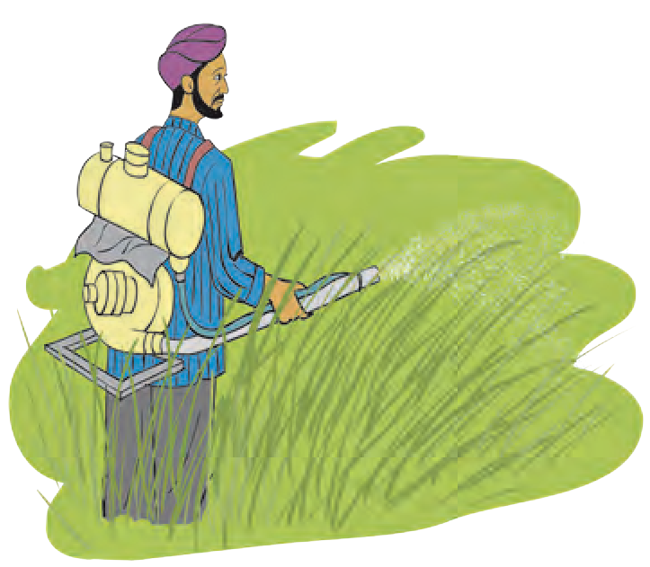Fill water in a spray pump, spray the water and observe the

spray.

The water droplets collected on the inside of the lid of the teapot are formed by condensation of the vapour from the boiling water. Water in the form of vapour is composed of extremely tiny particles and, therefore, we cannot even see them. You will see that the spray is also composed of small particles of water. Similarly, all substances are made of extremely tiny particles. The smallest particles of substances are molecules. A substance whose

* 1. **Spray-pump**

molecules are made of one or more atoms which are exactly alike, is called an **element**.

We do not get different substances by the decomposition of an element. The smallest particles of elements are made of only one type of atoms. We cannot see atoms with the naked eye, but when crores of atoms come together, their total volume is large enough to be visible to our eyes. The mass and volume of atoms of different elements are different.



**Do you know ?**

To date, scientists have discovered 118 elements. Of these, 92 elements occur in nature, while the remaining are man-made. Hydrogen, oxygen, nitrogen, carbon, iron, mercury, copper are a few of the important natural elements. More new elements are being discovered through research work.

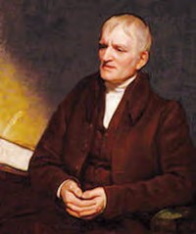

**Great Scientists**

Democritus named the small particles of elements ‘atom’ because in the Greek language *atomos* means indivisible.

In 1803, John Dalton proposed his theory stating that atoms cannot be created or divided into smaller particles or destroyed.

He used certain symbols to represent elements.

For example : © Copper, + Sulphur, ⊙ Hydrogen.



**Use your brain power !**

* + 1. Which elements are present in air ?
    2. Is carbon dioxide an element ?

Oxygen occurs in nature in the gaseous state. Two atoms of oxygen are joined to form a molecule of oxygen, which has an independent existence. Oxygen in air is always in molecular state. Just like atoms, molecules also cannot be seen with naked eyes.

* + 1. Are the atoms of different elements similar or dissimilar ?

What do the short forms Dr, H.M., AC, Adv., C.M., DC stand for ?



**Can you tell ?**

In day-to-day life, we use short forms in many places. A similar method is used to indicate elements.

|  |  |  |  |
| --- | --- | --- | --- |
| **Element** | **Symbol** | **Element** | **Symbol** |
| Hydrogen | H | Sodium | Na |
| Helium | He | Magnesium | Mg |
| Lithium | Li | Aluminium | Al |
| Beryllium | Be | Silicon | Si |
| Boron | B | Phosphorus | P |
| Carbon | C | Sulphur | S |
| Nitrogen | N | Chlorine | Cl |
| Oxygen | O | Argon | Ar |
| Fluorine | F | Potassium | K |
| Neon | Ne | Calcium | Ca |

The scientist, Berzelius, was the first to use the present method of using symbols for elements. The symbol of an element is written in the English script and is the short form of its name.

Some elements and their symbols are listed in the table alongside. When the initial letter in the names of two or more elements is the same, a pair of letters is used to write the symbol. For example, we write C for carbon and Cl for chlorine.

#### From the Internet or reference books, obtain information about elements and prepare a table according to the format given below.

|  |  |  |  |  |
| --- | --- | --- | --- | --- |
| **Name of the element** | **Symbol** | **Discovery of the element** | **State** | **Information and uses** |
|  |  |  |  |  |



**Can you tell ?**

1. Which metals do we use in day-to- day life ?



**Do you know ?**

The wire that we see in the electric bulb in our house is made of the element tungsten. Its symbol ‘W’ is derived from its German name ‘Wolfram’. Similarly the symbols of silver (Ag) and gold (Au) are derived from their Latin names Argentum and Aurum respectively. Elements occur in solid, liquid or gaseous state.

Some metals are difficult to use in pure form. For example, pure iron rusts in air, pure gold is very soft and bends easily. The properties of the original metal can be modified by mixing one or more elements in it. Such a mixture of metals is called an alloy. Brass, steel, twenty-two carat gold are a few examples of alloys.

1. Are metals elements ?

Elements are generally classified into two groups: metals and non-metals. We have studied the properties of metals such as malleability, ductility, conductivity of heat and electricity, density, lustre and sonority. The elements that do not show these properties are called non-metals, for example, phosphorus, sulphur, chlorine. The elements that show some properties of metals and some properties of non- metals are called metalloids. This is the third group of elements. Arsenic, silicon, selenium are examples of metalloids.



**Find out.**

#### Compounds



**Try this.**

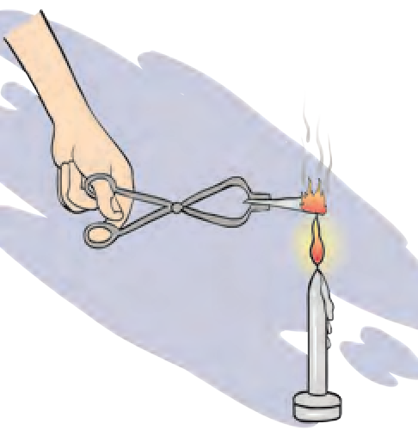

* 1. **Burning of**

**magnesium**

Which of the elements are metals, which are non-metals and which are metalloids ?

1. Take sugar in a test tube and heat the test tube. Observe what happens. What remains behind ?
2. Using tongs, hold a magnesium ribbon in a flame and observe. What changes took place in the above two experiments ?

In the first case, the sugar melts and then it loses water leaving behind a black substance. This black substance is carbon. What does this imply ? How many elements is sugar made of ?

What does the name carbon dioxide imply - how many and which elements is this substance made of ?

#### The substance formed by a chemical combination of two or more elements is a compound.

1. Which of these are compounds, which are elements - water, oxygen, carbon dioxide ?



2. What is the smallest particle of a compound called ?

**Always remember -**

A substance is a compound only if its molecules are made up of atoms of different types. Water is a compound. One molecule of water is made of two atoms of hydrogen and one atom of oxygen.

* 1. Which element helps combustion ?



**Can you tell ?**

* 1. Does water help combustion ?

Hydrogen is a combustible substance, that is, it burns. Oxygen helps combustion. But water, which is formed by a combination of hydrogen and oxygen is used to extinguish a fire. In other words, the properties of a compound are different from those of the constituent elements.

Like an element, a compound is also written in an abridged form. A molecule of a compound is formed by a chemical combination of atoms of two or more elements. Therefore, a molecular formula is used to represent a compound. A **molecular formula** of a compound is a short form of its name written with the help of the symbols of the constituent elements and the number of their respective atoms.

#### Collect information and prepare a table.

Constituent elements and molecular formulae of various compounds such as salt, alum, blue vitriol, ammonium chloride, baking soda, chalk, washing soda.

|  |  |  |  |  |
| --- | --- | --- | --- | --- |
| **Compound** | **Constituent elements** | **Symbol and number of atoms** | **Molecular formula** | **Characteristics** |
| Water |  |  | H2O |  |

#### Mixtures

1. Prepare a sherbet. 2. Prepare a *bhel*.



**Try this.**

Did the taste of the original ingredients change due to the above processes ?

A mixture is formed by mixing different elements or compounds. The proportion of various components in a mixture is not fixed. No chemical change takes place during the formation of mixtures and no new substance is formed.



**Can you tell ?**

1. What are the mixtures used in everyday life ?
2. Are all mixtures useful to us ?
3. How will you separate each component from a mixture of semolina, salt and iron filings ?

You might remember that mixing unwanted substances in any foodstuff is called adulteration. In other words, an adulterated foodstuff is also a kind of mixture.

When an unwanted and harmful substance is mixed with another substance the resulting mixture no longer remains useful. In such cases, we separate the unwanted ingredients from the mixture. For this purpose, simple and easy methods such as straining (filtering), sifting, picking, sorting, winnowing, combing with a magnet and sublimation are used. Which ingredients, from which mixtures could be separated by using these methods ? We have learnt about the properties of matter and the effects of heat. These properties are also used for separating the components of a mixture.

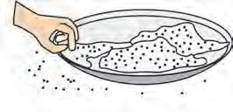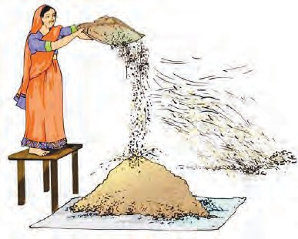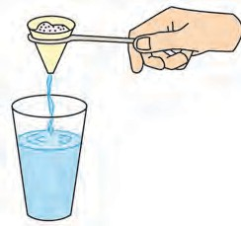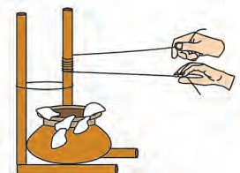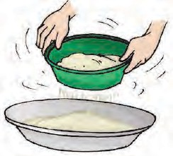

**Observe and discuss.**

#### Method of distillation

* 1. **Some methods of separating the components of a mixture.**

Take some salt water in a round-bottom flask. Arrange the apparatus as shown in the figure. Start heating the liquid in the flask placed on the wire gauze. Observe the conical flask. Slowly droplets of water start falling into it. Where did these drops come from ?

The salt water in the round- bottom flask boils on heating. The water in it vapourizes. When the vapour passes through the inclined tube, it gets cooled due to the surrounding cold water and condenses to form water. Thus, the drops falling into the conical flask are of the water from the salt solution in the round-bottom

**Stand**

**Thermometer**

**Round-bottomed flask**

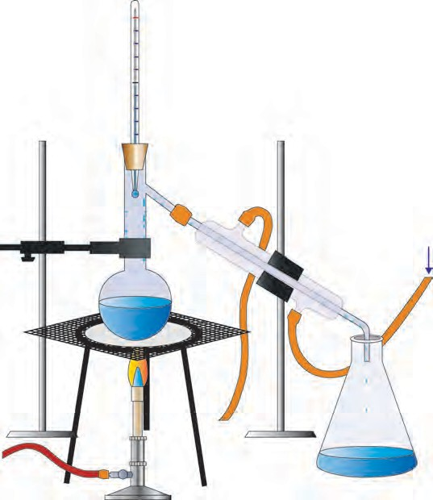

**Net**

**Water**

**Condenser Water**

flask. Salt remains behind at the bottom of the round-bottom flask when all the water has collected in the conical flask. This method is

**Burner**

**Water Tripod stand**

**Flask**

called distillation. Distillation is also used for purification of impure liquids.

* 1. **Distillation method**
     1. Is the water that falls from clouds naturally pure ?



**Use your brain power !**

* + 1. Which properties of a liquid are seen in the distillation method ?
    2. For what purposes is distilled water used ?

#### Method of separation using separating funnel

When a mixture of two immiscible liquids is left undisturbed two layers are clearly seen to have formed. The heavier of the liquids remains below and the lighter liquid floats on it. Two liquids in a mixture can be separated by making use of this property.

**Procedure :** Pour a mixture of kerosene and water into a separating funnel with its stopcock closed. Close the stopper. Fix the separating funnel firmly on a stand. Leave the mixture in the funnel undisturbed for a while. Water will remain below and kerosene will float on it.

**Separating funnel**

**Kerosene Water**

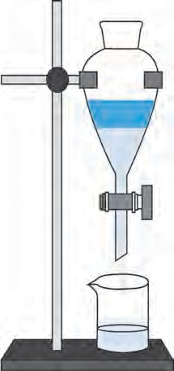

**Stopcock**

Now, without shaking the funnel remove the stopper. **Beaker**

Open the stopcock to collect the water at the bottom of

the funnel, in a beaker. Close the stopcock when all the water is collected in the beaker. Now, kerosene and water

**Water**

are separated. **14.5 Separation method**

#### Method of centrifugation

Turbid water, ink, milk, buttermilk, blood are mixtures of liquids and insoluble solids. When turbid water is kept undisturbed for a while, the soil particles in it slowly settle to the bottom. The particles of milk or ink, however, do not settle even on being left undisturbed. This is because the particles of the solids in such mixtures, being very tiny and light, remain evenly distributed in the liquid. These particles cannot be separated from the liquid even by methods like filtration or settling.

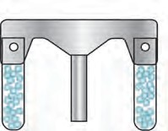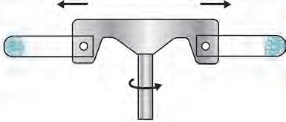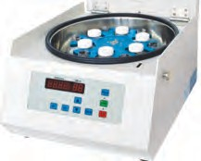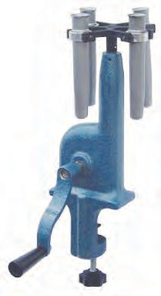

How will you separate such solid particles from the liquid ? In the laboratory, a centrifuge machine is used to separate solids from a mixture of a liquid and solid.

In consists of a disc, which rotates like a fan at great speed. There is a provision to attach test tubes at the rim of this disc.

When the tubes attached to the disc rotate at high speed, a force is generated which pushes the particles away from the centre. As a result, the solid particles in the mixture in the test tubes collect at the bottom of the tubes and are thereby separated from the liquid.

#### Method of chromatography

**Electrical centrifuge**

* 1. **Centrifuge**

**Manual centrifuge**

If two or more substances are dissolved in small proportions in the same solution, these substances are separated from each other by means of chromatography. This method is used in pharmaceutical science, factories and scientific laboratories for detecting new ingredients and for identifying and separating components of a mixture.

**Procedure :** Take some water in a beaker. Take a rectangular piece of a filter paper. Put one spot of blue ink on it about

2 cm away from one edge. Keep this paper upright in the water in the beaker. Place a lid on the beaker. After some time, the spot of the ink is seen to have risen and collected at a particular height on the filter paper. If there are two or more constituents of different colours in the ink, they will be seen to have risen to different heights due to their different colours and thus appear distinct from each other. This experiment can be done using a chalkstick instead of the filter paper.

In this method of separation called chromatography, two properties of substances are used. These are the solubility of the substance in the solvent that moves up and the ability of the substance to stick to the stationary filter paper. These properties are mutually opposite and are different for different substances. As a result, all the components of the mixture do not rise all the way to the upper end of the filter paper, but remain behind at different heights.

**Filter Paper**

**Spot of Ink**

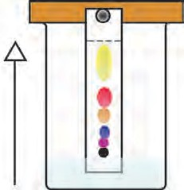

**Water**

* 1. **Chromatography**



**Exercise**

* + 1. **Who are my companions ? Group ‘A’ Group ‘B’**
       1. Stainless steel (a) Non-metal
       2. Silver (b) Compound
       3. *Bhajani* mixture (c) Mixture for milling
       4. Salt (d) Element
       5. Coal (e) Alloy
       6. Hydrogen (f) Metal
    2. **Write the names of elements from the following symbols : Zn, Cd, Xe, Br, Ti, Cu, Fe, Si, Ir, Pt.**
    3. **What are the molecular formulae of the following compounds ?**

Hydrochloric acid, sulphuric acid, sodium chloride, glucose, methane.

* + 1. **Give scientific reasons.**

1. Buttermilk is churned to get butter.
2. In chromatography, the ingredients of a mixture rise up to a limited height when water rises up to the upper end of the paper.
3. A wet cloth is wrapped around a water storage container in summer.
   * 1. **Explain the difference.**
4. Metals and non-metals
5. Mixtures and compounds
6. Atoms and molecules
7. Separation by distillation and by separating funnel
   * 1. **Write answers to the following questions in your own words.**
8. How are the components of mixtures separated by simple methods ?
9. Which elements (metals and non- metals), compounds and mixtures do we use in our day-to-day life ?
10. In everyday life, where and for what purpose do we use centrifugation ?
11. Where are the methods of separation by distillation and by separating funnel used ? Why ?
12. Which precaution will you take while using the methods of distillation and separation by separating funnel ?

**Project :** Visit a jaggery or a sugar factory. Obtain information about the methods that are used to separate the components of the mixture while making jaggery or sugar. Present it in the class.

⧫  

99

**15. Materials we Use**

* 1. What is meant by natural and man-made materials ?



**Let’s recall.**

* 1. Make a list of natural and man-made substances you see around you.

We have learnt that, a new substance produced by the chemical processing of natural substances is called a man-made substance. In this lesson, we will learn about some substances of daily use.



**Can you tell ?**

* + 1. Which substances were used earlier, for cleaning teeth ?
    2. What do we use today to clean our teeth ?



**Do you know ?**

In the period prior to 500 BC, in countries such as China, Greece, Rome, toothpaste was made by mixing the powder of bones and shells. Toothpaste, of which soap was the ingredient, came into use in the 19th century. Later, toothpaste was made using a chalk-like material. The first commercial toothpaste was made by the Colgate company in New York city in 1873.

We have seen that in olden times in India, acacia bark, neem twigs, coal powder, ash, tooth powder, salt, pomegranate rind were used for cleaning teeth. Today, however, a variety of toothpastes and tooth powders are used for this purpose.

#### Toothpaste

The principal ingredients of a toothpaste, calcium carbonate and calcium hydrogen phosphate, remove the dirt on teeth. These ingredients also polish the teeth. A certain proportion of

flouride in the toothpaste helps prevent tooth decay. Fluoride is essential for the strengthening of bones and the enamel covering of teeth.

1. What is the source of the fluoride in a toothpaste or tooth powder ?



**Find out.**

1. Note down all the information given on a tooth powder/ toothpaste container or carton and discuss.

#### Detergents

The word ‘detergent’ is derived from the Latin word ‘*detergere*’ which means ‘to wipe away’. A detergent is ‘a substance that cleans or wipes away dirt.’ Soap nut (*ritha*), soap pod (*shikekai*), soap, washing soda, washing powder, liquid soap, shampoo are all detergents.

* 1. What do we use for cleaning our body ?



**Can you tell ?**

**Apparatus :** A clean glass bottle, water, oil, detergent, etc.

**Procedure :** Take some water in a clean glass bottle. Add some oil to it. The layer of oil will float on the water. Shake the bottle vigorously. After some time, when the liquid in the bottle settles, the oil will again be seen floating on the water.

Now add a few drops of the solution of a detergent to the above mixture. Shake the bottle vigorously. You will see that the water and oil have become homogeneous and the colour of the mixture appears milky.

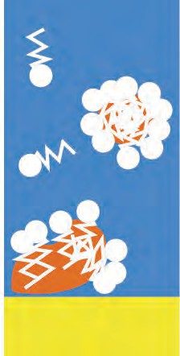

**Molecule of water**

**Molecule of detergent**

**Molecule of oil**

**Surface of cloth**

#### Why does this happen ?

The molecules of a detergent are long and the properties of its two ends are different. A molecule of a detergent holds on to a water molecule at one end and an oil molecule at the other. As a result, the molecules of oil mix with the water. This is how soap acts when we wash ourselves or our soiled clothes. Our body and clothes become oily for various reasons such as applying gels or creams, oiling our hair, etc. The oily layer sticks fast to the criss-crossing threads of the material of our clothes. Soap is used for removing it. Due to the property of holding on to both oil and water, soap water spreads easily on many types of surfaces. The property of a substance of spreading on a surface is called **surface**

**activity** and the substance is said to be a **surfactant**. Detergents are surface active. One effect of surface activity is lather formation.

#### Natural detergent

Soap nut (*ritha*) and soap pod (*shikekai*) are the natural detergents in common use. They contain a chemical named

* 1. **Action of detergents**

**Soap**

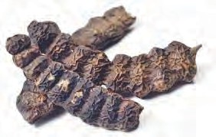

saponin. Soap nut and soap pod do not have any harmful effect on human skin or on silk and woolen threads and cloth.

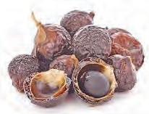

#### Man-made detergent

**Soap :** Soap is a man-made detergent which has been in use since ancient times. It is believed that soap was invented in the west about 2000 years ago. In those days, soap was prepared using animal fat and wood ash. Today we come

**Soap nut**

**pod**

across a variety of soaps.

* 1. **Natural detergents**

**Types of soaps :** Hard soap is used for washing clothes. It is a sodium salt of fatty acids. Soft soap is used for bathing. It is a potassium salt of fatty acids. It does not cause irritation of the skin.

As per the use of the

detergent, additives perfumes germicides,

supporting

such

as dyes,

anti-foaming

alcohol, agents,

moisturizers, fine sand, etc. are mixed with different detergents to give them certain useful properties.

In the hard water of a well or a tube-well, soap does not give lather but forms a scum. As a result, soap loses its cleansing property.

#### Synthetic detergent

Now synthetic detergents have taken the place of soap. There are several methods of producing these detergents. The long structural units in the synthetic detergents are obtained from raw materials which are mainly fats or kerosene. Detergents are obtained by subjecting these raw materials to a variety of chemical processes. Synthetic detergents are used in many types of cosmetics. Synthetic detergents can be used in hard water as well.

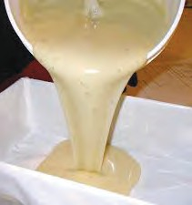

**Try this.**

* 1. **Making soap**

soap using the mould.

#### Preparation of soap

**Material :** 15g sodium hydroxide, 60 ml coconut oil, 15g salt, perfume, a glass rod, beaker, tripod, wire gauze, burner, water, mould, etc.

**Procedure :** Take 60 ml coconut oil in a beaker. Dissolve 15g sodium hydroxide in 50 ml water. Mix the sodium hydroxide solution in the oil slowly while stirring it with a glass rod. Heat the mixture, and boil it for 10-12 minutes, stirring it all the while. Take care that the mixture does not boil over while heating. Dissolve 15 g salt in 200 ml water. Pour this solution into the above mixture and stir. The soap formed by the chemical reaction now floats on the water. After some time, it becomes thick. Now, separate the thick soap and add the perfume to it. Shape the bar of

In the above process, fat and alkali combine to form salts of fatty acids. Chemically, soap is a sodium or potassium salt of fatty acids.

#### Cement



* 1. **Houses**
  2. **Cement**
     1. What are the materials used for construction ?
     2. Which of the houses seen in the pictures here have a strong structure ? Why ?



**Can you tell ?**

#### Cement production

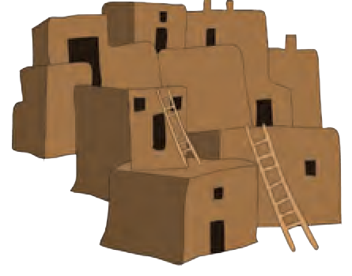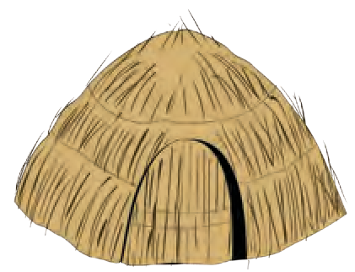

Cement is an important material in construction. Sheets, blocks, pillars and pipes are made from concrete produced from cement. Cement is a dry, greenish grey powder with fine particles. It is made from silica (sand), alumina (aluminium oxide), lime, iron oxide and magnesia (magnesium oxide).

Portland cement is the most commonly used cement for construction work. It is made from raw material which consists of 60% lime (calcium oxide), 25% silica (silicon dioxide), 5% alumina. The rest is iron oxide and gypsum (calcium sulphate). Portland cement gets its name from the stone quarried from the Isle of Portland in England, which has a similar texture.

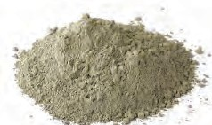In ancient times, the Romans had made cement as well as concrete. They used to make aqueous cement by mixing volcanic ash in moistened lime. It was a very durable cement. With the decline of the Roman empire, this art of making cement was also forgotten. In 1756, the British engineer, John Smeaton developed the method of making aqueous cement.

#### Concrete

Concrete is prepared by mixing cement, water, sand and gravel. For making a strong and leak proof slab certain substances are mixed in concrete.



**Find out.**

* + - 1. Nowadays, why are the roads made of concrete ?
      2. What causes the hardness of water ?



**Exercise**

1. **Fill appropriate terms in the blanks. (white cement, soap, detergent, wearing of bones, tooth decay, hard, soft, Portland, fatty acid)**
   1. The substance that helps water to remove dirt from the surface of materials is called ……….. .
   2. Fluoride is used in toothpaste to prevent ……. .
   3. Soap is a salt of and

sodium hydroxide.

* 1. Synthetic detergents can be used in

……….. water as well.

* 1. For construction purposes …………. cement is the most commonly used cement.

1. **Write answers to the following questions.**
   1. How does the use of a detergent help to clean soiled clothes ?
   2. How will you check with the help of soap powder whether water is hard ?
   3. What are the important ingredients of a toothpaste , and what is the function of each ?
   4. What are the ingredients of cement ?
   5. What will happen if cement is not used in making concrete ?
   6. Make a list of detergents that you use.
   7. What should be expected from a detergent for delicate garments ?
   8. What is meant by ‘surface activity’ ? Name three chemicals responsible for the surface activity of various detergents.
2. **What are the similarities and differences between -**
   1. Natural detergents and man-made detergents
   2. Soap and synthetic detergent
   3. Bath soap and soap for washing clothes
   4. Modern cement and ancient cement
3. **Explain why -**
   1. Soap cannot be used in hard water.
   2. Oil does not mix in water. However, oil and water become homogeneous if a sufficient quantity of detergent is added.
   3. Synthetic detergents are superior to soap.
   4. Often coloured spots are formed on clothes during washing.
   5. Tobacco *masheri* should not be used for cleaning teeth.

**Project :**

1. Visit a cement factory. See how cement is prepared and discuss the process.
2. Write a conversation based on cement houses, mud-houses and wattle-and-daub houses.

⧫  

**16. Natural Resources**

* 1. What is meant by natural resources?



**Let’s recall.**

* 1. Give some examples of natural resources.

We get many substances from nature. They satisfy a variety of our daily needs. Soil, stones, minerals, air, water, plants and animals on the earth are all various kinds of natural resources.



**Let’s recall.**

What is meant by lithosphere ?

#### Natural resources in the earth’s crust

Metals

are

obtained from their ore by extraction and purification. Impurities of sand and soil in an ore are called ‘gangue’.

The earth’s lithosphere is made up of land and the hard crust beneath it. The lithosphere is not homogeneous but is made up of many types of rocks. Resources in the earth’s crust include minerals, ores, mineral oil and other fuels, rocks, water, elements, etc.

#### Minerals and ores

Mineral wealth has an important place among natural resources. Minerals are formed by various processes taking place in the environment.



**Use your brain power !**

1. Why are all minerals not ores ?
2. What is meant by ‘metal mineral’ and ‘non-metal mineral’ ?

The rocks on the earth are mainly made of minerals. These minerals can be obtained by mining.

Only a few metals like, for example, gold, silver, copper, platinum and bismuth occur in the free state in nature. A majority of the metals occur in the form of compounds. Minerals that contain a high proportion of metal are called ores. It is economical to obtain metals from ores. The properties of minerals become clear from their characteristic colour, lustre, hardness, shape (length), cleavage or fracture and streak.

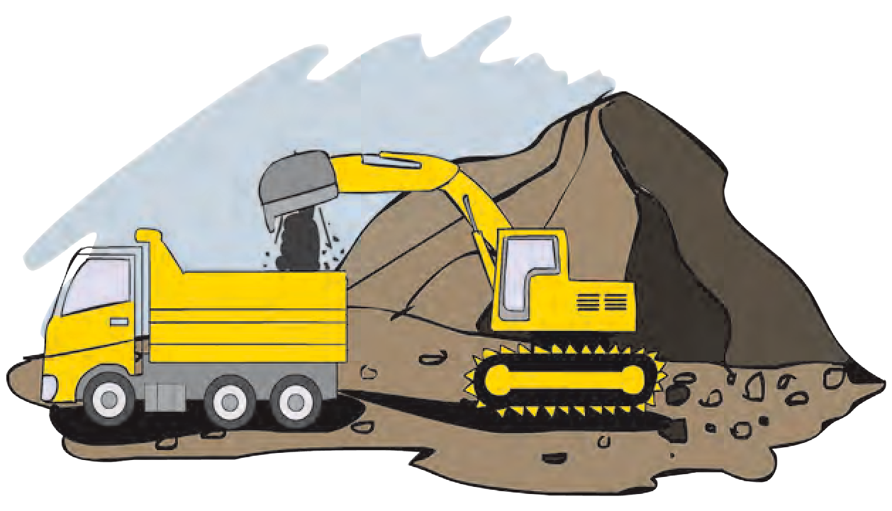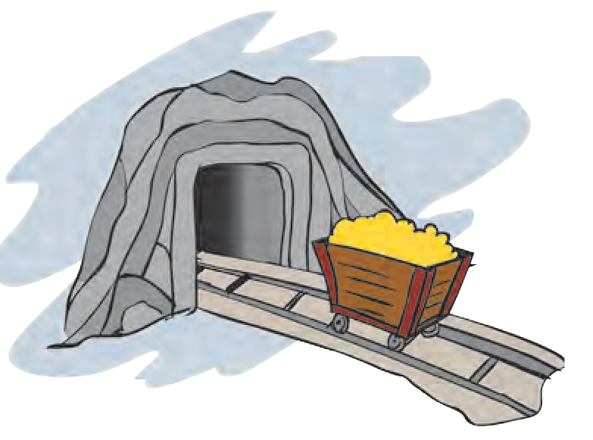

* 1. **Mining**

#### How are minerals formed ?

|  |  |  |  |
| --- | --- | --- | --- |
| Minerals are formed from the magma in the earth’s crust and the lava from the eruption of  volcanoes, when they cool and get transformed into crystals.    **Magnetite**  **Mica** | Minerals are formed when solid crystals remain behind after the process of evaporation.    **Halite**    **Gypsum** | Minerals get transformed from one form into another due to large changes in  temperature and pressure.  **Diamond**    **Graphite** | Some living organisms produce inorganic minerals. e.g., conches, shells, etc. formed for the protection of the body.    **Shell** |

**Classification of minerals according to their properties.**

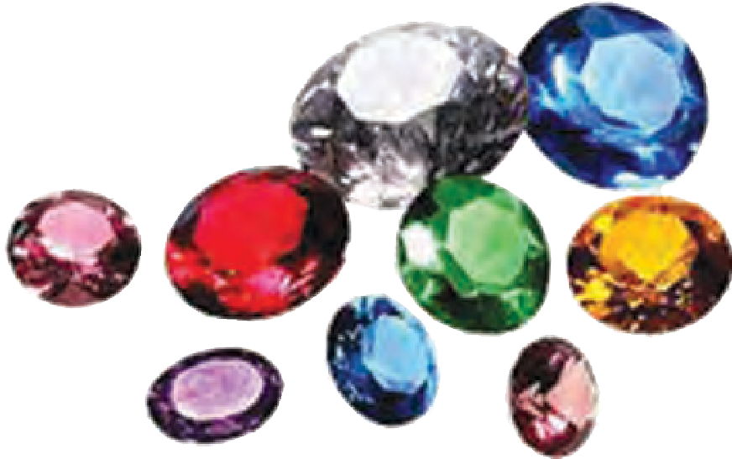

**Gems and gemlike minerals**

Some important minerals like diamond, ruby, sapphire, emerald, jade, zircon are used as gems. Gems are in great demand.

|  |  |  |
| --- | --- | --- |
| **Non-metal**  **minerals** | **Metal**  **minerals** | **Energy**  **minerals** |
| Mica, sulphur, gypsum, potash, graphite, diamond, feldspar. | Iron, gold, silver, tin, bauxite, manganese, platinum, tungsten. | Coal, mineral oil, natural gas. |

Pictures of various minerals. [www.rocksandminerals4u.com/mineral](http://www.rocksandminerals4u.com/mineral)

**National Institutions**

The Indian School of Mines, Dhanbad, was founded in 1926 to impart education in mining. This institute has now been converted into an **Indian Institute of Technology**.



**Do you know ?**

Deposits of common salt are also found in the earth. This salt is called rock salt. It is used in food and in some medicines.



**My friend, the internet !**

Obtain videos related to mining from YouTube and present them in the class.

#### Some important minerals and ores

1. **Iron ore :** Iron occurring in the impure state is called iron ore. Iron ore is used to make a variety of articles from pins to heavy machinery. For example, farming implements, rails of railway tracks, etc.

The four main ores of iron are magnetite, haematite, limonite and siderite.

1. **Manganese :** Manganese occurs in the form of its carbonate, silicate and oxide. Compounds of manganese are used in the preparation of medicines and for giving a pink tinge to glass. Manganese is also used in electrical appliances.
2. **Bauxite :** Bauxite is the most important ore of aluminium. It contains 55% aluminium. Bauxite consists mainly of aluminium oxide. Aluminium is a very good conductor of electricity and heat. Its density is low. Therefore, it is used mainly in aeroplanes, transport vehicles and to make electric wires.
3. **Copper :** Copper is found in the impure state in the vicinity of iron and other minerals. Copper is a very good conductor of electricity. Therefore, it is used to make electric wires as well as in radios, telephones, vehicles, and for making kitchen utensils and statues.
4. **Mica :** Mica is a bad conductor of electricity. Its value depends on the thickness of its layers. Mica has many uses such as in ayurvedic medicines, dyes, electric machines and equipment, wireless communication equipment, etc.

#### Fuel

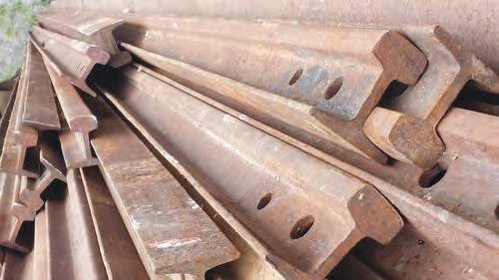

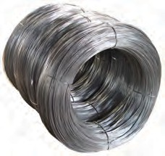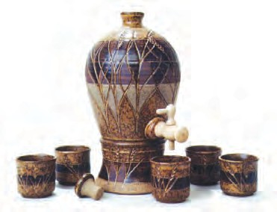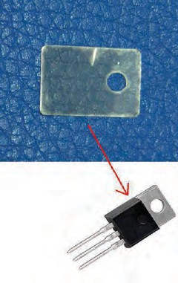

* 1. **Uses of minerals**



**Find out.**

How did the various ages of the prehistoric period get their names on the basis of the use of metals ?

* + 1. What is meant by fuels?
    2. Which natural resources do we use as fuels?



**Can you tell ?**

Various substances are used in day-to-day life for generating

energy. These substances are called fuels. Fuels are found in the solid, liquid or gaseous state.

#### Coal

Millions of years ago, forests got buried underground as a result of certain natural events. Layers of soil kept getting deposited over them. The very high pressure from above and the heat from the earth’s interior, slowly transformed the buried plants into fuel. Coal was thus formed from the remains of those plants. That is why coal is said to be a fossil fuel.

Coal is found in mines. Peat, lignite (brown coal), bituminous coal and anthracite are the various types of coal. Anthracite is the coal of the highest grade.

Coal is, in a way, a storehouse of carbon. It is burnt to obtain heat energy. Coal is used as fuel. It is used as a fuel in thermal power plants as well as to run boilers and railway engines. Coal is also

* 1. **Formation of coal**

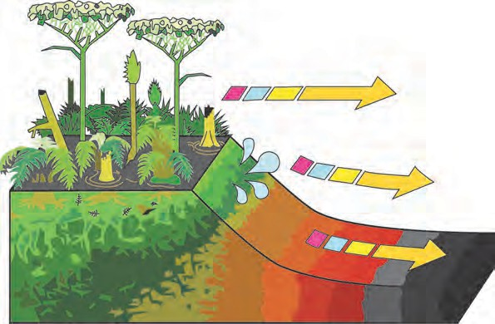

**Time**

**Pressure**

**Heat**

used as a fuel for cooking and for baking bricks in kilns on a large scale. The gaseous fuels, producer gas and water gas, are obtained from coal. Coal, as an energy resource, contributes greatly to industrial development.

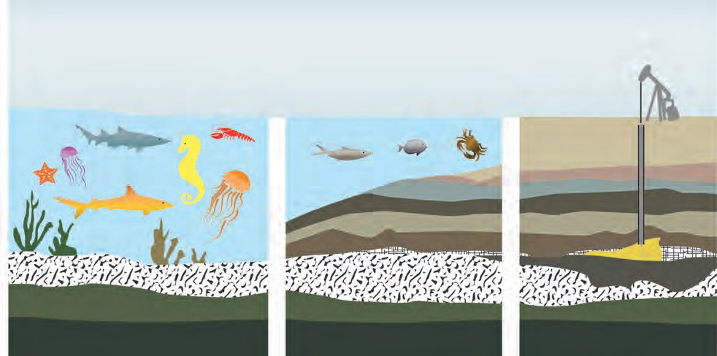

**Observe and discuss.**

How were mineral oil and natural gas formed ?

**Millions of years ago**

**Thousands of years ago**

**At present**

* 1. **Formation of mineral oil and natural gas**

**National Institutions**

The Oil and Natural Gas Corporation (ONGC) was established on 14th August 1956. It functions under the ministry of Petroleum and Natural Gas of the Government of India. ONGC is the largest oil and gas research and production company in India. Its head office is at Delhi. ONGC produces about 77% of the crude oil and about 62% of the natural gas produced in India. Of the seven commercially important underground oil reserves in India, ONGC has successfully explored six.

**Natural gas**

Natural gas is an important fossil fuel. It is found associated with petroleum in underground oil wells and in some places as natural gas alone. The main component of natural gas is methane (CH4) while ethane (C2H6), propane (C3H8) and butane (C4H10) are present in small proportions.

Natural gas is formed from the remains of organisms buried deep underground and subjected to high pressure. This fuel can be carried over long distances by means of a gas pipe line. But in the absence of a network of pipelines, it is transformed under high pressure into compressed natural gas (CNG) and liquefied natural gas (LNG). This makes it possible to transport the gas.

**Characteristics of CNG:**

1. Catches fire easily.
2. No solid waste remains after combustion.
3. Carbon dioxide and water are formed in small quantities.
4. Other pollutants are not produced.
5. Can be transported easily.
6. Combustion can be controlled easily.

**Mineral oil**

Mineral formed by organic

oil is the liquid fuel

the

decomposition

of

substances

buried

underground. Millions of years ago, bodies of dead sea organisms sank to the bottom of the sea. Layers of soil and sand collected on them. Due to high pressure and temperature the remains of the dead organisms were transformed into mineral oil.

The underground mineral oil is extracted through oil wells. Mineral oil is found mainly in oil sands, shale, sandstone and limestone at a depth of about 1000 to 3000 metres.

Mineral oil is also known as petroleum or crude oil. It is greenish brown in colour. Petroleum is a mixture of many compounds mainly of the hydrocarbon type. It also contains compounds of oxygen, nitrogen and sulphur. Petroleum is extracted through oil wells and refined by fractional distillation to separate other components. Aviation petrol, gasoline, diesel, kerosene, naphtha, lubricating oil, tar are all obtained from petroleum. They are used as fuel and for production of dyes, pesticides, perfumes and artificial fibres.



**Do you know ?**

Fossils are the preserved remains of dead organisms in rock. Fossils are the signs of their existence left behind by organisms that got buried billions of years ago. Sometimes impressions of the organisms are seen on the surfaces of coal and stones.



**Use your brain power !**

1. Why is mineral oil called ‘liquid gold’ ?
2. Why is coal called ‘black gold’ ?
3. What would happen if underground mineral resources are exhausted ?



**Do you know ?**

**Liquified Petroleum Gas (LPG)**

Petroleum gas is obtained during refining of crude petroleum. Petroleum gas is transformed into a liquid by subjecting it to high pressure and reducing its volume to 1/240 of the original. It is stored in thick-walled steel cylinders so that under pressure it remains in the liquid state. As it comes out from the storage cylinder it is transformed back into a gas. This gas contains mainly two components, propane and butane, in the ratio 30:70. It is an odourless gas; but a small amount of a chemical called ‘ethyl mercaptan’ which has a strong characteristic odour is added to it. This helps to detect any leakage of LPG gas immediately and thus, avoid any accident.

Why is natural gas an eco-friendly fuel ?



**Use your brain power !**

The demand for fuels has increased greatly due to the rapidly growing population but the reserves of fossil fuel are limited. It is becoming difficult to meet the increased demand. The likelihood of these reserves getting exhausted is known as the energy crisis.

As the reserves of fossil fuels, namely, mineral oil and coal are limited and the demand is increasing, alternative fuels are coming into use. Hydrogen, biofuels, methanol or wood alcohol, ethanol or green alcohol are some of the alternative fuels.

#### Forest resources

**Protective functions of forests**

1.

2.

3.

4.

5.

6.

7.

To reduce the velocity of water flowing over the land.

To prevent soil-erosion.

To help percolation of water into the ground.

To control floods.

To reduce the rate of evaporation. To protect wildlife.

To

maintain

the balance of

atmospheric gases.

Thus, forests help improve and maintain the quality of the environment.



**Can you tell ?**

1. What is meant by forests ?
2. What are their uses ?

An extensive area of land covered by a variety of plants is called a forest. A forest is a natural habitat of plants, animals and microbes. About 30% of the total land of the world is covered by forests. Forests perform certain specific protective and productive functions.

From your Geography textbook and other reference books, collect information about the various forests in India and the extent of land covered by them.



**Books, my friends !**

#### Medicinal plants

**Productive functions**

**Wood :** We get strong and durable wood as also firewood from trees like teak, mahogany, neem, acacia, *subabhul*. Wood is used for making furniture, farming implements and various other articles as well as in construction work.

|  |  |
| --- | --- |
| **Plant** | **Medicinal use : for treatment of** |
| Adulsa Bel Neem  Periwinkle Cinnamon  Cinchona | Cough and cold Diarrhoea Fever and cold Cancer  Diarrhea, nausea  Malaria |

Forest wealth includes fibres, paper, rubber, gum and aromatic substances. We get fragrant essential oils from

Prepare a list of medicinal plants like *ashwagandha, shatavari, amla, hirda, behda, tulsi* and their uses. Take the help of your grandparents or people in your neighbourhood who have knowledge of plants to obtain this information.

lemon grass, vanilla, *kewada*, vetiver (*Khus*), and eucalyptus. Sandalwood and oil of eucalyptus are used for making soaps, cosmetics and incense sticks. In addition, we get various fruits, bulbs and roots, honey, sealing wax, catechu, dyes, etc. from forests.

#### Use your brain power !

1. What useful things will we have to do without if rubber is no longer available ?
2. What are the adverse effects of clearing of forests or cutting down trees ?

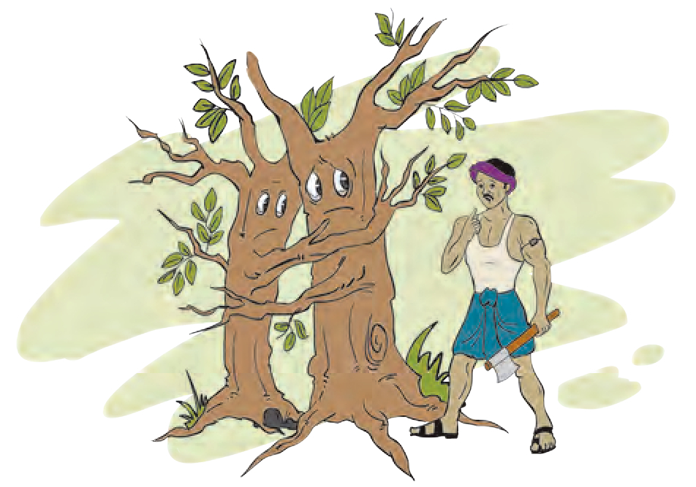

#### How to conserve forests ?

* 1. Young trees should not be cut.
  2. Many more trees, than are cut down, should be planted and looked after.
  3. The stringent restrictions / laws / regulations regarding use of forests should be strictly followed.

#### Ocean resources

1. Name the oceans of the earth.



**Let’s recall.**

1. How is seawater useful to us, even though it is salty ?

We have learnt that oceans occupy a greater part of the earth’s surface than land does.

Energy can be obtained on a large scale from oceans. Sea waves at high and low tide and ocean currents are being used for generation of power. Last year, we have learnt something about this in Geography. There are reserves of a variety of natural resources in seawater, at the bottom of the sea and beneath the seabed, too. These resources available from seas and oceans are called marine resources.

#### Mineral and bio-resources from oceans

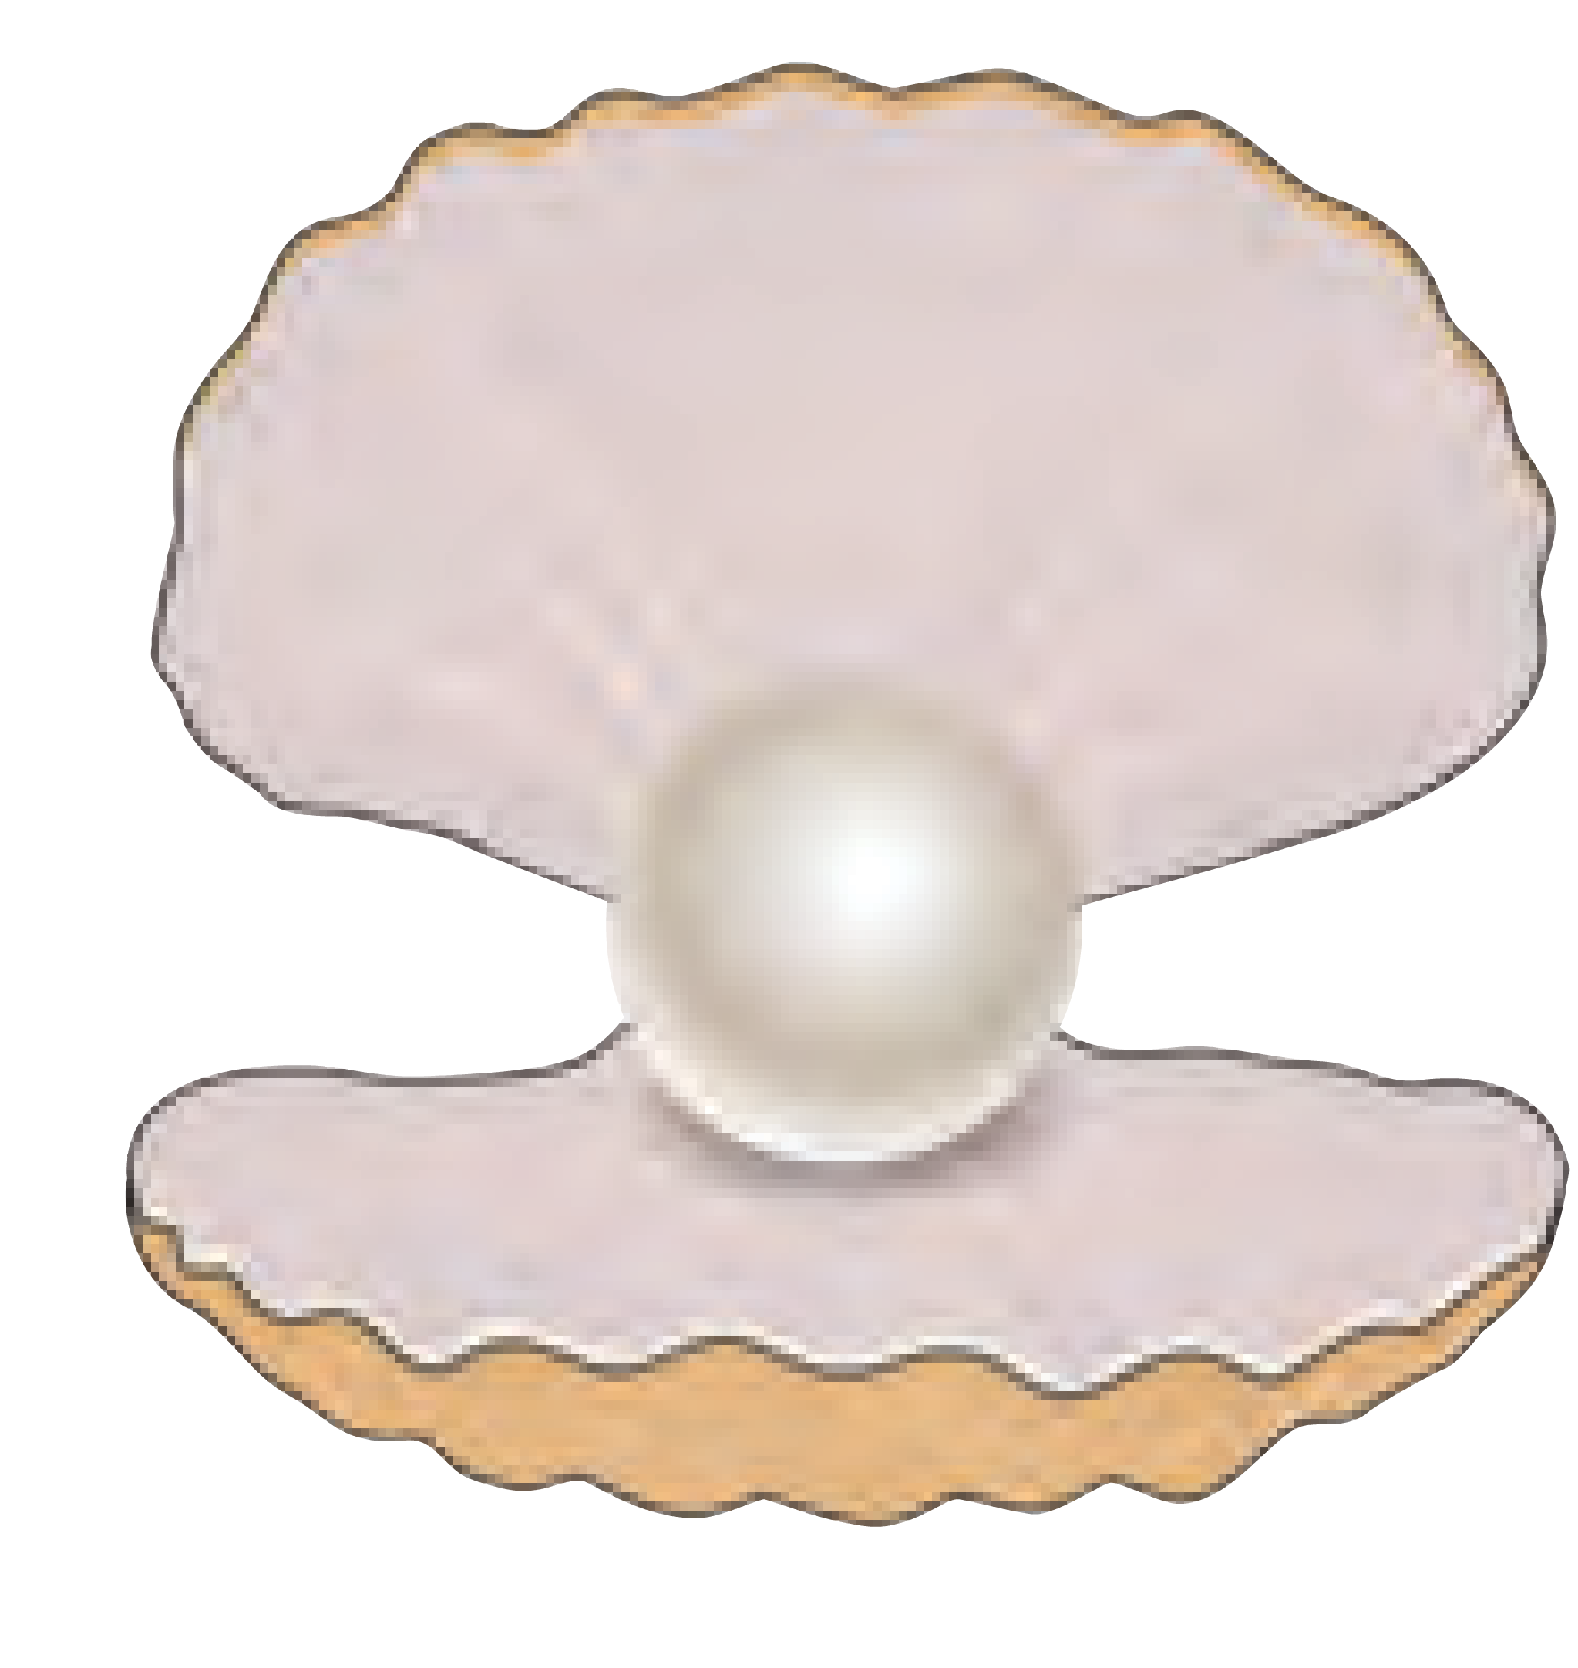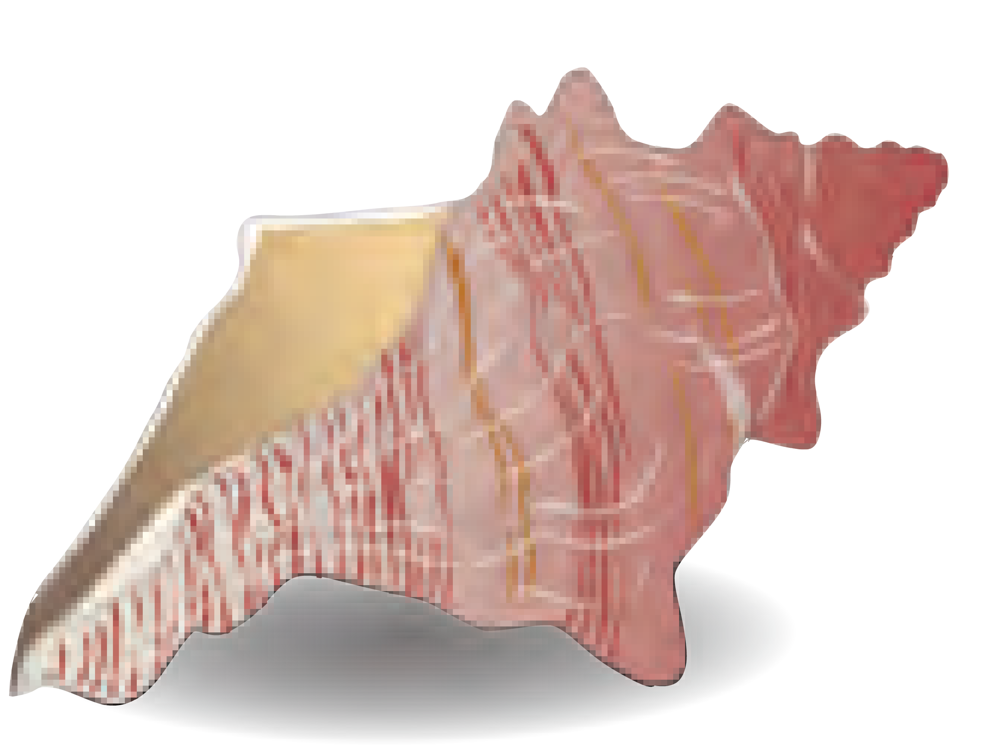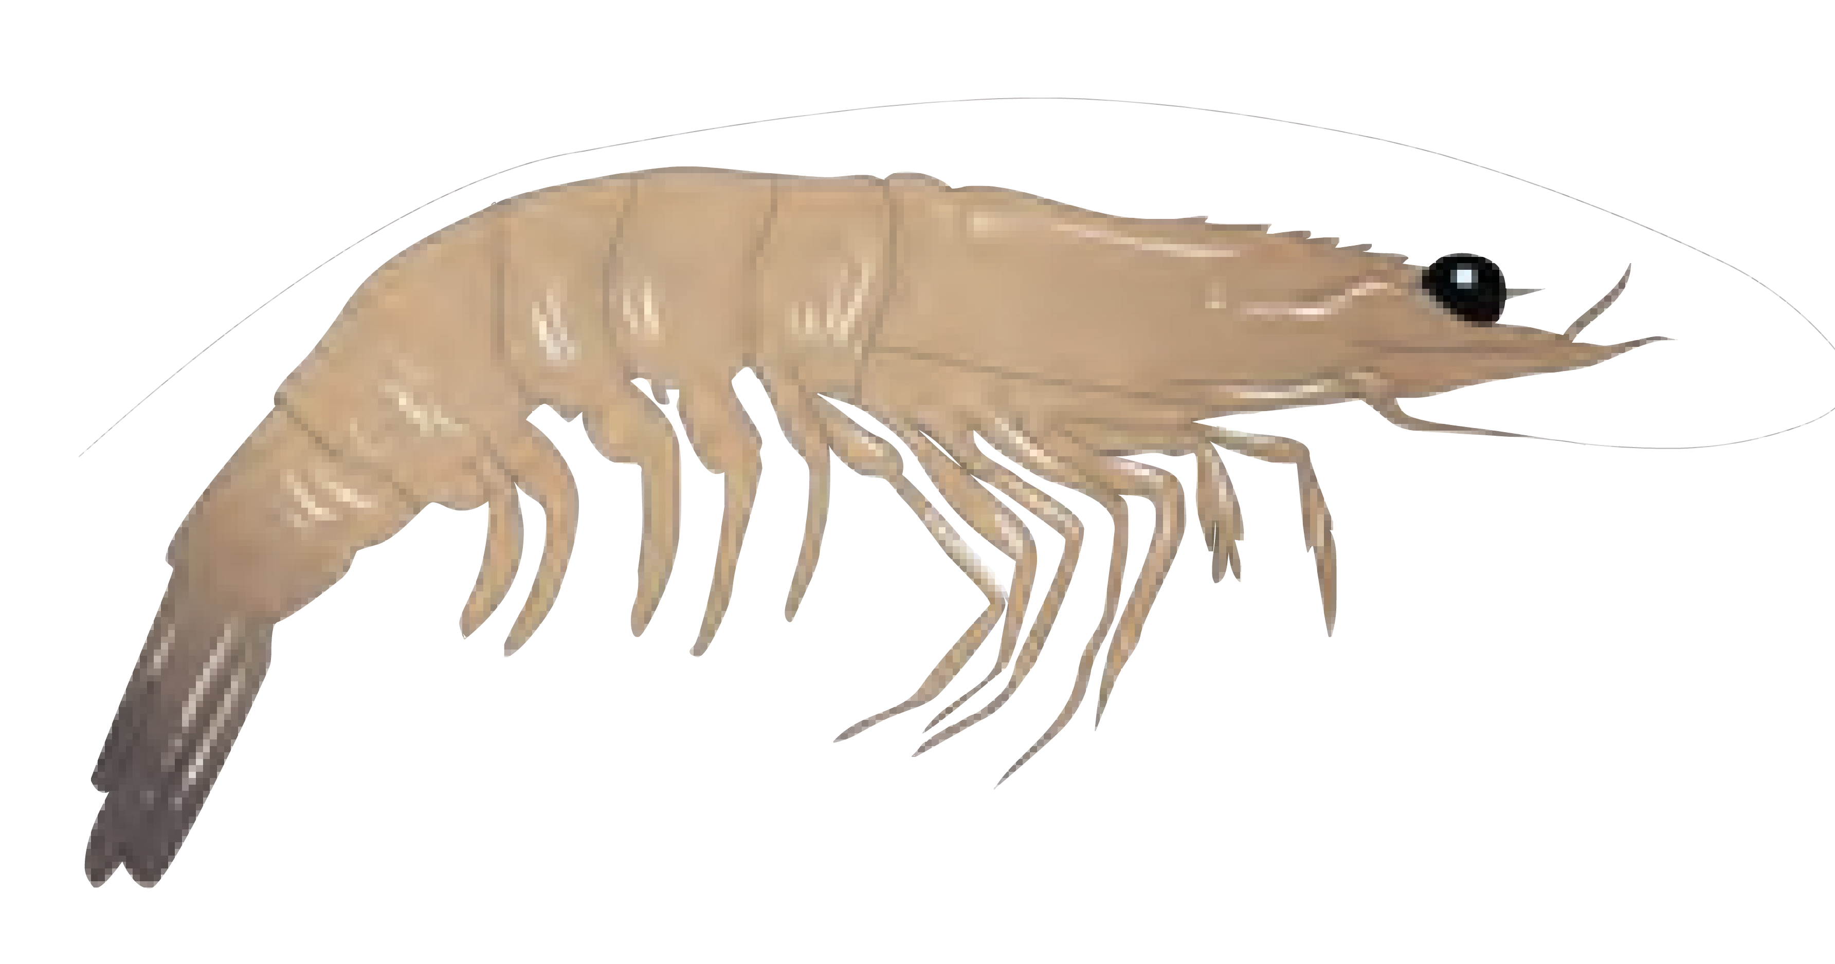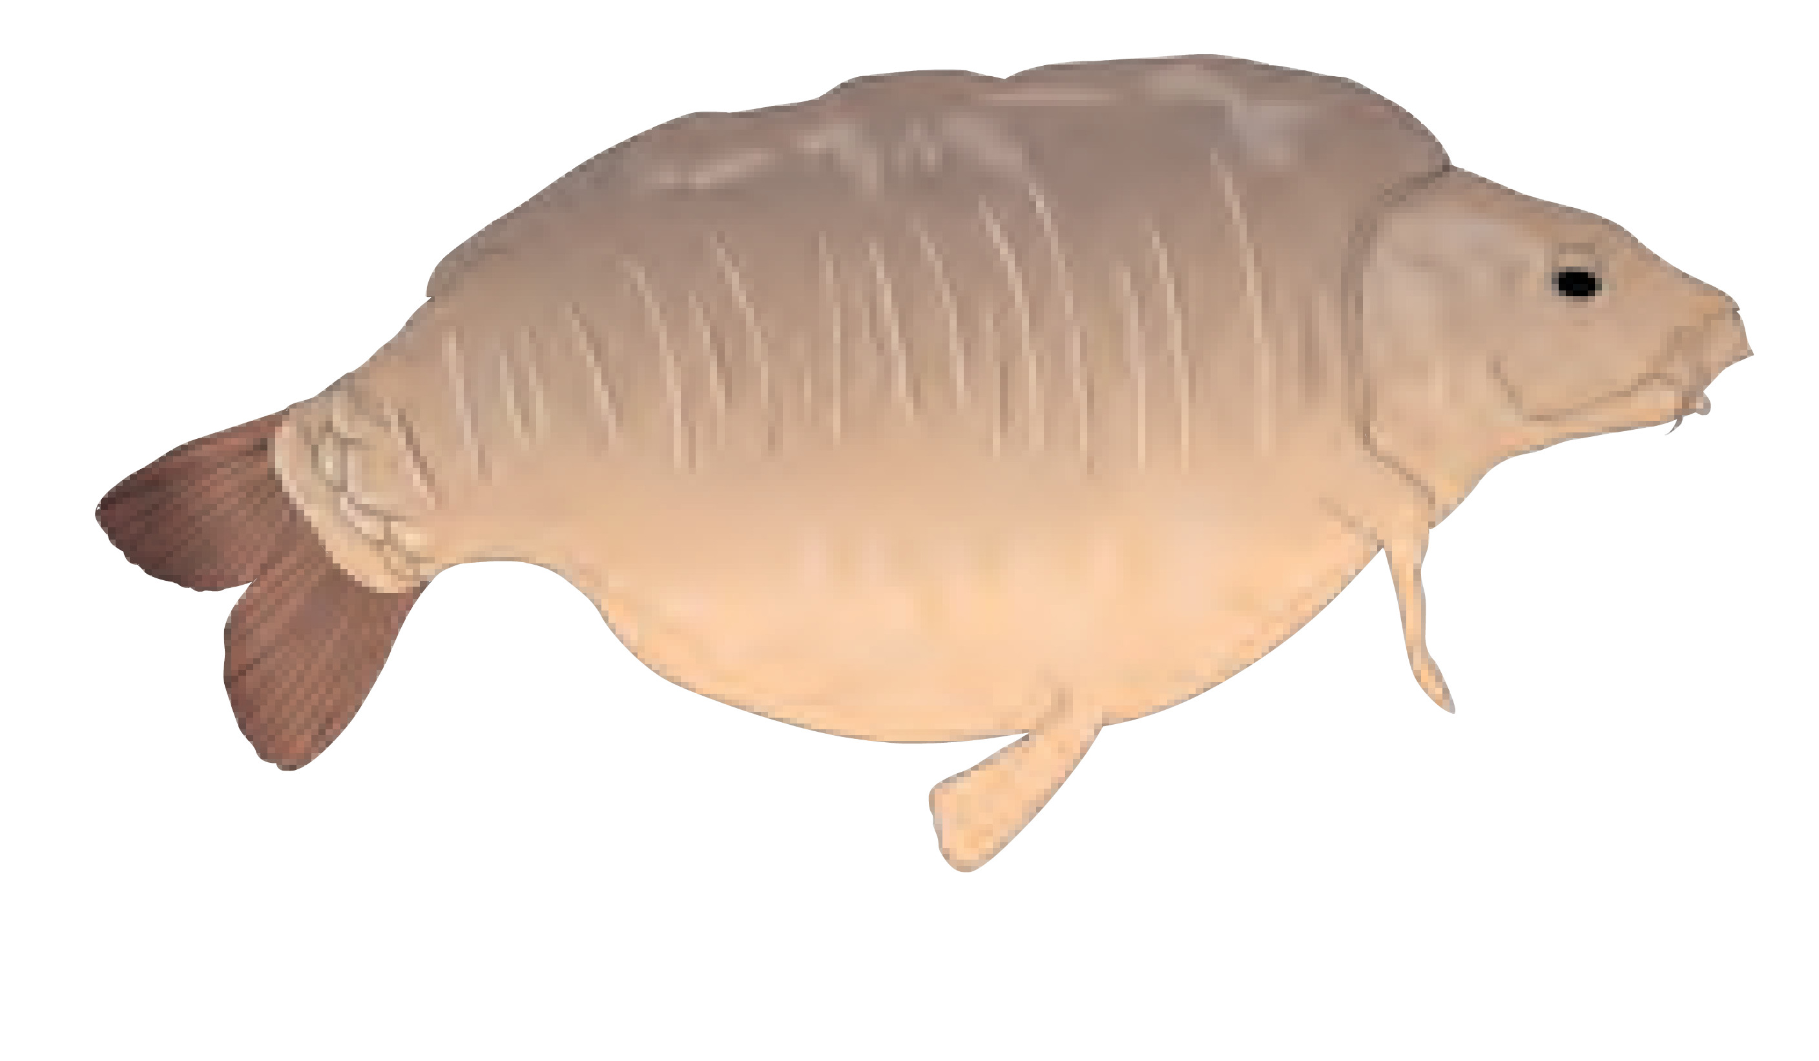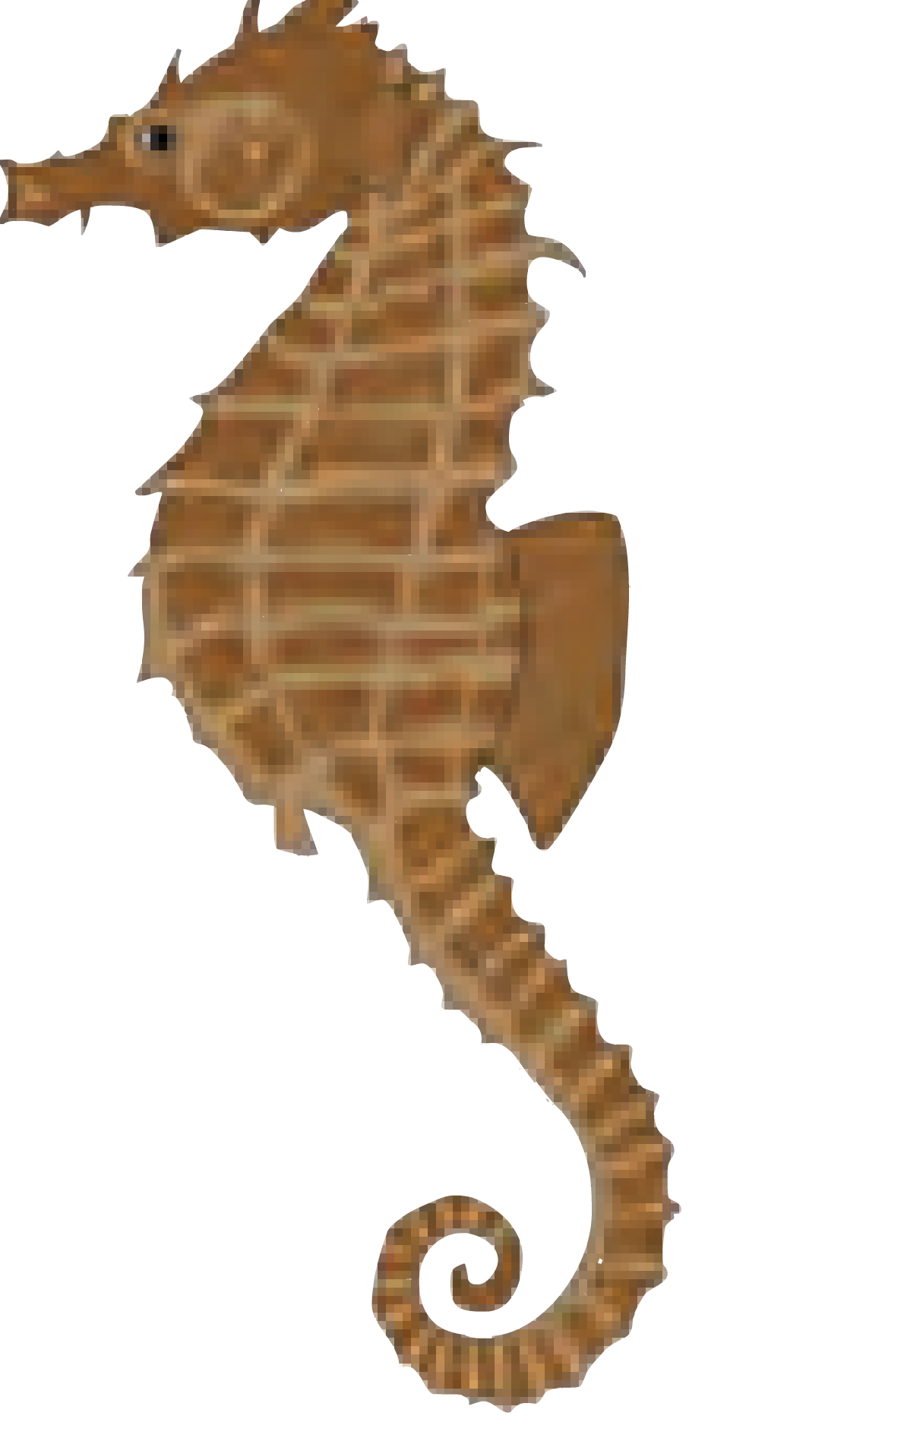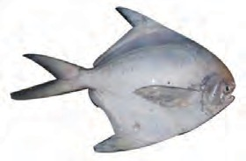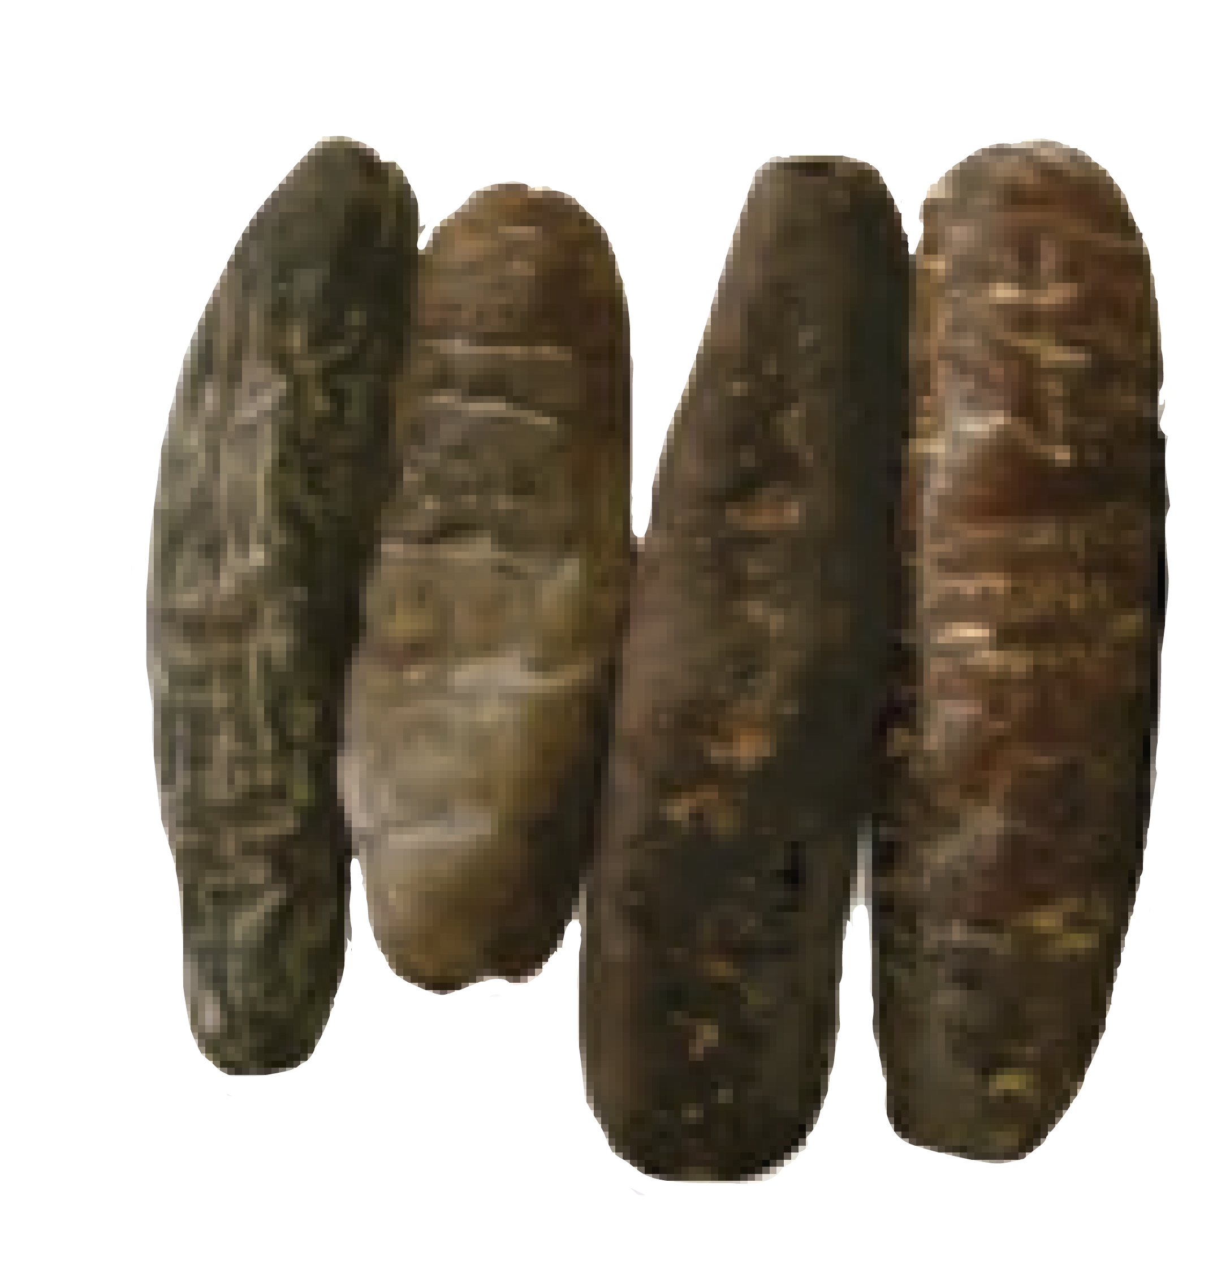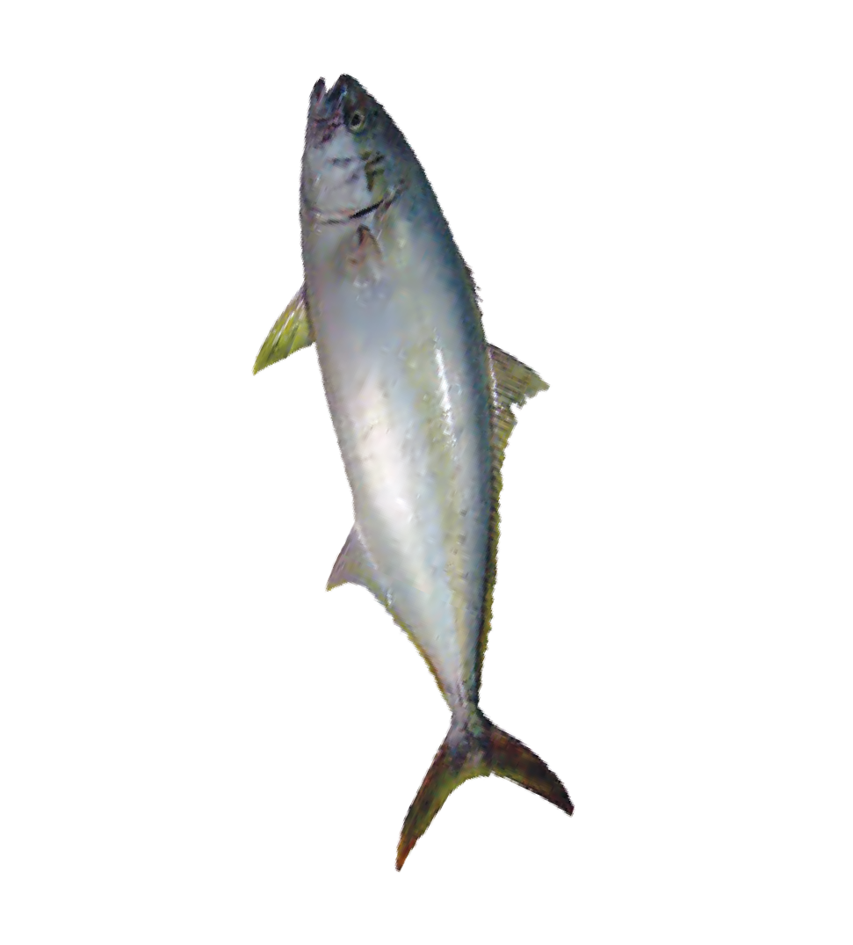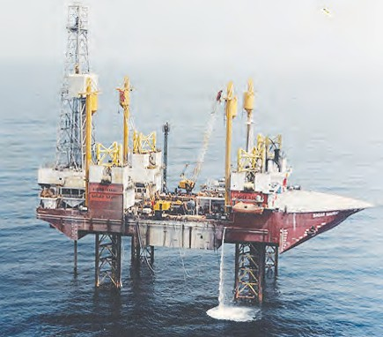

**Can you tell ?** Are minerals to be found in seas and on the seabed as they are found inside the earth ?

Scientists believe that billions of tons of minerals are to be found dissolved in ocean water. There are very large reserves of tin, chromium, phosphates, copper, zinc, iron, lead, manganese, sulphur, uranium, etc. in the ocean and seabeds. We get many types of gems, conches, shells and pearls from the sea. Real pearls are even costlier than gold.

There are large scale reserves of mineral oil and natural gas at the bottom of sea. We avail of these by drilling oil and gas wells.

**16.5 Marine wealth**

In India, mineral oil well was drilled by drill-ship ‘Sagar Samrat’ in 1974 at the oilfield called Bombay High for obtaining mineral oil and natural gas from the bottom of the sea. The natural gas from this well is carried via a pipeline to a place called Uran.

|  |  |
| --- | --- |
| **Mineral resources from oceans** | **Bio-resources in ocean** |
| **Thorium –** used in the production | **Fishes** like pomfret, seer fish as also shrimps |
| of atomic energy. | and prawns – they are sources of proteins and |
| **Magnesium –** used in the flash | vitamins, therefore, mainly used as sea food. |
| bulb of a camera. | **Dried shrimp, Bombay duck powder –** used |
| **Potassium –** the main ingredient | as poultry feed and is a good manure. |
| in production of soap, glass, | **Shells –** used for preparation of medicines, |
| fertilizer. | ornaments and decorative articles. |
| **Sodium –** used in the production | **Fungi –** used for the production of antibiotics. |
| of cloth and paper. | **Shark and cod fish –** used for producing edible |
| **Sulphate –** used in making | oil rich in Vitamins A, D and E. |
| artificial silk. | **Sea cucumbers –** used as medicine for treating |
|  | cancer and tumours. |

**Marine occupations**

1. Fishing – main occupation
2. Salt farming – a big industry
3. Transport business – transport by sea
4. Sea tourism – means of financial income
5. Manufacturing decorative articles



**Always remember -**

Natural resources are important for meeting our needs. Reserves of some resources are limited. There is a danger that excessive use will lead to their early depletion. We must keep a control on the use of natural resources to maintain the balance in nature.

**Exercise**



1. **Describe natural resources with reference to the following three types.**
   1. Mineral resources
   2. Forest resources
   3. Ocean resources
2. **Write answers to the following questions in your own words.**
   1. What is meant by fossil fuel ? What are their types ?
   2. Make a list of the components we obtain from mineral oil.
   3. What do we get from forests ?
   4. What are the items included in ocean resources? What are their uses ?
   5. Why should we prevent the wastage of fuel used for vehicles ?
   6. Why is the diversity of plants and animals in the forests declining ?
   7. Write the names of five minerals and the useful substances obtained from them.
   8. Name the two important stages in the process of obtaining metals from ores?
3. **What steps are taken for protection and conservation of natural resources ?**
4. **Complete the flow chart.**

Fuels

Fossil fuels

Solid

Mineral oil

Natural gas

Peat, lignite, bituminous coal, anthracite

1. **How does the economic condition of a nation depend on its natural resources?**
2. **Which medicinal pants will you grow on your school premises and near your house? Why?**

स्थायुरूप

**Project :**

1. Collect conches and shells of various shapes and colours and make a decorative article.
2. Collect information about the mines of various minerals.

⧫  

**17. Effects of Light**

When sunrays pass through a glass prism, what are the colours in the band of light seen on the other side of the prism ?



**Let’s recall.**

You have learnt that light is composed of several colours. You must have also seen the dust particles in a beam of sunlight entering the house through a small window. We switch on the head lamps of a car when we drive through a thick fog. You might have seen the beams of those lamps. What do we really see, when we see a beam of light ? We see tiny dust particles floating in the beam. That is why we are able to see the beam of light. We see a variety of shades of colour in the early morning and evening sky. In the photographs taken from space by satellites the earth appears to be bluish. What is the cause of all these effects ?

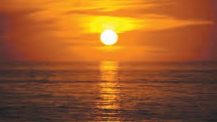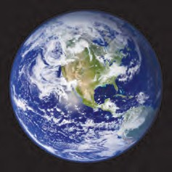

#### Scattering of light

(All the experiments using laser rays should be done under the supervision of the teacher)



**Try this.**

**Apparatus :** Glass beaker, diode laser (laser pointer), water, milk or milk powder, spoon, dropper, etc.

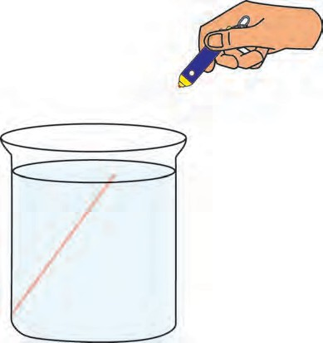

**Laser pointer**

**Beaker**

**Procedure :** Take clear water in a glass beaker. Pass a beam of laser rays through it. Check whether the beam is seen in the water.

Now use the dropper to add a few drops of milk to the water and stir. The water will be seen to have become slightly turbid. Now, pass the laser beam into it again. A light beam will show the existence of light rays.

A light beam is not seen in plain water, but is clearly seen in slightly turbid

water. The light rays hit the tiny particles of milk and get scattered. If these scattered rays enter our eyes, we perceive the light.

* 1. **A beam of laser light**
     1. Instead of using milk, mix salt, sugar and detergent powder in separate beakers of water and observe whether a laser beam is seen in them.



**Try this.**

When the sun rises our surroundings appear illuminated. The entire sky appears bright. This happens because of the dust and other tiny particles in the air. This is the scattering of sunlight by the tiny particles of the various constituents of air. Had there been no atmosphere on earth, the sky would have appeared dark during the day and of course, the sun would be directly seen. This has been verified by observations from the rockets and satellites which go out of the earth’s atmosphere.

**Apparatus :** A table lamp with a 60 or 100 W milky bulb (LED will not do), thick black paper, sticking tape, a

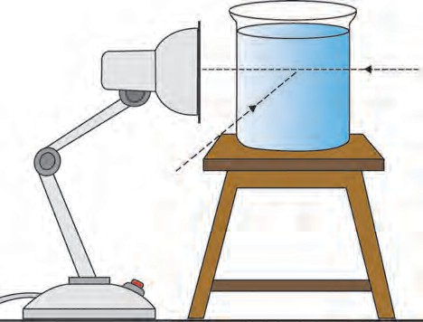

packing needle, 100/200 ml glass beaker, milk or milk powder, dropper, spoon, etc. **Procedure :** Cover the mouth of the

lampshade properly with black paper,

using sticking tape. Prick a hole of 1 to 2 mm diameter in the center of the paper with the help of the packing needle. Take clear water in the beaker. Light the bulb and place the beaker in contact with the hole. Observe from the front and at an angle of 90°. Now add 2-3 drops of milk to the water and stir. Observe again.

A few more drops of milk may have to be added to make the water turbid. A

**Table lamp**

**Black paper**

* 1. **Scattering of light**

**Water**

**Beaker**

blue tinge is seen when observed along the 90° angle. This is the scattered blue light. Because the blue light is scattered, a red-yellow light is seen from the front, and the hole appears reddish.

(**Important :** This experiment should be done in a dark room and by small groups of students.)

If a few more drops of milk are added, the reddish colour seen from the front becomes an



**Use your brain power !**

intense red. However, if many more drops are added, the reddish colour is not seen. Why is this so?

Sunlight is scattered by the molecules of gases like nitrogen, oxygen in the atmosphere. The blue colour in the sunlight is scattered the most, and, therefore, the sky appears blue.

Sunlight reaches us through the layer of the atmosphere. At sunset, the light reaching us travels a greater distance through the atmosphere. Due to the greater distance, there is more scattering of the blue colour. As a result the red-yellow light reaches us directly and the sun appears red. Red light is scattered less than blue light.

What is a shadow ? How is a shadow formed ?



**Let’s recall.**

#### The shadow obtained from a point source and extended source.



**Try this.**

**Apparatus :** Candle/torch, cardboard, screen, small ball, big ball, etc.

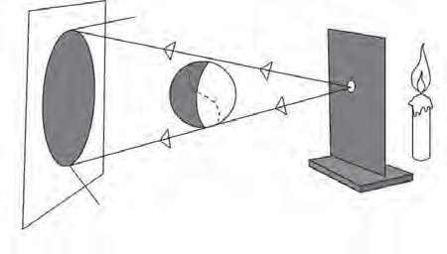

**A P**

O

**Q**

**Ball**

**B**

**17.3 Shadow formed by a point source**

Take either a candle or torch as a light source. In front of it, set up a cardboard with a tiny hole (O) as shown in the figure. Now the light is seen to emerge from the hole on the cardboard. Such a light source is called **point source.** Place a screen vertically at a distance of one metre beyond

the cardboard. Hang the big ball between the screen and the cardboard. Observe the shadow AB of the ball.

The rays OP and OQ starting from the point source just pass by the ball and fall on the points A and B on the screen, respectively. However, since no rays reach the screen between the points A and B, that part remains unlit. This is the dark shadow or the umbra.

What happens if the cardboard with the pinhole is removed ? Now, we do not have a point source. This source is called an **extended source**. What is the nature of the shadow formed by an extended source ?

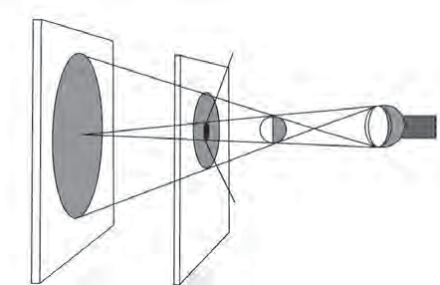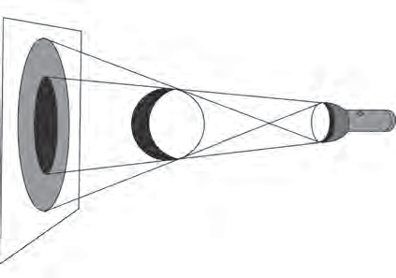

Due to the extended source, we see two B

parts in the shadow of the ball on the screen A P

- one faint and one dark. The faint part BC M

is called the **penumbra** and the dark part

AD, is called the **umbra**. N

Let us see what happens in the following D Q

activity when the ball is bigger than the C

extended source. Keeping the distance between

**Ball**

the extended source and the ball constant, move the screen further and further away and observe the shadow. As the screen moves further, the umbra and the penumbra in the shadow of the ball are seen to become bigger and bigger.

Now replace the big ball with one that is smaller in size than the light source. Observe its shadow on the screen. We see the umbra and penumbra of the ball on it. Now, without moving the light source and the

* 1. **Shadow formed by an extended source**

A

B P M

Q N

C

D **Ball**

* 1. **Shadow of a small object formed by an extended source**

ball, move the screen further away from the ball and observe its shadow. As the screen moves further, the umbra becomes smaller and smaller and at a certain point it disapperars.

115

#### Eclipses

**What is an eclipse?**

The moon revolves about the earth, and the earth along with the moon, revolves around the sun. Their orbits of revolution are all different. When the sun, the moon and the earth come in a straight line an eclipse is said to have taken place.

#### Solar eclipse

During its revolution, when the moon comes between the sun and the earth, a shadow of the moon is cast on the earth and the sun cannot be seen from the part in the shadow. This is called a solar eclipse. A solar eclipse is seen only on a new moon day. The solar eclipse may be either partial or total. Sometimes the solar disc is completely covered by the moon. This is the total solar eclipse. When the solar disc is not covered fully by the moon, we have a partial solar eclipse. During a solar eclipse, ultra-violet rays which are harmful to us reach the earth. A solar eclipse should never be watched with the naked eye. A special type of goggles should be used for this purpose.

#### Lunar eclipse

When the earth comes between the sun and the moon a shadow of the earth is cast on the moon and a part of the moon is covered. This is called the lunar eclipse. A lunar eclipse is seen only on a full moon night. If the whole moon comes in the shadow of the earth, it is a total lunar eclipse. When the shadow of the earth is cast only on a part of the moon, it is a partial lunar eclipse. You can watch a lunar eclipse with the naked eye. A lunar eclipse can be seen over a period of a few hours.

**Note :** For more information refer to the lesson ‘The Sun, the Moon and the Earth’ in the Geography textbook.

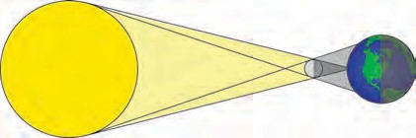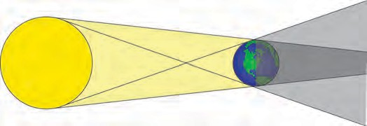

**Umbra**

**Earth**

**Moon Penumbra**

**Umbra**

**Moon**

**Penumbra**

**Sun**

**Sun**

**Solar Eclipse**

**Earth**

**Penumbra**

**Lunar Eclipse**



**17.6 Eclipse**

**Do you know ?**

Eclipses often occur in the solar system. As seen from the earth, when a planet or a star passes behind the moon, that state is called a ‘**occultation**’. It is a common phenomenon that occurrs with the sun, the moon or other stars. For example, in 2016 the star called ‘Rohini’ was hidden behind the moon. After some time it came appeared on the other side of the moon. Did you see this occultation ?

* + 1. Time periods of lunar and solar eclipse.



**Find out.**

* + 1. Various eclipses in the past and relevant interesting information about them.
    2. Eclipses and transits which will occur in the near future.

#### Zero shadow day



**Always remember -**

An eclipse is a natural phenomenon. Many superstitions connected to eclipses are prevalent in the society. It is necessary that everyone makes efforts to rid the society of superstitious beliefs.

The day on which the sun reaches exactly overhead is called the **zero shadow day**. On that day, at noon shadows completely disappear. This event can only be seen in the region between the Tropic of Cancer (23.50N) and the Tropic of Capricorn (23.50S). This event occurs in summer on different days in different places in this region.

**Think and discuss.**

1. Discuss why it is not right to tie lemon-chilli to our car ?
2. In our surroundings and in day-to-day life, we unknowingly believe in many such things. Is that right ?



**Exercise**

* + 1. **Fill in the blanks.**
       1. When the beams from the headlights of a car fall on an object in the night, the shadows called and

. can be seen.

* + - 1. During a lunar eclipse the shadow of the ............ falls on the ............ .
      2. During a solar eclipse the shadow of the .............. falls on the .............. .
      3. Various shades of colour are seen in the sky at sunrise and sunset due to

............ .

* + 1. **Give reasons.**
       1. Space beyond the earth’s atmosphere appears dark.
       2. We are able to read while sitting in the shade.
       3. We should not observe the solar eclipse with naked eyes.
    2. **Give some example of scattering of light that we come across in day-to-day life.**
    3. **Why is the shadow of a bird flying high not seen on the earth?**
    4. **Why is a penumbra not obtained from a point source?**
    5. **Answer the following questions in your own words.**
       1. What is meant by scattering of light ?
       2. Does the shadow really vanish in the zero shadow condition ?
       3. Will the laser beam be seen if it passes through a glass box which contains a lighted incense stick ?
    6. **Discuss and write.**
       1. Write a science based paragraph on ‘What if the sun did not rise ?’
       2. What efforts will you make to remove the misconceptions about eclipses ?
       3. Various eclipses and the conditions during that period.
    7. **Explain the difference :**
       1. Point sources and extended sources of light.
       2. Umbra and penumbra.

**Project :**

Obtain information about the special goggles used to watch a solar eclipse.

⧫  

**18. Sound : Production of Sound**

Some events are given below. Put a tick mark ‘✓’ in the box if you have experienced the event. If not, put a cross ‘🞪’ in the box.



**Let’s recall.**

1. Clapped your hands together.
2. Played a musical instrument.
3. Burst a fire cracker.
4. Knocked on a closed door.
5. Whistled using the cap of a pen.
6. Placed your palm on a mobile that is ringing.
7. Swung the clapper of the bell and the bell rang.
8. A metal utensil fell down with a clatter.
9. There was a thunderclap in the sky. 
10. Put your hand on a speaker which is producing sound.

It is seen from the above examples that sound is generated due to a variety of events. In some examples, sound was generated due to the vibration of an object, for example, the bell, or the strings or diaphragm of a musical instrument; while in some examples like bursting a cracker, clapping, a lightning strike, vibrations are not actually felt. However, vibrations are produced in those cases as well. All these vibrations are imparted to the molecules in the air and sound is produced. You might have seen that, when a stone is thrown into the calm water of a lake, waves are generated and they reach up to the banks of the lake. Vibrations reach our ears through the air in a similar way and the sound is heard.



**Use your brain power !**

When a singer tunes the musical instruments before he starts singing, what exactly does he do ? He ensures that the *tanpura* will produce the required notes, by adjusting the tension in its strings i.e. he ‘tunes’ the *tanpura*. A ***tabla*** player tunes the ***tabla*** by hammering the pegs to adjust the tension in the diaphragm of the ***tabla***. The harmonium accompanist finds out beforehand the key in which the singer will sing. To tune an instrument is to adjust how high or low the pitch of the notes produced will be. The pitch of a sound depends upon its frequency. In Indian music, the musical notes, ***Sa, Re, Ga, Ma, Pa, Dha, Ni,*** are of increasingly higher pitch. In scientific terms frequency is a measure of pitch.

You have learnt how sound is generated, how it reaches us on travelling through some medium and is heard by us. You have also seen that vibration of an object is necessary for generation of sound.

In the present lesson we will learn more about vibration, pitch, intensity and level of sound.

When the string of a musical instrument such as a *tanpura* is plucked, the string can be seen to vibrate but the two ends of the vibrating string are still. As it vibrates, the string moves to one side of the central position and comes back to the central position. This motion of the string is repeated again and again at fixed intervals of time. Such motion is called periodic motion.



**Always remember -**

Sound is generated by the rhythmic vibration of an object. We can hear the sound as long as the object vibrates. But, when we touch the vibrating object with our hand, the vibrations stop and we no longer hear the sound. Sometimes we can see the vibrations, but sometimes, the vibrations are so minute that we cannot see them with our eyes.

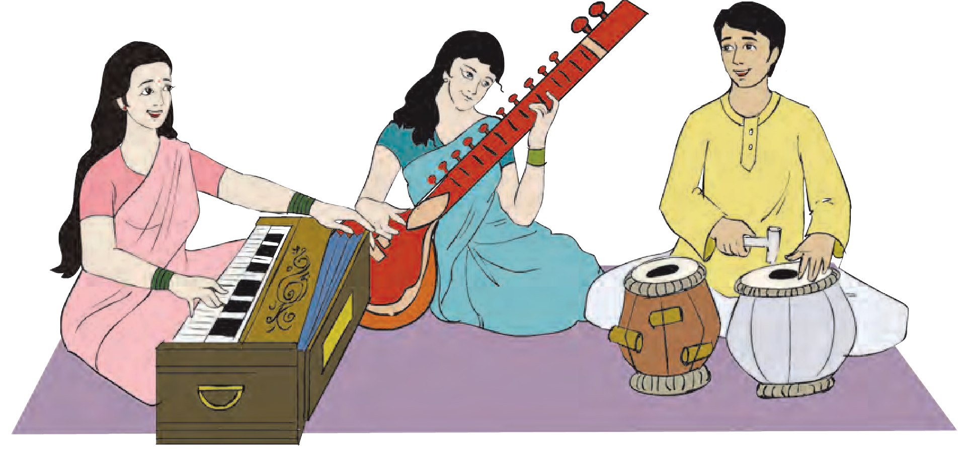

**18.1 Tuning the instruments**

Make a list of musical instruments you are familiar with. Find out which part of the instrument vibrates and produces the sound.



**Try this.**

Such vibrations, that produce sound, can be studied with the help of a simple ‘oscillator’.

#### Oscillator, oscillation and oscillatory motion

You must have seen children playing on a swing in a garden. Observe carefully the motion of the swing. Go to a swing at rest in a garden and mark its position on the ground below it. You can call this mark the central position of the swing. Now pull the swing to one side and let it go. Observe how it swings.

The swing will be seen to cross the central position again and again as it moves from one end to the other of its swing.

A swing that moves back and forth like this, is an **oscillator**. When the swing moves from one end to the other and returns to its starting point, it is said to have completed one **oscillation**. The back and forth motion of an oscillator on either side of a central position is called oscillatory motion.

Take an empty porcelain bowl or an empty steel glass. Stretch a rubber band and fix it on the bowl or glass as shown in the picture. Now give a jerk to the rubber band. Repeat this action applying a smaller or greater force. While doing this, observe the farthest distance to which the rubber band is stretched. Take note of the sound generated.

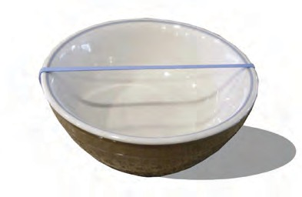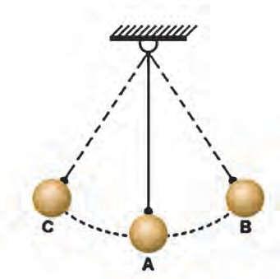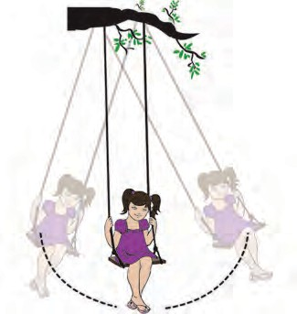

**18.1 Oscillation of a swing**

**A rubber band stretched over a porcelain bowl**

O

**Ball**

**Thread**

**Amplitude**

When the rubber band is stretched and released it vibrates. Compare the vibrations with the figure alongside. When the rubber is stretched from the original position A and comes to position B, it is seen to be curved. The maximum distance between the original position A and the position B on stretching the rubber, is called the **amplitude** of vibration.

When a greater force is applied to the rubber, it is stretched further, meaning that the amplitude increases. On releasing it, a louder sound is generated. When a smaller force is applied, the rubber is stretched less. Then the amplitude is smaller and the sound is softer, too.

Take a strong thread, about half a meter long. Tie a small iron or wooden ball to it and suspend it from a support as shown in the figure. Such an oscillator is called a pendulum.

Give an oscillatory motion to the pendulum. The maximum distance between the original positions A of the pendulum and the extreme position B or C is called the amplitude of oscillation. In the figure, AB or AC is the amplitude of oscillation.



**Do you know ?**

**18.2 Oscillatory motion and amplitude of oscillation**

1. A stretched rubber returns to its original state when it is released. This property is called elasticity.
2. When a stretched rubber band vibrates, elasticity is at work.
3. All the while that the pendulum oscillates, earth’s gravitation is at work.

#### Time period of oscillation and frequency

The time required by an oscillator to complete one oscillation is called the time period of the oscillator. In the previous activity, the oscillator traverses the distance from the extreme position B to central position A and from there to the position C, then back again to A and from A to B. The time required by the oscillator to traverse this distance B-A-C-A-B, is the time period of oscillation (T) of the oscillator. The number of oscillations completed by an oscillator in one second is called the frequency of oscillation.

The total motion B-A-C-A-B in the previous activity is one oscillation.

Frequency (n) = 1 1

=

time period of oscillation (T) T

Frequency is the number of oscillations occurring in one second. The unit of frequency is Hertz (Hz). 1 Hz means there is one oscillation in one second;

100 Hz means hundred oscillations in one second.



**Try this.**

Take a plastic ruler and hold one of its ends pressed down on the table, as shown in the picture, so that a large portion of the ruler is off the table. Now ask your friend to press the free end of the ruler down and release it. Observe what happens. Now press the ruler with your finger at such a point that it stops making any sound. Now pull in 10 cm more of the ruler onto the table and repeat the action. Listen to the difference in the first and the second sound. Take note of the difference in the frequency and pitch of the sounds. Also, take note of what happens by further decreasing the length of the free part of the ruler little by little.



**Use your brain power !**

**18.3 Vibration of the ruler and the sound produced**

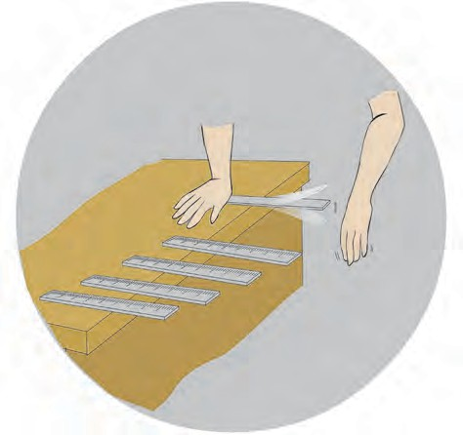

**Table**

**Ruler**

1. Will a sound be generated no matter how the ruler is kept on the table ?
2. Is there any correlation between the length of the free part of the ruler and the sound generated ?
3. If the ruler is plucked while it is held with 25 cm of it off the table, does it make any sound ? If there is no sound, look for the reason why it is so.



**Try this.**

Take a strong thread of sufficient length. Tie a wooden or metal bob to one of its ends to make a pendulum. Measure the length of the thread in centimetres and make a note of it. Suspend the pendulum freely from a support. Now swing the pendulum and with the help of a stop-watch record how many seconds are required for 20 oscillations. Repeat this procedure 4 or 5 times, decreasing the length of the pendulum by 10 cm every time. Record your observations in the following table. Deduce the time period of oscillation and the frequency of the pendulum by making use of the given formula.

|  |  |  |  |  |
| --- | --- | --- | --- | --- |
| S.No. | Length of the oscillator (in cm) | Time required for 20 oscillations,  t (in seconds) | Time period of oscillation  T = t/20 sec | Frequency n(Hz) =1/T (Hz) |
| 1.  2.  3.  4.  5.  6. |  |  |  |  |

1. What can we infer from these observations ?
2. What is the relationship between the frequency and the length of the pendulum ?
3. Explain what is meant by low frequency and high frequency ?

Now keep the length of the pendulum fixed at 30 cm but, varying the amplitude, measure the time required for 20 oscillations, in each instance. Deduce the time period of oscillation and frequency of the pendulum in each case. Use the following table for this purpose.

|  |  |  |  |  |  |
| --- | --- | --- | --- | --- | --- |
| S.  No. | Length of the pendulum in cm | Amplitude | Time required for 20 oscillations, t (in seconds) | Time period of oscillation  T (s) | Frequency n (Hz) |
| 1. | 30 | small |  |  |  |
| 2. | 30 | a little larger |  |  |  |
| 3. | 30 | larger |  |  |  |
| 4. | 30 | even larger |  |  |  |
| 5. | 30 | very large |  |  |  |

The time period of oscillation (T) depends on the length of the pendulum. The time period of oscillation increases if the length of the pendulum is increased.

The frequency remains the same even if the amplitude decreases or increases.

#### High and low pitch of sound

Take a wooden board, 80 to 90 cm long and 5 cm wide. Hammer two nails into it, each a few centimeters away from its two ends. Tie the ends of a thin metal wire to the nails so that the



**Try this.**

wire is stretched tightly between them. Insert a wedge-shaped wooden or plastic block under the wire near each of the nails and pluck the wire lightly.

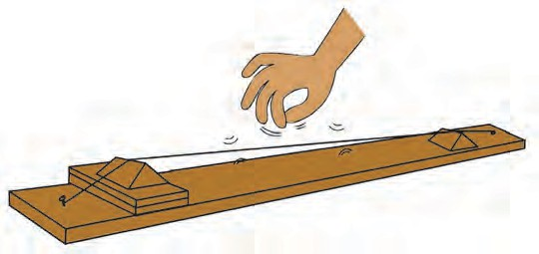

Did you hear any sound ?

Observe whether the wire vibrates. Now insert two or three small rectangular blocks below the wedge-shaped block on one side in such a way that the length of the wire

**Wooden board**

**Wooden blocks**

**Wire**

**18.4 The pitch of a sound**

does not change. Observe whether there is any change in the tension in the wire. Now pluck the wire with your finger and listen to the sound. Also watch its vibration. Note the difference you perceive in its frequency. What can you infer from this ? When tension in the wire is increased, the frequency is seen to increase and when it is reduced, frequency is also seen to decrease. We also perceive a difference in the sounds generated. When the tension is increased the resulting sound is shriller. When the tension is reduced the sound is also less shrill. This is what is called the high and low pitch of sound.

1. Which of the sounds, the roar of a lion or the hum of a mosquito has the higher pitch ?
2. What structures in the sitar help to produce higher or lower pitched sounds ?

#### Intensity of sound - sound level



**Do you know ?**

Decibel levels of some common sounds

1. Begining of audible sound – 0 dB
2. Normal breathing – 10 dB
3. Murmuring from 5 metres away – 30 dB
4. Normal conversation (between two persons) – 60 dB
5. Heavy traffic – 70 dB
6. Ordinary factories – 80 dB
7. Jet engine – 130 dB
8. Start of ear-splitting sound – 120 dB Hearing is temporarily affected by sounds of frequency greater than 1000 Hz and levels higher than 100 dB. This can result in temporary deafness.

Workers who work near aeroplane engines experience this.

Loudness or softness of sound is indicated by two terms, namely, intensity of sound and sound level. Sound level is the intensity of sound as perceived by our ears. The intensity of sound is proportional to the square of the amplitude of vibration. For example, if the amplitude is doubled the intensity of sound becomes four times as much.

The **decibel** (dB) is the unit for measuring sound level. It was named decibel in honour of the work of the scientist Alexander Graham Bell. The magnitude of sound level, ‘decibels’ can be deduced from the intensity of the sound using a mathematical formula. When intensity of sound becomes ten times the original, the sound level increases by 10dB.

#### Audible sound



**Use your brain power !**

What would be the difference perceived between hearing only two pupils in the class talking to each other and all the children talking to one another at the same time ?

The frequency of the sound audible to human beings is between 20Hz and 20,000 Hz. We can only hear sounds in this frequency range.

#### Infrasonic sound

Have you ever heard the sound of the movement of our hands or of the movement of leaves falling from a tree ?

Take a oscillator and swing an oscillator which makes 3-4 oscillations in a second, and listen carefully for any sound it makes.



**Try this.**

That the oscillator makes 3 to 4 oscillations in one second means that the frequency of the sound is 3 to 4 Hz. Humans cannot hear sounds of frequency less than 20 Hz. In all the above examples, oscillations did take place, but no sound was heard. It

means that this sound is of a frequency less than 20 Hz. A sound with a frequency

less than 20 Hz is called infrasonic sound. Sounds with a frequency less than 20 Hz are produced by some animals, namely, whales, elephants and rhinoceros.

#### Ultrasonic sound

A sound with a frequency higher than 20,000 Hz is called ultrasonic sound. Human beings cannot hear such sounds. However, some animals, for example, a dog, can hear such sounds.

**Find out.**

There is evidence that elephants communicate with each other over distances of up to 10 km using infrasonic sound inaudible to us. It is also believed that dogs and other animals can receive ultrasonic sound signals in advance of an impending earthquake. Find out more about this from the internet.

#### Uses of ultrasonic sound

1. To clean delicate ornaments and the tiny parts of a watch.
2. To observe internal organs of the body.
3. To detect tumours in the brain.
4. To detect faults in a metal.
5. In RADAR systems.
6. To kill certain microbes and insects.
7. SONAR (Sound Navigation And Ranging) is used to locate the seabed or the position of a ship.

#### Do you know ?



The pitch of sound is directly related to the frequency of sound. From the graph alongside we get further information about

Blue

**Infrasonic**

Whale

Violin Flute

Dolphin Bat

**Ultrasonic**

the frequency of sound and infrasonic, audible and ultrasonic sound.

**Audible to**

**Humans**

4 20 256 2048 20,000 524288

**Frequency of sound (Hz)**



**Exercise**

* 1. **Fill in the blanks.**
     1. Sound is generated by the rhythmic

…….. of any object.

* + 1. The frequency of sound is measured in ……………. .
    2. If ………… of sound is decreased, its loudness also decreases.
    3. A medium is necessary for

…………. of sound.

* 1. **Match the pairs.**

**Group ‘A’ Group ‘B’**

* + 1. Flute (1) Frequency less than 20 Hz
    2. Frequency (2) Frequency more

than 20000 Hz

* + 1. Sound level (3) Vibrations in

the air

* + 1. Ultrasonic (4) Measured in Hz sound
    2. Infrasonic (5) Decibel sound
  1. **Give scientific reasons.**
     1. In earlier times, people used to listen for the arrival of a distant train by putting their ear to the rail.
     2. The sounds generated by a *tabla*

and a *sitar* are different.

* + 1. If you were both on the moon, your friend will not be able to hear you call.
    2. We can hear the movement of a mosquito’s wings but we cannot hear the movement of our hands.
  1. **Write answers to the following questions.**
     1. How is sound produced ?
     2. What does the intensity of sound depend upon?
     3. Explain how the frequency of oscillation is related to the length of a pendulum and the amplitude of its oscillation.
     4. Explain the two ways by which the pitch of the sound generated by a stretched string can be changed.

**Project :**

The bat, a mammal, flies during the night manoeuvering with the help of the ultrasonic sounds it produces. Find out more about this.

⧫  

**19. Properties of a Magnetic Field**

* + - 1. Where and how are magnets used in our houses and our surroundings ?



**Let’s recall.**

* + - 1. 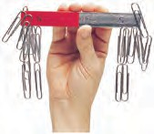In which direction does a freely suspended magnet settle ?
      2. What are the names given to the two ends of a magnet ? Why are they named thus ?
      3. Which metals are used for making magnets ?
      4. What are the characteristics of magnets ?

Magnets are made from alloys of iron, cobalt and nickel. Nipermag, an alloy of iron, nickel, aluminium and titanium is used to make magnets. We have also learnt that alnico is a magnetic alloy of aluminium, nickel and cobalt.

#### Magnetism

**Apparatus :** Steel bar, bar magnet, iron fillings, thread, etc.



**Try this.**

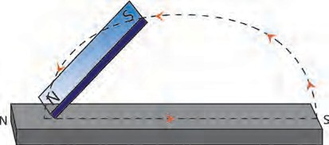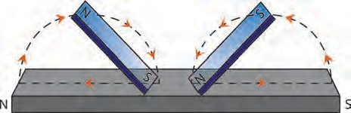

**Procedure :** Place a steel bar AB, on a table. Take a bar magnet. Place its ‘N’ pole on the ‘A’ end of the steel bar and drag it towards the ‘B’ end. Lift the bar magnet and drag its ‘N’ pole from the end A to the end B of the steel bar again. Repeat this 15 to 20 times. Now take the steel bar near some iron filings and observe what happens. Hang the bar freely by a thread and observe.

The steel bar will be seen to have developed magnetism. This method of magnetisation is called the single touch method. The magnetism created by this method is of low strength and lasts for a short time.

**Procedure :** Place a steel bar on a table. Take two bar magnets. Place two opposite poles of the two bar magnets at the centre of the steel bar. Drag these poles apart, one to the ‘A’ end of the steel bar, and the other to the ‘B’ end.

Repeat this 15 to 20 times. Now take the steel bar near iron fillings and observe. Hang the steel bar freely and observe.

This method of magnetisation is called the double-touch method. The magnetism generated by this method lasts longer compared to that generated by the single touch method.

A B A B

**19.1 Magnetising a steel bar**

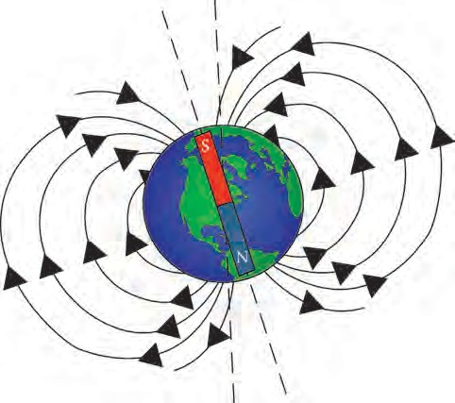Why does a freely suspended magnet always settle in the north-south direction ?



**Can you tell ?**

#### Earth : A gigantic magnet

The scientist William Gilbert gave a scientific explanation, based on experiment, of the observation that a freely suspended magnet always settles in the north-south direction only.

He gave a round shape to a naturally occurring magnetic rock. He suspended this spherical magnet so that it could turn freely and brought the north pole of a bar magnet near it. The south pole of the

magnetic sphere was attracted towards it. **19.2 Earth’s magnetism**

1. Which magnetic poles attract each other ?



**Can you tell ?**

1. Which pole of a spherical magnet will get attracted towards the south pole of the bar magnet ?

The north pole of a freely suspended magnet settles in the direction of the geographic north pole of the earth. It means that the south pole of some gigantic magnet must be near the geographic north pole of the earth and the north pole of that magnet, near the geographic south pole of the earth. Gilbert inferred from this that the earth itself is a gigantic magnet. However, the south pole of this magnet must be near the geographic north pole of the earth while the magnetic north pole is near the geographic south pole.

Which direction will a magnetic needle show on the geographic north pole ?



**Use your brain power !**

#### Magnetic needle

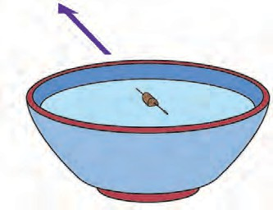

Take a square cardboard and mark the directions on it. Place a pot filled with water at the centre of the cardboard. Take a magnetized needle. Stick it to a small piece of a cardboard by means of

a sticking tape. Place the piece of W

cardboard with the needle, on the surface of water in the pot. In which direction does the magnetized needle point ?

E

S

* 1. **Magnetic needle**

In any place, why does the magnetic needle of a compass not settle parallel to the ground but at a an angle to it ?



**Find out.**

#### Magnetic field

**Apparatus :** A bar magnet, pins, cardboard, iron filings, plastic bottle, bucket, water.



**Try this.**

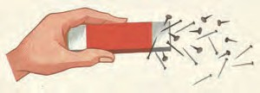**Procedure :** Take a bar magnet and some pins. Place them at such a distance from each other that they do not stick to each other. Now slowly move the magnet towards the pins. Observe the pins as they get pulled to the magnet.

The magnet attracts the needles from afar. In other words, a magnet has an effect even at a distance.

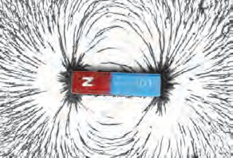**Procedure :** Take a small cardboard. Place a bar magnet at its centre. Sprinkle iron filings on the cardboard around the magnet. Tap the cardboard gently. Observe the iron filings.

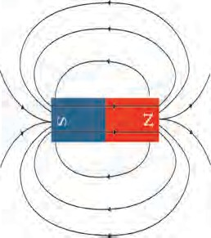What is the inference from the above experiments? The British researcher Michael Faraday named these lines, going from one end of the bar magnet to the other, ‘magnetic lines of force’. The region around a magnet where the magnetic force acts on an object is called a magnetic field. The magnetic field around a magnet can be shown by means of magnetic lines of force. The intensity of the magnetic field at a place can be guaged by the number of lines of force that pass through a unit area at that place, perpendicular to that area. Michael Faraday, imagined that there might be invisible lines of force going from one pole of a magnet to the other, and that magnetic attraction or repulsion might be taking place through the medium of these lines of force. If Faraday’s idea is accepted, the intensity of the magnetic field can be obtained from the number of lines of force, as explained above.

The intensity of a magnetic field is low where the lines of force are sparse, and the intensity is high where the lines of force are concentrated.



**Use your brain power !**

Is magnetic force a vector or a scalar quantity ?

#### Properties of magnetic lines of force

While proposing the concept of lines of force, Michael Faraday argued that, if all observed effects are to be explained satisfactorily, then the lines of force must have certain properties.

* 1. **Magnetic field**

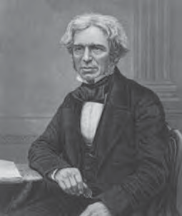

**Michael Faraday**

* + 1. Magnetic lines of force are imaginary connecting lines and Faraday introduced the concept of lines of force in order to explain magnetic attraction and repulsion.
    2. Magnetic lines of force always run from the north pole to the south pole. The south pole may be of the same magnet or a different one.
    3. Magnetic lines of force are in a state of tension like a stretched spring.
    4. Magnetic lines of force repel each other.
    5. Magnetic lines of force do not intersect each other.
    6. The number of the magnetic lines force at a particular point determines the strength of the magnetic field there.

You can now see from the figure, how the properties given above help to explain the repulsion between like poles and attraction between opposite poles. According to the third property, the lines of force joining the north

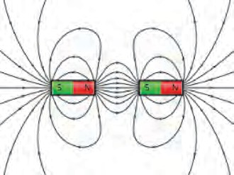

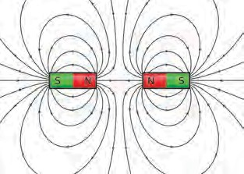

* 1. **Properties of magnetic lines of force**

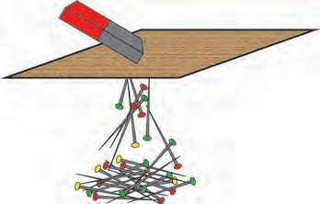and south poles of a magnet, being in a stretched state like a spring, pull the two opposite poles towards each other. By the fourth property they give rise to repulsion between like poles.

#### Penetrating ability of the magnetic field

**Procedure :** Spread some pins on a table. Hold a cardboard at a small distance above these pins. Place a bar magnet on the cardboard and observe. Now move the magnet slowly over the cardboard and observe. Repeat this procedure, increasing the layers of

cardboard, and observe.

**Procedure :** Fill water in a plastic bottle. Drop a few

* 1. **Penetrating ability of magnetic field**

pins in the water. Take a bar magnet near the bottle and observe. Move the magnet through a small distance near the bottle and observe.

From the above observations, we see that a magnetic field can pass through a cardboard, a bottle or water. However, in each case, the intensity of the magnetic field is found to decrease.

**Procedure :** Take water in a big basin. Place a bar magnet on a plastic lid and float it on the surface of the water. Magnetise a needle or pin. Stick this needle firmly to a small piece of thick cardboard by means of a sticking tape.

Place the magnetized needle stuck to the cardboard, in the water near the magnet. Observe the direction in which the needle moves. Repeat this, placing the magnet at difference places around the magnet and observe.

* + 1. What is meant by magnetic force ?
    2. How does a magnetic force act without direct contact ?



**Use your brain power !**

* + 1. What is the difference between gravitational force and magnetic force ?

#### Metal detectors



**Can you tell ?**

1. What is an electromagnet ?
2. How can an electromagnet be made ?

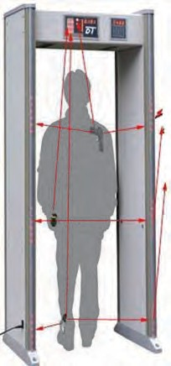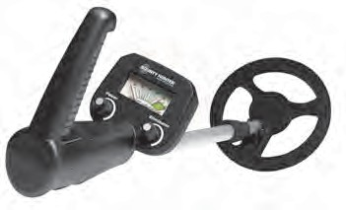

The function of these machines is based on electromagnets. Metal detectors are used in very important places like an airport, bus station, certain temples and buildings. They are used for inspection of persons entering these places. Metal detectors are used to detect very precious articles and also in the food-processing industry to detect any iron/steel objects mixed unknowingly in foodstuff as these would be harmful to health. In geology, these machines are used to detect the presence and quantity of metals.



**Use your brain power !**

1. Why is repulsion the real test for identifying a magnet ?
2. How will you find a magnet from among the various articles given to you ?

**19.3 Metal detectors**



**Exercise**

1. **Write the appropriate term in the blanks.**
   1. The alloys called and

…………… are used for making industrial magnets.

* 1. A magnetic field can pass through

……… and ……….. .

* 1. The intensity of a magnetic field is indicated by the lines of .............. .
  2. The real test of a magnet is ......... .

1. **With whom should I pair up ? Group ‘A’ Group ‘B’**
   1. Compass 1. The highest

magnetic force

* 1. Door of a 2. Like poles cupboard
  2. Repulsion 3. A magnet
  3. Magnetic 4. A magnetic pole needle

1. **Write answers to the following questions:**
   1. Distinguish between the two methods of making artificial magnets.
   2. Which substances are used for making electromagnets ?
   3. Write a note on ‘magnetic field’.
   4. Why is a magnetic needle used in a compass ?
   5. Explain with the help of a diagram how the intensity and direction of the magnetic field of a bar magnet can be determined.
2. **Give detailed information about how the merchants of olden times used a magnet while travelling.**

**Project :**

Obtain information about the function of metal detectors.

**20. In the World of Stars**

1. What is a galaxy ? What are the various components of a galaxy ?



**Let’s recall.**

1. What are the different types of stars ?

We have already learnt about galaxies and stars as well as the solar system and its different components. Stars are born out of nebulae. Nebulae are clouds made up mainly of hydrogen gas and dust particles. The particles in these clouds are attracted towards one another due to the force of gravity. As a result, the cloud contracts and becomes dense and spherical in shape. At the same time, the pressure of the gas at the core of the cloud increases causing the temperature to rise tremendously and energy generation processes start there. Such a spherical cloud of hydrogen is called a ‘star’. Later, processes such as contraction, expansion, rise in temperature, etc. bring about changes in the nature of the star. These changes occur over a very long period of time and constitute the lifecycle of stars. The different forms of the stars at various stages during this lifecycle are identified as different types of stars.

The following figure shows different stages in the lifecycle of stars after their birth from a nebula. Discuss these in the class.



**Observe and discuss.**

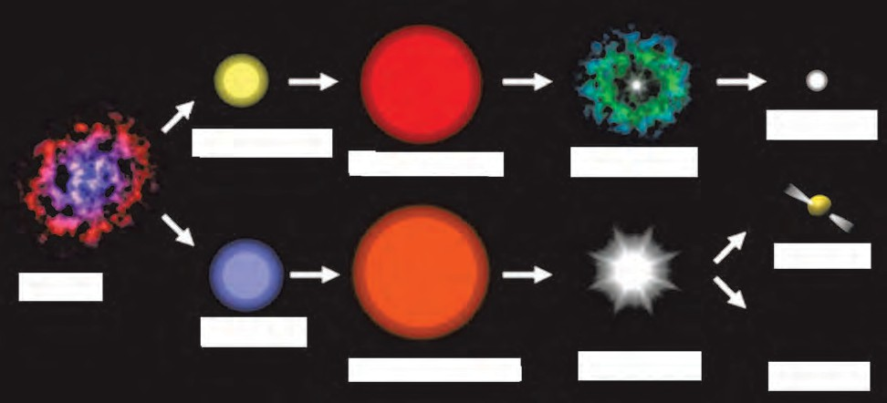

**White dwarf**

**Ordinary star**

**Red giant star**

**Planetary nebula**

**Neutron Star**

**Nebula**

**Massive star**

**Red super giant star**

**Supernova**

**Black Hole**

* 1. **Lifecycle of stars**

Our solar system is a tiny part of a galaxy called the Milky Way, which is many, many times larger than the solar system. There are lakhs of stars in the Milky Way, some of them being many times bigger than our Sun. Some of them have their own planetary systems. Stars in the Milky Way show a great diversity in colour, brightness, as well as size. Some stars, which appear to be close to one another making a particular figure are together known as a constellation. We shall learn more about constellations in this chapter. But, before that, let us learn a few basic concepts related to sky watching.

### [www.avkashvedh.com,](http://www.avkashvedh.com/) [www.](http://www/) space.com



**My friend, the internet !**

#### Sky watching



**Try this.**

Stand still in an open space and look into the distance. What do you notice about the ground and the sky ? Now, still looking into the distance, turn around yourself and observe the ground and the sky as you do so.

**Celestial equator**

**Meridian**

**Zenith**

**Zenith**

मध्यमंडल

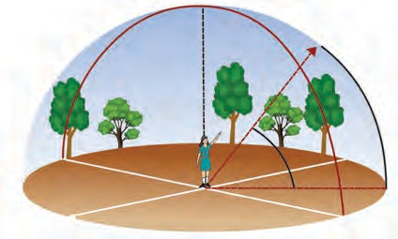

**Horizon**

N

E

W

**Nadir**

S

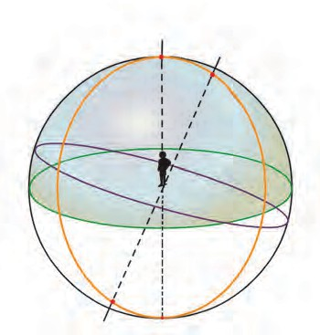

**Celestial North Pole**

Far away, the sky seems to be touching the ground. The line at which they meet is called the **horizon**. While turning around oneself, the horizon will be seen to form a circle and on looking up, the sky will appear to be a sphere based on this circle. The stars and planets moving in the sky appear to be moving on this sphere. This virtual sphere is called the **celestial sphere**. The circular horizon divides this sphere into two halves.

1. **Zenith :** While standing on the ground, the point on the celestial sphere exactly above our head is called the zenith.
2. **Nadir :** While standing on the ground, the point on the celestial sphere exactly below our feet is called the nadir.
3. **Celestial poles :** If we extend the axis of rotation of the earth in the north and south directions it will penetrate the celestial sphere at points called the celestial North

**Celestial South Pole Nadir**

**20.2 Celestial Sphere**

* 1. **Virtual sphere**

Pole and the celestial South Pole, respectively.

1. **Meridian :** In astronomy, the great circle which passes through both the celestial poles and the observer’s zenith and nadir is called a **meridian**.

**Sky and space**

**Sky :** Standing in an open space, if we look at the sky on a cloudless night, we see numerous stars against a dark background. The portion of earth’s atmosphere and the portion beyond that which can be seen in the form of a roof by our eyes while standing on the earth is called the sky.

**Space :** The continuous, empty space between the spheres (planets, stars, etc.) in the sky is called space. It may contain gas and dust particles. Numerous star clusters have formed in space.

1. **Celestial equator :** If we uniformly expand earth’s equator in all directions indefinitely, it will penetrate the celestial sphere along a circle. This circle is known as the **celestial equator**. It is in the same plane as the earth’s equator.
2. **Ecliptic :** The earth moves around the sun, but, seen from the earth, the sun appears to move along a circle on the celestial sphere. This circle describing the apparent motion of the sun around the earth is called the **ecliptic.**

#### Constellations

The sun, the moon and the stars are seen to rise in the east and set in the west because the earth rotates from the west to the east. If we observe carefully, we will also notice that stars rise and set 4 minutes earlier every day. That is, if a star rises at 8 pm tonight, it will rise at 7:56 pm tomorrow. Against the background of stars, the sun and the moon appear to move from the west to the east, the sun moving through one degree every day and the moon through 12 to 13 degrees. This happens due to the motion of the earth around the sun and that of the soon around the earth.

A group of stars occupying a small portion of the celestial sphere is called a **constellation**. Some of these stars appear to form certain figures of animals, humans or objects. These figures have been named after certain events or beliefs of the times when the constellations were identified. In this way, western observers have divided the celestial sphere into 88 constellations. Similarly, ancient western astronomers put forward the idea of 12 zodiac signs, whereas Indian astronomers suggested the 27 *nakshatras*. **Zodiac sign :** The ecliptic has been imagined to be divided into 12 equal parts. Thus each part subtends 30 degrees at the centre of the celestial sphere. Each of these parts is called a *raashi* or zodiac sign. They are named Aries, Taurus, Gemini, Cancer, Leo, Virgo, Libra, Scorpio, Sagittarius, Capricorn, Aquarius and Pisces.



**Find out.**

Using a Marathi calendar, collect information about the 27 *nakshatras* and divide them into the following three categories:

**Use your brain power !**

One zodiac sign = ….. *nakshatras*.

**Nakshatra :** The moon completes one revolution around the earth in approximately 27.3 days. The portion traversed by the moon in one day is called a *nakshatra*. So if we divide 360 degrees into 27 equal parts, each part is about 13 degrees and 20 minutes. A *nakshatra* is known from the brightest star that it contains. This brightest star is called the *yogatara*. Which *nakshatra* we can see during a sky watch depends upon the position of the earth along its orbit.

#### Always remember -

1. The place for sky watching should be away from the city and, as far as possible, it should be a new moon night.



1. Binoculars or telescopes should be used for sky watching.
2. Identifying the Pole Star in the north makes the sky watch easier. Hence, the Pole Star should be used as a reference point for sky watch.
3. As the stars in the west set early, sky watching should begin with stars in the west.
4. As in geographical maps, the east and west are shown to the right and left respectively in a sky map.
5. On a sky map, the north and south are towards the bottom and top of the map respectively. This is because the sky map is to be held overhead. Hold the sky map in such way that the direction we face is at the bottom side.

|  |  |
| --- | --- |
| **Monsoon *nakshatras*** |  |
| **Winter *nakshatras*** |  |
| **Summer *nakshatras*** |  |

#### Getting to know some constellations

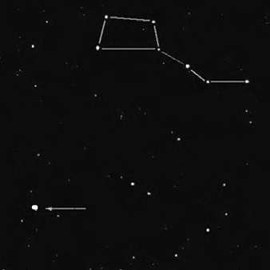

**Saptarshi or The Great Bear**

**Pole Star**

* 1. During summer nights one can see a particular arrangement of seven stars. We call them Saptarshi. In the month of February, this constellation rises around 8 pm in the north-east. It is on the meridian in the month of April and in the month of October, it sets around 8 pm. As the name suggests, Saptarshi is a group of seven bright stars. It is in the shape of a quadrangle with a tail made up of three stars. It thus resembles a kite and can be easily recognized. If we extend one side of the quadrangle, it reaches the Pole Star or Polaris as shown in figure 20.3. Different countries have different names for this constellation. In English it is called the Great Bear.

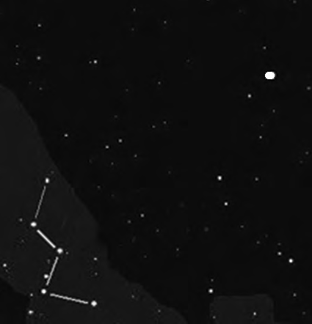

**Pole Star**

**Sharmishtha or Cassiopeia**

* 1. The constellations of Saptarshi and Sharmishtha or Cassiopeia are useful in locating the Pole Star. Sharmishtha is made up of five bright stars which are distributed along the figure of the letter M. The perpendicular bisector of the line joining the third and fourth stars in Sharmishta goes towards the Pole Star. (See figure.) The Pole Star has Saptarshi on one side and Sharmishtha on the other. As Sharmishtha sets, Saptarshi rises. Thus, we can always use either one or the other as a reference point on any given night.

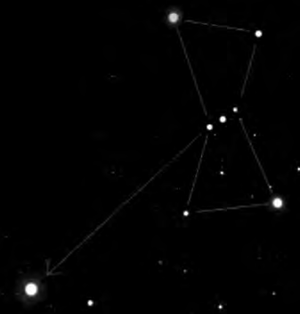

**Mrug or Orion**

**Vyadh or Sirius**

* 1. Mrug *nakshatra* or Orion has very bright stars. On winter nights, they can be easily identified. It has seven - eight stars of which four are at the corners of a quadrangle. The line passing through the three middle stars of the constellation, when extended, meets a very bright star. This is Vyadh or Sirius. During the month of December, Mruga *nakshatra* rises at 8 pm on the eastern horizon. It is on the meridian during February and in June, it sets around 8 pm.

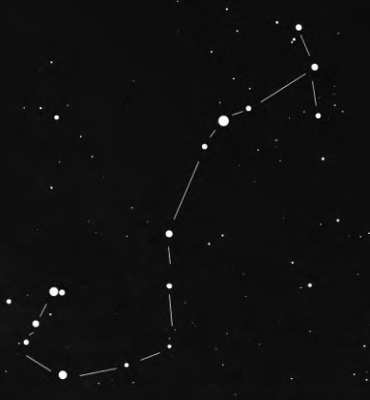

**Jyeshtha or Antares**

**Vrushchik or Scorpio**

* 1. Vrushchik or Scorpio is a constellation with 10 to 12 stars. Jyeshtha or Antares is the brightest among them. This constellation is below the equator, in the sky of the southern hemisphere. In the third week of April, it can be seen in the eastern sky a few hours after sunset.
  2. **Some constellations**

1. Why is the Pole Star important for sky watch ?
2. What is the relation between the Pole Star and the constellations Saptarshi and Sharmishtha ?

With the help of your friends, draw a big circle on the ground as shown in figure 20.4. Ask twelve of your friends to stand at equal distances along the circle, each holding a placard with the name of one zodiac sign in proper order.

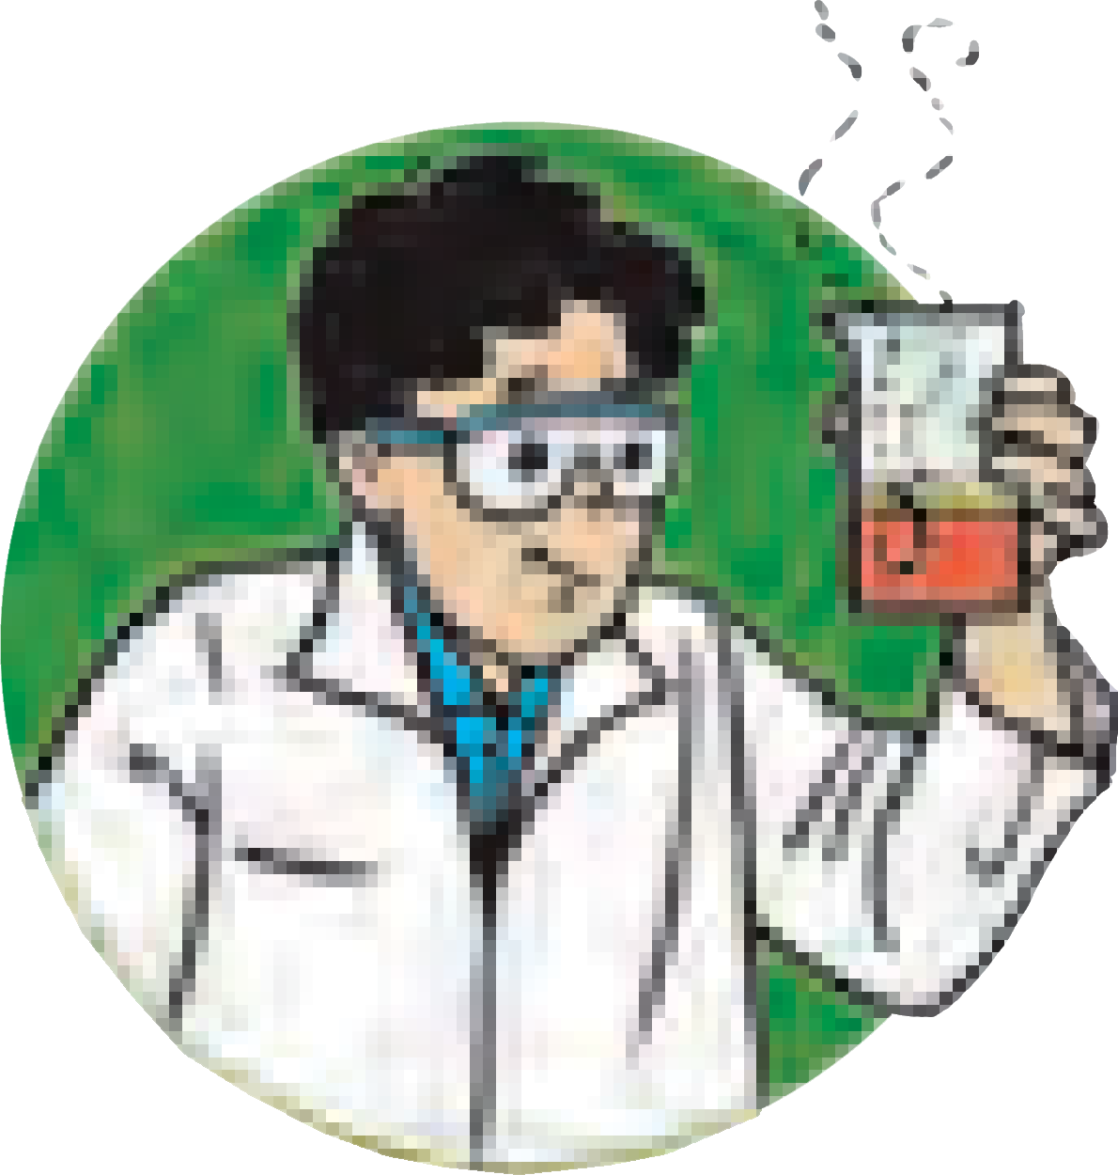

**Try this.**

Make one friend stand as the sun at the centre of the circle. Now, move along a smaller circle around the sun, as if you are the earth, facing the sun all the time. What do you notice as you move along this circular orbit ? Ask your friends to take turns to do the same. Discuss what everybody sees.

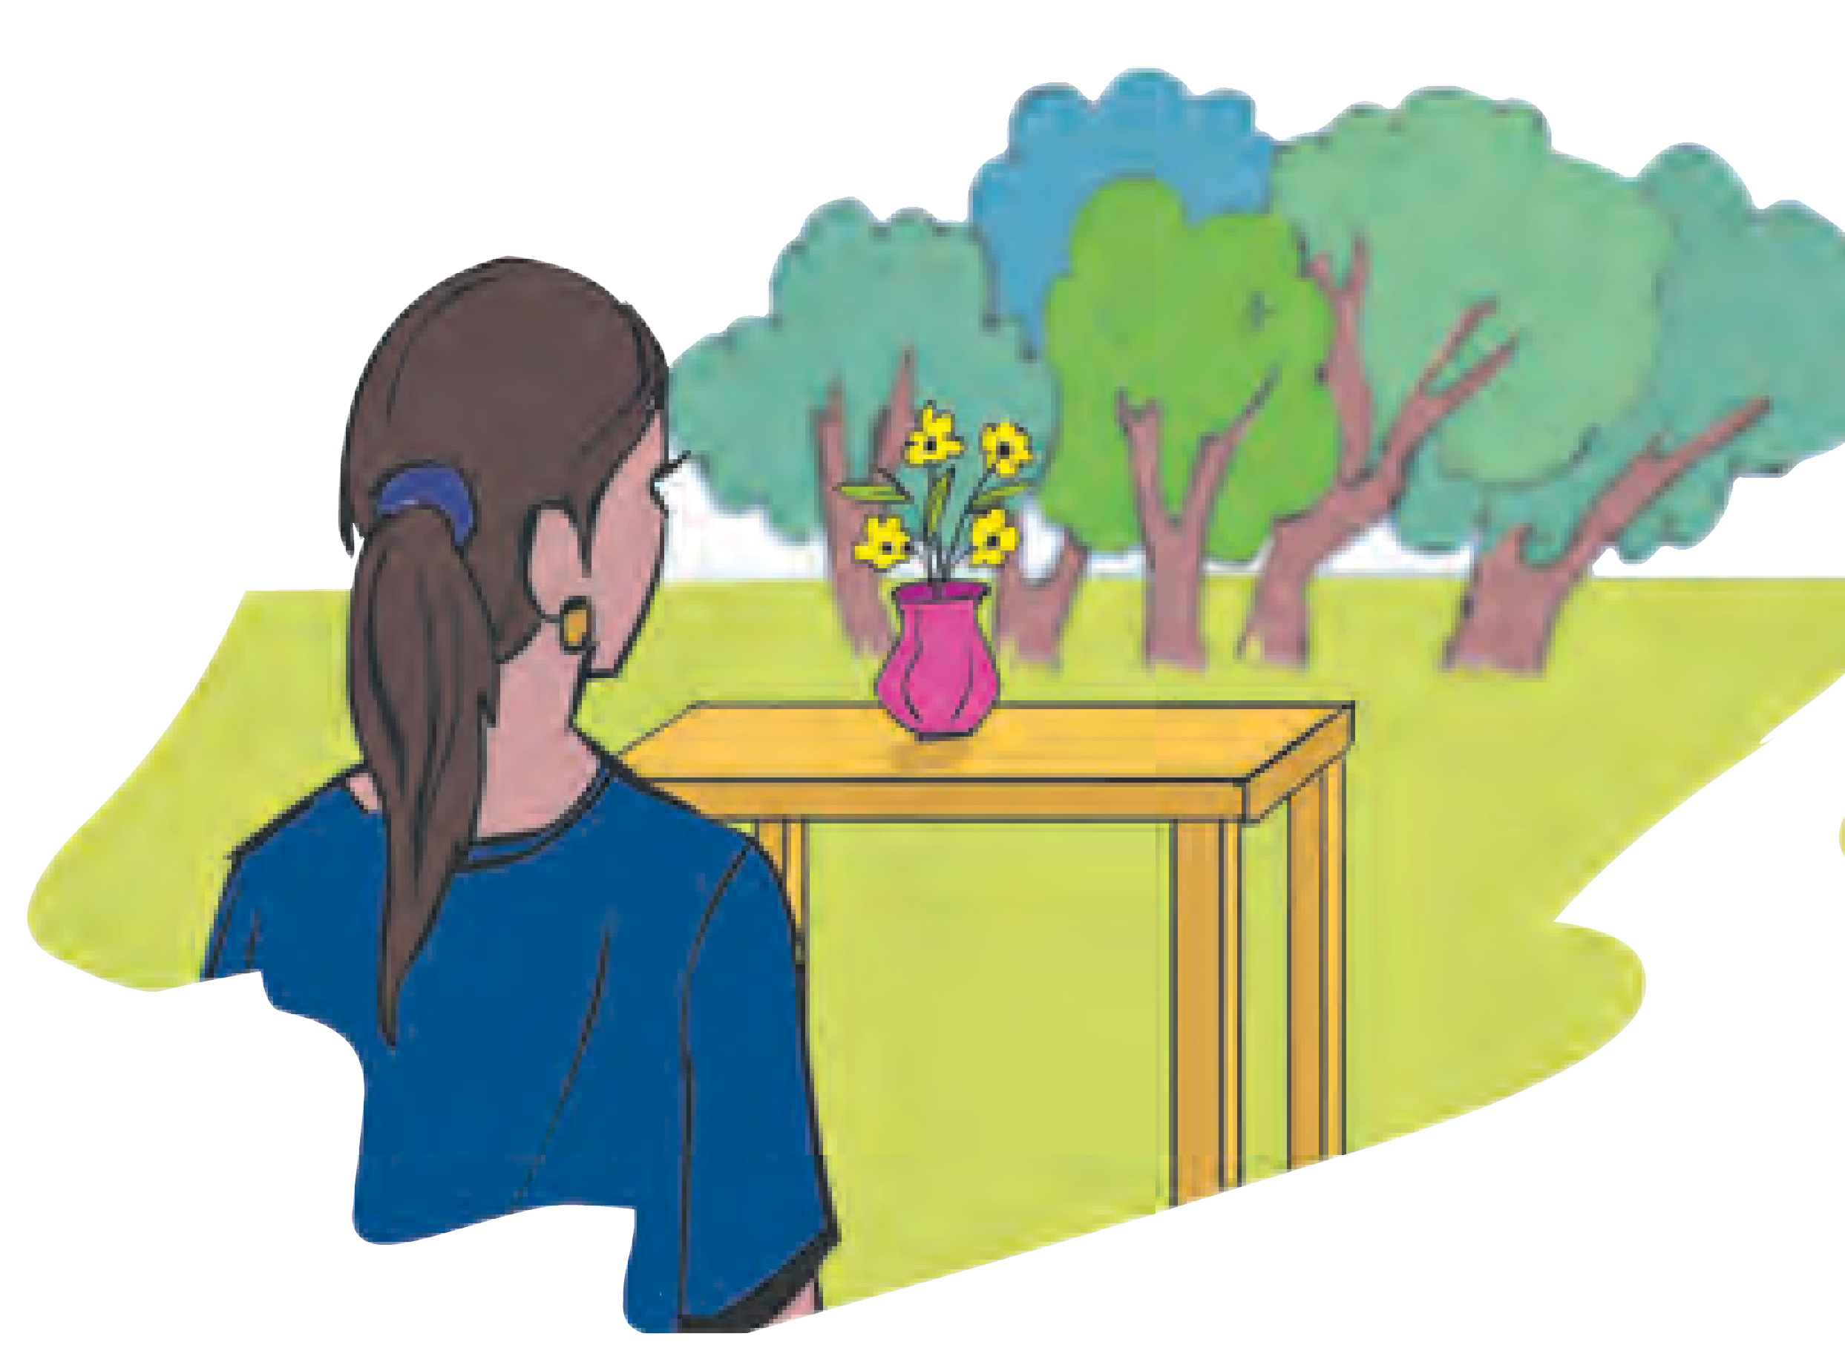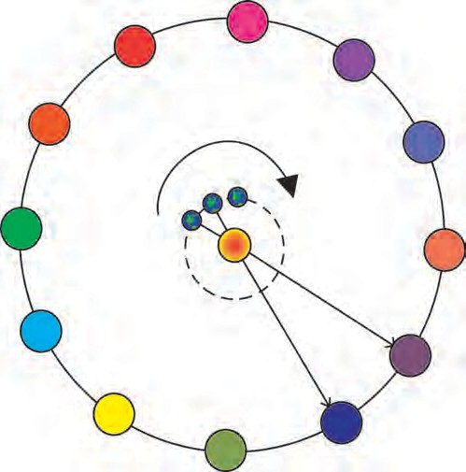

***Raashi***

Virgo

Libra

Leo

Ecliplic

Scorpio

Cancer

Sun

Earth

Sagittarius

Gemini

B C

A

Capricorn

Tauras

Aquarius

Aries

Pisces

In this figure, when the girl looks at the flower pot, in addition to the flower pot, she also sees the trees in the background.

* 1. **Diagram of the experiment**

The observer looking at the sun sees not only the sun but also a constellation behind the sun. The constellation cannot be seen in bright sunlight, but it is indeed present behind the sun. As the earth changes its position, a different constellation or zodiac sign or *raashi* appears behind the sun. This is what we express when we say that the sun enters a particular zodiac sign or *raashi*. For example, on Makar Sankranti we say that the sun enters Makar *raashi* (Capricorn zodiac sign).

When the earth is at A, for an observer on the earth, the sun appears to be in the Scorpio zodiac sign. When the earth moves from A to B, the observer will say that the sun has entered Libra. In reality, the sun does not move, but we perceive it as moving due to the motion of the earth around it. This motion of the sun is called its **apparent motion** and its path is called the **apparent path**. The rising of the sun in the east and its setting in the west is also an apparent motion. You might have heard some elders saying that a particular *nakshatra* is in the rising and now prevails. It means that, at that time, if you look at the sun from the earth, that particular *nakshatra* is behind the sun and gives you an idea about the position of the earth revolving around the sun.



**Always remember -**

Science has proved that the constituents of the solar system e.g. planets, satellites and comets as also distant stars and constellations do not have any influence on human life. Man stepped on the moon in the twentieth century. He will conquer Mars in the twenty-first century. Hence, in this age of science, holding on to beliefs which have been proved to be wrong through numerous scientific tests, is an unnecessary waste of one’s time, energy and money. It is necessary to consider all these issues with a scientific frame of mind.



**Books, my friends !**

‘*Aakashashi Jadale Naate*’, ‘*Chhand Aakashadarshanachaa*’, ‘*Vedh Nakshatrancha*’, and ‘*Taarakanchya Vishvat*’ are a few books which you may read to get more information on constellations and sky watching.

**Exercise**

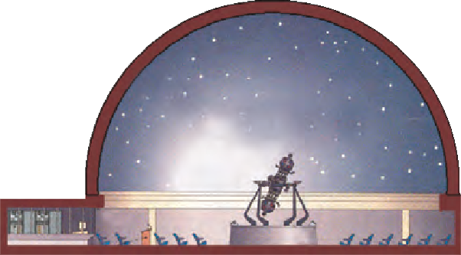

**National Institutions**

**IUCAA** (Inter University Centre for Astronomy and Astrophysics) in Pune carries out fundamental research in astronomy.

In India, planetariums named after Pandit Jawaharlal Nehru have been established at New Delhi, Bangaluru, Allahabad, Mumbai and at New English School in Pune. They present a virtual projection of various stars and constellations as if it were a sky watch. Do visit these places during a school tour or whenever possible.

**Layout of a planetarium**

**Website :** [**www.taralaya.org**](http://www.taralaya.org/)

1. **Write the proper words in the blanks.** (meridian, horizon, twelve, nine, apparent, celestial, ecliptic)
   1. When seen from a great distance, the sky seems to be touching the ground along a circle. This circle is called the .............. .
   2. The .............. is used while defining the zodiac signs.
   3. Classified according to seasons, one season will have *nakshatras*.
   4. The rising of the sun in the east and its setting in the west is the .............. motion of the sun.
2. **A star rises at 8 pm tonight. At what time will it rise after a month? Why?**
3. **What is meant by ‘The sun enters a *nakshatra*’ ? It is said that in the rainy season the sun enters the Mrug *nakshatra.* What does it mean?**
4. **Answer the following questions.**
   1. What is a constellation?
   2. What points should be considered before a sky watch ?
   3. Is it wrong to say that the planets, stars and *nakshatras* affect human life ? Why ?
5. **Write a paragraph on the birth and lifecycle of stars using figure 20.1**

**Project :** Visit a planetarium, collect information and present it in your

school on Science day.

⧫  

